Truth and lies
Lecture 2
False simplicity
Learning outcomes:
- Define dichotomous/binary thinking and be able to explain how it relates to the appeal to ignorance logical fallacy.
- Describe Connor et al’s (2025) attempt to encourage dialectical thought and how it was effective and ineffective.
- Describe at least three reasons why individuals might choose to be on the ‘CAM’ side of a medical dichotomy.
- Apply what you know about binary thought to issues which arise with political elections and the use of status and power in pseudoscience.
At a soccer game there are only two sides competing with each other. It's very simple. You pick a team and go for your team. You wear the colours and cheer when they score and complain about the ref when the other team scores. It's great fun.
In the real world things are rarely so black and white. We know science works by making probabilistic conclusions based on the weight of evidence. There are lots of uncertainties and shades of grey.
Simplicity is fine for games that are meant to be entertainment, but many people want this black and white simplicity in all aspects of their life. They simply want to support one team, join one tribe, and adopt and agree with everything that comes with that tribe. That desire for simplicity can cause a lot of problems.
In this lecture I am going to focus on a single logical and cognitive issue and explore it in depth (false dichotomy/ excluded middle), but if this topic of science vs pseudoscience intrigues you – or you see it helping someone close or in your community – here are some general resources:
Sagan, C. (1996). The demon-haunted world : science as a candle in the dark. Random House. (Excerpt here: The Baloney Detection Kit: Carl Sagan’s Rules for Bullshit-Busting and Critical Thinking – The Marginalian).
Skeptics dictionary: https://www.skepdic.com/ A great resource for logical fallacies, pseudoscience, false claims and products and reasoning phenomena.
Think back to the last lecture and what science gives us: probabilistic statements, theories supported with the weight of current evidence, and always room for improvement. At its core is understanding uncertainty, embracing it as inevitable, and trying to reduce it or build around it (e.g. make the wall thicker to account for uncertainties). Science gives us shades of grey approaching certainty. The opposite of that, is dichotomous thinking – thinking in terms of black and white – binary thinking it is it sometimes called and it is also linked to the logical fallacies ‘false dichotomy’ and ‘excluded middle’, framing questions as if there are only two possible answers. It further links to the logical fallacy ‘appeal to ignorance’, because if someone believes there are only two possible explanations (e.g. creationism and evolution), they may believe that attacking one side supports the other: you do not have certain evidence for your claim, therefore mine must be true. That does not make sense, if we aren’t quite sure how zebras evolved, that is a lack of evidence for an understanding of how zebras evolved, it is not evidence at all for your belief that zebras were sneezed out of a noodly appendage of a giant spaghetti monster. Yet as we saw from the last lecture, some people have a low need for cognition and seek out simple descriptions of the world. The world is a far simpler place if every question has only two possible answers, and there are no shades of grey, or uncertainty.
Connor et al. (2025) explore the construct of intellectual humility: “a tendency for individuals to recognize the fallibility of their own ideas and attitudes”. By their methods, they do not treat intellectual humility as an enduring personality trait, rather something that arises from our experiences with the world. They attempt to both increase and decrease intellectual humility by manipulating participants’ experiences with dichotomous thinking.
They write:
“a propensity to simplify problems into binary causes – and solutions into binary outcomes - may result in individuals being overly confident of their interpretations of the world and less willing to modify their views based on the opinions of others. On the contrary, we suggest that low dichotomous/ high dialectical thinking might better enable intellectual humility within individuals. We argue that non-binary thinking, characterised by the consideration of multiple perspectives and recognizing that important problems tend to be complex, and rarely attributable to binary causes, reduces the need for cognitive closure and allows individuals to recognize the limitations of their own knowledge and consequent intellectual fallibility.” Connor et al. 2025, p.3)
Four hundred and ninety nine participants were randomly allocated to one of three conditions:
High dichotomous thinking: They were shown 12 paired pictures (e.g., black and white dogs, male and female faces, African and Caucasian babies, hamburgers and sandwiches, pizzas and salads) and then asked to categorize the pictures along a particular dimension (e.g., colour, gender, race) and to assign the most appropriate binary label (e.g., black or white, male or female, healthy or unhealthy) as quickly as possible.
Dialectical thinking: They read a moral dilemma around the character Heinz, who steals medicine that he cannot afford in a desperate attempt to save his terminally ill wife. During their engagement with the moral dilemma, participants were explicitly instructed to adopt a multifaceted viewpoint, endeavouring to explore the intricate complexities from multiple angles. They were further prompted to generate three potential advantages and three potential disadvantages associated with Heinz’s actions, alongside identifying one reason as to why one might not be able to say with certainty that Heinz was either right or wrong.
Control condition: They read a passage from Moby Dick.
And after this all participants completed measures assessing their intellectual humility.
Connor et al. (2025) found that the dichotomous image classification task did not reduce intellectual humility but the dialectical thinking task did increase it. Considering the methodology, I can’t imagine reading a short story is somehow going to make people consider shades of grey more in general, the story may have simply primed certain responses on the questionnaire. Nevertheless, it is a sobering thought that being exposed to cultural narratives that are simplistic might not be helping us understand shades of grey. Consider the ‘goodies vs baddies’ approach of many films originating in North America. You can ‘kill’ the problem, usually with a gun – the struggle of society does not come from imperfect distribution of wealth or unfair laws, it comes from that person over there wearing the dark suit, kill them! It sounds ludicrous, but many years ago a sitting US president declared war on ‘terror’ – a concept..!? When simplistic dichotomous ‘us vs them’ thinking takes over at the highest diplomatic levels, you know complexity and detail is lost.
Dichotomous thinking does not just divide complex issues into two sides, it homogenises each of the sides. Sydney University should be seen as a collection of diverse people with diverse ideas and research interests, not a single entity. ‘Medical science’ should be understood as an unending process of debates and controversies and research, not a monolithic institution: “Big Pharma” people used to call it. And in the other corner, you have CAM (complementary, alternative medicine). Shades of grey are lost in the binary expression. The most tentative, experimental medical treatments get stuck on one side, and many well understood remedies stuck on the other, when every remedy ought to be considered in itself. People want to pick a tribe though – choosing a side is part of some people’s identity, and once you do that then the binary thinking is locked in, and from that point on one side is completely correct, the other side is completely wrong.
For this particular example the dichotomy makes little sense logically. If you’re on the CAM ‘side’, you might believe in chiropractic, acupuncture and homeopathy, not realizing that each of those systems contradict the other logically. Also what about ‘cupping’ – it used to be part of the established medical side (based on bloodletting), now the practice has moved, so if you are proudly showing your cupping scars is that a social sign of supporting CAM…. or supporting the 1850’s medical establishment? Considering ‘medical science’ as one thing is misguided also, chemotherapy (hurting yourself and hoping the cancer dies first) is highly effective for early stage breast cancer, but some forms of pancreatic cancer you might only get 2 more months of life for all the agony. Antibiotics for viral infections and routine imaging for lower back pain are treatments commonly proscribed, but they have no effect at all – doctors might blame patient demand, but why can’t they explain it won’t do anything? Lots of grey and lots of overlap.
Monika Lamot and others (2024) asked 858 adults living in Slovenia about their trust in the healthcare system, attitudes towards CAM, and their political alignment during the Covid-19 pandemic.
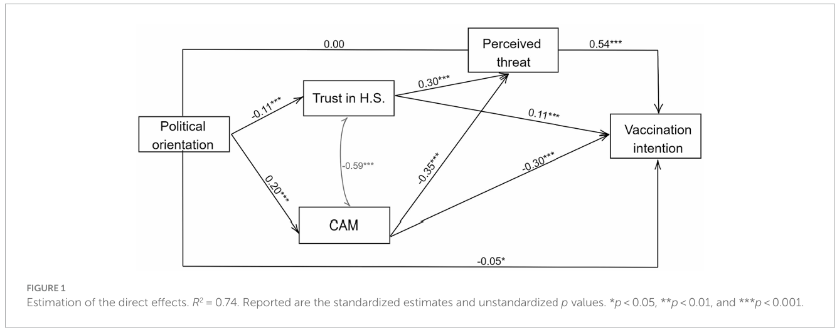
They found that while political orientation had no direct association with vaccine intention, it did predict endorsement of CAM and trust in the healthcare system. Those with a ‘leftist ideology’ were less likely to endorse CAM and were more likely to trust the healthcare system. Trust in the healthcare system was positively associated with vaccine intention whereas CAM endorsement led to lower intention to vaccinate. Those who trusted CAM were less likely to note a ‘perceived threat’ while those who trusted the healthcare system were more likely to see a perceived threat. In correlational designs like this, you can speculate about causal mechanisms but not definitively show them.
Souček (2025) ran a very similar study (also on a thousand Slovenians!?), and similarly found that those who endorsed CAM were more likely to refuse or be sceptical about vaccines.
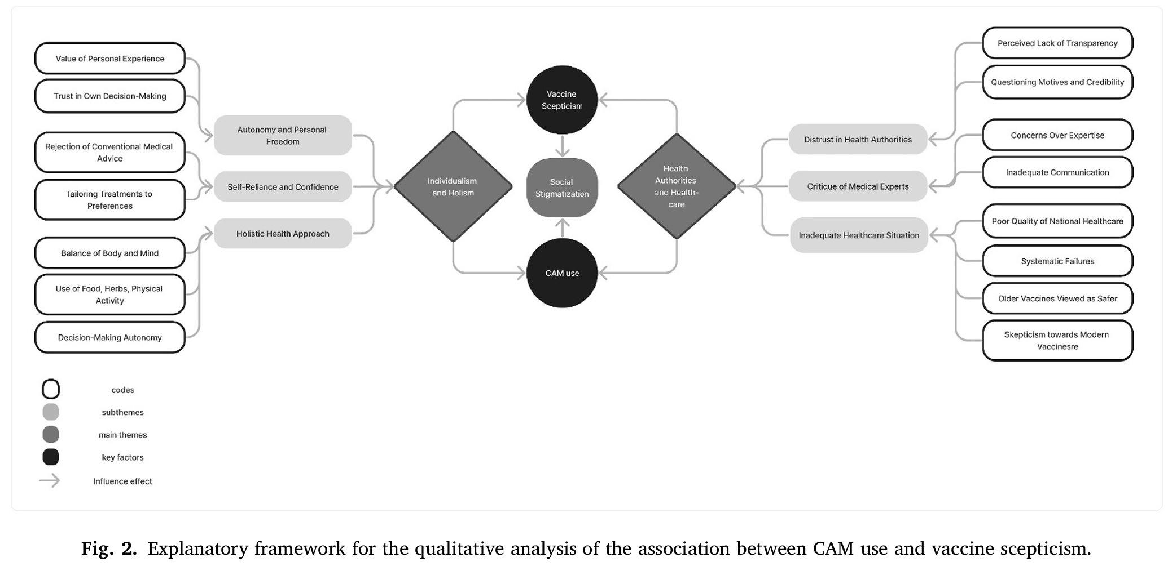
They argue their data shows it is not a simple direct cause. They claim that mistrust in health authorities and healthcare drives some people to both CAM and vaccine refusal, but others endorse and engage with CAM because of the autonomy and freedom it gives them: these people were not identified in the study as the ones refusing vaccines. In other words if you are attracted to CAM because of feeling empowered and in charge of your treatment, you’re going to get a vaccine; but if you’re engaging with CAM because of mistrust in evidence based medicine, of course you won’t get a vaccine. I read through quite a few vaccine studies like this and most at some point said that the patterns they found were different to that normally found and they speculated that covid-19 was different. The overwhelming nature of the pandemic and number of deaths presumably pushed a lot of people who might normally be hesitant decide to protect themselves (this came up in the last lecture also).
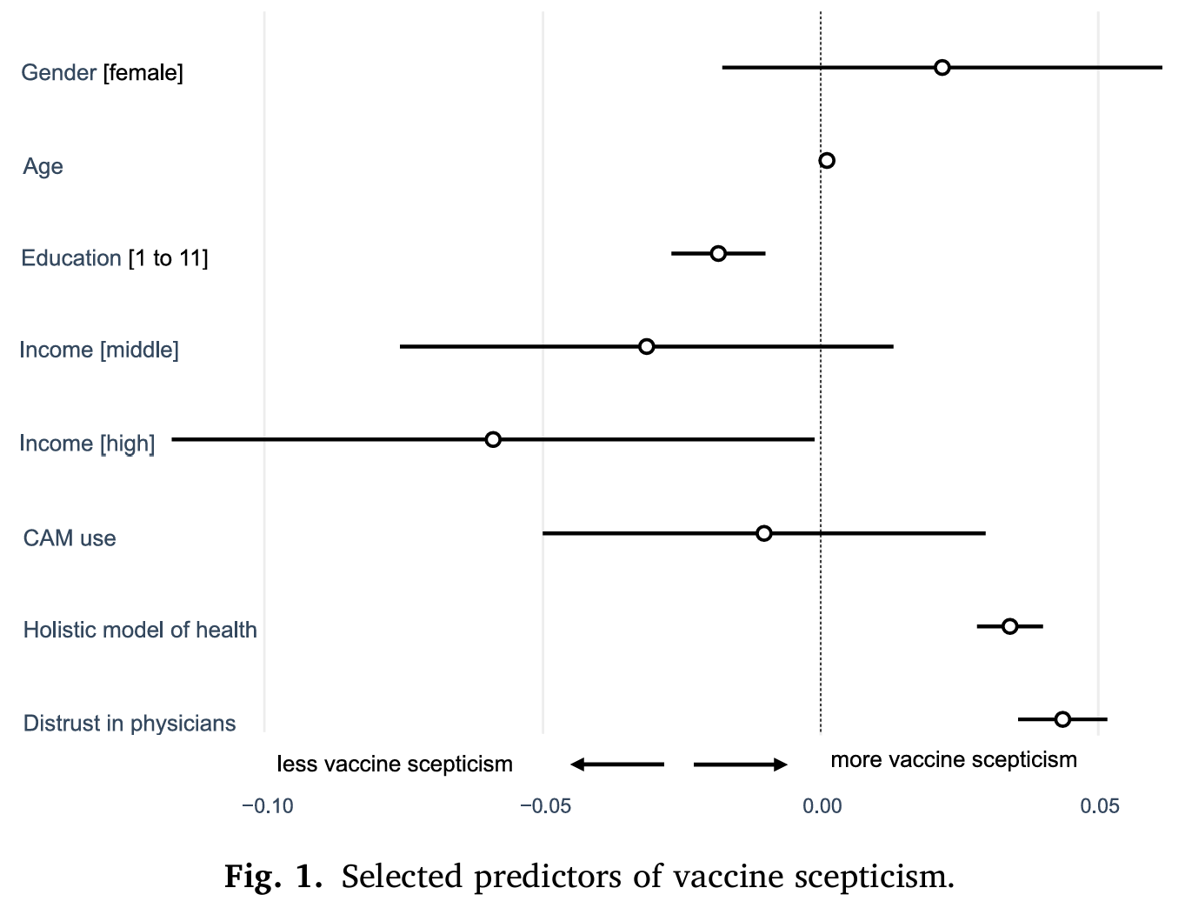
As with the research on need for cognition I covered in the last lecture, political conservatives appear more likely to be the simplistic thinkers in vaccine studies, choosing the side supported by the least evidence. Racism arises from the same simplistic dichotomous thinking that leads to the “us vs them” CAM/big Pharma conflict just covered. At the heart of racism is the belief that the ‘other’ side is homogenous – all the same. It has long been thought that conservatives are much more racist, homophobic and so on, more generally intolerant (see Sibley & Duckitt, 2008, for a meta-analysis) than liberals, and this is referred to as the ‘prejudice gap’. However Brandt et al. (2014) claim to have evidence that people from both sides of politics hold prejudices against the ‘other’ side. They argue that many previous studies the prejudice gap only measured prejudice towards groups liberals tend to support. They were able to replicate those strong prejudices by conservatives against liberal targets; but by also including ‘conservative groups’ as targets (e.g. anti-abortionists, religious fundamentalists, climate sceptics, corporations) the prejudice gap disappeared – liberals leaning left were just as prejudiced.
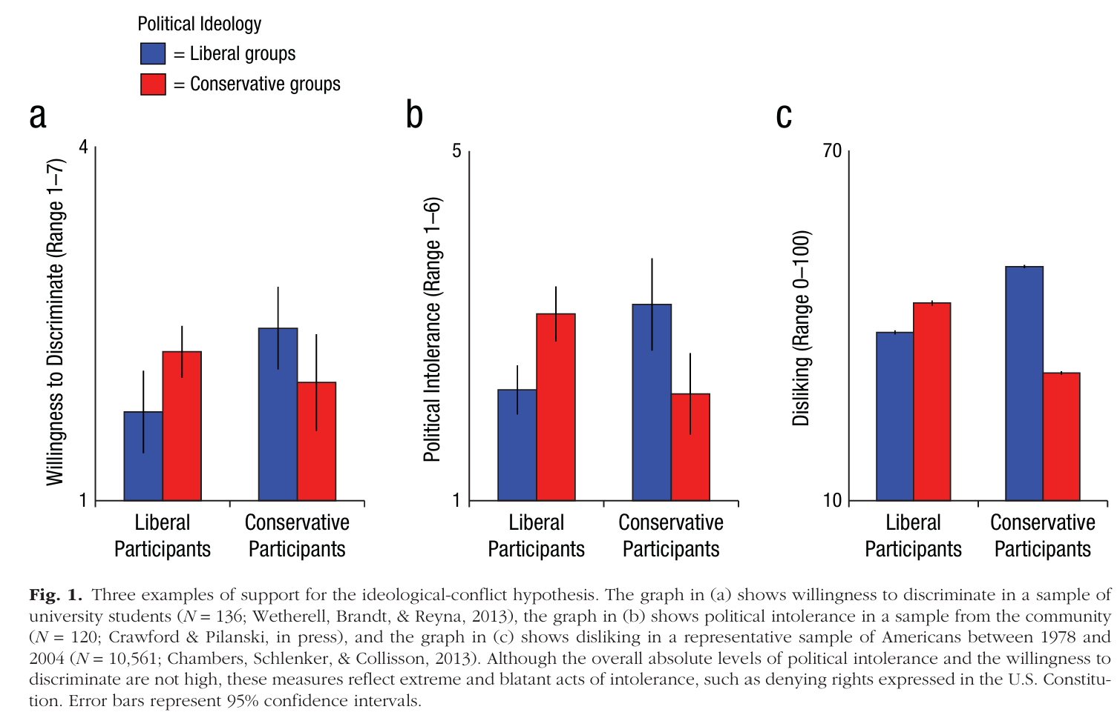
Instead of a prejudice gap, Brandt et al. (2014) proposed a ‘ideological conflict hypothesis’ , where everyone shows prejudice toward groups whose values contradict their own. You hate people who think differently basically. It means to tendency the form tribes and simplify the world into dichotomies and conflicts is universal and something we need to deal with as a species.
What is most problematic about binary thinking is that detail, nuance and diversity is lost. Incumbent governments tend to get blamed for whatever economic conditions exist at the time, even if they have no control over them (e.g. wars, pandemics), which drives voters to vote for an alternative party – just to oppose the government. You would imagine in times of economic downturn, conservative right wing parties which support the status quo (wealth inequality, lower taxes on the rich, fewer social services) would never have any chance of gaining power, but around the world the opposite is happening. Such parties often gather working class support by identifying and focusing on a new ‘other’ (usually immigrants or minorities) to redirect the simplistic binary thinking away from themselves.
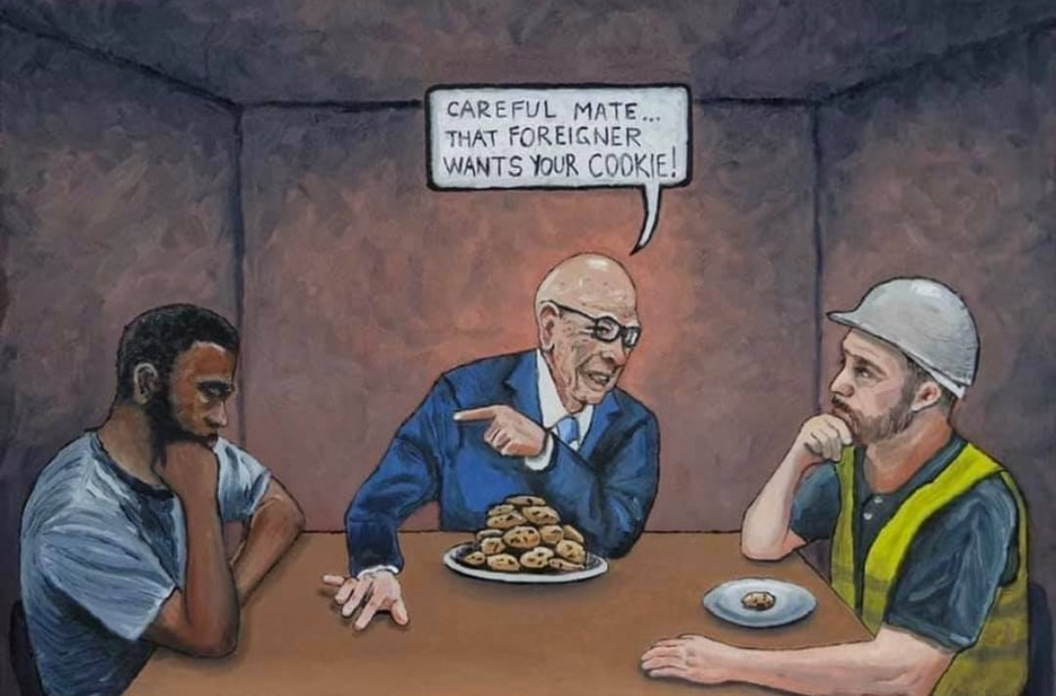
(Artist: Denis Lushch, Victoria, Australia)
Are people really so cognitively inept that they can only think in terms of two? Trying to make a binary decision when you have to combine multiple considerations is cognitively taxing. For a decade though apps/websites have existed to assist. “Vote compass” started in Canada but the ABC hosts an Australian version: Vote Compass Australia 2025 - Australia Votes - ABC News Have a go if you like – it will ask lots of questions, then tell you how closely your responses align with existing political parties. The version I have linked to relates to the most recent election – I’m sure they’ll update it for the next one. The only peer reviewed research I could find on Vote Compass concerned the algorithms weighting the outcomes, with is mathematical, but I can understand that issue, because if you are poor, in desperate need of social services, but want much lower immigration, an app is going to struggle to advise you – how important is your healthcare relative to ensuring fewer immigrants enter the country? While imperfect, ‘Vote Compass’ surely improves the quality of decisions, or at the least might encourage deeper thought. In 2026 people should not be voting for politicians because of their appearance?
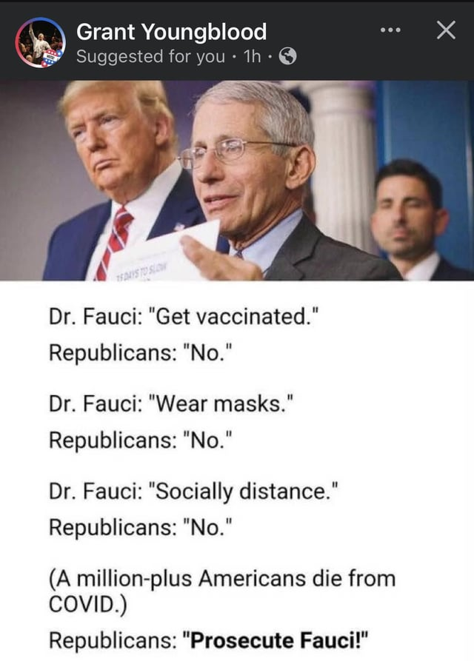
To summarise so far: people usually do not consider the weight or diversity of evidence when making decisions about their health or who to vote for. Instead, people will frame the issue as having two sides, and either consider just a single line of evidence, or worse, simply attack the ‘other’ side and take that as evidence that ‘their’ side is valid. Scientific decision making is always weighted by evidence – not just how much, but how good it is (if you notice for most studies I introduce I mention the method or sample or the way inferences were drawn, I’m pondering how robust the findings are). Evidence is argued about, analysed mathematically, compared and ideally replicated. If cognitively lazy binary thinkers are not doing this, what is the currency that drives their decision making?

In the modern age we can easily online for evidence and information regarding products and treatments. If we seek out peer reviewed sources and avoid looking only for what confirms our beliefs we can build a reasonable perspective which would allow us to avoid harmful or ineffective products. (Someone doing ‘online research’ by listening to non-experts actually selling the products or using non-peer reviewed sources is not going to accumulate much of value). However, when you navigate society physically or commercially, legitimacy is communicated not by evidence but by the status of shopfronts, packaging and brands. If someone sets up a stall on a footpath on top of a cardboard box with coloured pills displayed in a plain jar and claims that they help you fall asleep even though they contain nothing except the magic memory of what used to be associated with them, no one is going to buy them or even go near them.
Put those same claims on a formal looking package, and ask that a retailer who sells highly effective remedies (a pharmacist) to put your product on the same shelves, and suddenly you have a profitable respectable business making money, selling nothing of any value at a high price.
Homeopathy is a belief that water remembers what used to be in it, and a belief that the more diluted a substance is, the more powerful it is in the opposite direction to its usual effect. None of those beliefs have any basis in science (or common sense). Twenty years ago (2005), preparing for a psychology lecture, I walked into the USYD campus pharmacy on Science Road, within site of the Wallace lecture theatre where I would give the lecture. I picked up a box of “homeopathic sleeping tablets”. The pharmacy had a huge poster in the window appealing to students “Trouble sleeping?” with an image of the product. I picked up a box and asked the friendly pharmacist “Does this product work and how does it work?” and he chose his words very carefully. Every sentence began “Some people believe.” I read the labels on the boxes carefully, bought three of them, and took them to my lecture.
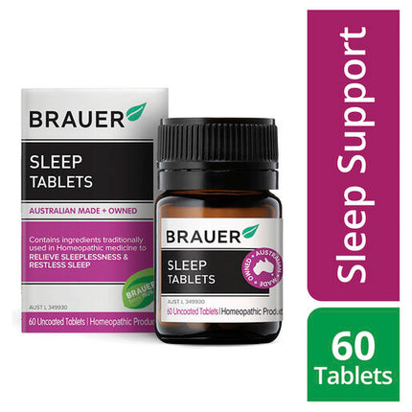
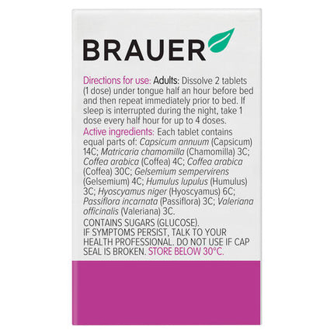
Ingredients
Each tablet contains equal parts of: Capsicum annuum (Capsicum) 14C Matricaria chamomilla (Chamomilla) 3C Coffea arabica (Coffea) 4C Coffea arabica (Coffea) 30C Gelsemium sempervirens (Gelsemium) 4C Humulus lupulis (Humulus) 3C Hyoscyamus niger (Hyoscyamus) 6C Passiflora incarnata (Passiflora) 3C Valeriana officinalis (Valeriana) 3C
Contains: Each tablet contains equal parts of: Capsicum annuum (Capsicum) 14C Matricaria chamomilla (Chamomilla) 3C Coffea arabica (Coffea) 4C Coffea arabica (Coffea) 30C Gelsemium sempervirens (Gelsemium) 4C Humulus lupulis (Humulus) 3C Hyoscyamus niger (Hyoscyamus) 6C Passiflora incarnata (Passiflora) 3C Valeriana officinalis (Valeriana) 3C
Active Ingredients: Each tablet contains equal parts of: Capsicum annuum (Capsicum) 14C Matricaria chamomilla (Chamomilla) 3C Coffea arabica (Coffea) 4C Coffea arabica (Coffea) 30C Gelsemium sempervirens (Gelsemium) 4C Humulus lupulis (Humulus) 3C Hyoscyamus niger (Hyoscyamus) 6C Passiflora incarnata (Passiflora) 3C Valeriana officinalis (Valeriana) 3C

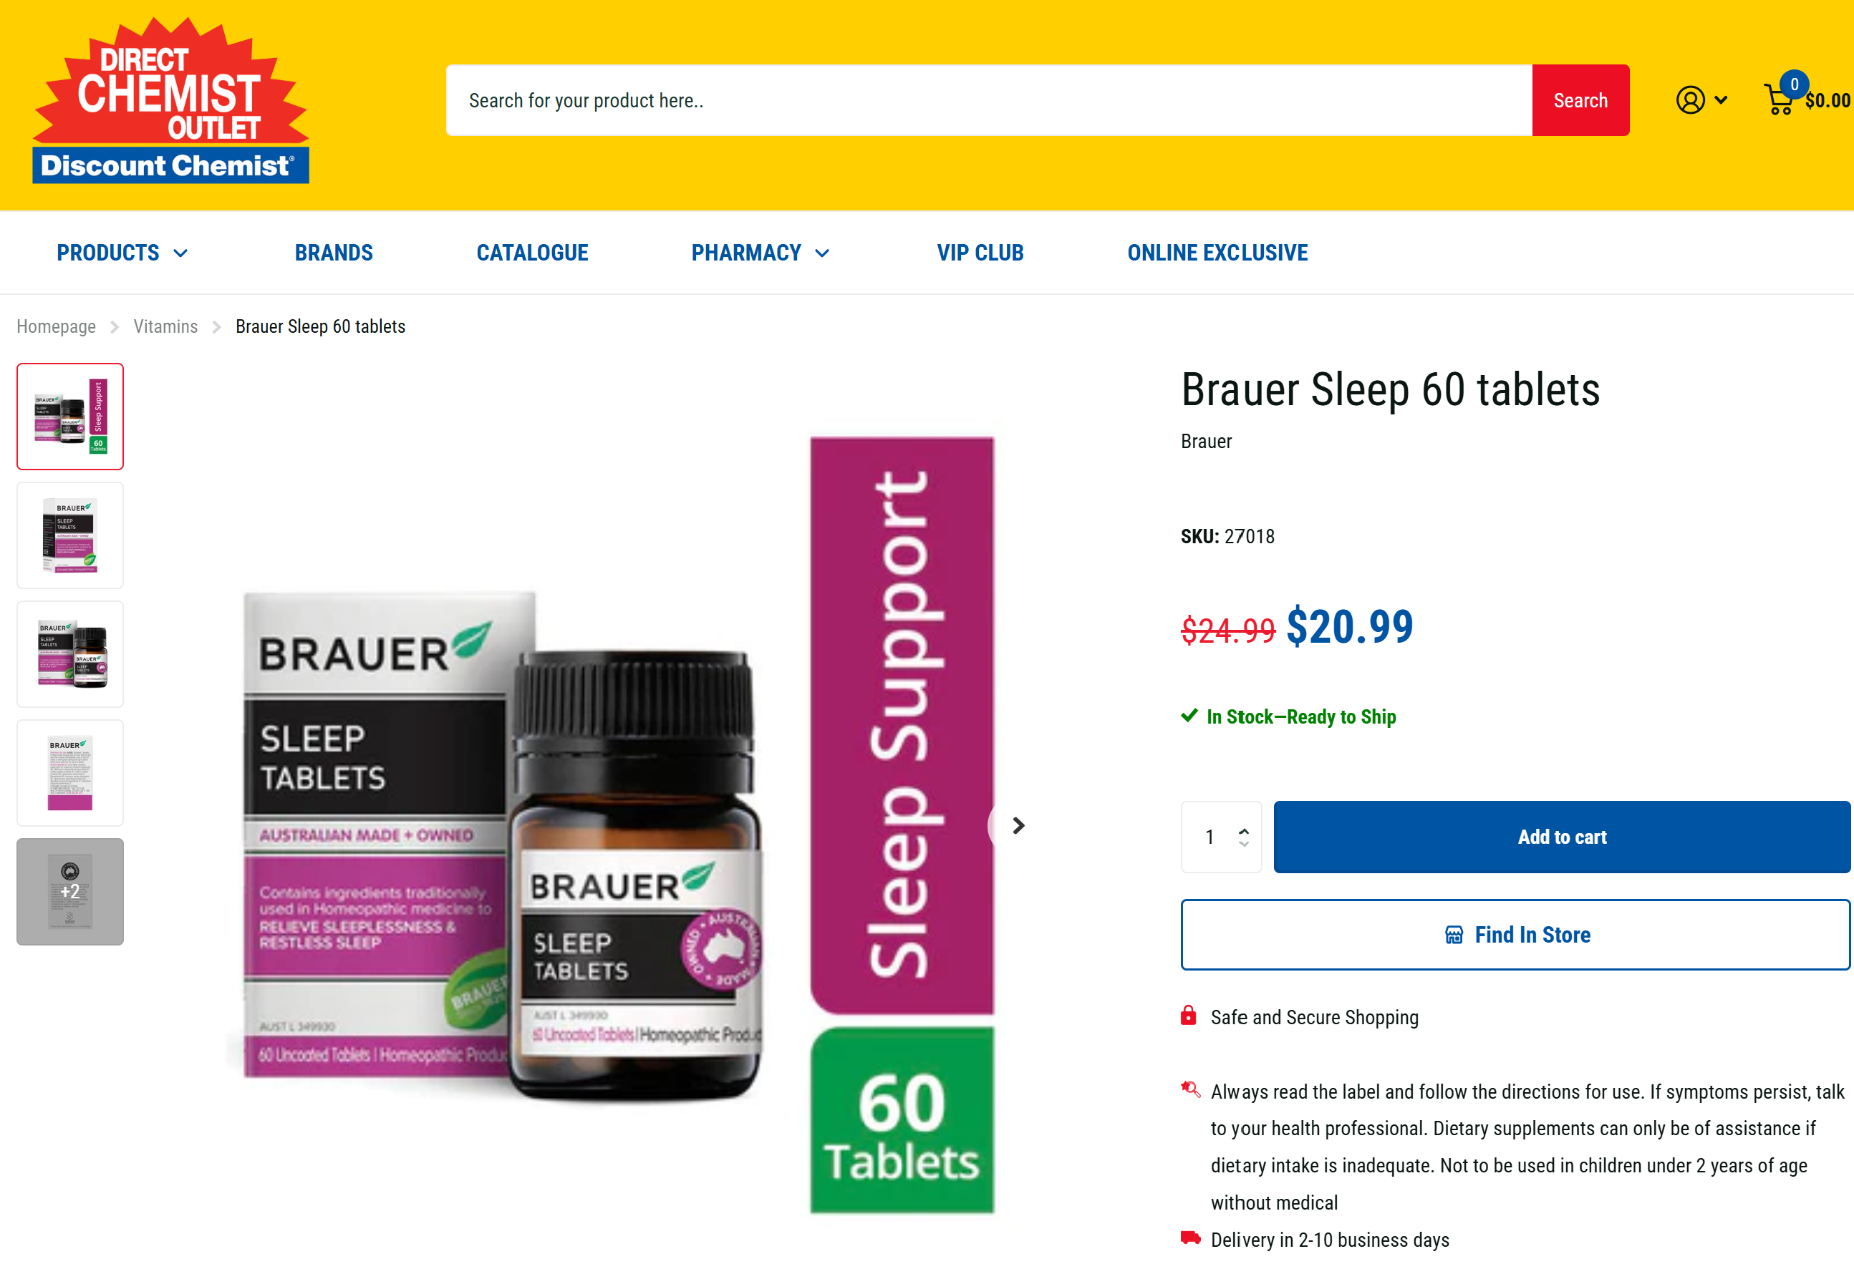

I was expecting to have to go through my old office drawers to find old boxes, but shockingly, this product is still on sale two decades later and has barely changed. Twenty years of this sitting on pharmacy shelves, making money. It consists entirely of sugar and nothing else. It is a shock to many to learn that in Australia the TGA “Therapeutic Goods Administration” does not test for the effectiveness of anything. It is solely focused on ensuring products are safe. I had to put faith in the TGA and in the accuracy of the labelling of this product, because – in front of several hundred students – I consumed the whole box of tablets in one go. Because we repeated lectures three times in a single day back then (everyone wanted to attend on campus lectures!), I had to buy three boxes each year, and eat the whole box three times in a day. It was theatrical of course, sleeping tablets with active ingredients would be quite harmful taken in such quantities. But homeopathic remedies don’t contain any active ingredients. Look at the ingredients list:
“Coffea arabica (Coffea) 4C”
What does that mean? Remember the two ‘beliefs’ that make up homeopathy: water remembers what used to be in it; the more diluted a substance is, the more powerful it is in the opposite direction to its usual effect.
The ingredient is coffee… in a sleeping tablet, but hold on if you dilute it enough it has the opposite effect.
4C means that the coffee has undergone 1:100 dilutions (in water), four times. The final dilution is one part coffee, one hundred million parts water. There is almost nothing left. There is a 30C on the list also:
30C Gelsemium sempervirens (Gelsemium)
That is a 1 in 1,000,000,000,000,000,000,000,000,000,000,000,000,000,000,000,000,000,000,000,000
dilution.
This is far beyond Avogadro’s limit, meaning no molecules of the original substance are expected to remain.

…this is a product bought from a pharmacy, on campus, on Science Road, that contained nothing. I gave those lecture for five years (2005-2010), that’s a lot of tablets consumed. In the later years when students had phones with cameras they would film me taking the tablets, they assumed I was hiding them somewhere but quickly realised I was eating them (and chewing them up, sugar tablets are crunchy). The feedback was overwhelmingly positive, people were shocked and intrigued, I remember a biology major pointing out that they would make me sleepy because of the insulin spike from all the sugar. One incident sticks in my mind. A student had watched me do the demonstration in her 10am lecture, and rushed home to her mother, a homeopath. She returned for the 3pm lecture and at the end of the lecture approached the lectern with her mother frowning behind her. “Does the University of Sydney support what you are saying about homeopathy?” she asked – I explained “I wanted to give you an example of an apparently legitimate product which has no evidence supporting it.”, but with the mother still frowning she repeated: “Does the University of Sydney support what you are saying about homeopathy? I explained further that if the idea that something which is more diluted has more power were true, the laws of physics and engineering as we understand them would be wrong and the roof of the lecture hall above us would fall on us right now. I cannot remember what I said to them exactly, but after they left, and for the decades since, it concerns me greatly that the student’s first reaction of attending university, when confronted by a claim – and a demonstration – which challenged her beliefs, ran home to her mother. In retrospect, it was oppressive, threatening, and I fell very sorry for that student. It takes effort and energy to cling to beliefs unsupported by evidence, and the response is usually not about evidence at all, it is about status. Think of the statuses clashing in my story: the USYD Pharmacy, the professional homeopath, the claims of USYD itself. I just wanted to talk about something illogical, but people pushing products rely entirely on an aura of legitimacy with no foundation. In April 2008 in the UK Dr Simon Singh wrote an article criticising Chiropractic treatments for childhood asthma, despite a lack of any evidence (Chiropractic is founded on beliefs surrounding undetectable energy systems ‘subluxations’ and the belief that our spines must be straightened so we can better communicate – upwards presumably – with god). Think of the mechanism of science I described in the last lecture, a relentless cycle of criticism and evolution of ideas. Pseudoscience does not work that way. The British Chiropractic Association did not want to discuss the lack of evidence. They sued Dr Singh for libel for implying that they had knowingly promoted ineffective treatments. The courts found that Dr Singh had implied the organisation was deliberately dishonest and ordered him to pay damages.
The psychology of conning people rests on status and prestige. “Does the University of Sydney support X...?” – that does not make sense, a university exists to teach people how to ask questions, how to formulate logical arguments, and how to accumulate evidence. In the corporate legal world though, status is how you sell your products and it matters much more than actual evidence or logic.
In addition to status ‘fairness’ is often weaponised to elevate the importance of claims unsupported by evidence. If you are ever curious about any scientific claim, be sure to search for ‘peer reviewed’ papers – it means the research has been scrutinised by competing scientists. It is far from perfect, but the culture it comes from is one of a battle of ideas and scepticism about methods and data. Even if a peer reviewed paper is published, there is every chance the conclusions will overturned by a failed replication later – the battle never ends. If you are making claims that cannot be supported by evidence that could stand up to criticism, how can you get your ideas published? Media institutions (and journalists, many of whom dropped science mi-High School) often feel pressure to be ‘fair and balanced’. Scientists want to be fair also, they reach straight for the evidence and statistics. To a media institution though, it means giving equal time to every perspective. Since that would never be possible – no surprises what they do after all this discussion of dichotomous thinking – they pick two sides to give equal time. The balance may or may not be fair depending on which sides you pick. A debate on climate change might be quite informative if you choose an active debate in science, for example whether or not the North Atlantic Ocean current which warms the UK could reverse suddenly at a tipping point (google AMOC debate). Have a scientist present their evidence in favour and another against to balance things out. Or, a media director might decide that she will instead invite a climate scientist to have a debate with someone who does not even think the planet is warming. She might feel she can still tick the ‘fair and balanced’ box, but what this false balance will do is give viewers the impression that the debate over climate change is still at the ‘is it even happening’ stage we passed decades ago.
You might assume the only threat to informed decision making is binary black and white thinking, but since that originates from lack of effortful thought, another outcome is people who simply disengage and assume that ‘every side is just as bad’. Consider that in the most recent (2024) US presidential election, 32% of eligible voters voted for Trump and 31% for Harris, but 35% did not vote at all. Shades of grey must be understood in all reasoning tasks, but what if a person only sees grey – they don’t care to process any information. In places like Australia where voting is compulsory maybe they will just vote based on appearances, status, or a single issue because they cannot grasp what is going on. If we benefit from living in a society, we all have a responsibility to engage with it.
I feel I could give a dozen lectures on science and pseudoscience, but for the concise chill PSYC1003 version here’s the summary for now:
- Embrace uncertainty – it will always be with us. Learn ways to weight and balance evidence. If you cannot manage statistics and scientific knowledge yourself, rely only on peer reviewed papers published in reputed journals.
- Always mistrust certainty.
- If status is presented instead of evidence, there is no evidence. Status derives from a ‘shopfront’, an institution (often ‘established XX years ago’), a charismatic individual or a cultural practice.
- Appeals to politeness and fairness in place of evidence mean there is no evidence. If it is considered disrespectful to ask questions, then the culture is based on power not reason.
- Something is not true because the alternative is false or uncertain. There are always more than two possibilities.
- Do not aggregate or group. Even amongst very similar treatments one might be effective, one might be harmful. Diversity is everywhere and details are everything.
- For most questions there is a single cluster of ‘best as of now’ answers supported by current evidence. If someone is saying ‘the evidence is not settled’ or ‘we just don’t know’ it is because their own belief is not supported currently.
- Know what will change your mind. Embrace the uncertainty of your own beliefs, know what they rest on, be able to express to others what they rest on, and be prepared to discard them. If nothing can change your mind, you do not hold a reasoned belief, only a fanatical belief.
If you are struggling to reach a family member or a client or a friend or partner who is spending their money on magic crystals to make them taller, your overall objective is deeper more detailed thought. There is only one question you need to ask them: “What evidence would convince you that you are wrong?” If they cannot answer because they have never given that any thought then they are a believer who may or may not ever care to change their mind. Consider if it any further conversations are worth your time.
“One of the saddest lessons of history is this: If we've been bamboozled long enough, we tend to reject any evidence of the bamboozle. We're no longer interested in finding out the truth. The bamboozle has captured us. It's simply too painful to acknowledge, even to ourselves, that we've been taken.”
— The Demon-Haunted World (1995)
Challenging ideas is important though, but there are hurdles to face there also – and that’s the topic of the next and final lecture.

References
Brandt, M. J., Reyna, C., Chambers, J. R., Crawford, J. T., & Wetherell, G. (2014). The Ideological-Conflict Hypothesis: Intolerance Among Both Liberals and Conservatives. Current Directions in Psychological Science : A Journal of the American Psychological Society, 23(1), 27–34. https://doi.org/10.1177/0963721413510932
Lamot, M., Kerman, K., & Kirbiš, A. (2024). Ideological differences in COVID-19 vaccine intention: the effects of trust in the healthcare system, in complementary and alternative medicine, and perceived threat from the disease. Frontiers in Psychology, 15, 1332697. https://doi.org/10.3389/fpsyg.2024.1332697
O’Connor, P. J., Spark, A., Awan, Y., Moss, J., & Chandra, J. (2025). Beyond black and white: Reducing dichotomous thinking to foster intellectual humility. Thinking Skills and Creativity, 57, Article 101841. https://doi.org/10.1016/j.tsc.2025.101841
Sibley, C. G., & Duckitt, J. (2008). Personality and prejudice: A meta-analysis and theoretical review. Personality and Social Psychology Review, 12, 248–279.
Souček, I., Hofreiter, R., & Beňová, K. K. (2025). Understanding vaccine scepticism among complementary and alternative medicine users: A comprehensive mixed-methods investigation. Social Science & Medicine (1982), 367, Article 117808. https://doi.org/10.1016/j.socscimed.2025.117808

I normally don’t mention deities by name to avoid offense but I felt I needed to centre this sentence. If you are a Pastafarian note that I am simply making a logical point and mean no disrespect to followers of the church of the FSM.
In the recorded lecture I place this study right at the end and there are other differences in the order of content. Everything is there, I just felt it worked better as a spoken lecture in a different order.
I’m using Brandt et al.’s terminology which comes from North America (‘liberals’ there are progressive left wing voters), but it can get confusing in Australia, particularly if you’re an international student. In Australia “The Liberal Party” (still in existence when these notes were made, mid 2026) a conservative right wing party, Labor is centre and Greens are left wing.
As I explain in the video, I had a great deal of trouble finding it on pharmacy shelves and had to resort to buying it online. It was available in one mainstream pharmacy (the only stock they had was at the airport), but the difficulty I had was a good sign of some progress at least in two decades.

