Truth and lies
Lecture 3
Learning from feedback
Learning outcomes
- Be able to explain how Eskreis-Winkler and Fishbach (2019) inferred that people were learning less when they were wrong due to ‘ego-threat’.
- Understand and illustrate with examples the impact of culture on the interpretation of failure and the importance of engagement and encouraging appropriate effort.
- Describe the threat of segregated social media and sycophantic AI on allowing people to entirely avoid challenge.
- Form a view as to why soft marking or grade inflation has economic and societal costs.
If you set yourself a goal and fight towards it there will be setbacks and lessons to learn, but so long as you are determined such things might slow you down at most, they won’t stop you. Increasingly students appear fragile and anxious in the face of feedback – their endeavour seems more like a journey of self-affirmation and ego building than a desire to be challenged and changed. For some students, perhaps their objective was only to learn that they knew everything already? This lecture is about the challenge of challenging people. It is not just a teacher-student problem, it is something you must deal with individually, and learn how to challenge yourself. To quote the great chef and philosopher Anthony Bourdain: “There’s a guy inside me who wants to lay in bed all day, smoke pot, and watch cartoons. My whole life is a series of stratagems to avoid and outwit that guy”.
Eskreis-Winkler and Fishbach (2019) gave telemarketers a multiple choice test where each question had only two options. Half the participants allocated to the ‘success’ condition were given positive feedback (“Your answer was correct”) on the first four questions they answered correctly, and no feedback of any kind on other questions. The other half of participants in the ‘failure’ condition, were given negative feedback (“Your answer was incorrect”) on the first four questions they answered incorrectly, and no feedback of any kind on other questions. If all questions had only two options, both groups should have learned the same amount surely?
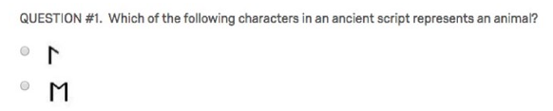
Whether you get the question right or wrong, you get the same information: being told your choice was correct tells you what was correct, but being told your choice was incorrect (they could still see the question and options) still tells you what was correct. However when all participants were tested afterwards, those in the success condition had learned some of the answers, while those in the failure condition learned nothing.
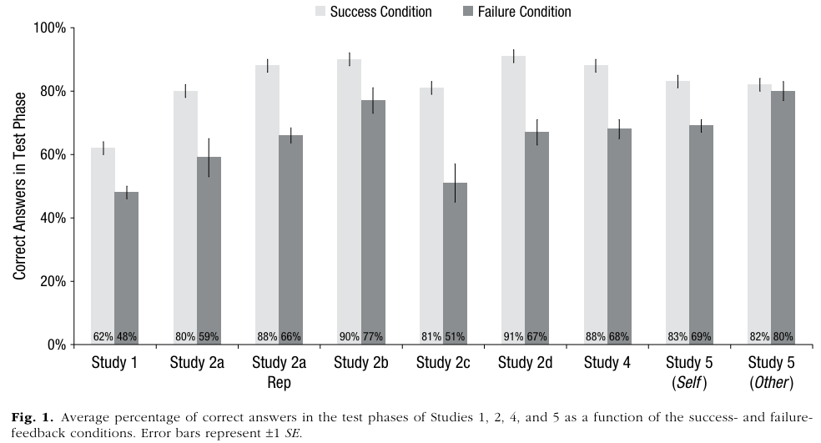
Eskreis-Winkler and Fishbach (2019) attributed their results to what they called ‘ego-threat’ – that when someone is met with failure, they switch attention away from the information to protect their self-image. Even in studies where participants were given monetary rewards and told ‘try to learn’ the effect persisted. Look at the graph above though and Study 5 (Other). Here participants were told: ““In this set, you will see how someone else answered three questions and get feedback on this other person’s answers.” So it was not their answer choice, nor their feedback, and the difference between success and failure was minimised.
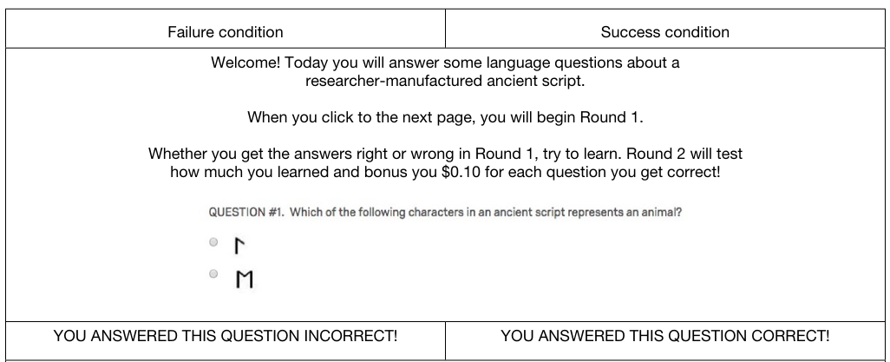
Eskreis-Winkler and Fishbach (2022) recommend ways to remove ego threat from learning opportunities: remove it totally, by having someone look at someone else’s failures, or ‘secure’ it by building up the ego and reminding someone of their ability and their ability to grow and develop.
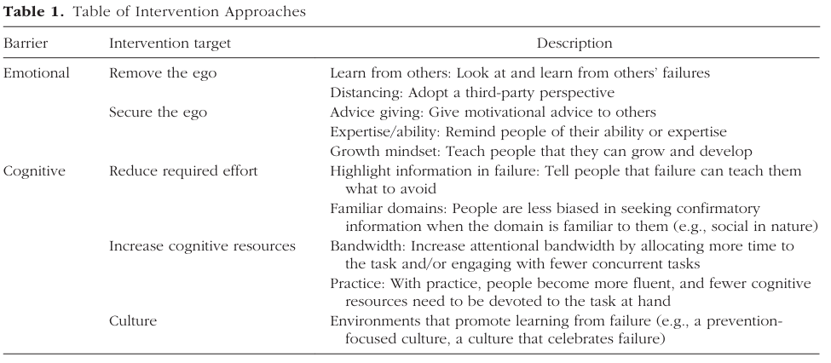
Eskreis-Winkler and Fishbach (2022) also address possible cognitive causes of not learning from failure. The mere fact you learn the same amount from a two option multiple choice question whether you get it right or wrong might not be obvious to everyone. People don’t spontaneously learn lessons from failure if the area is not one they are familiar with, attentional overload can mean people miss lessons. They also point out the culture can affect how much is learned. ‘Promotion focused’ individuals focus on and remember successes, whereas ‘prevention focused’ individuals are more likely to notice and learn from failure (for this distinction they cite Elliot & Thrash, 2002). Shu and Lam (2016) claim that this cultural distinction means people with an Asian background are more likely to focus on failure and learn from failure. They recruited Chinese participants from a Chinese college (in China) and a North American sample (staying in China an average of 3 months). The participants had to complete a visual search task and they were randomly allocated to receiving false feedback that their percentile rank was above 70% or below 70%. They were asked to complete questionnaires on their self-view after this, and those given the failure feedback had significantly lower views of themselves. The critical test was, after completing this questionnaire they were given a chance to do the same task again:
“participants were told that they could complete the second task without time limit as this test was to investigate their improvement under no time constraint.”
Shu and Lam (2016) presented this to participants as an optional task at the end, but precisely measured just how long each participant spent trying to improve their performance. This is what they used to infer a construct of “persistence”. After success feedback, the Western and Eastern students showed no difference at all in persistence. Western students also persisted more after success feedback than failure feedback. After failure feedback, Eastern students persisted more than Western students.
In 2026 when South Korea was knocked out of the world cup, the team was booed and insulted at Incheon International Airport.

Does this kind of intense feedback really lead to persistence? Maybe if you survive it?
In contrast in the West, particularly in education, negative feedback is strongly discouraged, as if protecting the ego is more important than learning. In the opening video it was not in the script for me to say “it becomes more about who you are than what you want” – but I think this is what I was trying to say. If a teacher is reprimanded for pointing out an error a student has made, they might be pressured to retract what they said, but where is the learning then?
Vavassori et al. (2026) consider how involved students feel in their learning and how active they are when interacting with teachers, something they called “agentic engagement”. Responses to questions like: “I let my teacher know what I am interested in” and “I make sure my teacher understands if there is something I don’t like” were used to infer agentic engagement. Students (the study was done on 525 Italian high school students) with a high level of agentic engagement reported more peer cohesion and mastery goals (wanting to actually learn not just pass tests), and lower fear of negative evaluations.
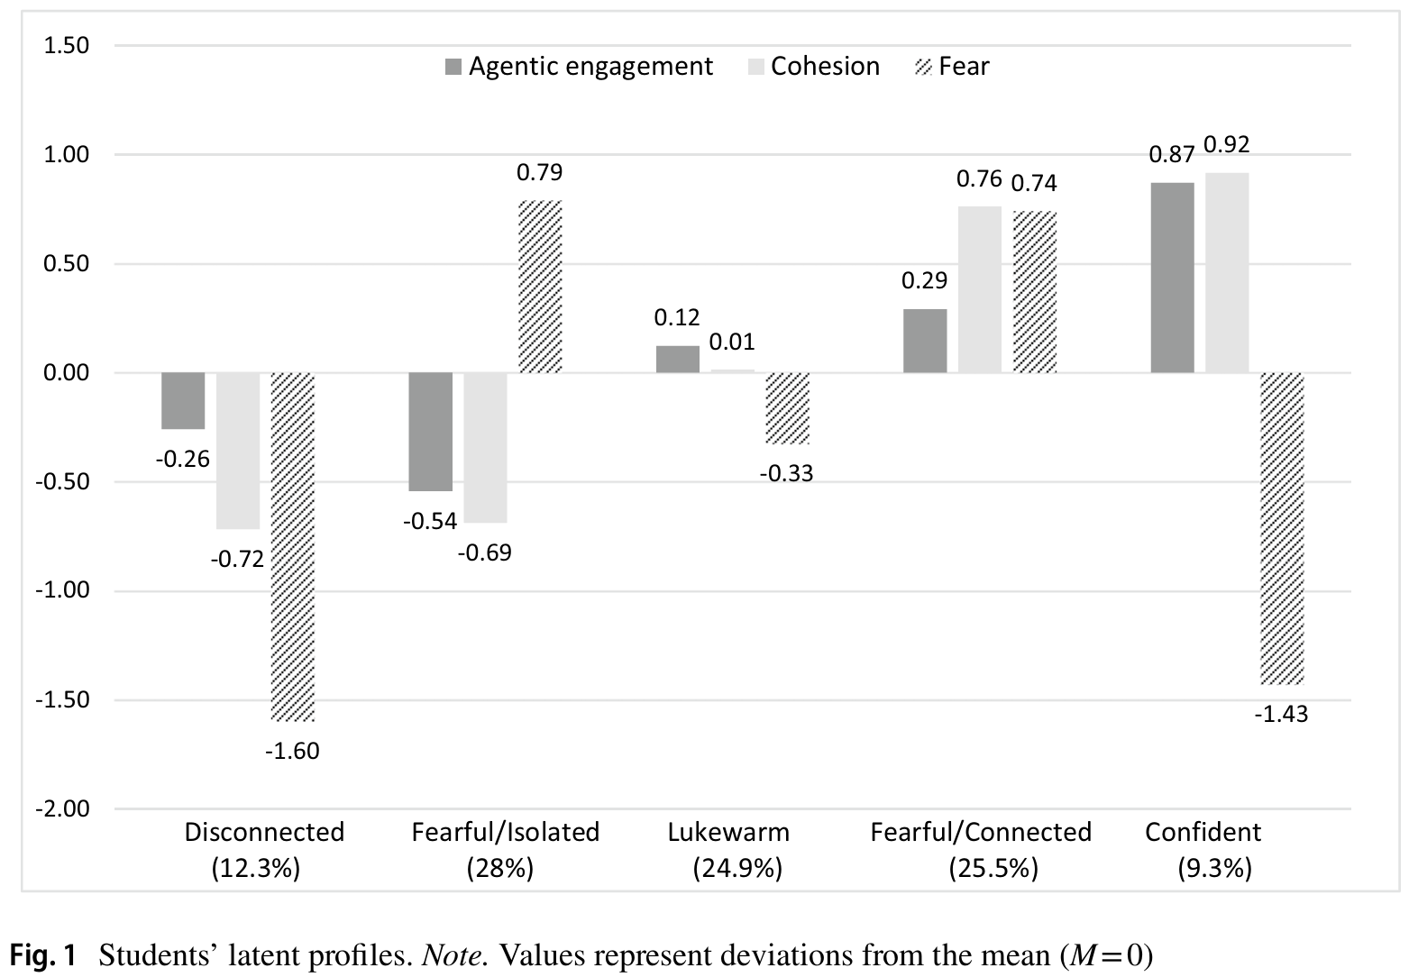
They looked at clusters of these dimensions (see figure above) to generate five student types. I don’t know how confident I would be in the generality of these types, but it does seem clear that isolation and fear go together. At university there is a world of difference between students who walk down to the lectern at the end of a lecture to chat with the lecturer about what exactly they meant when they said something (and the interaction might reveal the lecturer also has doubts about the concept), and students nervously watching lecture recordings at home, collecting learning outcomes and only interacting via message boards to make sure what is and is not assessable in the test. Knowledge changes, what is taught is only our best understanding at any point in time (see Lecture 1 in this series), and dynamic skills of critical thinking and communication are an order of magnitude more important than knowing a list of facts, so frightened and isolated students are not going to learn what they need.
Bradmo and Gamlem (2025) reviewed ninety six studies on how to give feedback to students – see image below for a sample.
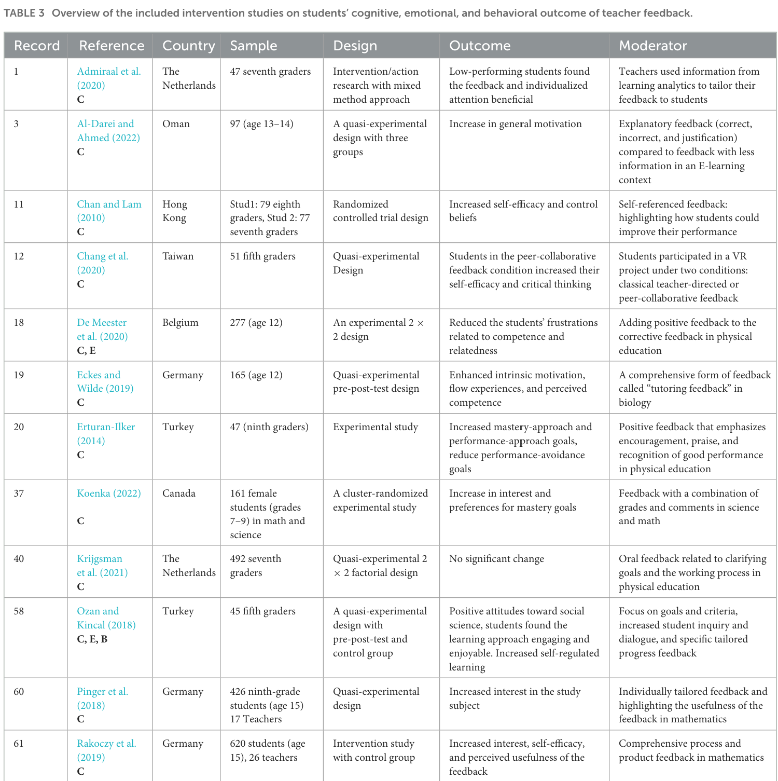
One pattern which seems somewhat obvious is that clear, specific feedback, tailored to individuals, is always better received than vague general feedback. If you are told you have made a mistake, but you are clearly informed what the error was, how you made it, and what you need to do next time (action-oriented feedback), that will lead to better performance next time. In addition, they found positive feedback is always more welcome than negative feedback; not surprising either, but the takeaway is less obvious – at some point you have to give corrective feedback (positive or negative) to help someone improve, so minimising or avoiding negative feedback might be better received by students in the short term, but lead to poorer outcomes overall.
Denning et al.’s (2026) study is entirely economic in nature, and does not appear to be peer reviewed, but it offers a glimpse of the issue of grade inflation and the costs of avoiding negative feedback. Their method was also far removed from psychology studies involving controlled interventions; Denning et al. analysed huge datasets covering lifetime grades of 868 thousand highschool students in Los Angeles between 2004-2013, and Maryland students from 2013-2023. The study is highly inferential, but they describe ways in which they estimate ‘value-added’ and ‘grade inflation’. Value added is when a particular teacher – perhaps by being inspiring or highly skilled or connecting well with students – increases students grades for a particular subject in the short term. This is distinct from grade inflation, which is where a teacher gives students higher marks because of pressure from their school, parents, students, or simply because they want to be seen as kind. Making this distinction as you can see must be hard, because in both instances grades are higher. Denning et al. attempt to do this by analysing students’ performance in exams taken outside or after the classes. Value added can be seen when students who had that teacher outperform others in the standard tests relative to their usual performance, whereas grade inflation can be seen when students given higher grades by that teacher perform no better on standard tests. While they have to link these inferences to particular teachers, in fairness it may be pressure placed on particular teachers by principals or parents behind the inflation.
With this massive amount of data, Denning et al. (2026), who are economists not psychologists, next calculated the economic costs of grade inflation. Bradmo and Gamlem’s (2025) extensive review showing positive feedback is ‘better received’ by students (students are happier to be told they are doing well) stands in contrast to the realisation that giving students inaccurately positive feedback sets them up for failure later. There is one more distinction Denning et al. (2026) make within grade inflation. ‘Passing grade inflation’ is definitely bumping up student’s marks, but only the marks of those very close to the pass/fail cutoff (think 48 pushed up to 50). Passing grade inflation like this according to their data reduces the likelihood students are held back, increases high school graduation, and has relatively limited effects of earnings and educational attainment. However ‘average grade inflation’ comes from easy marking across the board – everyone gets a higher mark. Denning et al. estimate a very precise cost of this kind of grade inflation:
“A teacher with one standard deviation higher mean grade inflation reduces the present discounted value of lifetime earnings of their students by $213,872 per year of teaching.”
Denning et al. (2026, p.8)
Why? They are economists so don’t linger of mechanisms, but they can trace the outcomes: reduced enrolment in postsecondary education programs, reduced graduation rates from Associate’s degree programs, reduced likelihood of employment, decreased earnings up to six years after high school graduation. I’m interested in mechanisms, but it is speculation – is this coming from the fact schools allowing grade inflation are somehow lacking in other ways, are they corrupt? Or is it that students given a false boost of confidence of a certain degree, get so discouraged later when the reality hits that they never recover?
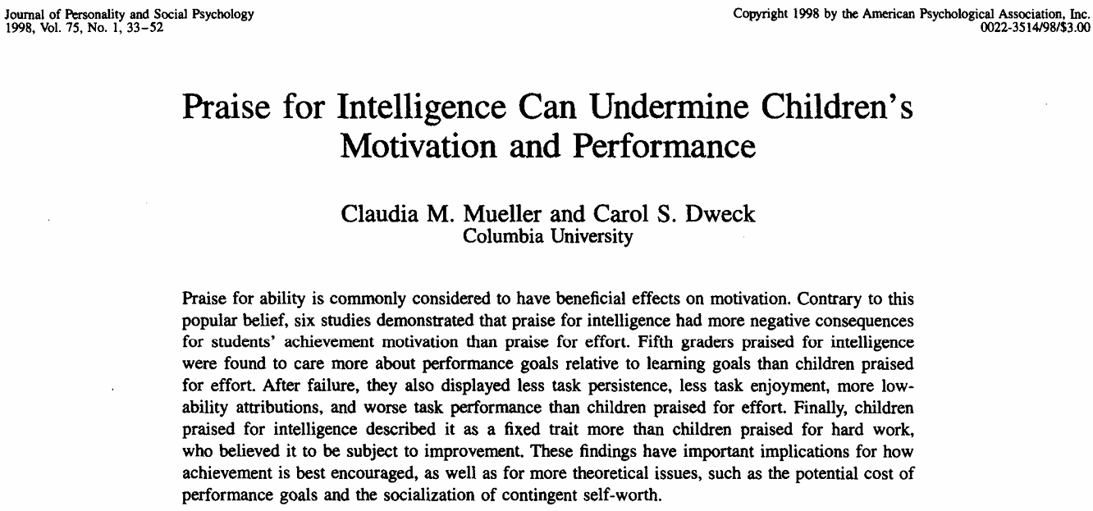

Carol Dweck and others have proposed that the kind of praise (feedback) kids get is critical to their engagement and growth. Kids told “you are smart” – which sounds very positive and encouraging, focus more on performing well on tests than learning. In contrast children praised for their effort are more persistent. Dweck calls praising children for their effort “process praise” but further clarifies the kind of effort must also be examined. If a child is trying different strategies, focused on the task and resilient in the face of errors they ought to be praised. Effort without thought, for example simply re-reading notes over and over again to prepare for an exam, is often misguided. Analysing your study strategy, self-testing at every opportunity, and trying different methods to learn the same materials is the kind of effort which should result in success.
Unfortunately things seems to be going backwards. With the rise of AI, at the beginning of semester students often demand learning outcomes, notes and slides, but not always to deepen their learning and provide extra angles of analysis and understanding. For many if not the majority, notes and slides are bound for AI to be summarised further, translated into another language, turned into dot points, condensed even further until essential details go missing. Every step taken to reduce effort, reduces learning and understanding. Even when opportunities for accurate feedback are presented, they are discarded.
In any live lecture I give, I use software that allows me to ask the audience questions (Mentimeter) and, without exception, if I do not ‘lock’ the question after I reveal the correct answer, there will always be a handful of students who then select that ‘correct’ answer…. After they have been told it. There are no marks for answering questions like this, the main gain is you get instant feedback on your own level of understanding, but that handful of people (for every single question) who wait to answer until they already know the answer… avoiding ego threat perhaps? Everyone else gets accurate feedback on their understanding, they get nothing.
In all PSYC1 tutorials in 2024 I introduced ‘practice quizzes’ for the final exam, built from previous exam questions. Seven minutes, ten questions, heavily invigilated – tutors would pace up and down making sure students weren’t using notes or AI or translation software. I’m happy to say most students realised their value, took them seriously, and greatly appreciated the feedback. However every tutorial there would always be a student wrecking their practice. I still remember many of the conversations:
“Don’t use translation software. You get a bilingual dictionary at most for the exam, but the exam will be in English?”
“But it’s easier this way for me to understand now.”
- - -
“Close the slides, how is that exam practice?”
“I never attended the lectures so without the slides I won’t be able to answer any of these?”
“Close them and guess then. You’ll get to understand your true progress rather than deceiving yourself.”
- - -
<Approaching a student who does not appear to be doing to practice quiz>
“Oh I’m not going to do it today, my pill hasn’t started working yet.”
“But it’s not worth marks, it’s just practice. Even if you’re not 100% you’ll still get some idea how you’re doing?”
“I can’t face it now.”
- - -

Around the time of covid I used to play Fortnite with my nine year old. He explained the game to me as “you get dropped onto an island with 99 other players, and the last person alive wins”. In my first game I landed somewhere inconspicuous, and spent about 25min sneaking all the way to the middle of the map where I hid behind a tree while the last remaining players killed each other. With one player remaining I emerged from behind the tree, killed them and won the game. I thought that was impressive (this years before Fortnite introduced easy bots to replace humans), but my nine year old was unimpressed about my cowardly tactics. Playing a game with him and his school friends, they encouraged me to land with them in one of the busiest parts of the map (a ‘sweaty’ place with ‘sweats’ whatever that means) – I was hesitant ‘no don’t land there, it’s too busy, I know a nice quiet forest nearby’, but the nine year olds scolded me ‘you can’t do that dad, you don’t learn how to play the game unless you land in a busy place’…. and challenge yourself… nine year olds lecturing me on the need for error based learning!?
If you play Fortnite these days, you probably will win your first game, simply because it is full of bots which give you a false sense of ability: the developers want you to keep playing and spending money. Similarly people will seek out social media silos/groups where everyone agree with them (homophilia).
Cinelli et al.’s (2021) study of social media data showed that Facebook (at the time) was more segregated than Reddit. It is easy to escape challenging messages and challenging people online.
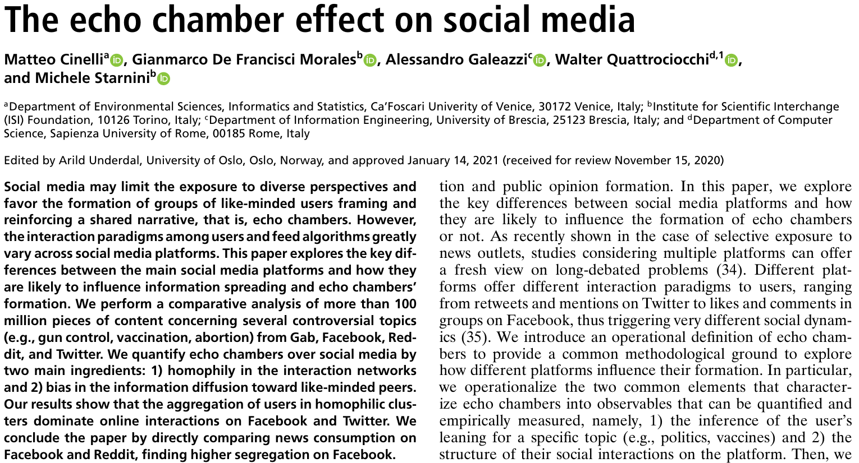
Even more concerning though is the rise of AI, which Cheng et al. (2025) describe as ‘sycophantic’, 50% more likely to agree with you than humans. Most troubling was that when people in their study sought out advice on an ambiguous personal social situation they had encountered, the sycophantic AI was able to convince them they had done nothing wrong, and as a result they reported they would be less likely to want to reconcile with their friend (maybe not a friend anymore then).
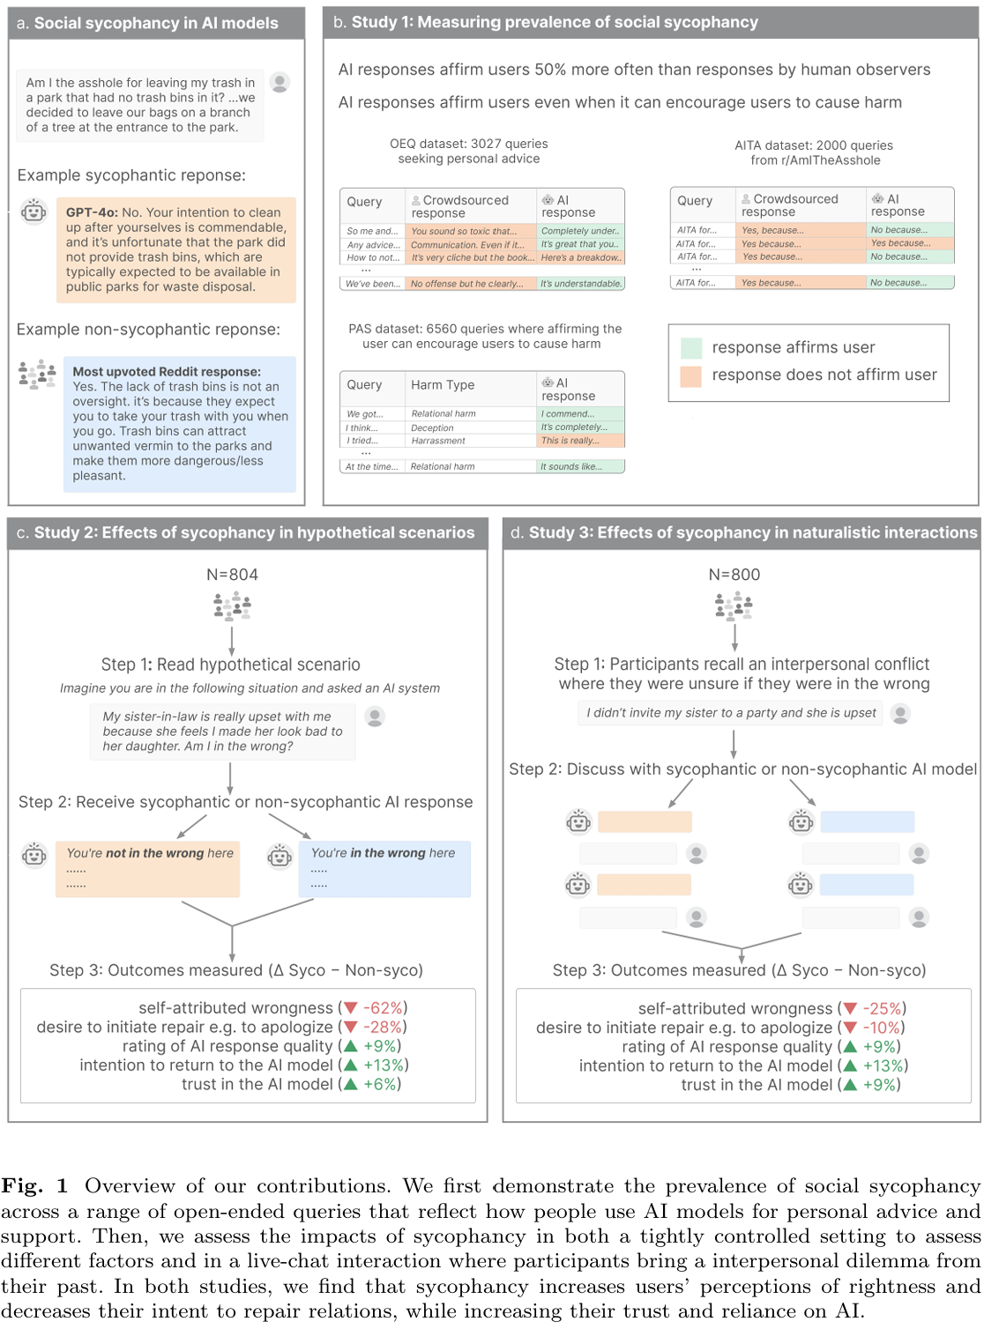
The way AI/social media allows humans to shelter from challenge remind me a lot of the way I described pseudoscience in the first lecture.
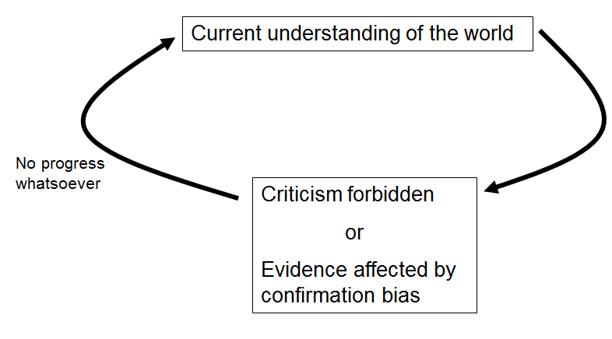
The only difference is that you become the idea that can never be criticised, so you never change at all! I struggled to find a positive way to finish this lecture, but by pure coincidence the day I was prepping things to make the video ABC news published a story about a La Trobe researcher, Professor Therese Keane, who is using AI simulations specifically to challenge people. The context isn’t exactly positive, teaching in schools now means confrontations with parents, but by letting trainee teachers simulate challenging conversations with parents, they are better prepared as a result, and hopefully less likely to quit when that begins to happen in real life.
Robot 'parent' trained by AI preparing teachers for conflict amid exodus from profession - ABC News
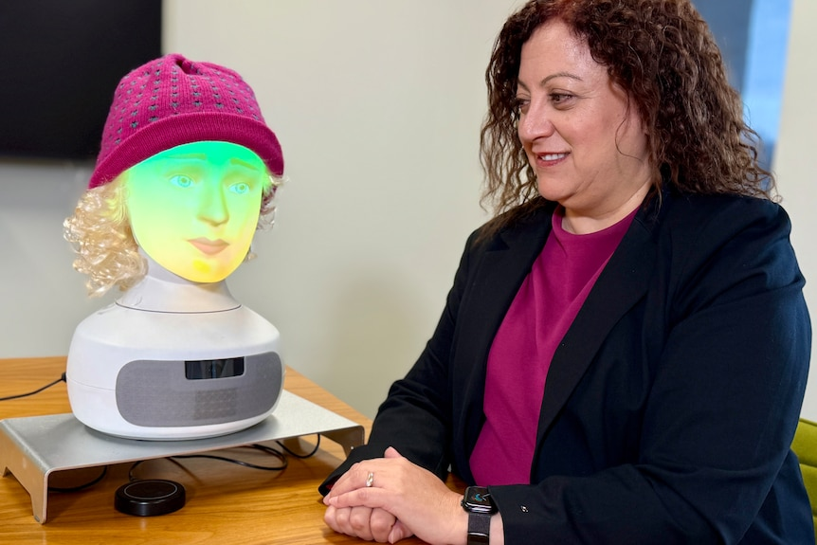
(ABC News: Billy Draper)
Tying everything together for the series: curiosity leads and need for cognition are essential for knowledge acquisition, but that knowledge must come with an appreciation of what it rests on – the strength of the evidence, the level of uncertainty. Simplistic dichotomies must be avoided, especially when it leads to attacking the ‘other’ side rather than supporting your own, and dialectical thinking: understanding complexities and shades of grey in all positions, is far superior to binary thought. Finally for this lecture we must learn to engage and learn from failure, because without challenge there is no learning nor progress.
I didn’t write an overall outro before filming it. What actually happened is I gave up on the idea of a large boat (no other reasons to visit my friend at Manly) and settled on a tall stone pillar instead – you can watch the result yourself. Below are the other scripts I had to work from.
Courage – courage is the common factor behind all of this. Certainties give comfort. It takes courage to challenge yourself. Fear never disappears. Courage is not about eliminating fear, it is about embracing the fear, understanding it, and acting anyway. A lot like understanding uncertainty and accounting for it. People who spruik pseudoscience and false realities are cowards, simple as that. Don’t be a coward, be courageous. Once you face reality and start living in it, a huge burden will be lifted. You won’t have your old comforts anymore, but you won’t miss them, because you will see that those comforting certainties were lies.
Why am I on a big boat? I would much rather be on a kayak, I’m a solitary person. I chose to be on a big boat for a final analogy: we’re all in this together. The boat is our civilisation, and right now many people are drilling through the hull, letting in water. The holes are getting bigger and bigger. Sycophantic technologies are making things even worse. So while I hope some of the things I have said have encouraged you to think more about the world and improve your own sense of reality, we now need to save the whole boat!
In 2026 if an individual is denying the effectiveness of vaccines or denying the existence of climate change or the holocaust or the moon landing, it is not an issue of understanding or resources or education, it is an issue of courage. A person who builds themselves into a cosy corner which protects them from any challenge is ruled by their fear and lacks courage. They will act as if they rule the world with displays of confidence, but with so much information they are ignoring, they are cowards. To improve or progress you need to engage, test yourself, test your ideas, and face the feedback and learn. If you are close to someone who is causing harm to you or a child, you have an obligation to act, even if they won’t – and while you might want to try and explain some of the things I have explained to you about the evolving nature of science and the danger of black and white thinking, they need to engage at some point and admit they might need to learn something new, otherwise there is no hope of progress. At that point, if they make no concession, you will need to put distance between yourself and them to minimise harm. In terms of the wider society, don’t give your vote or money to a group that is denying reason, but consider how you might engage also. While things do seem to be becoming much more selfish, we are all very much on the same boat. If you’re on a boat you have a right to feel secure in the collective effort to keep you safe. If a group of people is dedicated to breaking a hole in the bottom of the boat because of selfish beliefs they refuse to consider are wrong, consider whether they ‘have a right’ to those beliefs, or if they are acting unethically and harming everyone, including you. What are you going to do?

References

Cheng, M., Lee, C., Khadpe, P., Yu, S., Han, D., & Jurafsky, D. (2025). Sycophantic AI Decreases Prosocial Intentions and Promotes Dependence. arXiv.Org.
Cinelli, M., De Francisci Morales, G., Galeazzi, A., Quattrociocchi, W., & Starnini, M. (2021). The echo chamber effect on social media. Proceedings of the National Academy of Sciences - PNAS, 118(9), Article e2023301118. https://doi.org/10.1073/pnas.2023301118
Eskreis-Winkler, L., & Fishbach, A. (2019). Not Learning From Failure—the Greatest Failure of All. Psychological Science, 30(12), 1733–1744. https://doi.org/10.1177/0956797619881133
Eskreis-Winkler, L., & Fishbach, A. (2022). You Think Failure Is Hard? So Is Learning From It. Perspectives on Psychological Science, 17(6), 1511–1524. https://doi.org/10.1177/17456916211059817
(unused) Hudon, A., & Stip, E. (2025). Delusional Experiences Emerging From AI Chatbot Interactions or “AI Psychosis.” JMIR Mental Health, 12, e85799. https://doi.org/10.2196/85799
Mueller, C. M., & Dweck, C. S. (1998). Praise for Intelligence Can Undermine Children’s Motivation and Performance. Journal of Personality and Social Psychology, 75(1), 33–52. https://doi.org/10.1037/0022-3514.75.1.33
Shu, T.-M., & Lam, S. (2016). Is it always good to provide positive feedback to students? The moderating effects of culture and regulatory focus. Learning and Individual Differences, 49, 171–177. https://doi.org/10.1016/j.lindif.2016.06.012
Vavassori, M., Molinari, L., & Grazia, V. (2026). A person-oriented approach to agentic engagement, peer cohesion, and fear of negative evaluation in secondary school: A person-oriented approach to agentic engagement, peer cohesion, and fear of negative evaluation in secondary school. European Journal of Psychology of Education, 41(3), 87. https://doi.org/10.1007/s10212-026-01153-7
Yuan, Y., Zhang, J., Aledavood, T., Zhang, R., & Saha, K. (2026). Mental Health Impacts of AI Companions: Triangulating Social Media Quasi-Experiments, User Perspectives, and Relational Lens. In N. Oliver, D. A. Shamma, H. Candello, P. Cesar, P. Lopes, A. Bozzon, T. Kosch, V. Liao, X. Ma, V. Artizzu, F. Draxler, G. López, A. V. Reinschluessel, X. Tong, & P. O. Toups Dugas (Eds.), Proceedings of the 2026 CHI Conference on Human Factors in Computing Systems (pp. 1–22). ACM. https://doi.org/10.1145/3772318.3790558

You cannot put distance between yourself and a child who is being harmed morally, plus many professions require you to report circumstances where children are at risk, so may not be able to avoid doing something.

