**Markdown Cheat Sheet**

**Block Elements**

**Paragraphs and Line Breaks**

* Line1 ␣␣ 🡪 Line Break like <br /> in HTML  
  Line2
* Make an empty line after Paragraph 🡪 return

**Headers**

* Header-Text 🡪 **Header-Text** 🡪 First level Header (larger)  
  ===========
* Header-Text 🡪 **Header-Text** 🡪 Second level Header (smaller)  
  -----------------
* #Text 🡪 <h1> …h2… ###Text 🡪 <h3> …h4…h5… ######Text 🡪 <h6>

**Blockquotes**

* 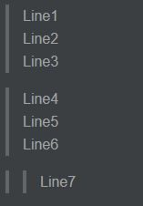>Line1␣␣ 🡪  
  Line2␣␣  
  Line3  
    
  >Line4␣␣  
  Line5␣␣  
  Line6  
    
  >>Line7

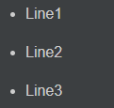**Lists**

* (*, +, -) Line1 🡪   
  (*, +, -) Line2  
  (*, +, -) Line3
* 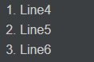(Number) Line1 🡪   
  (Number) Line2  
  (Number) Line3
* 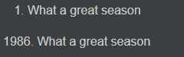1986. What a great season 🡪  
     
  1986\. What a great season

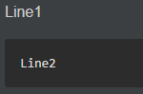**Code Blocks**

* Line1 🡪   
    
   Line2
* <div class=”footer”> 🡪   
   &copy; 2004 Foo Corporation  
  </div>

**Horizontal Rules**

* * * * 🡪 Horizontal Rule like <hr /> in HTML (use a minimum of 3)  
  ******  
  - - -  
  ___

**Span Elements**

**Links**

* [Link1](http://link.com/ "Title") is an inline link. 🡪 Title while hover over it  
  [Link2](http://link.com/) has no title attribute.
* This is [an example][id] reference-style link. 🡪 define link afterwards  
  [id]: <http://example.com/> "Optional Title"

**Emphasis**

* 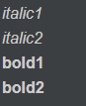*italic1* 🡪   
  _italic2_  
  **bold1**  
  __bold2__

**Code**

* 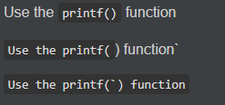Use the `printf()` function. 🡪   
  `Use the printf(`)function.`  
  ``Use the `printf(`) function``.

**Images**

* ![Alt text](/path/to/img.jpg "Optional title") 🡪 Title while hover over it  
  ![Alt text](/path/to/img.jpg) has no title attribute
* ![Alt text][id] 🡪 define image afterwards  
  [id]: /path/to/img.jpg "Optional title"