1. Problem Statement

The Burmese language is an underrepresented language in the field of NLP. Its script presents unique challenges due to ambiguities in complex grammar rules, and the lack of standardized word segmentation. These challenges are especially evident in digital communication, where users often make usage and typing errors. Unlike widely studied languages like English, Burmese lacks reliable tools for automatic sentence correction.

This project aims to develop a deep learning-based model that can automatically transform incorrect Burmese sentences into correct ones. The correction will focus on grammar structure, and word segmentation, with the scope limited to simple sentence patterns (ဝါကျရိုး) from the figure shown below, forms limited to affirmative, negative, question, with formal past, present, and future tenses. Solving this problem will improve digital text processing in Burmese and contribute to the advancement of Burmese NLP tools, enabling better educational and linguistic applications, especially for Burmese as a second language learners.



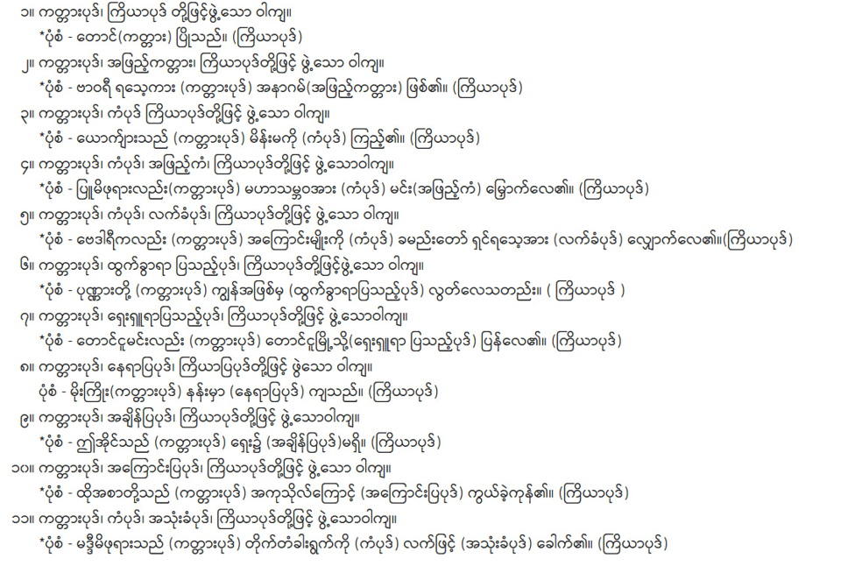

**Figure 1** – Simple Sentence Patterns Scope (Wikipedia, 2023)

1. Example of input, output

Input – correct/incorrect Burmese sentence

Output – correct Burmese sentence

1. ကျွန်တော်+သွားမည်+ပါသည်။ ->ﾠကျွန်တော်သွားပါမည်။ (redundancy error)
2. သွားမည် ကျွန်တော်။ -> ကျွန်တော် သွားမည်။ (order error)
3. သူ သွားကို။ -> သူ သွားသည်။ (particle misuse error)
4. သူ မ သွား။ -> သူ မသွားဘူး။ (negation error)
5. ဘယ်သူ လာသည်။ -> ဘယ်သူ လာသလဲ။ (interrogation error)
6. Dataset – minimum 1000
7. Expected outcome

Model performance goal: >=70%

Evaluation metrics:

* 1. Accuracy score
  2. Precision
  3. Recall
  4. F1 score
  5. BLEU/ROUGE

**Reference**

Wikipedia. (2023, May 10). ဝါကျ: တည်းဖြတ်မှု ရာဇဝင်. Retrieved August 2, 2025, from https://my.wikipedia.org/wiki/%E1%80%9D%E1%80%AB%E1%80%80%E1%80%BB#%E1%80%80%E1%80%BC%E1%80%AD%E1%80%9A%E1%80%AC%E1%80%90%E1%80%85%E1%80%BA%E1%80%81%E1%80%AF%E1%80%9B%E1%80%BE%E1%80%AD%E1%80%9E%E1%80%B1%E1%80%AC_%E1%80%9D%E1%80%AB%E1%80%80%E1%80%BB%E1%80%96%E1%80%BD%E1%80%B2%E1%80%B7%E1%80%94%E1%80%8A%E1%80%BA%E1%80%B8%E1%80%99%E1%80%BB%E1%80%AC%E1%80%B8