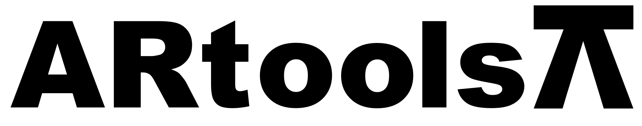 **Technical sheet** artools.com

LLAVE CORONA DOBLE ACODADA

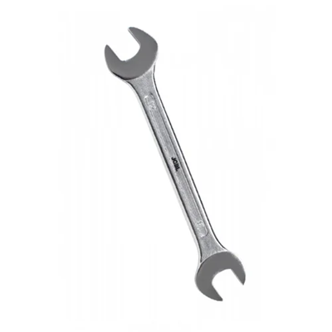

**Características:**

* Según normas DIN 3110.
* Níquel cromado.
* Fabricado en acero CRV de alta calidad.
* Debidamente endurecido y templado.

**Presupuesto**

| **Artículo N°** | **Tamaño (mm)** | **A1(mm)** | **A2(mm)** | **S1 = S2 (mm)** | **D1 (mm)** | **D2 (mm)** | **T (mm)** | **Largo ± 2 (mm)** | **Peso (gr/m2)** |
| --- | --- | --- | --- | --- | --- | --- | --- | --- | --- |
| 010501 | 6 x 7 | 6.03 – 6.15 | 7.03 – 7.15 | 6.4 – 5.6 | 11.7 | 10.7 | 4.4 | 178 | 52 |
| 010502 | 8 x 9 | 8.03 – 8.15 | 9.03 – 9.15 | 7.4 – 6.3 | 14.2 | 13.2 | 4.8 | 190 | 64 |
| 010503 | 10×11 | 10.04 – 10.19 | 11.04 – 11.19 | 8.8 – 8.0 | 17.2 | 16.0 | 5.4 | 200 | 90 |
| 010504 | 12×13 | 12.04 – 12.24 | 13.04 – 13.24 | 9.4 – 9.0 | 20.0 | 18.8 | 6.0 | 215 | 115 |
| 010505 | 14×15 | 14.05 – 14.27 | 15.05 – 15.27 | 1.6 – 9.8 | 22.8 | 21.5 | 6.4 | 233 | 150 |
| 010506 | 16×17 | 16.05 – 16.27 | 17.05 – 17.30 | 11.8 – 10.6 | 25.0 | 24.0 | 6.6 | 245 | 190 |
| 010507 | 18×19 | 18.05 – 18.30 | 19.06 – 19.36 | 12.6 – 11.0 | 28.0 | 27.4 | 6.8 | 265 | 239 |
| 010508 | 20×22 | 20.06 – 20.36 | 22.06 – 22.36 | 13.6 – 12.6 | 32.8 | 30.4 | 7.2 | 290 | 300 |
| 010509 | 21×23 | 21.06 – 21.36 | 23.06 – 23.36 | 14.0 – 12.8 | 34.5 | 31.0 | 7.4 | 315 | 330 |
| 010510 | 24×27 | 24.08 – 24.36 | 27.08 – 27.48 | 14.6 – 13.2 | 39.5 | 35.8 | 7.8 | 327 | 370 |
| 010511 | 25×28 | 25.08 – 25.36 | 28.08 – 28.48 | 14.8 – 13.8 | 41.0 | 37.5 | 7.8 | 330 | 429 |
| 010512 | 30×32 | 30.08 – 30.48 | 32.08 – 32.48 | 16.8 – 14.8 | 46.0 | 43.5 | 9.6 | 360 | 574 |