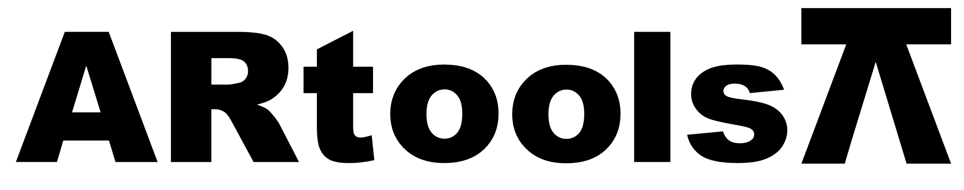 **Technical sheet** artoolsweb.com

LLAVE SEMILUNA

**Características:**

* Completamente Pulido
* Cromado Brillante
* Debidamente endurecido y templado.
* Fabricado en acero CRV de alta calidad.

| **Artículo N°** | **Tamaño (mm)** |
| --- | --- |
| 011901 | 10x11 |
| 011902 | 11x13 |
| 011903 | 12x13 |
| 011904 | 14x15 |
| 011905 | 14x17 |
| 011906 | 16x17 |
| 011907 | 18x19 |
| 011908 | 19x22 |
| 011909 | 21x23 |
| 011910 | 24x27 |
| 011911 | 30x32 |