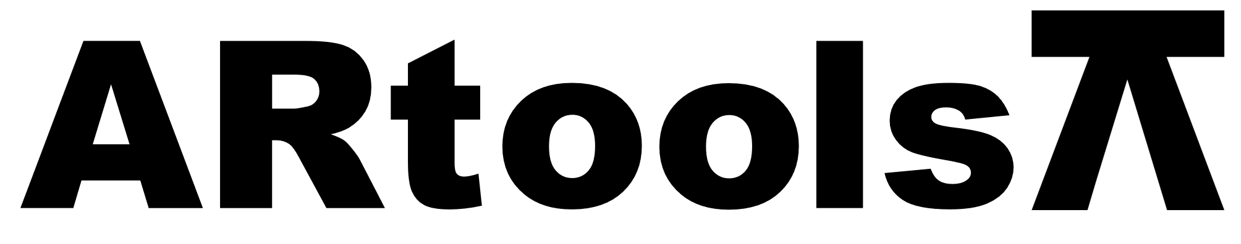 **Technical sheet** artools.com

LLAVE PARA FILTROS DE ACEITE CON FAJA

**Características:**

* Bend Type Filter Wrench.
* Reinforced Plastic Head With Spring Steel Strip.
* Heavy Duty Plastic Body & Control Knob.
* Remove Filters With Minimum Risk Damage.

**Presupuesto**

| **Artículo N°** | **Tamaño (pulgadas)** |
| --- | --- |
| 012001 | 12 |