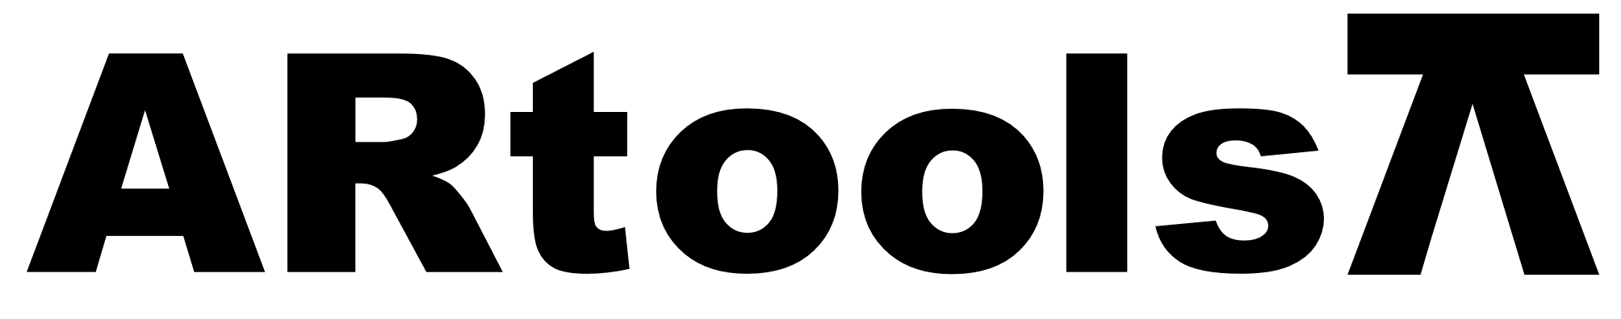 **Technical sheet** artoolsweb.com

LLAVE PARA FILTROS DE ACEITE CON CADENA

**Características:**

* Casting With Hardened Jaws.
* Aleaje Acero Especial de Calidad Industrial.

| **Artículo N°** | **Tamaño (pulgadas)** |
| --- | --- |
| 012001 | 12 |