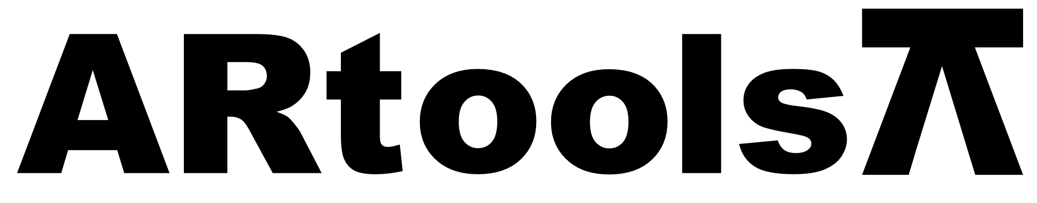 **Technical sheet** artoolsweb.com

EXTRACTOR DE ROLES 2 BRAZOS AJUSTABLES

**Características:**

* Fabricado en acero especial de calidad Industrial.

| **Artículo N°** | **Tamaño (pulgadas)** |
| --- | --- |
| 050101 | 6 |
| 050102 | 8 |
| 050103 | 10 |
| 050104 | 12 |