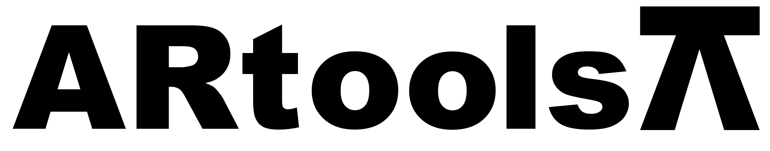 **Technical sheet** artoolsweb.com

EXTRACTOR DE ROLES 3 BRAZOS AJUSTABLES

**Características:**

* Fabricado en acero especial de calidad Industrial.

| **Artículo N°** | **Tamaño (pulgadas)** |
| --- | --- |
| 050201 | 6 |
| 050202 | 8 |
| 050203 | 10 |
| 050204 | 12 |