UAS-Based Environmental Disturbance and Terrain Risk Assessment
WireGrass Gravel Pit, Alabama

Prepared by:
Nico Dillman

Course:
GEO 892 – Geospatial Applications of Unmanned Aerial Systems

Instructor:
Dr. Qassim Abdullah

Date:
March 10, 2026

Table of Contents
1.0 Mission Objective 3
2.0 Scope of Work 3
3.0 Project Deliverables 4
4.0 Study Area Overview 5
5.0 System Selection and Technical Specifications 6
5.1 Unmanned Aircraft System (UAS) 6
5.2 Sensor and Payload 7
6.0 Mission Planning and Design 7
6.1 Concept of Operations (CONOP) 7
6.2 Flight Parameters 8
6.3 Ground Control Design 9
6.4 Airspace Authorization and COA Considerations 10
6.5 Risk Mitigation and Safety 11
7.0 Project Schedule 11
8.0 Project Budget 12
9.0 Data Processing Workflow 13
10.0 Value-Added Analysis and Results 14
10.1 Supervised Land Cover Classification 14
10.2 Surface Disturbance Intensity Mapping 15
10.3 Feature Extraction: Stockpile Digitizing 17
11.0 Conclusion 19
References 20

Mission Objective
The objective of this project was to evaluate how unmanned aerial systems (UAS) can be used to generate high-resolution geospatial datasets capable of supporting environmental monitoring and terrain assessment within an industrial extraction landscape. Using imagery collected over the WireGrass Gravel Pit in Alabama, the project applied a photogrammetric workflow to produce a georeferenced orthomosaic and digital surface model (DSM), which served as the primary datasets for subsequent spatial analysis.
Beyond generating standard photogrammetric deliverables, this project focused on deriving analytical insights from the UAS data through geographic information system (GIS) techniques. Specifically, the analysis investigated patterns of land cover distribution, the spatial extent of surface disturbance associated with extraction activities, and the footprint of aggregate stockpiles across the site. By integrating high resolution aerial imagery with GIS based classification and terrain analysis, this study demonstrates how UAS derived data can support quantitative assessment of environmental disturbance within actively managed landscapes (Colomina & Molina, 2014).

2.0 Scope of Work
This project evaluates the use of unmanned aerial systems (UAS) and photogrammetric processing techniques for analyzing environmental disturbance within the WireGrass Gravel Pit study area in Alabama. The project focuses on demonstrating how high-resolution aerial imagery collected from a UAS platform can be processed and analyzed to generate geospatial products capable of supporting terrain assessment and land cover analysis in an active extraction landscape.
The scope of this project includes the conceptual planning of a UAS mapping mission, photogrammetric reconstruction of aerial imagery, and GIS based spatial analysis. The workflow begins with mission planning considerations such as airspace evaluation, flight parameters, and system selection. Although the imagery used in this study was obtained from an existing dataset provided through course materials, the project assumes a realistic UAS mapping scenario using a DJI Matrice 300 RTK platform equipped with a Zenmuse P1 RGB mapping camera.
The collected imagery is processed using Pix4Dmapper to generate photogrammetric outputs including a georeferenced orthomosaic and a digital surface model (DSM). These datasets are then imported into ArcGIS Pro where spatial analysis techniques are applied to derive value added information from the imagery.
The GIS analysis focuses on three primary objectives. First, a supervised land cover classification is performed to identify dominant surface types within the gravel pit environment. Second, the classified land cover data is reclassified to produce a disturbance intensity map that illustrates the spatial distribution of industrial activity across the site. Finally, aggregate stockpiles are identified and digitized using terrain visualization from the DSM to estimate the footprint of stored material within the site.
Through this workflow, the project demonstrates how UAS derived datasets can support environmental monitoring, terrain analysis, and operational assessment within highly modified industrial landscapes.

3.0 Project Deliverables
The following deliverables were produced as part of the UAS mapping and spatial analysis workflow completed in this project:

• Georeferenced orthomosaic generated from UAS imagery using Pix4Dmapper
• Digital Surface Model (DSM) derived from photogrammetric reconstruction
• Supervised land cover classification identifying vegetation, bare soil, aggregate piles, and site structures
• Surface disturbance intensity map derived from reclassification of the land cover dataset
• Digitized aggregate stockpile polygons representing the spatial footprint of material storage areas
• Sectional aeronautical chart figure illustrating the airspace classification for the project location
• Final project report describing mission planning, photogrammetric processing, and GIS analysis workflow
• Final presentation summarizing project objectives, methodology, and results

All spatial datasets generated in this project were processed within Pix4Dmapper and analyzed within ArcGIS Pro to demonstrate the integration of photogrammetric products with GIS based spatial analysis techniques.

4.0 Study Area Overview
The study area for this project is the WireGrass Gravel Pit located in Alabama. This site is an active aggregate extraction site characterized by substantial terrain modification and material processing activities. The landscape is composed primarily of exposed soil surfaces, gravel stockpiles, operational access roads, and localized patches of vegetation along the perimeter of the site.
Industrial extraction environments such as gravel pits represent highly dynamic landscapes where terrain conditions evolve rapidly due to excavation and material storage operations, making them well suited for monitoring with unmanned aerial systems (Siebert & Teizer, 2014). These characteristics make gravel pits particularly well suited for monitoring using high resolution aerial imagery collected by UAS platforms. The contrast between disturbed soil surfaces, aggregate materials, and vegetated areas provides strong spectral variation that can be exploited for remote sensing classification and spatial analysis.
Additionally, the irregular terrain produced by excavation activities introduces measurable elevation differences that can be captured through photogrammetric surface modeling. These elevation variations enable terrain-based analysis such as stockpile identification and disturbance intensity mapping. The study area represents an actively managed aggregate extraction facility characterized by exposed soil surfaces, large gravel stockpiles, access roads, and surrounding patches of vegetation.
The analysis for this project was conducted using the WireGrass Gravel Mine dataset from GEOG 892 Exercise 1. This dataset consists of 89 JPEG images containing embedded geotags (WGS84) and was supported by 8 Ground Control Points (GCPs) in NAD83 (2011) Alabama State Plane East. Utilizing this established dataset allowed for a controlled environment to test value-added classification and disturbance modeling workflows.
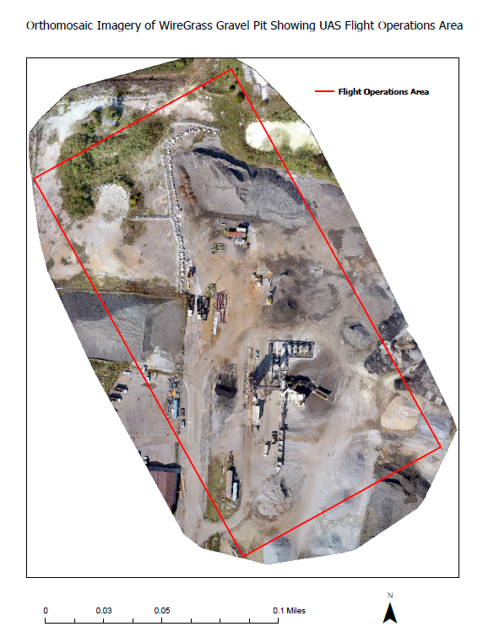
Figure 1: Orthomosaic overview of the WireGrass Gravel Pit illustrating the spatial extent of the study area (Esri, 2023)

5.0 System Selection and Technical Specifications

5.1 Unmanned Aircraft System (UAS)
The DJI Matrice 300 RTK multirotor platform was selected as the conceptual aircraft for this mission due to its operational stability and integrated high-precision positioning capabilities. The Matrice 300 RTK incorporates a Real-Time Kinematic (RTK) positioning system, which enables centimeter-level positional accuracy during flight operations.
The RTK capability significantly improves the spatial accuracy of photogrammetric outputs by reducing positional uncertainty during image capture. This improves the reliability of derived datasets such as orthomosaics and digital surface models. In addition, the multirotor configuration allows for vertical takeoff and landing as well as stable hovering, which is advantageous when collecting high-overlap imagery over complex terrain.
These characteristics make the Matrice 300 RTK well suited for high-resolution mapping missions conducted in industrial environments such as gravel pits (DJI, 2023).

5.2 Sensor and Payload
The selected imaging payload for the mission was the DJI Zenmuse P1 RGB mapping camera, which features a 45-megapixel full-frame sensor specifically designed for photogrammetric mapping operations.
The larger sensor size and high resolution enable the acquisition of extremely detailed aerial imagery suitable for terrain reconstruction and object identification. When paired with a 35 mm focal length lens, the sensor can achieve a ground sampling distance (GSD) of approximately 1 inch (2.54 cm) at a moderate flight altitude (DJI, 2023).
This level of spatial resolution allows fine-scale terrain features, material stockpiles, and subtle surface disturbances to be captured within the imagery. Such detail is critical when performing classification and terrain analysis within industrial landscapes.

6.0 Mission Planning and Design

6.1 Concept of Operations (CONOP)
The Concept of Operations (CONOP) describes the operational framework under which the UAS mission would be conducted (Abdullah, 2024). The mission would involve a single multirotor aircraft operating from a designated launch site located near the perimeter of the WireGrass Gravel Pit.
A Remote Pilot in Command (RPIC) would maintain visual line of sight (VLOS) with the aircraft throughout the operation while the aircraft follows the preprogrammed grid flight path designed to capture high-overlap imagery. The mission would be conducted autonomously using a mission planning platform, allowing the aircraft to follow a systematic flight pattern across the study area.
During the mission, nadir imagery would be captured at regular intervals to ensure sufficient overlap for photogrammetric reconstruction. Following data collection, imagery would be transferred to a workstation where photogrammetric processing would be conducted using Pix4Dmapper. The resulting geospatial datasets would then be integrated into ArcGIS Pro for spatial analysis.
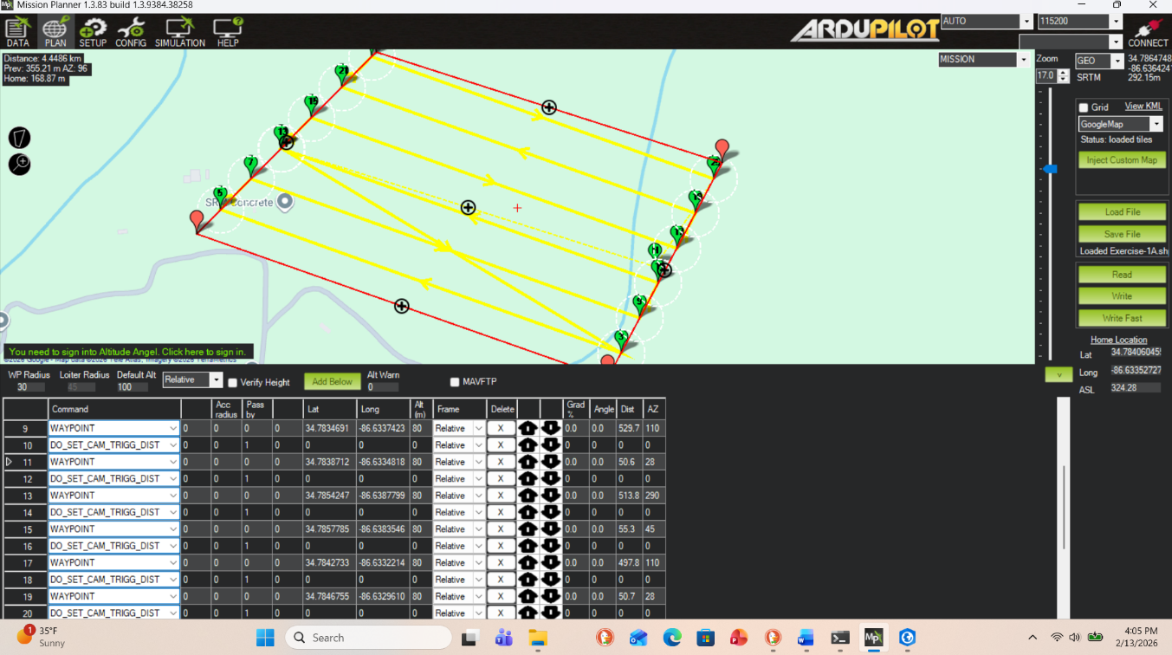
Figure 2: Mission planning summary detailing flight distance, estimated duration, and strip calculations (Mission Planner, 2024).

6.2 Flight Parameters
The mission was designed to meet the photogrammetric data requirements necessary to generate high-quality orthomosaic and surface models. The flight plan incorporated a synthetic grid pattern to ensure consistent coverage across the study area.
The planned flight parameters were as follows:
- Altitude: approximately 80 meters (262 feet) above ground level
- Ground Sampling Distance (GSD): 1 inch (2.54 cm)
- Forward overlap: 80 %
- Side overlap: 70 %
These parameters ensure that each point on the ground surface is captured in multiple overlapping images, which is necessary for accurate three-dimensional reconstruction during photogrammetric processing. High image overlaps are critical for photogrammetric reconstruction because it ensures that each ground feature is visible in multiple images, allowing the software to accurately match key points between images and generate reliable three-dimensional models of the terrain (Pix4D, 2024). The selected flight altitude of approximately 80 meters provides a balance between spatial resolution and efficient site coverage, allowing the Zenmuse P1 sensor to achieve a ground sampling distance of approximately 1 inch while still capturing sufficient area within each image (DJI, 2023).
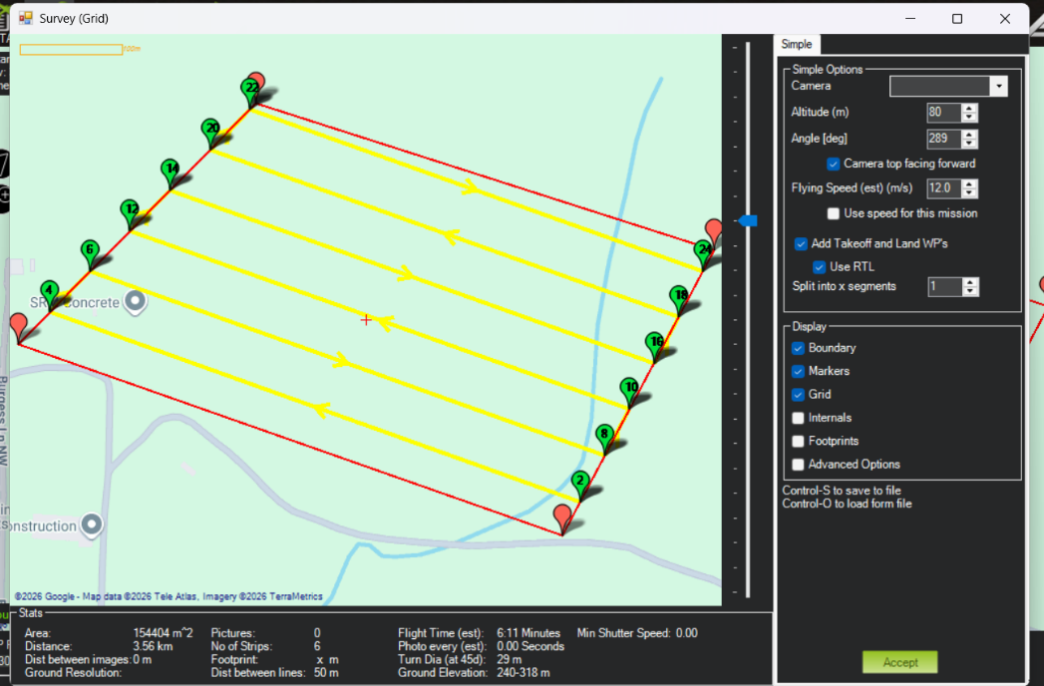
Figure 3: Automated grid flight mission showing planned flight lines and photo trigger locations used to capture overlapping imagery across the WireGrass site (Mission Planner, 2024).
The automated grid mission used to plan flight lines and photo trigger locations was generated using Mission Planner software (Mission Planner, 2024).

6.3 Ground Control Design
Ground Control Points (GCPs) were incorporated into the dataset used for this project to improve the spatial accuracy of the photogrammetric reconstruction. The WireGrass dataset included eight surveyed GCPs distributed throughout the study area. These control points were measured in the NAD83 (2011) Alabama State Plane East coordinate system and served as reference locations during photogrammetric processing.
During image processing in Pix4Dmapper, the GCPs were used to refine the camera alignment and reduce positional error within the reconstructed model. By linking known ground coordinates with image observations, the GCPs improve the absolute positional accuracy of the orthomosaic and digital surface model generated from the imagery (Pix4D, 2024).
Although this project used a pre-existing dataset provided through course materials, a typical UAS survey would involve placing clearly visible ground targets across the study area prior to flight operations. These targets would be surveyed using high accuracy GNSS equipment to ensure that the resulting photogrammetric products maintain reliable horizontal and vertical accuracy (Siebert & Teizer, 2014).

6.4 Airspace Authorization and COA Considerations
The planned mission would operate under FAA Part 107 regulations governing small, unmanned aircraft systems in the United States (Federal Aviation Administration, 2023). These regulations allow UAS flights below 400 feet above ground level provided that the remote pilot maintains visual line of sight and adheres to operational safety requirements.
The WireGrass Gravel Pit is located within Class G uncontrolled airspace, which typically does not require additional airspace authorization for operations conducted below 400 feet.
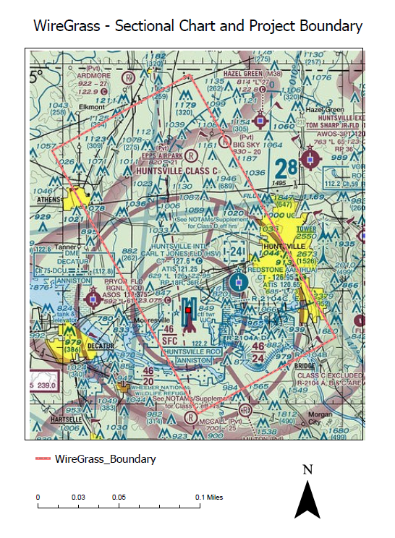
Figure 4: Sectional aeronautical chart showing the WireGrass Gravel Pit project boundary and surrounding Class G uncontrolled airspace used for mission planning.
Airspace conditions for the study area were verified using a sectional aeronautical chart to confirm the classification of the surrounding airspace. The WireGrass Gravel Pit is located within Class G uncontrolled airspace, which allows small, unmanned aircraft operations below 400 feet above ground level without additional airspace authorization. Sectional charts and VFR mapping tools are commonly used during mission planning to evaluate potential airspace restrictions and ensure compliance with FAA regulations (Federal Aviation Administration, 2024; SkyVector, 2024).

6.5 Risk Mitigation and Safety
Operational safety considerations were incorporated into the mission planning process to reduce potential risks during flight operations. Weather conditions represent one of the most significant factors influencing UAS mission safety and data quality. Flights should only be conducted when wind speeds remain below approximately 12 miles per hour to maintain aircraft stability and minimize motion blur within captured imagery.
Lighting conditions were also considered during mission planning. Flights conducted near solar noon reduce the presence of long shadows, which can interfere with terrain reconstruction and image classification.
Additionally, automated safety procedures such as Return-to-Home (RTH) were configured to ensure that the aircraft would return safely to the launch location in the event of signal loss or low battery conditions.

7.0 Project Schedule
The project schedule for this study represents a theoretical operational timeline for a UAS based mapping mission. Because the WireGrass dataset used in this project was previously collected as part of course materials, the actual flight operations were not conducted by the author. However, the schedule below reflects the typical workflow that would be required to plan, execute, and process a UAS mapping mission of this type.
The project would begin with mission planning and airspace evaluation to ensure compliance with Federal Aviation Administration (FAA) regulations and safe flight operations. During this stage, the pilot would review sectional aeronautical charts, evaluate airspace classification, and define the operational boundary of the survey area. Mission planning software such as Mission Planner would then be used to define the flight path, image overlap, and altitude required to achieve the desired ground sampling distance.
Following mission planning, the next phase would involve image acquisition using the selected UAS platform and RGB mapping camera. A single automated flight mission would typically be sufficient to capture the required imagery for the study area. Once the imagery has been collected, the dataset would be processed using Pix4Dmapper to generate the orthomosaic and digital surface model required for spatial analysis.
After photogrammetric processing is complete, the resulting raster products would be imported into ArcGIS Pro for further analysis. The final phase of the project would involve supervised classification of land cover types, disturbance analysis, and digitization of aggregate stockpiles within the study area. The results of this analysis would then be compiled into the final project report and presentation.

8.0 Project Budget
Because the dataset used in this project was previously collected as part of course materials, no actual operational costs were incurred during the completion of this analysis. However, the following table provides an estimated budget that would typically be associated with conducting a UAS mapping mission using the selected equipment and software.
The estimated costs include the drone platform, mapping sensor, photogrammetry processing software, GIS analysis software, and personnel required to operate the mission and process the data. For example, a commercial mapping platform such as the DJI Matrice 300 RTK with a Zenmuse P1 camera can cost around $19,000, while photogrammetry software such as Pix4Dmapper may cost approximately $350–$370 per month depending on licensing.
These costs represent typical industry level equipment used for high resolution aerial mapping and geospatial analysis.

Table 1: These estimates represent typical costs associated with commercial UAS mapping operations and are provided to illustrate the resources required for conducting a similar real-world mission.
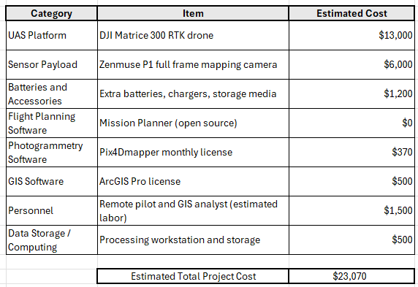

9.0 Data Processing Workflow
The aerial imagery dataset in this project consisted of 89 RGB images, which were processed using Pix4Dmapper to generate photogrammetric outputs (Pix4D, 2024). Ground control points (GCPs) were incorporated during processing to improve the geospatial accuracy of the photogrammetric outputs. The processing workflow followed the standard structure used in most photogrammetric mapping projects.
The first stage involved initial processing, which included aerial triangulation and bundle block adjustment. This step established the geometric relationships between images and generated a sparse point cloud representing the overall structure of the study area.
The second stage involved the generation of a dense point cloud, which reconstructed the terrain surface in three dimensions. From this dataset, Pix4D produced two primary deliverables: a georeferenced orthomosaic and a digital surface model (DSM).
These outputs were subsequently imported into ArcGIS Pro, where spatial analysis and classification procedures were conducted (Esri, 2023).
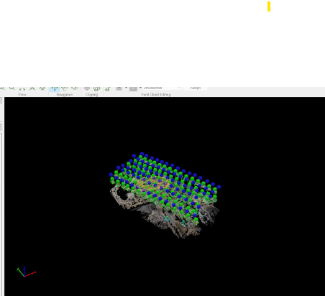
Figure 5: Camera alignment and image overlap during the initial photogrammetric processing stage in Pix4Dmapper (Pix4D, 2024).

10.0 Value-Added Analysis and Results

10.1 Supervised Land Cover Classification
A supervised classification was performed using the orthomosaic dataset within ArcGIS Pro. Training samples were selected to represent the dominant land cover types present within the study area.
The classification identified 4 primary land cover categories:
- Bare soil + access roads
- Vegetation
- Structures and equipment
- Aggregate Piles
The classification results indicate that the site is dominated by exposed soil and aggregate surfaces associated with active extraction activities. Vegetation is primarily concentrated along the perimeter of the site where disturbance levels are lower.

Table 2: Land cover classification results for the WireGrass Gravel Pit from ArcGIS Pro.
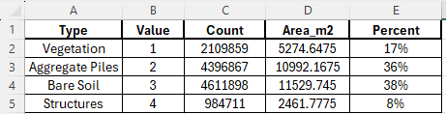
The classification results indicate that exposed soil and aggregate surfaces dominate the study area, accounting for approximately 74% of the site. This distribution reflects the operational characteristics of active gravel extraction sites, where vegetation is removed and large areas of exposed soil and processed aggregate are present due to excavation and material staging activities.
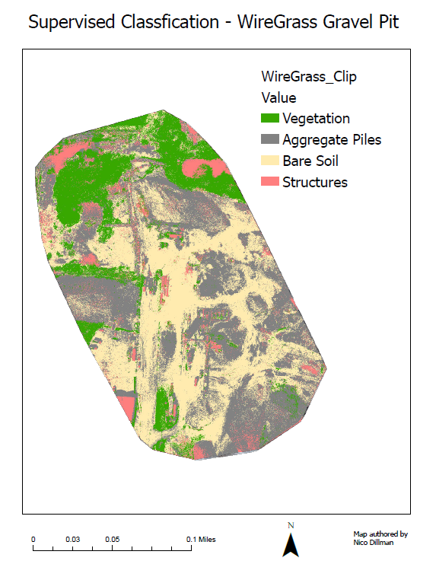
Figure 6: Supervised land cover classification derived from the orthomosaic dataset (Esri, 2023)

10.2 Surface Disturbance Intensity Mapping
To further evaluate the environmental impact of site operations, the classified land cover dataset was reclassified into categories representing varying levels of surface disturbance.

Three disturbance categories were defined:
High Disturbance – excavation zones and aggregate piles
Moderate Disturbance – access roads and staging areas
Low Disturbance – peripheral vegetation

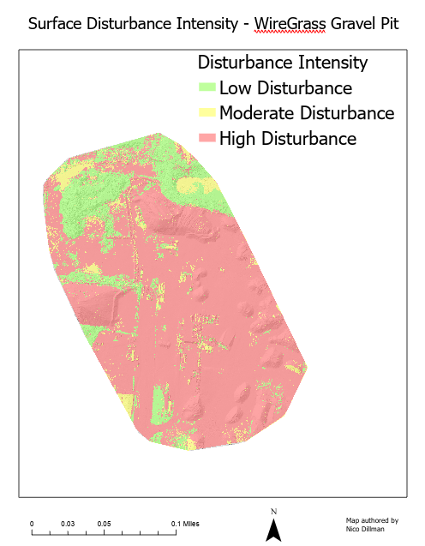
Figure 7: Disturbance intensity map illustrating the spatial extent of industrial activity (Esri, 2023).
The disturbance intensity map highlights the spatial distribution of industrial activity across the site and provides a useful visualization for understanding the extent of landscape modification. Areas classified as high disturbance correspond primarily to excavation zones and active material storage areas, while lower disturbance levels are concentrated along the vegetated perimeter of the site.

Table 3: Disturbance intensity classification derived from land cover reclassification from ArcGIS Pro.
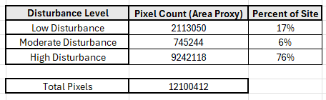
The disturbance intensity analysis indicates that approximately 76% of the site exhibits high disturbance associated with excavation and stockpile areas.

10.3 Feature Extraction: Stockpile Digitizing
Aggregate stockpiles were identified using the digital surface model (DSM) combined with hill shade visualization. Elevation differences and surface geometry were used to distinguish stockpiles from surrounding terrain.
Polygon features were manually digitized around each identifiable stockpile within ArcGIS Pro. The total footprint of aggregate stockpiles across the site was estimated to be approximately 9,900 square meters.
Although this study quantified the spatial footprint of aggregate stockpiles through manual digitization, the dataset also provides the potential for volumetric analysis using the digital surface model. By establishing a base elevation surface and calculating elevation differences between stockpile surfaces and surrounding terrain, it would be possible to estimate the volume of stored material. GIS tools such as surface volume or cut-and-fill analysis could convert elevation measurements from the DSM into volumetric estimates of aggregate storage capacity.
This additional analysis was not included in the final workflow due to challenges encountered while attempting to implement the volumetric tools within the project environment. During testing, the processing tools produced unstable results that risked altering or corrupting the existing project datasets. Given the time constraints of the project and the importance of preserving the completed photogrammetric outputs, the decision was made to focus on spatial footprint analysis rather than full volumetric modeling. However, incorporating stockpile volume estimation would represent a valuable extension of the analysis in future implementations.
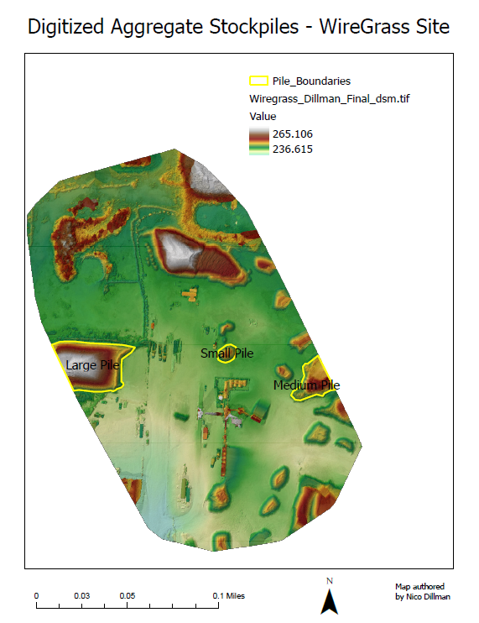

Figure 8: Digitized aggregate stockpiles identified using DSM and hill shade visualization (Esri, 2023).

Table 4: Estimated aggregate stockpile footprint derived from digitized DSM features from ArcGIS Pro.
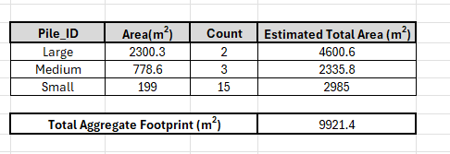

11.0 Conclusion
This project demonstrates how unmanned aerial systems (UAS), photogrammetric processing, and GIS based spatial analysis can be combined to evaluate environmental disturbance within an industrial landscape. Using high resolution imagery from the WireGrass Gravel Pit dataset, I generated a georeferenced orthomosaic and digital surface model that served as the foundation for land cover classification, disturbance intensity mapping, and the identification of aggregate stockpiles. Together, these outputs show how UAS derived imagery can be used to better understand terrain conditions and operational patterns within active extraction sites.
These results highlight the growing role of UAS technology as an efficient tool for collecting high resolution geospatial data capable of supporting environmental monitoring, terrain analysis, and industrial site assessment (Colomina & Molina, 2014). High resolution photogrammetry makes it possible to quantify areas of disturbance, identify operational features across the site, and visualize how extraction activities modify the landscape. Compared to traditional ground-based surveying methods, UAS workflows allow large areas to be mapped efficiently while still maintaining a high level of spatial detail.
Looking back at the workflow, one thing I would approach differently is defining the analytical goals earlier in the project. Much of my initial focus was on understanding the photogrammetric workflow and ensuring that the datasets were processed correctly. If I were to complete this project again, I would spend more time brainstorming potential analyses during the planning stage so that the analytical direction of the project was clearer before processing the data.
This course was also my first real exposure to drone-based mapping and UAS workflows. While some of my classmates already had experience flying drones, my background with UAS technology was mostly conceptual before starting this class. At times this made the analytical portion of the project feel a little uncertain. However, working through the full workflow from mission planning concepts to photogrammetric processing and GIS analysis helped me better understand how UAS platforms can be used to solve real geospatial problems. Overall, this project provided valuable insight into how drone collected imagery can support environmental monitoring and spatial analysis in real world applications.

References
Abdullah, Q. (2024). GEOG 892 course materials: Design requirements for a UAS based operation. The Pennsylvania State University.
Colomina, I., & Molina, P. (2014). Unmanned aerial systems for photogrammetry and remote sensing: A review. ISPRS Journal of Photogrammetry and Remote Sensing, 92, 79–97. https://doi.org/10.1016/j.isprsjprs.2014.02.013
DJI. (2023). Matrice 300 RTK user manual and Zenmuse P1 specifications.
Esri. (2023). ArcGIS Pro (Version 3.x) [Computer software]. Esri.
Federal Aviation Administration. (2023). 14 CFR Part 107: Small unmanned aircraft systems. U.S. Department of Transportation.
Federal Aviation Administration. (2024). Aeronautical chart users guide and sectional aeronautical charts. U.S. Department of Transportation.
ArduPilot Project. (2024). Mission Planner ground control software [Computer software].
Pix4D. (2024). Pix4Dmapper desktop manual: Photogrammetric processing workflow.
Siebert, S., & Teizer, J. (2014). Mobile 3D mapping for surveying earthwork projects using an unmanned aerial vehicle system. Automation in Construction, 41, 1–14. https://doi.org/10.1016/j.autcon.2014.01.009
SkyVector. (2024). VFR aeronautical charts and sectional maps. https://skyvector.com

