Generic Universal Role Playing System Item Generation System

(GURPS IGS?)

A Project For KSU CIS560

A Collaboration between
Nicholas Sixbury and Sarah Diener

Introduction:
GURPS, or the Generic Universal Role Playing System, is a tabletop roleplaying game that has been published by Steve Jackson Games since 1986. It offers extreme flexibility as a system due to its large number of published material supporting the game along with its very generic and adaptable rule sets. Now, while it’s great that the system offers a lot of optional depth, many of the more realistic rule options in particular can become cumbersome to keep track of with pencil and paper.
One fantastic example of GURPS’s sometimes cumbersome-to-keep-track-of rules comes from the article “The Deadly Spring” by Douglas H Cole, published in Pyramid 3rd Edition, Volume 33, Low-Tech. In the article, Cole describes an optional system by which players may design their own custom bow and arrows, calculating or customizing draw force, working length of the bow, target draw length, bow components and materials, cross section and shape of bow staff, whether to use a compound or crossbow, among several others and derive game statistics from these options. While the customization and realism can be great, it also involves a great deal of math and planning, such as the formula shown below, taken from the article, used for calculating the maximum draw distance of a particular bow, shown to the right.
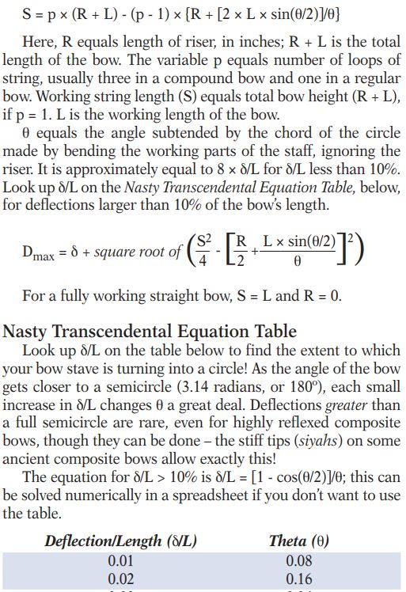Figure 1: Equation For Calculating Maximum Draw Distance, Pyramid 3-33 pg 7
Now, while some aspects of the game can require a good deal of time calculating things out and planning, a good deal of this can be mitigated using computers. Another example of material for the game that can require some time calculating things out and rolling dice comes in the form of the book “GURPS 4th - Dungeon Fantasy 8 - Treasure Tables”. The book allows for random generation of thematic and appropriately stat-ed items for a wide variety of environments and situations, and all it requires is a bit of dice rolling. Well, for better or worse, the book is nearly 60 pages of large tables and rows upon rows of statistical information on various common and uncommon items.
The book starts with a nine-paragraph description of how to actually use all the tables, and right after that is a large table, taking up four full pages, used simply to randomly select a category of item. While the book is carefully cross referenced, it can still be a bit of a chore to flip back and forth several times across the 60+ page volume just to generate a single item. Now, many GURPS books would be horrifically complicated to computerize, but Dungeon Fantasy Treasure Tables, relatively speaking, is much simpler. It simply involves going back and forth between a large amount of organized data while rolling dice for randomness. The data can be stored in a database, in tables similar to those in the book, and the dice can be simulated by computer algorithms as well.
This is where the GURPS Item Generation System comes in. It automates the process of going through the tables by handling all of that processing digitally, and even comes with the added bonus of sharing stat tables created by the community to other players, similarly to sites like GURPS-Repository or the official GURPS forums, which already allow users from all over the world to share materials for the game. With the GURPS Item Generation System, users can both make use of a great system to generate random items for their game, or share custom-made tables with other players.

Technical Description:
-The GURPS Item Generation System, or GURPSIGS, is a combination of C# code, SQL databases, and React JavaScript webpages. It uses a {explain webDevStuffHere) to connect from the backend server to client webpages.
In terms of development environments, Microsoft Visual Studio was used for the C# and Web-API aspects, Microsoft SQL Server Management Studio 18 was used to interact with the systems database, and Microsoft Visual Studio Code was used for designing webpages. A variety of Microsoft NuGet packages are used in the C# code, along with a package for JSON functionality in order to facilitate communication between the Web-API and client browsers. Additionally, a project titled “DataAccess” was provided by John Keller, the instructor of the course, in order to facilitate database access from c#. It should be noted however, that while much of the tools used to develop the application are Microsoft based, the client webpage itself should run in most standard web browsers on common operating systems.
In terms of the overall system design, we adopted an “MVC-ish” approach, separating application logic, database access, and frontend views from each other. Several different structures of similar classes were also used throughout.
So called “Model” classes served as temporary storage containers for records from the database, allowing information to be passed around as objects instead of a mess of various similarly named properties for every table in the database.
SQL code was also separated out into different categories and folders, with Setup scripts being intended to only be run once in order to set up the database, Create scripts being used to add new rows to the database, Delete scripts being used to delete certain reference entries in the database, Select scripts being used to retrieve many rows at a time from a particular table in the database, and Save scripts being intended to update information already in the database. There were also four Report scripts which used the advantages of database access to generate various report information about the data in the database.
Within the backend, our system also included DataDelegates, Repositories, and Controllers.
Repositories were used in order to quickly and painlessly perform set operations on the database, stored as various classes with methods that would each correspond to a particular operation, and would only be concerned with the high level input and output of each procedure. The Controller classes served in a similar role to Repositories, but instead of being used by the backend as a front-facing data-access tool, the Controller classes were used to interface between client web browsers and the backend data, with each one using a Repository object in order to do its job.
DataDelegates, on the other hand, act as a connecting piece between the front-facing Repositories, raw SQL procedures, and various classes in the DataAccess project, which facilitates and largely handles actual command execution. DataDelegates in particular make up a large part of the code base, as in order for the frontend (or even most of the backend) to link up with the database for a particular operation, a DataDelegate class must be written (with our current system) for each and every SQL procedure in the database. This means that to fully implement every part of every operation, a DataDelegate class must be written for each of our systems eighty three SQL procedures, defining both the parameters and return data for each and every single procedure.

Database Design:
-

System Design:
-

System Features and Usage:
-

Report Queries:
-

Summary and Discussion:
-

