How to Scan and Process Flour Samples

Nicholas Sixbury

January 22, 2024

(2018 Guide by Sophia Grothe)

Overview:

This project uses an EPSON Perfection v600 scanner to take flour samples, and ImageJ to perform image processing on those samples. Software has been developed by Nicholas Sixbury, Dan Brabec, and Bill Rust to simplify the process of data collection and processing.

# How to Scan and Process Flour Samples

1. On the Dell Latitude 5410, named ARSKSMHK5R223-2, which already has the program installed, click the shortcut labeled “Flour Scan Full” to open the program. [See Figure 1]

Figure 1

1. Ensure that the EPSON v600 scanner is turned on, and then click “Connect to Scanner” in the program. [See Figure 2]
2. The flour sample should be in a clear petri dish without any tape or markings on the bottom. Place the sample in bottom right of the metal placement guide provided.

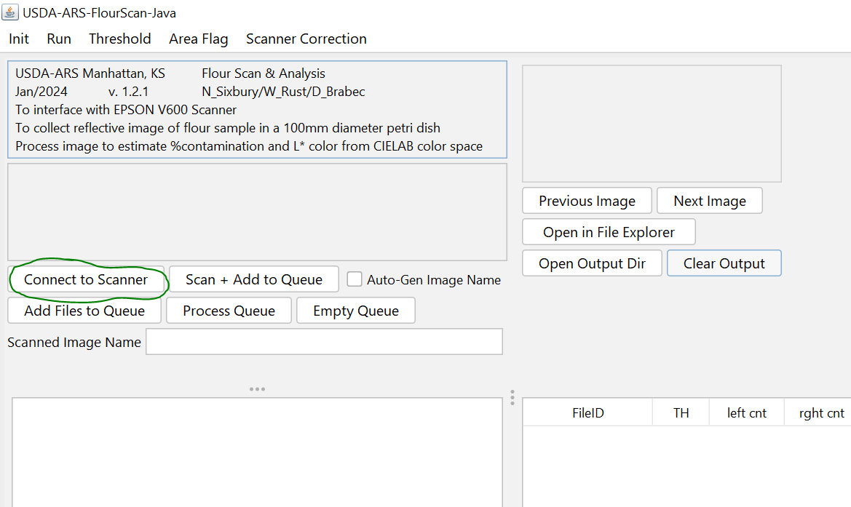Figure 2

1. Provide a name for the scanned image in the box provided. [See Figure 3]

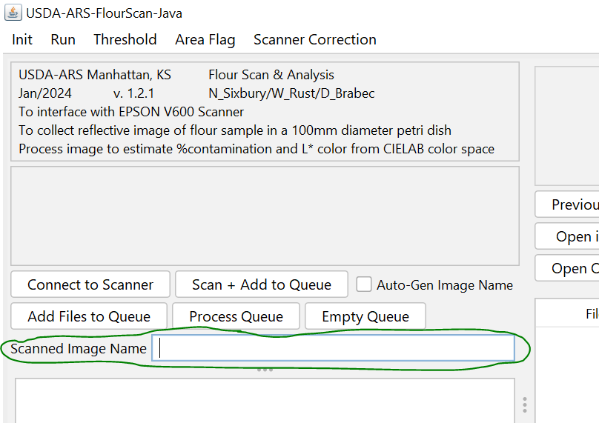Figure 3

1. After closing the lid of the scanner, click the “Scan + Add to Queue” button in the software. [See Figure 4]
2. After the sample has finished scanning, you can repeat steps 3-6 for each sample you wish to scan. Note: Do not interrupt a scan in progress.

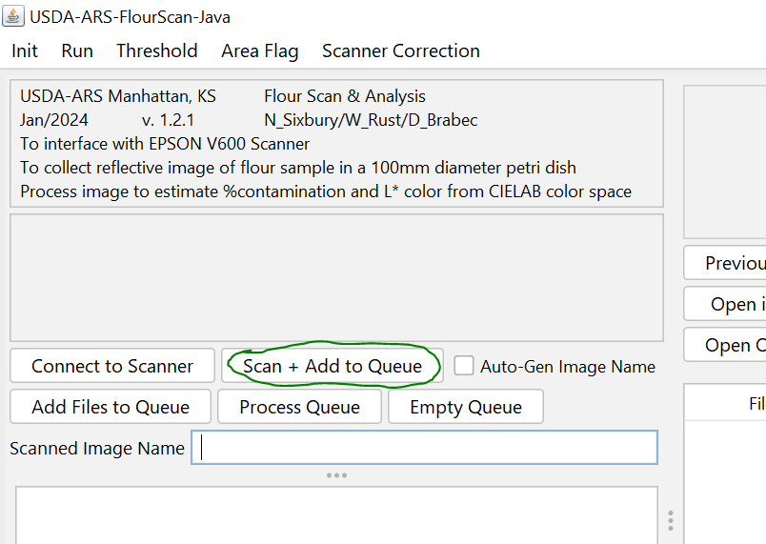Figure 4

1. After your scans have been completed, click the “Process Queue” button in the software to get results. [See Figure 5]
2. After all images have finished processing, they will show up in the table to the right in the software. [See Figure 6]

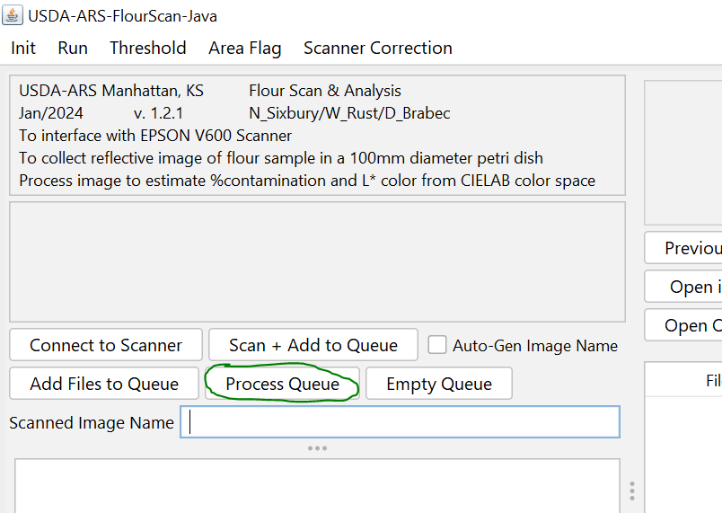Figure 5

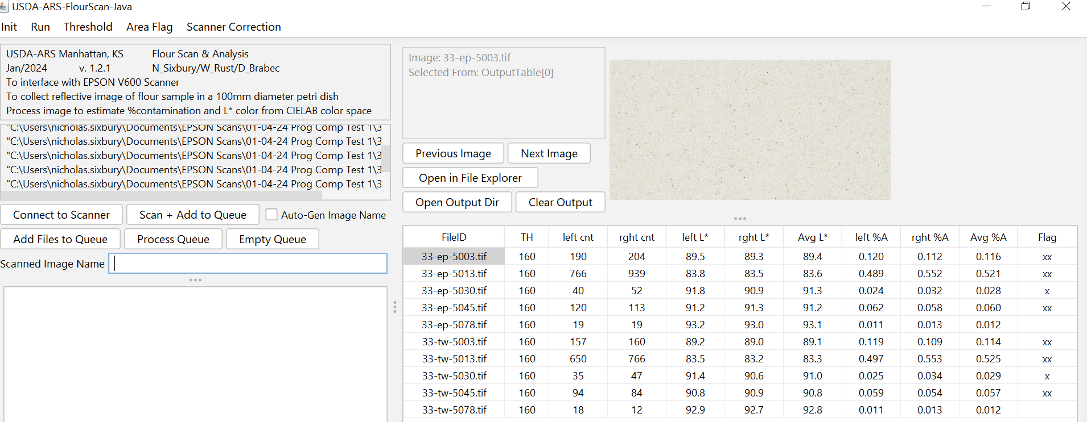Figure 6

1. To view the results in a csv format, click the “Open Output Dir” button above the output table. This will open the directory of output files, which are organized by date and time.

# Troubleshooting and **Potential** Issues

* Program says that scanner is connected, but an error occurs whenever you try to scan:
  + This problem can occur when the scanner is not connected. The “Connect to Scanner” button actually only establishes which type of scanner you want to try and connect to, and the real connection attempt doesn’t occur until the program actually attempts to scan something. As such, the program saying the scanner is connected doesn’t even mean the scanner is on.
  + Make sure the scanner is turned on and connected to the computer via USB. Also make sure to wait for the scanner to fully finish the startup process that occurs whenever it’s turned on.
* The metal placement guide is missing, or the scanner is scanning in the wrong area:
  + If this problem occurs, then you can set a new scan area within the program. Use the top menu “Scanner Correction” > “Set Scanner Area”, and then set new coordinates for the top left and bottom right corner of the scan area. When you’re done, click “Confirm” to save your changes.
* The configuration settings have been changed or corrupted and need to be reset:
  + In order to reset the configuration settings, simply find the “flour-scan.config” file in the base directory of the software. While the program is not running, delete this file, and it will be regenerated the next time you run the program.
* Someone tried canceling an ongoing scan, and the program is acting strangely:
  + The cancel button that shows up during an active scan is created by EPSON and cannot be manipulated or handled by this program. To fix any issues, simply restart the program and re-add any image files you already scanned using the “Add Files to Queue” button.
* There’s some other problem not covered or solved by this guide:
  + If there’s some other problem not covered here, please try the following general tips:
    - restart the program by closing it and re-opening it
    - install or re-install the EPSON Scan Utility using the disk that came with the scanner
    - ensure that the scanner is turned on and connected to the computer
    - if possible, see if the EPSON Scan Utility has the same problem in order to narrow down where the problem is occurring
    - make sure you’re using the usda-java-flour-scan.bat file to run the program instead of the jar file, as this will ensure the program is using a 32-bit version of java, which is necessary for connecting to the scanner

# Detail of Configurable Options

This program contains a number of settings that can be configured by the user. These settings can be read and changed in two places: the flour-scan.config file and the various menus within the program itself. Any changes made in the menus will be reflected in the flour-scan.config file, and vice versa.

#### More About the Config File:

In the config file, lines not determined to hold values for variables will be ignored, so you can leave comments and notes in the file. When the file is generated, each variable setting will have a comment above it which explains what the variable does. You should be somewhat careful when changing the settings of variables in the config file, as if the program cannot parse the line, that variable will likely be reset by the program back to the default value.

#### More About the Menus:

The menus can be found at the top of the program. When changing values in a configuration menu, any changes you make will only take affect if you click “Confirm” to exit the dialog. If you instead click “Cancel” to exit, then the changes will be ignored.