# User Guide for Flour-Scan Software;

# evaluates images of flour samples

# after scanning w/ Epson V600 scanner

Nicholas Sixbury, Sophia Grothe, Daniel Brabec

January 22, 2024

Overview:

This project uses an EPSON Perfection v600 scanner to take 1”x2” images of flour samples which are contained in 3.5” petri dish. The images are processed using ImageJ-software routines to determine whether the flour is clear or estimate any levels of potential smut contamination in the flour. This software has been developed by Nicholas Sixbury, Dan Brabec, and Bill Rust in 2023.

This work was accomplished at USDA-ARS facility at Manhattan, Kansas.

Note: previous version: 2018 User Guide: by Sophia Grothe

# Basic system

The basic system includes a scanner, computer, and flour samples as stored in petri dishes. The scanner has a metal template for positioning the petri dish. This version of the software is currently set to process a single petri dish which is positioned in the lower right circular holder. The computer can be laptop which has Window 10 installed. The program uses a 32-bit version of java 8 which is packaged along with the software, so as long as the program is run from the bat file, users don’t have to worry about having the wrong version of java. All files used by the software are located within the folder “C:\Users\Flower Scan\Documents\NetBeans Projects\usda-java-flour-scan”.

Fig 1: Scanning petri dish of flour to inspect for amount of smut speckles and flour color.

# Associated research publication

A publication was prepared and accepted by Cereal Chemistry. This publication describes experiments related to testing flours with the scanner and includes data from a set of 30 flour samples. The following citation is for the research with the flour scan system.

Brabec, D., Grothe, S., Perez‐Fajardo, M., Pordesimo, L., & Yeater, K. (2024). Potential of a flatbed scanner for evaluation of flour samples for dark specks and flour color. Cereal Chemistry, 1–10. https://doi.org/10.1002/cche.10758

# Using Flour-Scan Software;

1. On the Dell Latitude 5410, named ARSKSMHK5R223-2, which already has the program installed, click the shortcut labeled “Flour Scan Full” to open the program. [Fig. 2]

Fig 2: Icon of Flour Scan software

1. Ensure that the EPSON v600 scanner is turned on, and then click “Connect to Scanner” in the program. [Fig. 3]

Fig 3: Flour scan software – user interface with the “Connect to Scanner” button circled.

1. When scanning images with the program, all images are categorized by date and placed in a folder named “scanned-images”. This folder is located at “C:\Users\Flower Scan\Documents\NetBeans Projects\usda-java-flour-scan\scanned-images”.

1. Provide a name for the flour sample in the box provided. [See Figure 4]

Fig 4: Flour scan software – user interface with Scanned Image Name circled.

1. The flour sample should be stored in a new clear petri dish which is free of markings on the bottom of the dish. Ensure that the scanner glass top is clean and free of dust or flour. Place the petri dish in bottom right of the circular metal placement guide provided.

After closing the lid of the scanner, click the “Scan + Add to Queue” button in the software. [Fig. 5]. Scanning each 1”x2” image of flour take ~ 1 minute.

Fig 5: Flour scan software – user interface with Scan + Add to Queue button circled.

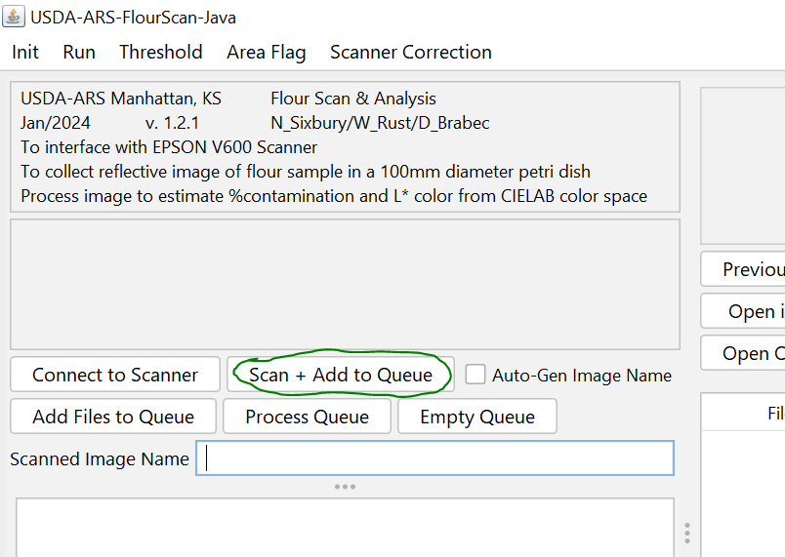

1. After the sample has finished scanning, additional flour samples can be scanned. For additional samples, repeat steps 3-6. Caution: Do not interrupt a scan in progress. When the scan is in progress, EPSON might show a dialog box with a progress bar and a cancel button. This dialog is not controlled by this program, and the cancel button doesn’t work.
2. After all the flour samples have been scanned, the images are evaluated. The “Que” shows all the images files to process. Click “Process Queue” button to get the result [Fig. 6]

Fig 6: Flour scan software – user interface with “Process Queue” button circled.

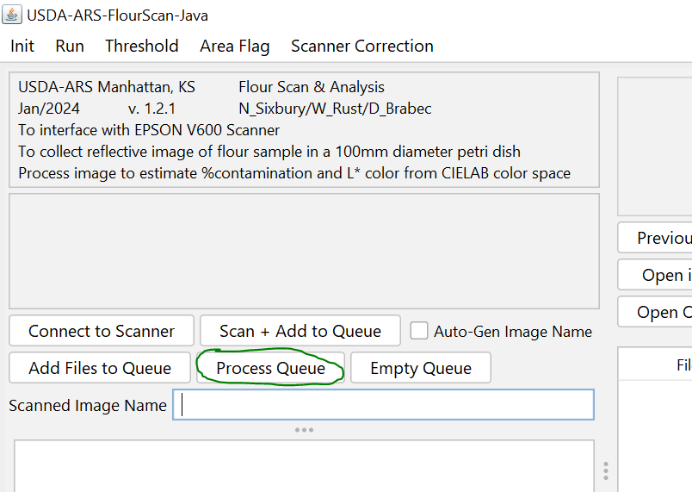

1. After all images have finished processing, the results will be displayed in the table to the right in the software, [Fig. 7]. The image processing divides the 1”x2” image into 2 images which are 1”x1” and labeled as either Left or Right. The results are given for 3 parameters; spec count, brightness L*, and %spec area. Also, a flag is included to mark samples that have %spec area larger the 0.025% and 0.05%.

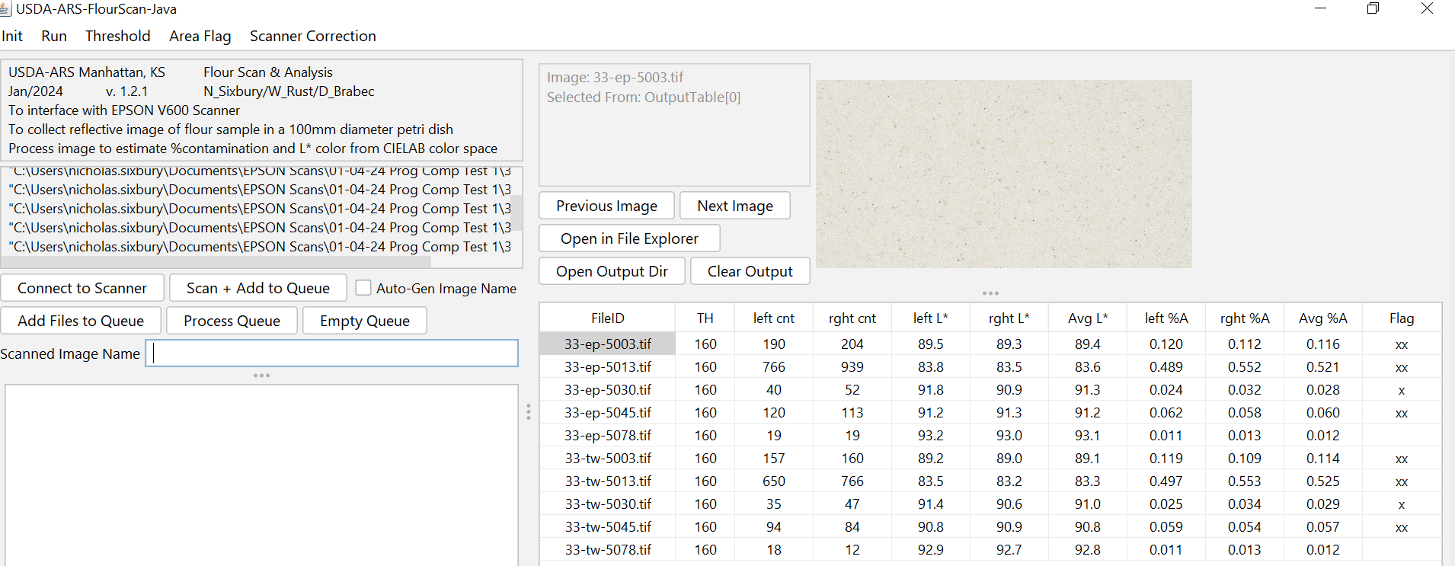

Fig 7: Flour scan software – user interface, to the right find Open Output Dir for the excel file.

1. In addition, a file containing the “saved” results can be viewed. To view the results in a csv format, click the “Open Output Dir” button above the output table on the right. This will open the directory of output files, which are organized by date and time.

# Detail of Configurable Options

This program contains a number of settings that can be configured by the user. These settings can be read and changed in two places: the flour-scan.config file and the various menus within the program itself. Any changes made in the menus will be reflected in the flour-scan.config file, and vice versa.

#### More About the Config File:

In the config file, lines not determined to hold values for variables will be ignored, so you can leave comments and notes in the file. When the file is generated, each variable setting will have a comment above it which explains what the variable does. You should be somewhat careful when changing the settings of variables in the config file, as if the program cannot parse the line, that variable will likely be reset by the program back to the default value. The config file is stored at “C:\Users\Flower Scan\Documents\NetBeans Projects\usda-java-flour-scan\flour-scan.config”.

#### More About the Menus:

The menus can be found at the top of the program. When changing values in a configuration menu, any changes you make will only take affect if you click “Confirm” to exit the dialog. If you instead click “Cancel” to exit, then the changes will be ignored.

#### Default Configuration File:

# This is the number used as the upper threshold in imagej particle analysis

proc_threshold = 160

# Any file with average % area greater than this will get a flag of x

area_threshold_lower = 0.025

# Any file with average % area greater than this will get a flag of xx

area_threshold_upper = 0.05

# Sigma radius to use with unsharp mask to try and replicate epson setting.

unsharp_sigma = 1.5

# Mask weight to use with unsharp mask to try and replicate epson setting.

unsharp_weight = 0.5

# if true, then the unsharp mask will be skipped

unsharp_skip = false

# if true, the unsharp masked image will be renamed as a new file. Otherwise, it will overwrite the original.

unsharp_rename = false

# x coordinate in inches of upper left corner of scan area

scan_x1 = 1.05

# y coordinate in inches of upper left corner of scan area

scan_y1 = 8.98

# x coordinate in inches of lower right corner of scan area

scan_x2 = 3.05

# y coordinate in inches of lower right corner of scan area

scan_y2 = 9.98

# Troubleshooting and Potential Issues

* Program says that scanner is connected, but an error occurs whenever you try to scan:
  + This problem can occur when the scanner is not connected. The “Connect to Scanner” button only establishes which type of scanner you want to try and connect to, and the real connection attempt doesn’t occur until the program actually attempts to scan something. As such, the program saying the scanner is connected doesn’t even mean the scanner is on.
  + Make sure the scanner is turned on and connected to the computer via USB. Also make sure to wait for the scanner to fully finish the startup process that occurs whenever it’s turned on.
* The metal placement guide is missing, or the scanner is scanning in the wrong area:
  + If this problem occurs, then you can set a new scan area within the program. Use the top menu “Scanner Correction” > “Set Scanner Area”, and then set new coordinates for the top left and bottom right corner of the scan area. When you’re done, click “Confirm” to save your changes.
* The configuration settings have been changed or corrupted and need to be reset:
  + In order to reset the configuration settings, simply find the “flour-scan.config” file in the base directory of the software. While the program is not running, delete this file, and it will be regenerated the next time you run the program.
* Someone tried canceling an ongoing scan, and the program is acting strangely:
  + The cancel button that shows up during an active scan is created by EPSON and cannot be manipulated or handled by this program. To fix any issues, simply restart the program and re-add any image files you already scanned using the “Add Files to Queue” button.
* There’s some other problem not covered or solved by this guide:
  + If there’s some other problem not covered here, please try the following general tips:
    - restart the program by closing it and re-opening it
    - install or re-install the EPSON Scan Utility using the disk that came with the scanner
    - ensure that the scanner is turned on and connected to the computer
    - if possible, see if the EPSON Scan Utility has the same problem in order to narrow down where the problem is occurring

Make sure you’re using the usda-java-flour-scan.bat file to run the program instead of the jar file, as this will ensure the program is using a 32-bit version of java, which is necessary for connecting to the scanner

How to Scan and Image analyze flour samples

Sophia Grothe

December 20, 2018

Overview:

This project uses a scanner and imaging software to evaluate flour and wheat samples from June 2018. Using an EPSON (Perfection V600 Photo) scanner the flour was scanned and using ImageJ evaluated using YUV and RGB lighting. `````````````````````````````````````````````````````````````````````

How to Scan and Image analyze flour samples

1. On the Dell Laptop (Precision 3520) open EPSON Scan on the Desktop
2. Place wheat sample in the righthand corner of the scanner

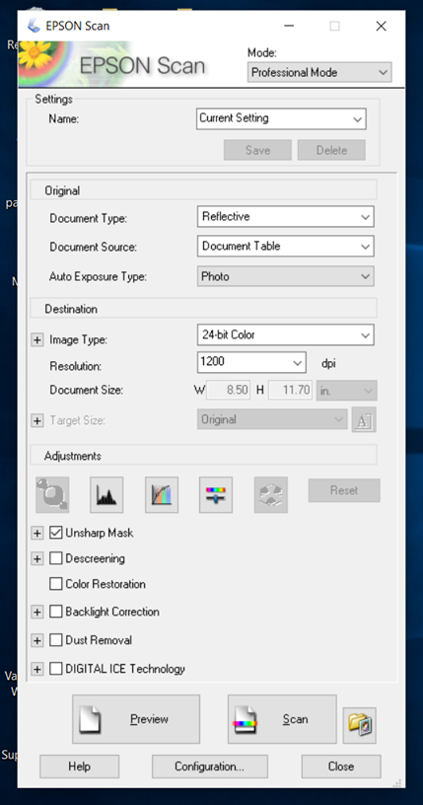

On the EPSON Scan screen make sure Image Type: 24-bit Color and Resolution: 1200 dpi

1. Click Preview to preview the picture
2. Put your mouse over the picture so it shows a ‘+’ cursor and select a 1X1 inch square of the flour sample
3. Preview the flour sample again
4. Press Scan

In the File Save Settings screen make sure Type: BITMAP and press OK

1. Press Scan again (this may take a few seconds) place on a USB drive
2. Look up ImageJ in search bar and Press on it
3. Go to File, Open, 2018 June flour pics, and Top5Bottom5 (if not already selected)
4. Go to Image and Duplicate, Press OK

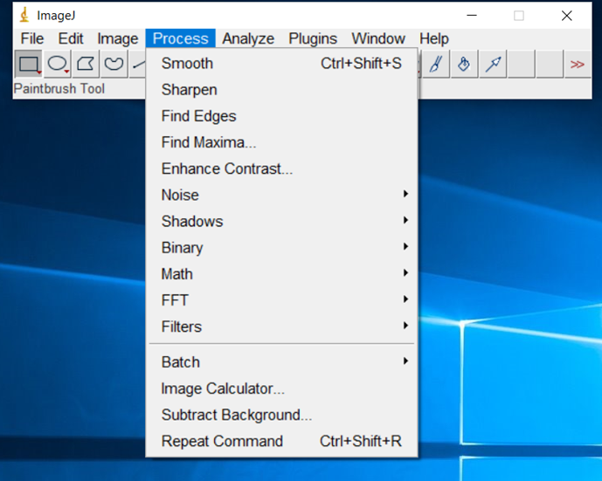

Go to Process and press Smooth

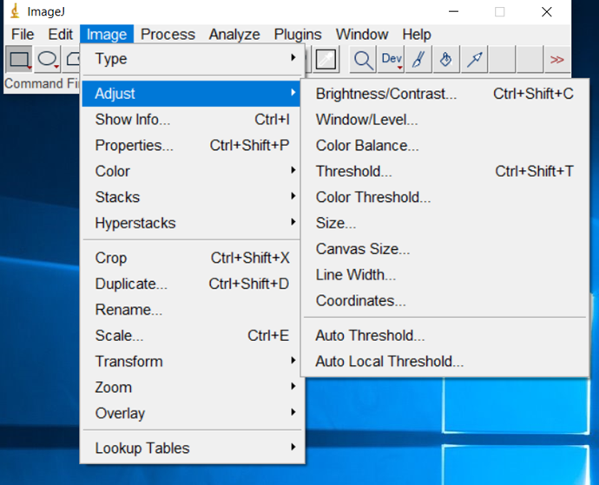

Go to Image, Adjust, and select Color Threshold

Type is for Y: 0 and 211, U: 118 and 255, V: 0 and 255

Also make sure Threshold color is on White and Color space is in YUV

1. Go to Process again and press Sharpen this time

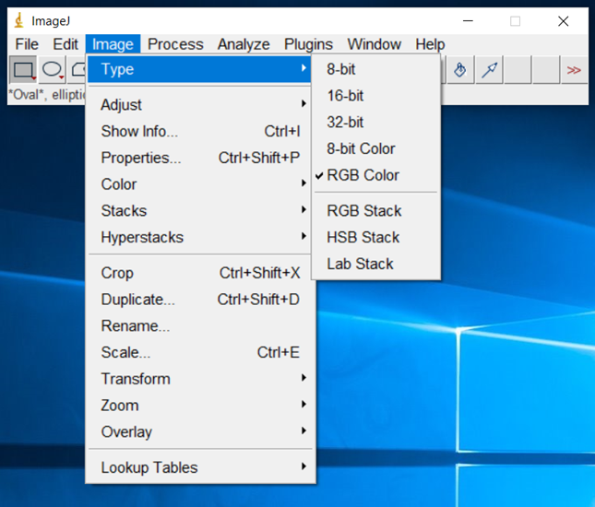

Go to Image, Type and select 8-bit



Go to Image, Adjust, and select Threshold

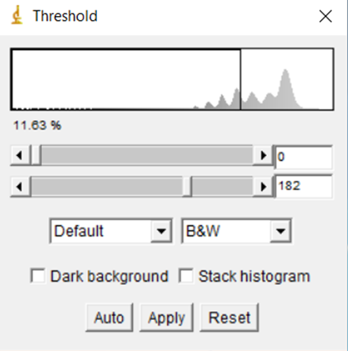

The Threshold should be 0 and 182 and press Apply

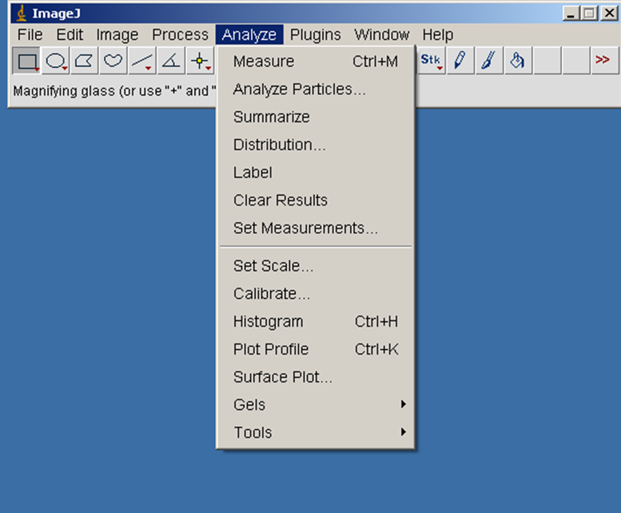

Go to Analyze, Analyze particles. Make sure Display results and Summarize are check marked and click Save.

1. The summary should pop up on the screen. Save on USB drive.
2. Put the USB drive of the flour samples on to the Dell (Latitude D620) laptop
3. Click on the ImageJ icon on Desktop
4. Open the flour sample files from USB
5. Go to Image and Duplicate, Press OK

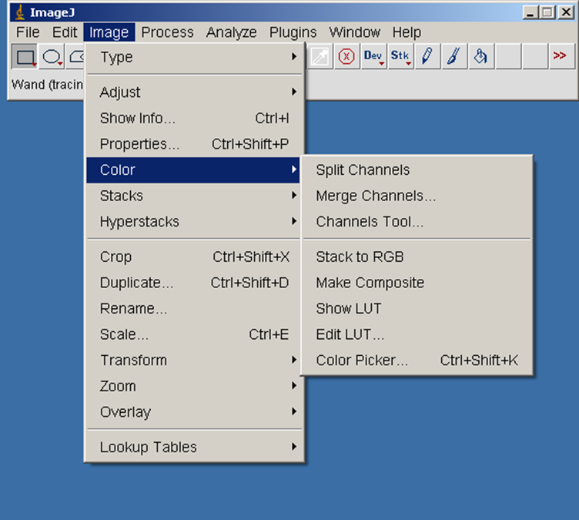

Go to Image, Color, Split Channels



Go to Analyze, Histogram (will have to do this for each color (red, green, blue))