

HOUSE OF MORE

Platform Onboarding Guide

Studio1642 | 2026 | studio1642.com

This document provides a complete technical overview of the House of More membership platform — covering architecture, integrations, automation, and key workflows for platform administrators and stakeholders.

Contents

01 Platform Overview
02 Architecture & Tech Stack
03 Repository & Codebase
04 Memberstack Setup
05 Make.com Automation
06 Platform Features
07 Key Workflows
08 Security & Access Control

01 — Platform Overview
House of More is a spiritual community and membership platform rooted in Jewish tradition, built to explore ancient wisdom through transformative gatherings, workshops, and retreats. Currently serving South Florida and Los Angeles, the platform operates under a single guiding principle:

"Where Seeking Meets Connection"

The platform is built on Webflow and powered by a suite of modern SaaS tools that handle authentication, automation, payments, and communication — all integrated through a secure API layer.

Three Entry Points
- Public Website — thehouseofmore.com — Marketing, event listings, about, resources
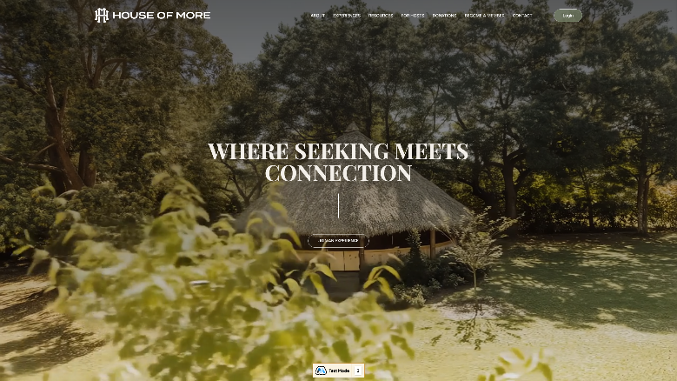

- Member Portal — thehouseofmore.com/app/member — Personalized member workspace
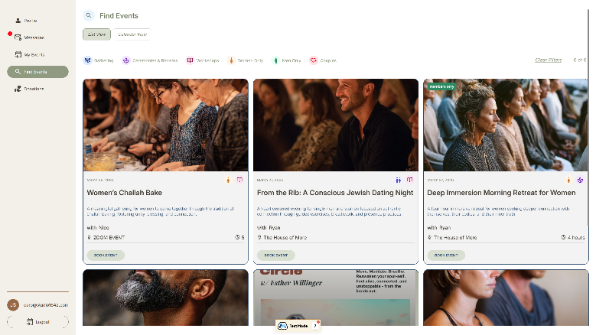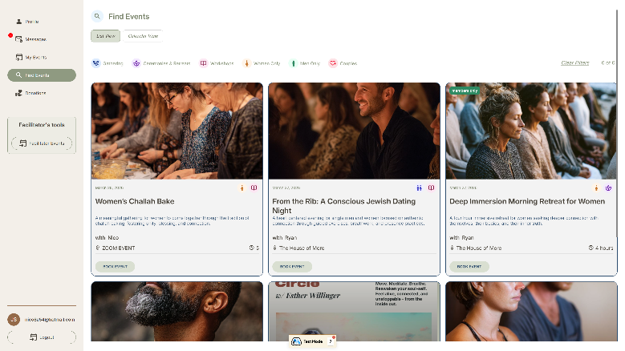

- Admin Dashboard — thehouseofmore.com/app/admin — Community management tools
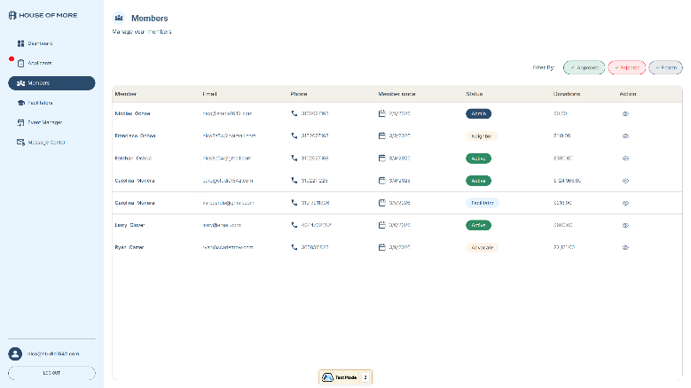

Platform At a Glance
Component | Details
Live Domain | thehouseofmore.com
Webflow Site ID | 67ec00a8fb871e234c405e38
Memberstack App | app_cmiyx2vit00ld0ruubtoi3ih7
Max Members | 5,000
Make.com Org | HOM — us2.make.com
Total Scenarios | 37 (30 active, 7 inactive)
Payment Processor | Stripe (acct_1P0lsSDtQVSRXGyV)

02 — Architecture & Tech Stack
The platform uses a layered architecture designed for security and flexibility. All browser requests route through a Cloudflare Worker proxy before reaching any backend service — keeping API credentials completely hidden from the client.

System Architecture Diagram
BROWSER
↓ HTTP Request
CLOUDFLARE WORKER (houseofmore.nico-97c.workers.dev)
↓ Authenticated Webhook (API key injected server-side)
MAKE.COM (us2.make.com)
Memberstack API | Webflow CMS | Stripe API | Gmail

Security Note: API keys are stored exclusively as Cloudflare Worker environment secrets. They are never exposed to the browser or included in any frontend JavaScript.

Technology Stack
Technology | Role | Key Detail
Webflow | Frontend & CMS | Site builder, page hosting, events CMS
Memberstack | Auth & Member Management | Plans, sessions, custom fields, content gating
Make.com | Automation Engine | 37 scenarios, webhook orchestration
Cloudflare Workers | API Proxy Layer | Secure key injection, request routing
Stripe | Payment Processing | One-time & recurring donations
Gmail | Transactional Email | Confirmations, reminders, notifications
Finsweet Attributes v2 | Webflow Utilities | Dynamic UI behaviors on Webflow pages

Request Flow
- Member action triggers in browser (RSVP, profile update, donation, etc.)
- JavaScript sends fetch() to Cloudflare Worker endpoint
- Worker validates request, injects API key, forwards to Make.com webhook
- Make.com scenario processes: reads/writes Memberstack, Webflow CMS, Stripe, data stores
- Response returned through Worker to browser
- Email notifications dispatched via Gmail when triggered

03 — Repository & Codebase
The project codebase is currently managed as a local project. GitHub version control is recommended as a next step to enable collaborative development, code history, and deployment automation.

Local Project Structure
Root: C:\GIT\House of More

Folder / File | Contents
/house-of-more.webflow/ | Full Webflow site export — HTML, CSS, JavaScript for all pages including admin and member app
/cloudflare-worker/ | Cloudflare Worker source code — API proxy, routing logic, key injection
/MAKE/ | Make.com scenario blueprint exports (JSON) for backup and version tracking
/Reports/ | Build and style analysis reports generated from the codebase
build-reports.js | Node.js script that generates style and class usage reports

Key Application Pages
Page | Path | Purpose
Admin Dashboard | /app/admin | Full community management workspace (6 tabs)
Member Portal | /app/member | Personalized member workspace
Questionnaire | /questionnaire | New member application & onboarding form
Event Detail | /detail_events | Individual event page with RSVP capability
Donation | /donation | Donation initiation page (Stripe checkout)
Login | /log-in | Memberstack authentication page
Sign Up | /sign-up | Registration entry point

Recommendation: Set up a GitHub repository to track changes to /cloudflare-worker/ and /house-of-more.webflow/ — these are the most actively modified parts of the codebase.

04 — Memberstack Setup
Memberstack handles all authentication, member data, and access control. Each member is assigned a plan that determines what content and features they can access across the platform.

App Configuration
Setting | Value
App Name | House of More
App ID | app_cmiyx2vit00ld0ruubtoi3ih7
Stack | Webflow
Session Duration | 14 days
Member Limit | 5,000
After Login Redirect | /questionnaire
After Logout Redirect | /
Concurrent Logins | Disabled — one session per member at a time
Disposable Emails | Blocked
2FA Required | No
Passwordless Login | Disabled

Member Lifecycle
Signup Form → PENDING → Admin Review → APPROVED (full portal access)
Signup Form → PENDING → Admin Review → REJECTED (no access)
Active Member → FROZEN (access suspended, reversible by admin)

Member Plans
Plan | Plan ID | Purpose
Approved Member | pln_approved-member-bd2jv0hp1 | Full access — active community member
Rejected | pln_rejected-fo1l60nm3 | Application denied — no platform access
Freeze | pln_freeze-yy2kn0ejb | Temporarily suspended — reversible by admin
Pending | (signup default) | Awaiting admin review after questionnaire
Facilitator | (separate plan) | Event hosts — access to facilitator tools
Admin | (separate plan) | Full admin dashboard access

Custom Member Fields
Field Key | Type | Usage
first-name | Text | Member first name — displayed in portal and admin view
last-name | Text | Member last name — used in greetings and admin lists
phone | Text | Contact number — editable in member profile

05 — Make.com Automation
Make.com is the automation backbone of the platform. Every data operation — from creating a member to confirming a donation — runs through a Make.com scenario triggered via webhook.

Organization | Team | Zone | Total Scenarios
HOM (ID: 4435224) | My Team (ID: 1078488) | us2.make.com | 37 (30 Active, 7 Inactive)

Folder Structure
— HOM Memberstack — 27 scenarios — Core platform automation
— Ticket Spice — 2 scenarios — TicketSpice → Webflow CMS sync

Core Member Flow (Scenarios A–I)
Scenario | Trigger | Purpose
A — Create a Member | Questionnaire submit | Creates Memberstack record, sends welcome email
B — List Members | Admin dashboard load | Returns all members with plan/status for admin view
C — Get Member Detail | Admin clicks member | Fetches single member profile for action modal
D — Approve / Reject / Freeze | Admin takes action | Updates Memberstack plan, sends status email
E — Bring Member Profile | Member portal load | Returns logged-in member profile data
F — Update Profile | Member saves edits | Writes updated profile fields to Memberstack
G — List My Events | Member views events | Returns member's personal RSVP list
H — RSVP an Event | Member RSVPs | Creates booking record, sends confirmation email
I — List All RSVPs | Admin event manager | Returns all RSVPs across all events

Event Management Scenarios
Scenario | Purpose
Add ID to Event in CMS | Syncs new Webflow CMS event to Make data store with unique ID
Update an Event from CMS | Updates event record when CMS item is edited
Delete an Event from CMS | Removes data store record when CMS item is deleted
Admin — List a Specific Event | Returns event details and attendee list for admin
Admin — List All Events | All events for admin event manager view
List All Events (public) | Event listing for member portal browse
Facilitator List All Events | Events managed by a specific facilitator
Facilitator Check In RSVP | Marks attendee as checked in at the door
Facilitator — Close Event | Closes event, triggers post-event workflow
Event 24h Reminder | Automated email reminder 24 hours before event
Event 7-Day Review Request | Automated review request email 7 days post-event

Messaging Scenarios
Scenario | Purpose
Admin Create a New Message | Admin sends a targeted message to a specific member
Admin List All Messages | Retrieves full message center content for admin view
Member Read Message | Marks message as read, returns content to member portal

Donation Scenarios
Scenario | Purpose
Donation — Create Checkout Session | Creates Stripe checkout URL for one-time donation
Donation One-Time — Confirmation | Confirms donation post-Stripe, sends receipt email
Donation — Recurring Payment | Handles recurring donation payment webhook from Stripe
Donation List All | Returns all donations for admin impact dashboard
Donation List Mine | Returns current member's donation history

06 — Platform Features

Admin Dashboard — thehouseofmore.com/app/admin
A 6-tab workspace for managing the entire community. Access restricted to members with admin plan.

Tab | Key Features
01 Dashboard | Member counts by status (Active, Pending, Frozen, Rejected, Facilitators) — Total donations impact value
02 Applications | Review pending applications — Approve, reject, or freeze — Member profile detail modal
03 Members | Full member directory — Filter by status — Individual member view with donation history
04 Facilitators | Facilitator-specific management and overview
05 Event Manager | All events with RSVP counts — Booked vs. cancelled tracking — Per-event attendee lists
06 Message Center | Send messages to members — View incoming messages — Delete message threads

Member Portal — thehouseofmore.com/app/member
A personalized workspace for community members. Access gated by the approved-member Memberstack plan.

Section | Features
Profile | View and edit personal info — First name, last name, phone, community profile fields — Save/cancel edit mode
My Events | Upcoming and past RSVP list — Interactive calendar with event day highlights — Event detail links
Find Events | Browse all upcoming experiences — Filter by category and type — One-click RSVP
Messages | Read messages sent by admins — Mobile-optimized message list and detail view
Donations | Initiate one-time Stripe donation — View personal donation history with totals
Facilitator Events | Manage hosted events — Check in attendees — Close completed events (facilitators only)

07 — Key Workflows

New Member Signup
1. Applicant completes questionnaire at thehouseofmore.com/questionnaire
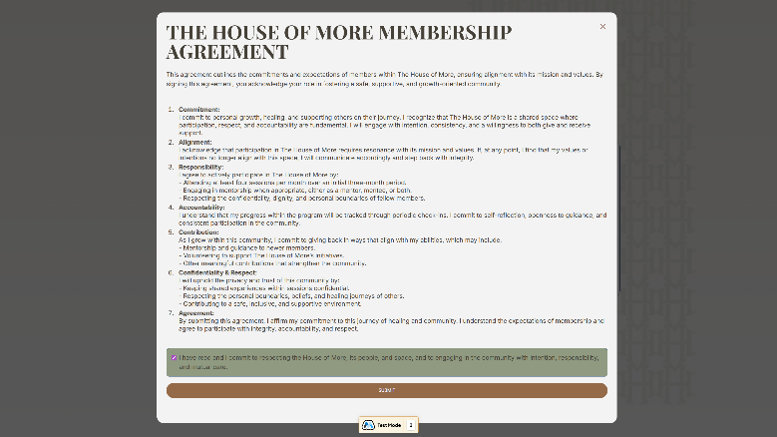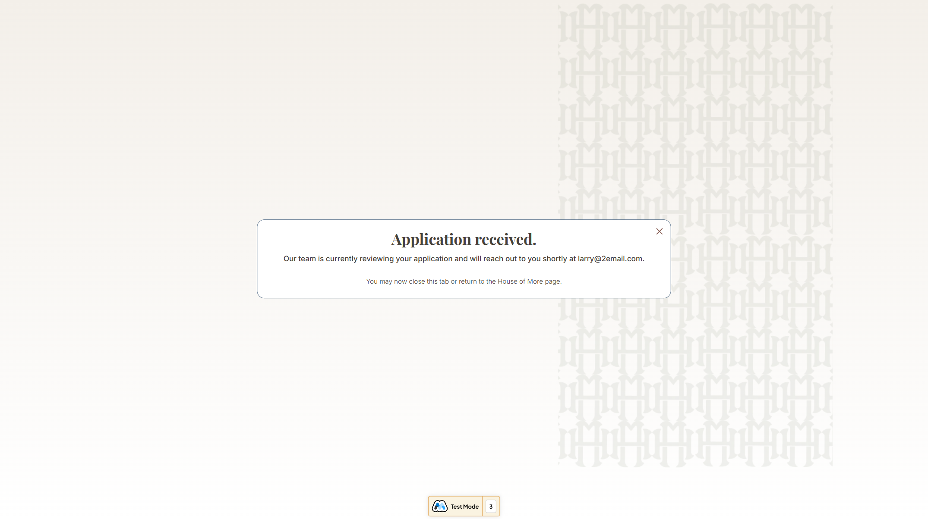

2. Make Scenario A creates member in Memberstack with pending status

3. Admin receives notification and reviews the application

4. Admin opens Applications tab in dashboard, reviews member profile in modal
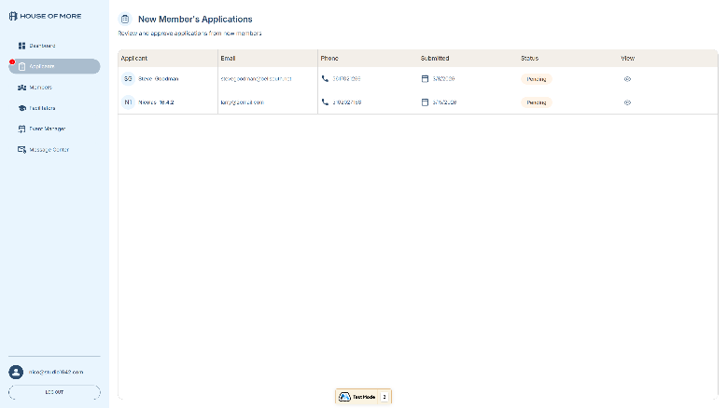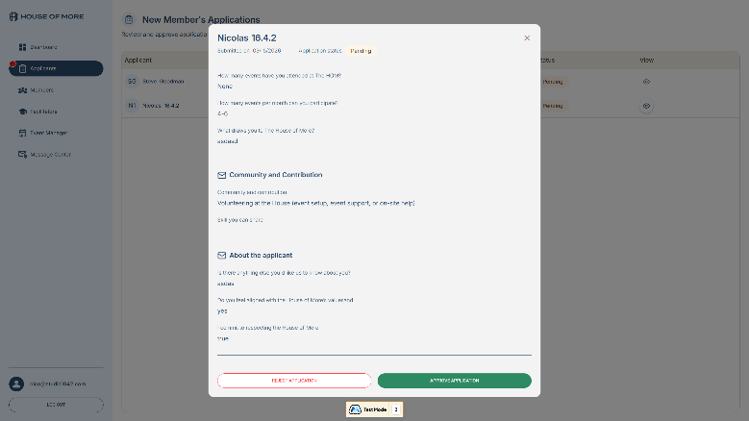

5. Admin clicks Approve → Make Scenario D updates plan to approved-member + sends welcome email

6. Member can now log in and access the full member portal

Event RSVP
1. Member browses events in Find Events or My Events section
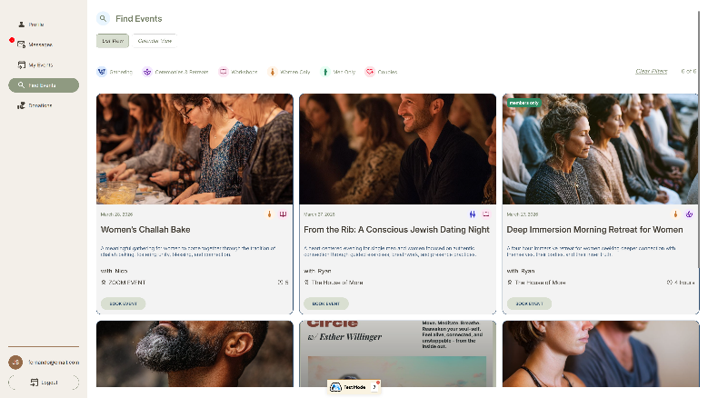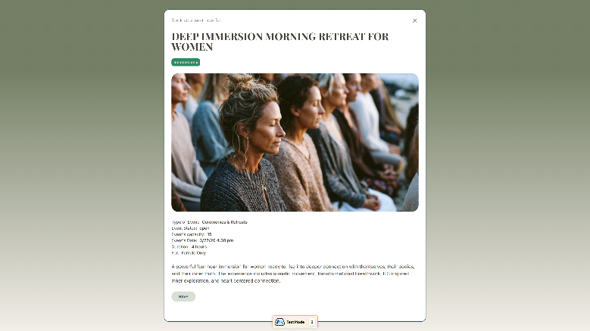

2. Member clicks RSVP → Make Scenario H creates booking record in data store

3. Confirmation email sent automatically via Gmail
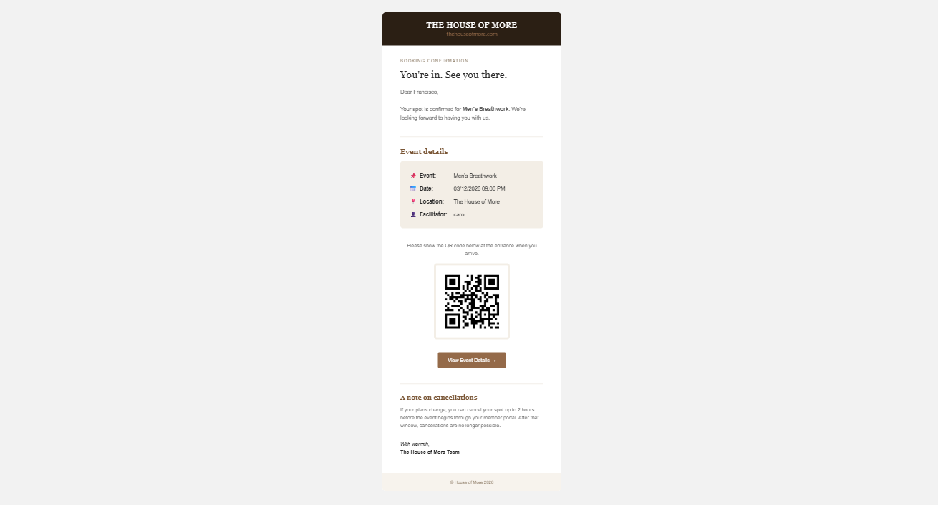

4. 24 hours before event: automated reminder email sent

5. Facilitator checks in attendees on event day via Facilitator portal
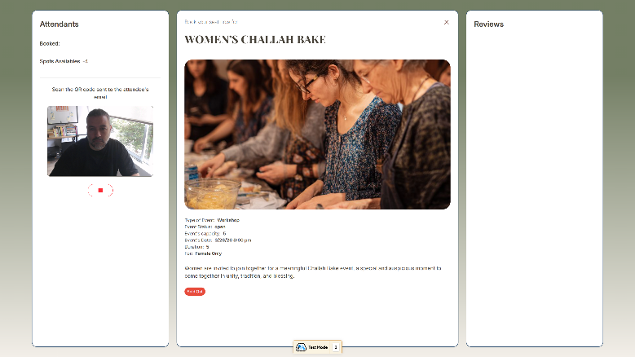

6. After event closes: 7-day review request email sent automatically

Donation Flow
1. Member navigates to Donations section in member portal

2. Member selects amount and clicks Donate
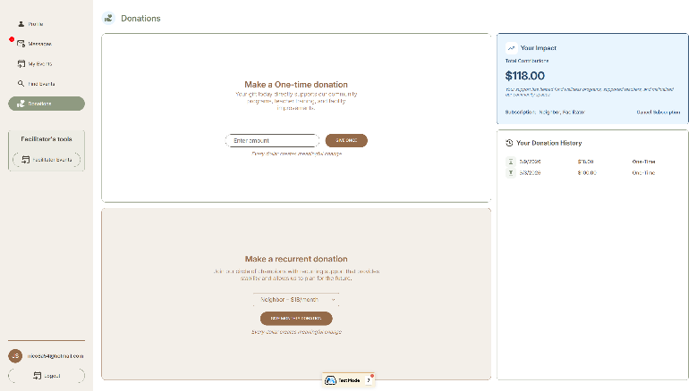

3. Make Scenario creates Stripe checkout session and returns URL
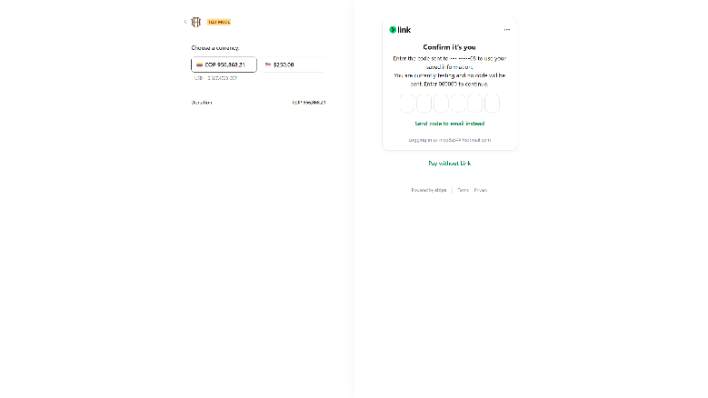

4. Member completes payment on Stripe hosted checkout page

5. Stripe webhook triggers Make confirmation scenario

6. Donation recorded in data store, receipt email sent to member

7. Total impact value updated on admin dashboard

Admin Member Action
1. Admin opens member record in Applications or Members tab

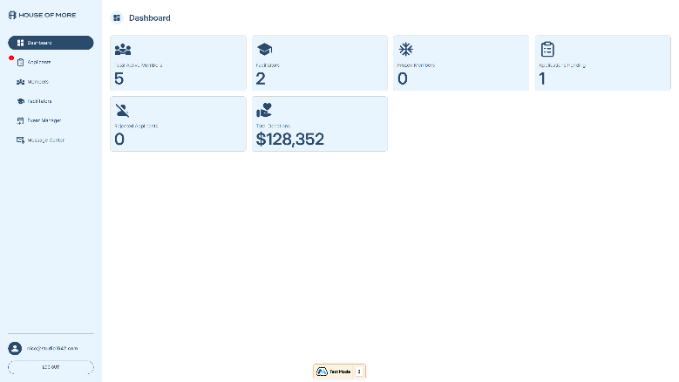

2. Member detail modal loads via Make Scenario C

3. Admin selects action: Approve / Reject / Freeze / Unfreeze

4. Make Scenario D sends plan_id to Memberstack API — status updates instantly

5. Notification email dispatched to member confirming status change

08 — Security & Access Control
The platform applies a defense-in-depth approach — combining server-side secret management, session-based authentication, and plan-level content gating to ensure members only access what they are permitted to.

All Make.com webhook URLs and API keys are stored exclusively as Cloudflare Worker environment secrets. No credentials are ever embedded in frontend JavaScript or Webflow embed code.

Security Layers
Layer | Mechanism | Protects
API Key Storage | Cloudflare Worker secrets | Make.com API key never reaches the browser
Request Routing | Cloudflare Worker proxy | All webhook endpoints hidden from public
Authentication | Memberstack sessions (14 days) | Member identity verified on every request
Concurrent Sessions | Disabled by Memberstack | Prevents account sharing between users
Disposable Emails | Blocked by Memberstack | Reduces fake and spam account registrations
Admin Gating | Memberstack admin plan | Admin dashboard inaccessible without admin plan
Member Gating | Memberstack approved-member plan | Portal inaccessible to pending/rejected/frozen

Access Matrix
Member Status | Public Site | Member Portal | Admin Dashboard
Pending | Yes | No | No
Approved Member | Yes | Yes | No
Facilitator | Yes | Yes + Facilitator Tools | No
Admin | Yes | Yes | Yes
Frozen | Yes | No (frozen page shown) | No
Rejected | Yes | No | No

For questions about platform access, security configurations, or Make.com scenario management, contact Studio1642 — nico@studio1642.com

