**Mars**

**(turismo)**

**Do you want to go to the Olympus?**

Mars is your next destination. Let’s go for a hike in the big red planet.

This planet is rich in iron oxide which gives it that beautiful reddish color. Its radius is approximately one half of the Earth and has also one iced pole! This is the location of the Olympus Mons, the highest known mountain in our solar system. The weather in this first destination is pretty similar to the one on our planet, but be careful, temperatures can be as low as -143°C.

(business)

**Small planet big profit**

Mars offers you a place to build an auto sustainable empire. The resources on its atmosphere such as oxygen, water, inert gasses, metals, ceramics, etc. make it a perfect place to start. You won’t need to go back to earth, this rich planet has everything you need to start your achieving your dreams without problems. The oxygen price today is:

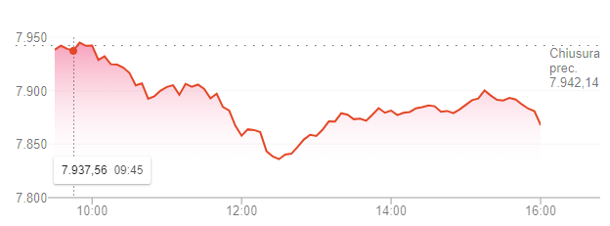

**Saturn**

**(turismo)**

**Why go to the moon if you can travel around many?**

Saturn is famous for its gorgeous rings, this piece of jewelry is composed of billions of chunks of ice, try not to freeze. This planet is actually made of gas, so you won’t be able to stand on it, but we sure are going to see some of its 82 moons.

**Neptune**

(turism)

Neptune reminds us of the greek god of the seas, but it should be called Eolo instead, the god of winds: the wind can reach 2,000 km/h! Neptune is the only planet in our solar system which can’t be seen by naked eye from the Earth: why don’t get closer and be fascinated by its incredible color, quite blue hugh?

(business)

**I don’t think you’ll find this back home**

The high temperature and pressure of this planet create the conditions for a phase of water that can’t be find on Earth: superionic ice. Water molecules break apart and the hydrogen ions float around within the oxygen lattice: superionic water can conduct electricity as well as metals can. Can you think about any good use for it? Let’s start this new project! The superionic price today is:

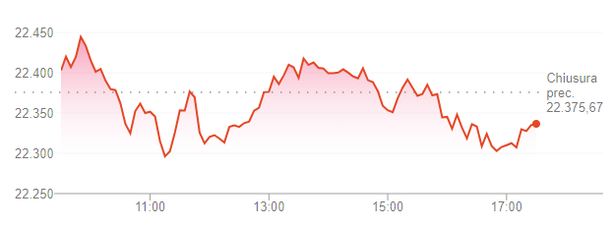

**Pluto**

**(tourism)**

**Would you go to Italy without seeing Rome? Why going to the trans-Neptunian area without seeing Pluto?**

It is the largest known plutoid, and it was consider a planet of our solar system. It’s part of the enormous quantity of dwarf planets in the Kuiper Belt. Pluto’s surface is 98% nitrogen ice, the minimum temperature on the surface is -229°C, and the maximum about -218°C, so not exactly the summer vacation you were expecting. Don’t take your suit off!

**(business)**

**Are you missing some polymers?**

The blue tint of Pluto’s atmosphere is due to the Tholins, that in presence of water can be raw materials for prebiotic chemistry. Soil bacteria are able to use laboratory -produced tholins as a source of carbon. Soon may be needed… The tholin price today is:

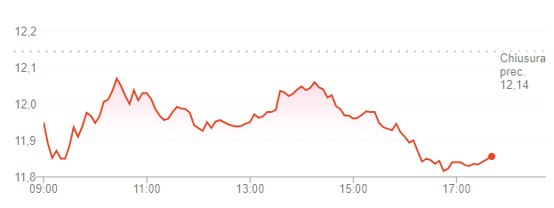

**Encelado**

If you are on a romantic trip, you can’t avoid bringing your beloved one to the brightest moon ever!

**Kuiper belt**

(tourism)

The Kuiper belt is one of the most populated area of our solar system (populated by rocks! 😊) there have been discovered more than 2,000 objects and this are, but this is just a small part of them. There are actually hundreds of thousands of rocks and dwarf planets (bigger rocks) in this region. Just imagine the view!

(business)

The … price today is:

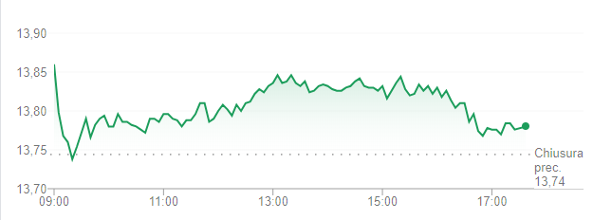

**Haumea**

**How many sun raises and dawns can you count on an Earth day?**

Don’t you think this could be the perfect place for a romantic date. Haumea is a dwarf planet in the Trans-Neptunian area, its charming does not only come from its fast rotation, but also its egg-like shape and the high albedo due to crystalline water on the surface. So go to the bright point on the horizon.

**Ultima Thule**

**No, that’s not a snowman**

Ultima Thule is one of the most interesting objects you can find in this rich area. It is composed by two flat lobes connected with a neck. It might not seem a piece for a museum but actually this is one of the remnants of the ancient past of our solar system. You can try to walk on it, but will you be able to stay? The gravitational force is a bit tricky in here.

**38628 Huya**

**Planet X**

**What is that black thing over there?**

The planet X, also called planet 9 is one of the most exciting discoveries! It was believed to be another planet of our solar system. But is it? It might be a very small black hole, about the size of a bowling ball. So take a look to the stars and tell us what can you see (you won’t see a thing, it’s far, small and black. Although it would be very cool to take a selfie with it).