- Name of Use Case

Name of the Use Case | Remote home health monitoring system
Version No. | v0.1
Submission Date | 13/12/2019
Team Members (with student ids) | - Joud Basso s262607  - Maya Maatouk s262759  - Vladimir Perlutchi s265853  - Nicola Bartolini s266005
- Scope and Objectives of Function

Scope and Objectives of Use Case
Scope | The proposed IoT platform aims at providing services/information for home healthcare system.
Objective(s) | The expected result is to provide the medical staff real-time information about the patient and about the room condition to minimize healthcare costs. Eventually sending health alerts or emergency calls for faster response.
Domain(s) | Smart home, Smart Healthcare
Stakeholder(s) | Patients, Medical staff
Short description | The proposed IoT platform aim at reducing the burden of the national healthcare system, providing better and more personalized care for the individual patient, and for faster intervention in case of critical situations. It provides information on the most important parameter like Heart rate, ECG, blood pressure, oxygenation and (if necessary) glucose levels. Also the room conditions, temperature and humidity, are took into consideration for the comfort of the patient. Finally, according to the data, in case of abnormal values of any of the parameters and abnormal pattern of the motion sensor. a message of alert or emergency call is issued.  Summarizing, the main features it offers are:  - Monitoring of health parameters  - Monitoring of room conditions  - Alerts for emergency situations
- Diagram of Use Case

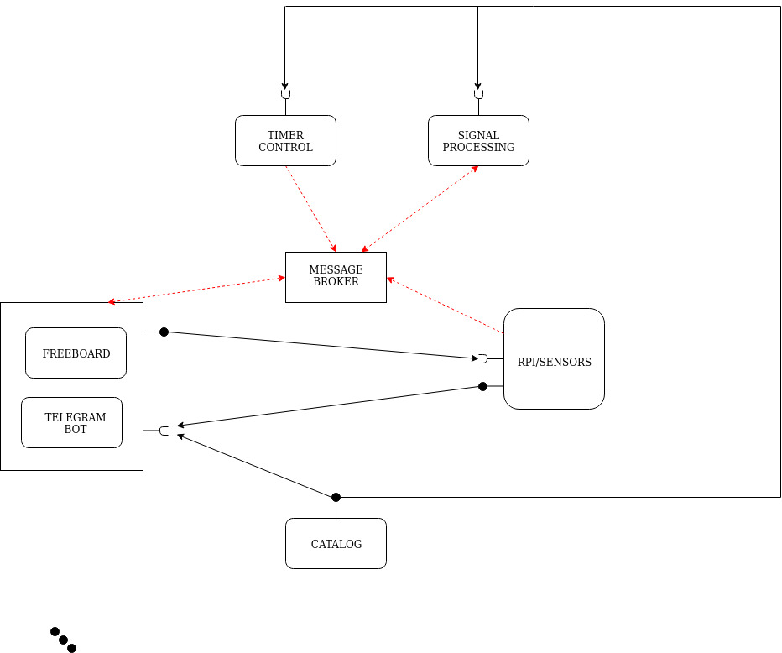
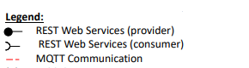
- Complete description of the system

The proposed IoT platform for a remote home healthcare monitoring system follows the micorservices designing pattern. It also exploits two communication paradigms:
- publish/subscribe based on MQTT protocol
- request/response based on REST Web Services.In this context.
The identified actors are the following:
- The Message Broker provides an asynchronous communication based on the publish/subscribe approach. It exploits the MQTT protocol.
- The Catalog works as service and device registry system for all the actors in the system. It provides information about end-points (i.e. REST Web Services and MQTT topics) of all the devices, resources and services in the platform. Each actor, during its start-up, must retrieve such information from the Home Catalog exploiting its REST Web Services.
- Rpi/Sensors represents the enseble of all the sensors integrated in the system. It consist of the environmental sensor integrated in the raspberry (temperature and umidity) and the medical sensor connected to the patient. It provides Rest Web Services to retrieve information. It also works as an MQTT publisher sending all the information on the patient.
- iHealth adaptor is an MQTT subscriber that retrieves the measurements of the iHealth devices and recovers the data from the iHealth cloud through REST Web Services
- The Timer Control is a control strategy that verifies the state of each device (sensor) depending on the last time data has been sent. It controls the current and recent past state of the devices, verifying that every device is working and sending data. If needed it sends an alert informing of the malfunction or the anomaly detected. It works i) as an MQTT subscriber to receive information on the device state.
- The Signal Processig is a service for the elaboration and visualization of the biomedical signals, recieving the raw data and sending the processed data. It is also necessary for the classification of the different types of alerts that the system is required to send. The processing is personalized for every biomedical signal, the main purpose is , if necessary, denoising (for a better representation of data) and the creation of alerts. The alerts should be based on single or multiple thresholds, eventually selected with machine learning algorithms.
- Freeboard is a dashboard to retrieve data from IoT devices and visualize them exploiting the REST Web Services provided by Raspberry Pi.
- Telegram Bot is a service to integrate the proposed infrastructure into Telegram platform, which is cloud-based instant messaging infrastructure. It recievies information, in the form of medical alerts on various danger levels, from IoT devices exploiting the REST Web Services provided by Raspberry Pi. It also gives the possibility to retrieve more general information about the current state of the patient.
- Desired Hardware components (only among those we can provide)

Device Name | Quantity | Needed for…
Blood pressure | 1 | Physiological measurement
Pulse oximeter | 1 | Physiological measurement (Heart rate and oxygenation)
Analog heart rate monitor sensor (ECG) | 1 | Physiological measurement
GLUCOMETER | 1 | Physiological measurement
Motion Sensor | 1 | Movement of the patient
Arduino | 1 | Conversion of ECG analog signal (xboard relay)

