**Project title:**

Biological mechanisms of sensory selectivity in autism spectrum condition: Pupillary responses as index of locus coeruleus norepinephrine (LC-NE) system activity in event-related potential (ERP) to oddball stimuli

**Name and details of lead and senior investigators, and all co-investigators:**

* Lead investigator: Nico Bast, Christina Luckhardt
* Senior Investigators: Emily J.H. Jones, Luke Mason, Tobias Banaschewski, Eva Loth, Declan G.M. Murphy, Jan K. Buitelaar, Gahan Pandina, Christine M. Freitag

Nico Bast (1)*, Christina Luckhardt (1), Luke Mason (2), Christine Ecker (1), Sarah Baumeister (3), Tobias Banaschewski (3), Emily J.H. Jones (2), Declan G.M. Murphy (4), Jan K. Buitelaar (5), Eva Loth (4), Gahan Pandina (6), the EU-AIMS LEAP Group and Christine M. Freitag (1)

(1) Department of Child and Adolescent Psychiatry, Psychosomatics and Psychotherapy, Autism Research and Intervention Center of Excellence, University Hospital Frankfurt, Goethe-University, Deutschordenstraße 50, 60528 Frankfurt am Main, Germany

(2) Centre for Brain and Cognitive Development, Birkbeck College, University of London, Malet Street, London, UK

(3) Department of Child and Adolescent Psychiatry, Central Institute of Mental Health, Medical Faculty Mannheim, University of Heidelberg, Mannheim, Germany

(4) Institute of Psychiatry, Psychology and Neuroscience, King’s College, London, London, UK

(5) Department of Cognitive Neuroscience, Donders Institute for Brain, Cognition and Behaviour, Radboud University Medical Center, Nijmegen, The Netherlands

(6) Janssen Research & Development, 1125 Trenton Harbourton Road, Titusville, NJ 08560, USA

**Abstract, including goals and proposed methods:**

A central function of the brain is sensory processing, i.e. the translation of input to neural representations. Sensory processing serves as a pre-attentive input filter by amplifying the neural representations of salient stimuli and weakening the neural representations of irrelevant stimuli, also known as sensory selectivity [1]. Sensory selectivity raised research interest with the latest version of the Diagnostic and Statistical Manual of Mental Disorders (DSM-5) that introduced altered sensory reactivity as ASD symptom.

Sensory selectivity has primarily been investigated by electroencephalography (EEG). Event-related potentials (ERPs) can be recorded during an oddball task that infrequently presents deviating and thus salient stimuli (“oddballs”) in a series of frequent stimuli. The resulting P3b component is associated with contextual updating [2], whereas the resulting Mismatch Negativity (MMN) is associated with auditory change detection [3]. In ASD, altered sensory selectivity has been indicated in meta-analyses by attenuated P3b amplitude to visual/auditory oddballs and MMN to non-speech auditory oddballs [3, 4]. In addition, some studies reported attenuated neurophysiological habituation to frequent stimuli [5, 6]. Together, these findings suggest decreased sensory selectivity to salient stimuli and increased sensory selectivity to frequent stimuli in ASD.

Sensory selectivity is regulated by neurotransmitters released via brainstem neuro-modulatory systems [7]. A key mechanism is neural gain adaptation, which is a change in the input-output relationship of neuronal firing [8]. The Locus-Coeruleus-Norepinephrine (LC-NE) system induces a decrease of spontaneous and an increase of input-driven neuronal firing via norepinephrine (NE, figure 1) [9]. This unique effect on neural gain adaptation is specific to LC- NE activity as it increases the signal-to-noise ratio in synaptic transmission (‘high gain’) [11, 12]. High gain is expected to cause a positive feedback loop of NE and glutamate release in local circuits that amplifies sensory processing of salient stimuli [4]. Thus, LC-NE activity causes high gain in response to salient stimuli, which provides an underlying mechanism of sensory selectivity on the cortical neuronal level [13].

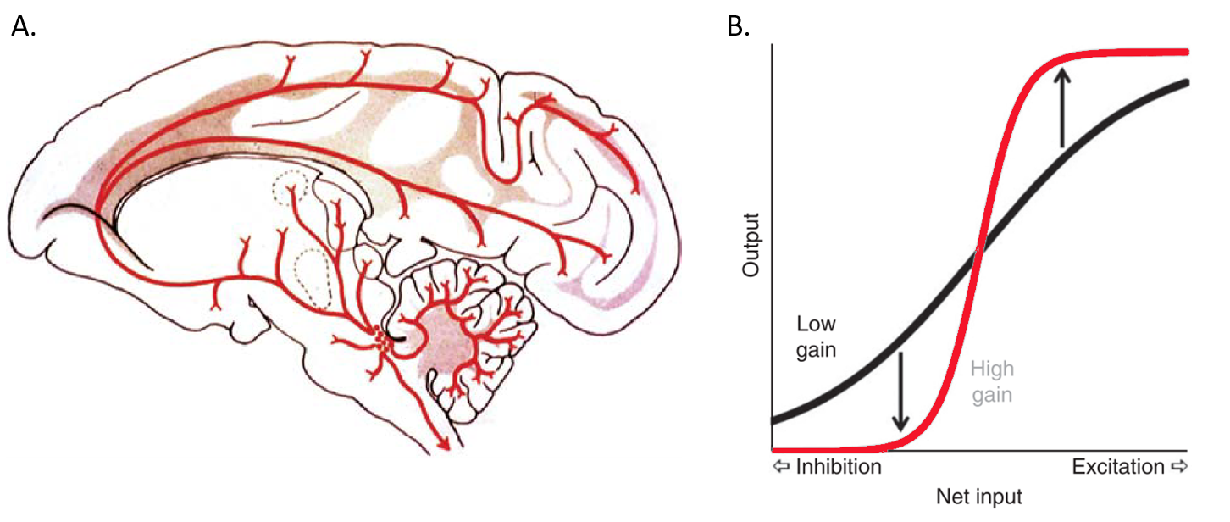

***Figure 1.*** *A. The Locus-Coeruleus (LC, red dot cluster) in the macaque brain and its projections that provide cortical norepinephrine (NE) and constitute the LC-NE system (Aston-Jones & Cohen 2005). B. Change in neural gain adaptation by phasic LC-NE activity (‘high gain’). X-axis = neuronal input, Y-axis: neuronal output (Eldar et al. 2013).*

LC-NE activity is indexed by pupillary responses in video-based eye tracking [10-12]. Previous research of my research group showed altered pupillary responses in ASD were associated with quantitative autism phenotypes like an attenuated preference for biological motion [13], a different memory retrieval [14], and slower reaction times in orienting attention [15]. In addition, an independent research group showed attenuated pupillary responses to oddballs in children with ASD [16]. These pupillometry findings suggest a different adaptation of LC-NE activity in ASD that might further explain atypical sensory selectivity in ASD [17].

The overall aim of the proposed study is thus to assess effects of LC-NE phasic activity on sensory selectivity in a group comparison of ASD and neurotypical controls. In the EU-AIMS LEAP sample, we want to utilize the combined eye-tracking and electroencephalography (EEG) data during the auditory oddball task. We will apply stimulus-evoked pupillary responses (SEPR) to oddballs as index of LC-NE activity. In addition, we utilize principal component analysis to decompose pupillary responses into distinct response factors that might represent differential underlying neurophysiological processes that modulate LC-NE activity [18, 19]. We will further apply P3b and MMN as index of sensory selectivity. In linear mixed model, we will estimate effects of LC-NE activity on sensory selectivity on the per trial level. We hypothesize:

1. Positive associations of LC-NE activity and P3b or MMN to oddball stimuli across groups
2. Attenuated LC-NE activity (SEPR) to oddball stimuli in ASD compared to TD
3. Attenuated sensory selectivity (P3b, MMN) to oddball stimuli in ASD compared to TD
4. LC-NE activity explains group differences in sensory selectivity

In preliminary data on combined pupillometry and EEG (n=10), we showed the feasibility on the association of LC-NE activity (SEPR) and sensory selectivity (P3b) on per-trial level in a Posner-type orienting task (see figure 2).

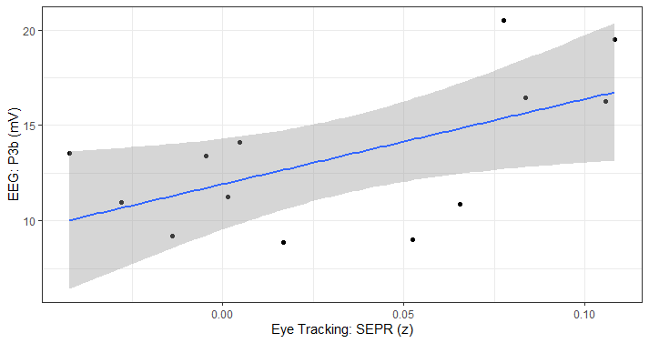

**Figure 2.** Scatterplot of Stimulus-evoked Pupillary Response (SEPR) and P3b amplitude per subject. Blue line indicates linear fit and grey shade indicates error margin.

**Measures / Data requested**

* Eye-tracking data of the mismatch negativity / oddball task
* Electroencephalography data of the mismatch negativity / oddball taks
* Demographic / Phenotype data of the EU-AIMS LEAP sample (Wave 1)

**Type of project**

* Post-doc research project

**Approximate Start / End data**

* Start date: end of 2022
* End date: end of 2023

**Brief data management plan to ensure that downloaded AIMS-LEAP data will be securely stored**

All data downloaded from the Pasteur server will be securely stored within our on-premise science net. In line with the European Data Protection Directive (DSGVO), personally identifiable information (PII) will be strictly separated from the research data and can only be linked by a personal identification code (PIC). PII including PIC codes is stored on a separate network located in the clinical net of the University Hospital that fulfills the highest data protection requirements according to European standards. Research data is stored in a pseudonymized way in the science net of the department, which is physically separate from the clinical net. Research databases are professionally administrated by a database manager and fulfil DSGVO standards. Data can only be accessed by research staff directly associated with the project (primary investigators, doctoral researchers) and is backup-ed automatically.

**Literature**

1. Mather, M., et al., *Norepinephrine ignites local hotspots of neuronal excitation: How arousal amplifies selectivity in perception and memory.* Behavioral and Brain Sciences, 2016. **39**: p. e200-e200.

2. Polich, J., *Updating P300: an integrative theory of P3a and P3b.* Clinical neurophysiology, 2007. **118**(10): p. 2128-2148.

3. Schwartz, S., B. Shinn-Cunningham, and H. Tager-Flusberg, *Meta-analysis and systematic review of the literature characterizing auditory mismatch negativity in individuals with autism.* Neuroscience & Biobehavioral Reviews, 2018. **87**: p. 106-117.

4. Cui, T., et al., *P300 amplitude and latency in autism spectrum disorder: a meta-analysis.* European Child & Adolescent Psychiatry, 2016: p. 1-14.

5. Guiraud, J.A., et al., *Differential habituation to repeated sounds in infants at high risk for autism.* Neuroreport, 2011. **22**(16): p. 845-849.

6. Kolesnik, A., et al., *Increased cortical reactivity to repeated tones at 8 months in infants with later ASD.* Translational psychiatry, 2019. **9**(1): p. 1-11.

7. Jacob, S.N. and H. Nienborg, *Monoaminergic neuromodulation of sensory processing.* Frontiers in neural circuits, 2018. **12**: p. 51.

8. Ferguson, K.A. and J.A. Cardin, *Mechanisms underlying gain modulation in the cortex.* Nature Reviews Neuroscience, 2020. **21**(2): p. 80-92.

9. Thiele, A. and M.A. Bellgrove, *Neuromodulation of attention.* Neuron, 2018. **97**(4): p. 769-785.

10. Megemont, M., J. McBurney-Lin, and H. Yang, *Pupil diameter is not an accurate real-time readout of locus coeruleus activity.* eLife, 2022. **11**: p. e70510.

11. Joshi, S., et al., *Relationships between Pupil Diameter and Neuronal Activity in the Locus Coeruleus, Colliculi, and Cingulate Cortex.* Neuron, 2016. **89**(1): p. 221-234.

12. Murphy, P.R., et al., *Pupil diameter covaries with BOLD activity in human locus coeruleus.* Human brain mapping, 2014. **35**(8): p. 4140-4154.

13. Polzer, L., C.M. Freitag, and N. Bast, *Pupillometric measures of altered stimulus-evoked locus coeruleus-norepinephrine activity explain attenuated social attention in preschoolers with autism spectrum disorder.* Autism Research, 2022. **n/a**(n/a).

14. Bast, N., et al., *Arousal-modulated memory encoding and retrieval in adults with autism spectrum disorder.* Autism Research, 2022. **15**(9): p. 1609-1620.

15. Bast, N., et al., *Atypical Arousal Regulation in children with Autism but not with ADHD as indicated by pupillometric measures of Locus Coeruleus Activity.* Biological Psychiatry: Cognitive Neuroscience and Neuroimaging, 2021.

16. Zhao, S., Y. Liu, and K. Wei, *Pupil-Linked Arousal Response Reveals Aberrant Attention Regulation among Children with Autism Spectrum Disorder.* Journal of Neuroscience, 2022.

17. Bast, N., L. Poustka, and C.M. Freitag, *The locus coeruleus - norepinephrine system as pacemaker of attention - A developmental mechanism of derailed attentional function in autism spectrum disorder.* European Journal of Neuroscience, 2018. **47**(2): p. 115-125.

18. Bast, N., et al., *Pupil Dilation Progression Modulates Aberrant Social Cognition in Autism Spectrum Disorder.* Autism Research, 2019.

19. Wetzel, N., et al., *Infant and adult pupil dilation in response to unexpected sounds.* Developmental psychobiology, 2016. **58**(3): p. 382-392.