Supplements
abbreviations: baseline pupil size (BPS), stimulus-evoked pupillary response (SEPR), mismatch-negativity-associated amplitude (MMN-amp)

Table of Content
Figure S1 – histograms of participant characteristics between groups 2
Figure S2 – canonical pupillary response function 3
Figure S3 – Sample trial of LTI-filtered pupillary response 4
Figure S4 – relative luminance across the task 5
Figure S5 – data quality as missing data with task progression between groups 6
Figure S6 – data quality as gaze center deviation with task progression between groups 7
Figure S7 - histograms of per-participant estimates 8
Figure S8 - histograms of per-trial estimates 9
Figure S9 - Bayesian posterior estimate MCMC chain convergence 10
Figure S10 - BPS association with age, IQ, biological sex 11
Figure S11 - SEPR association with age, IQ, biological sex 12
Figure S12 - MMN-amp association with age, IQ, biological sex 13
Figure S13 – scatterplot of BPS and SEPR between timepoints 14
Figure S14 – data point distributions between stimulus conditions and with task progression 15
Table S1 - descriptive statistics per participant 16
Table S2 - descriptive statistics per trial 17
Table S3 - group comparisons on per-participant estimates 18
Table S4 - covariate effects: BPS group difference 19
Table S5 - correlation table of BPS, SEPR, MMN-amp, NG 20
Table S6 – SEPR regression model with BPS as predictor between groups 21
Table S7 – SEPR regression model with MMN as predictor between groups 22
Table S8 - polynomial fit comparison for BPS, SEPR; MMN-amp 23
Table S9 - BPS linear mixed model - task progression 24
Table S10 – descriptive statistics between sites 25
Supplementary Note 1 - effect of medication on group differences 26

Figure S1 – histograms of participant characteristics between groups

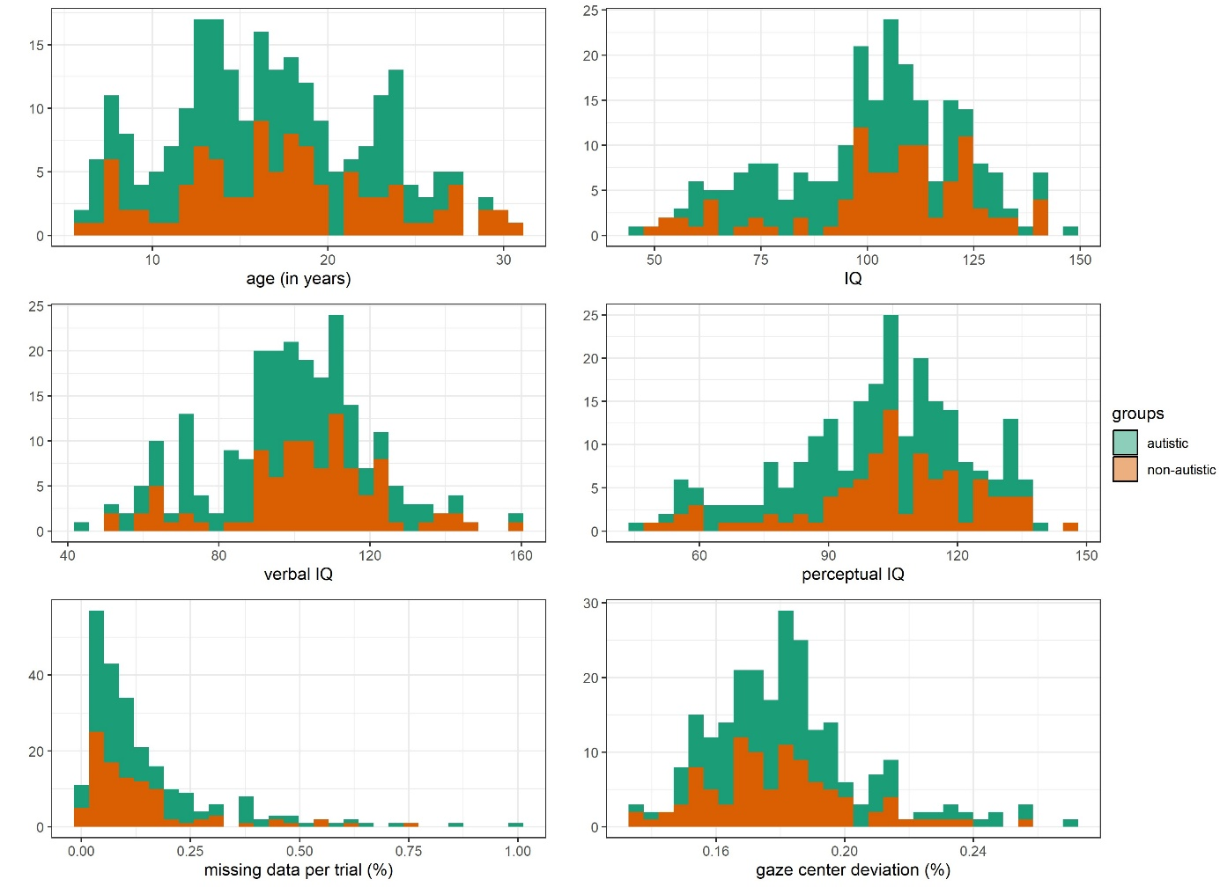

Figure S2 – canonical pupillary response function
Figure S1. The canonical pupillary response function (CPF) was estimated in an independent data set of a passive, auditory oddball task in adolescents. Top: Red - Data of the pupillary response for stimuli. Blue – Optimized fit of a gamma function (shape = 6.65 [6.47, 6.82], rate = 7.68 [7.47, 7.89]) to replicate the pupillary response. This optimized fit is used as a CPF in the epoched data of the current study. The fit is R² = 0.89 [0.84, 0.94] based on regression boots-strapping. Bottom: Residuals of the fit over time of a trial. Residuals appear randomly distributed with increasing variation over time. The R code documentation for the generation of the CPF can be found here: https://github.com/nicobast/oddball_LEAP/blob/master/analysis/data_preprocessing_oddball_leap.Rmd

Figure S3 – Sample trial of LTI-filtered pupillary response
Figure S2. Sample trial of LTI-filtered pupillary response with the CPF (see Figure S1). Top: Randomly selected trial. Blue - Observed pupil size changes. Red - LTI-filtered pupillary response. Bottom: Visualization of simulated pupil size changes. Orange: Expected pupillary response to all trial within an epoch. Green: LTI-filtered pupillary response. The canonical pupillary response function (CPF) represents a gamma function (shape = 6.65 [6.47, 6.82],

Figure S4 – scatterplot of BPS and SEPR between timepoints

Figure S5 – relative luminance across the task
supplement 2. Relative luminance (0-1) of the video stimuli that is applied as a covariate in pupillary models to control for the effects of luminance on pupil size- Vertical line represents the end of the task (presentation of standard/oddball stimuli) while the video continue for some additional time. The graph shows that the tonic upregulation and downregulation of in baseline pupil size as an inverted u-shaped curve is unlikely to the induced by video luminance changes.

Figure S6 – data quality as missing data with task progression between groups
supplement 3. Missing pupil data (0-100%) with task progression as index of data quality between groups. The graph indicates a higher missing pupil data in autistic versus non-autistic individuals. In addition, missing pupil data increases with task progression. However, no systematic differences occur between groups with task progression supporting that dynamic changes of BPS and SEPR with task progression between groups are not driven by systematic changes of missing pupil data with task progression between groups. This variable is also considered in all statistical models.

Figure S7 – data quality as gaze center deviation with task progression between groups
supplement 4. Gaze center deviation (0-100%) with task progression as index of data quality between groups. The graph indicates a slightly higher gaze center deviation in autistic versus non-autistic individuals. However, no systematic differences occur between groups with task progression supporting that dynamic changes of BPS and SEPR with task progression between groups are not driven by systematic changes of gaze center deviation with task progression between groups. This variable is also considered in all statistical models.

Figure S8 - histograms of per-participant estimates

Figure S9 - histograms of per-trial estimates

Figure S10 - Bayesian posterior estimate MCMC chain convergence
Supplement 5. Top: Chain convergence of posterior estimates in autistic and non-autistic individuals. Bottom: Stationarity of posterior estimates in autistic and non-autistic individuals.

Figure S11 - BPS association with age, IQ, biological sex

Figure S12 - SEPR association with age, IQ, biological sex

Figure S13 - MMN-amp association with age, IQ, biological sex

Figure S14 – data point distributions between stimulus conditions and with task progression

Table S1 – descriptive statistics between sites
Sample description between sites
 | KCL London (Tobii X-120) | CIMH Mannheim (Tobii TX-300)
n | 184 | 54
gender (M/F) | 126/58 | 40/14
timepoints (1/2/1+2) | 41/80/63 | 27/4/23
age (in years) | 17.2/6.16 [6.24-30.98] | 14.91/3.33 [6.57-20.94]
IQ | 99.69/22.59 [46-148] | 105.14/15.42 [69-139]
perceptual IQ | 100.01/22.03 [46-147] | 106.5/16.73 [57-137]
verbal IQ | 98.87/22.78 [45-160] | 101.22/12.93 [73-130]
missing data per trial (%) | 15.26/17.12 [0.46-99.98] | 13.14/11.24 [0.41-42.97]
gaze center deviation (%) | 17.91/2.4 [13.39-26.9] | 18.96/2.15 [15.42-25.53]
BPS | 3.44/0.54 [2.2-4.84] | 3.56/0.52 [2.71-5.9]
SEPR - standard | 0/0.01 [-0.05-0.06] | 0/0.01 [-0.01-0.02]
SEPR - pitch | 0.01/0.03 [-0.17-0.23] | 0.01/0.01 [-0.02-0.05]
SEPR - length | 0.01/0.02 [-0.22-0.09] | 0/0.02 [-0.04-0.05]
SEPR - pitch + length | 0/0.02 [-0.11-0.05] | 0.01/0.01 [-0.02-0.06]
MMN - standard | -10.77/3.37 [-21.33--3.06] | -10.52/3.59 [-22.09--5.66]
MMN - pitch | -11.8/3.87 [-28.11--3.06] | -11.31/3.37 [-18.14--5.59]
MMN - length | -12.16/3.98 [-22.48--3.87] | -11.95/2.9 [-19.9--6.56]
MMN - pitch + length | -11.84/3.72 [-25.18--4] | -11.8/3.37 [-18.18--6.05]

Table S2 - descriptive statistics per participant
Per-participant level: Descriptive statistics of baseline pupil size (BPS in mm), stimulus-evoked pupillary response (SEPR in mm), and mismatch negativity (MMN in μV).
variable | n | mean | sd | min | max | skew | kurtosis
BPS | 331 | 3.468 | 0.536 | 2.202 | 5.899 | 0.619 | 0.677
SEPR - standard | 331 | 0.003 | 0.008 | -0.047 | 0.059 | 1.870 | 16.518
SEPR - pitch oddball | 331 | 0.007 | 0.025 | -0.166 | 0.228 | 1.487 | 27.677
SEPR - length oddball | 331 | 0.004 | 0.021 | -0.220 | 0.088 | -3.224 | 37.762
SEPR - pitch+length oddball | 329 | 0.005 | 0.016 | -0.114 | 0.061 | -0.948 | 9.235
MMN - standard | 257 | -10.706 | 3.423 | -22.095 | -3.065 | -0.639 | 0.210
MMN - pitch oddball | 256 | -11.672 | 3.751 | -28.107 | -3.055 | -0.599 | 0.520
MMN - length oddball | 256 | -12.107 | 3.728 | -22.484 | -3.872 | -0.583 | 0.049
MMN - pitch+length oddball | 256 | -11.833 | 3.626 | -25.176 | -4.002 | -0.486 | -0.102

Table S3 - descriptive statistics per trial
Per-trial level: Descriptive statistics of baseline pupil size (BPS in mm), stimulus-evoked pupillary response (SEPR in mm), and mismatch negativity (MMN in μV)
variable | n | mean | sd | min | max | skew | kurtosis
BPS | 427296 | 3.462 | 0.586 | 1.982 | 7.415 | 0.671 | 0.914
SEPR - standard | 347627 | 0.002 | 0.128 | -2.811 | 3.805 | 0.235 | 21.337
SEPR - pitch oddball | 20595 | 0.007 | 0.127 | -1.345 | 2.275 | 0.442 | 11.226
SEPR - length oddball | 24512 | 0.005 | 0.128 | -2.039 | 2.043 | 0.283 | 17.611
SEPR - pitch+length oddball | 25489 | 0.006 | 0.132 | -2.776 | 2.118 | -0.273 | 20.083
MMN - standard | 18227 | -10.691 | 9.403 | -91.488 | 50.221 | -0.805 | 2.975
MMN - pitch oddball | 15295 | -11.521 | 9.502 | -94.139 | 37.635 | -1.014 | 3.253
MMN - length oddball | 15404 | -12.012 | 9.673 | -88.872 | 32.803 | -0.901 | 2.630
MMN - pitch+length oddball | 15436 | -11.678 | 9.537 | -87.129 | 68.538 | -0.828 | 3.210

Table S4 - group comparisons on per-participant estimates
Per-participant level: Group comparisons of baseline pupil size (BPS), stimulus-evoked pupillary response (SEPR), and mismatch negativity (MMN)
 | F | df1 | df2 | b | std. error | p
BPS - across stimuli | 6.645 | 1 | 329 | -0.287 | 0.111 | 0.01
SEPR - standards | 2.456 | 1 | 329 | -0.175 | 0.112 | 0.118
SEPR - pitch oddball | 0.092 | 1 | 329 | -0.034 | 0.112 | 0.761
SEPR - length oddball | 0.073 | 1 | 329 | -0.03 | 0.112 | 0.787
SEPR - pitch+length oddball | 1.818 | 1 | 327 | 0.151 | 0.112 | 0.178
MMN - standards | 0.673 | 1 | 255 | 0.104 | 0.127 | 0.413
MMN - pitch oddball | 2.157 | 1 | 254 | 0.186 | 0.127 | 0.143
MMN - length oddball | 2.645 | 1 | 254 | 0.206 | 0.127 | 0.105
MMN - pitch+length oddball | 1.183 | 1 | 254 | 0.138 | 0.127 | 0.278

Table S5 - covariate effects: BPS group difference
Per participant: Full Linear model of baseline pupil size (BPS) with all potential covariates
 | Sum Sq | df | F | p
intercept | 0.287 | 1 | 0.360 | 0.549
group | 2.156 | 1 | 2.705 | 0.101
age | 46.796 | 1 | 58.711 | 0.000
perceptual IQ | 2.643 | 1 | 3.315 | 0.070
sex | 1.158 | 1 | 1.453 | 0.229
sampling rate | 1.272 | 1 | 1.595 | 0.207
gaze center deviation | 6.620 | 1 | 8.306 | 0.004
data quality | 0.003 | 1 | 0.004 | 0.951
residuals | 257.449 | 323 | NA | NA

Per participant: Reduced Linear model of baseline pupil size (BPS) with significant covariates
 | Sum Sq | df | F | p
intercept | 1.022 | 1 | 1.271 | 0.260
group | 2.456 | 1 | 3.053 | 0.082
age | 43.779 | 1 | 54.437 | 0.000
gaze center deviation | 10.049 | 1 | 12.496 | 0.000
residuals | 262.974 | 327 | NA | NA

Table S6 - correlation table of BPS, SEPR, MMN-amp, NG
correlations of baseline pupil size (BPS), stimulus-evoked pupillary response (SEPR), and mismatch negativity (MMN) for different stimuli.
correlation | coefficient (r) | p | p adjusted
SEPR (standard) and BPS | 0.164 | 0.003 | 0.036
SEPR (pitch oddball) and BPS | 0.043 | 0.436 | 1.000
SEPR (length oddball) and BPS | 0.167 | 0.002 | 0.024
SEPR (pitch+length oddball) and BPS | 0.060 | 0.279 | 1.000
SEPR (standard) and MMN (standard) | -0.200 | 0.001 | 0.012
SEPR (pitch oddball) and MMN (pitch oddball) | -0.143 | 0.022 | 0.264
SEPR (length oddball) and MMN (length oddball) | -0.121 | 0.054 | 0.648
SEPR (pitch+length oddball) and MMN (pitch+length oddball) | -0.027 | 0.669 | 1.000
BPS and MMN (standard) | -0.177 | 0.004 | 0.048
BPS and MMN (pitch oddball) | -0.195 | 0.002 | 0.024
BPS and MMN (length oddball) | -0.214 | 0.001 | 0.012
BPS and MMN (pitch+length oddball) | -0.213 | 0.001 | 0.012

Table S7 – SEPR regression model with BPS as predictor between groups
Per participant: Regression model of stimulus-evoked response (SEPR) to standards with baseline pupil size (BPS) as predictor between groups
 | Sum Sq | df | F | p
intercept | 0.330 | 1 | 0.342 | 0.559
BPS | 12.028 | 1 | 12.468 | 0.000
group | 1.577 | 1 | 1.634 | 0.202
BPS x group | 4.335 | 1 | 4.494 | 0.035
residuals | 315.466 | 327 | NA | NA

Table S8 – SEPR regression model with MMN as predictor between groups
Per participant: Regression model of stimulus-evoked response (SEPR) to standards with mismatch-negativity (MMN) to standards as predictor between groups
 | Sum Sq | df | F | p
intercept | 0.309 | 1 | 0.397 | 0.529
MMN | 6.840 | 1 | 8.784 | 0.003
group | 4.423 | 1 | 5.680 | 0.018
MMN x group | 0.386 | 1 | 0.496 | 0.482
residuals | 196.218 | 252 | NA | NA

Table S9 - polynomial fit comparison for BPS, SEPR; MMN-amp
Model comparison on the linearity of trial number on baseline pupil size (BPS)
 | number of parameters | AIC | BIC | log likelihood | deviance | Chi-squared | df | p-value
linear fit | 4 | 475043.0 | 475086.9 | -237517.5 | 475035.0 | NA | NA | NA
quadratic fit | 5 | 467752.9 | 467807.7 | -233871.4 | 467742.9 | 7292.1632 | 1 | 0
cubic fit | 6 | 467614.5 | 467680.3 | -233801.3 | 467602.5 | 140.3606 | 1 | 0

Model comparison on the linearity of trial number on stimulus-evoked pupillary response (SEPR)
 | number of parameters | AIC | BIC | log likelihood | deviance | Chi-squared | df | p-value
linear fit | 4 | 1186583 | 1186627 | -593287.5 | 1186575 | NA | NA | NA
quadratic fit | 5 | 1186584 | 1186639 | -593287.1 | 1186574 | 0.7436042 | 1 | 0.389
cubic fit | 6 | 1186577 | 1186643 | -593282.7 | 1186565 | 8.7644318 | 1 | 0.003

Model comparison on the linearity of trial number on mismatch negativity (MMN)
 | number of parameters | AIC | BIC | log likelihood | deviance | Chi-squared | df | p-value
linear fit | 4 | 175331.9 | 175368.2 | -87661.94 | 175323.9 | NA | NA | NA
quadratic fit | 5 | 175328.7 | 175374.1 | -87659.36 | 175318.7 | 5.148342 | 1 | 0.023
cubic fit | 6 | 175324.7 | 175379.2 | -87656.37 | 175312.7 | 5.976667 | 1 | 0.014

Table S10 - BPS linear mixed model - task progression
Linear mixed model: baseline pupil size (BPS) - task progression
 | Sum Sq | Mean Sq | df1 | df2 | F | p adjusted
stimulus (S) | 1.778 | 0.593 | 3 | 425391.030 | 3.629 | 0.012
group | 0.693 | 0.693 | 1 | 311.290 | 4.246 | 0.040
task progression (TP) | 360.456 | 120.152 | 3 | 425392.199 | 735.892 | 0.000
video luminance | 100.995 | 100.995 | 1 | 425391.183 | 618.563 | 0.000
age | 10.808 | 10.808 | 1 | 311.054 | 66.192 | 0.000
perceptual IQ | 0.504 | 0.504 | 1 | 311.004 | 3.089 | 0.080
sex | 0.330 | 0.330 | 1 | 311.007 | 2.024 | 0.156
sampling rate | 0.977 | 0.977 | 1 | 311.032 | 5.983 | 0.015
gaze center deviation | 538.530 | 538.530 | 1 | 425427.173 | 3298.322 | 0.000
data quality | 1170.123 | 1170.123 | 1 | 425509.275 | 7166.625 | 0.000
S x group | 1.765 | 0.588 | 3 | 425391.029 | 3.603 | 0.013
S x TP | 25.589 | 2.843 | 9 | 425391.035 | 17.414 | 0.000
group x TP | 23.161 | 7.720 | 3 | 425391.758 | 47.285 | 0.000
S x group x TP | 1.824 | 0.203 | 9 | 425391.025 | 1.242 | 0.264

Covariate effects on baseline pupil size (BPS)
covariate | estimate | lower bound (2.5%) | upper bound (97.5%)
video luminance | -0.02 | -0.03 | -0.01
age | -0.37 | -0.46 | -0.28
sampling rate (300Hz vs. 120Hz) | 0.23 | 0.03 | 0.43
gaze center deviation | 0.04 | 0.02 | 0.06
data quality / missing data | 0.09 | 0.08 | 0.10

Supplementary Note 1 - effect of medication on group differences
A higher proportion of autistic versus non-autistic individuals received medication (ASD: 46.4%, non-ASD: 20.4%, Chi² = 15.88, p < .001). 11 autistic and 3 non-autistic participants received more than one medication. Medication was primarily related to comorbid symptoms in those receiving medication (melatonin: 23%, methylphenidate: 22%, selective serotonin reuptake inhibitor: 15%, antiepileptics: 11%, risperidone: 7%, atomoxetine: 6%, other: 16%). We calculated a variable whether participants received any medication (yes versus no), which was included as a covariate into models that reported group differences.
On a per participant level, the inclusion of medication did not have an effect on baseline pupil size (BPS) and did not alter the group differences (BPS: F(1, 328) = 6.63, p = .010). For the dynamic BPS model, medication also had no significant effect on the cubic fit of BPS (F(1, 317) < 1) and did not alter the dynamic group difference (group x task progression: F(3, 426980 = 42.27, p < .001).
For the dynamic SEPR and MMN model, medication did not have a significant effect on SEPR or MMN (F < 1).

