All the endpoints (GET /api/endpoints):

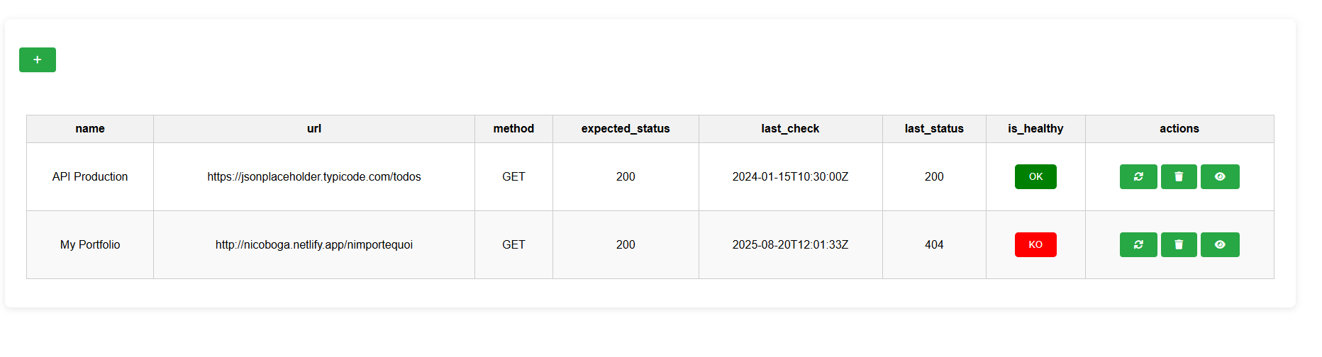

* *

Here the endpoints with all the attributes (is_healthy is a boolean converted into a button, red for KO and green for OK). On each line, three actions are possible: check, removal and history. I tried with a demonstration API and my portfolio.

Create an endpoint (POST /api/endpoints):

I used a form with name, url, method (GET or POST) and status. It appears when clicking on the “+” button.

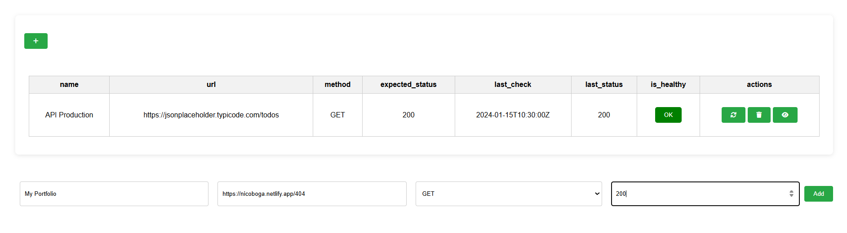

Delete an endpoint (DELETE /api/endpoints/{id})

The action is performed when clicking on trash button. The user is redirected to the list of endpoints after row removal.

Check an endpoint (GET /api/endpoints/{id}/check)

It updates last_check, last_status, is_healthy columns and it is stored for history purpose.

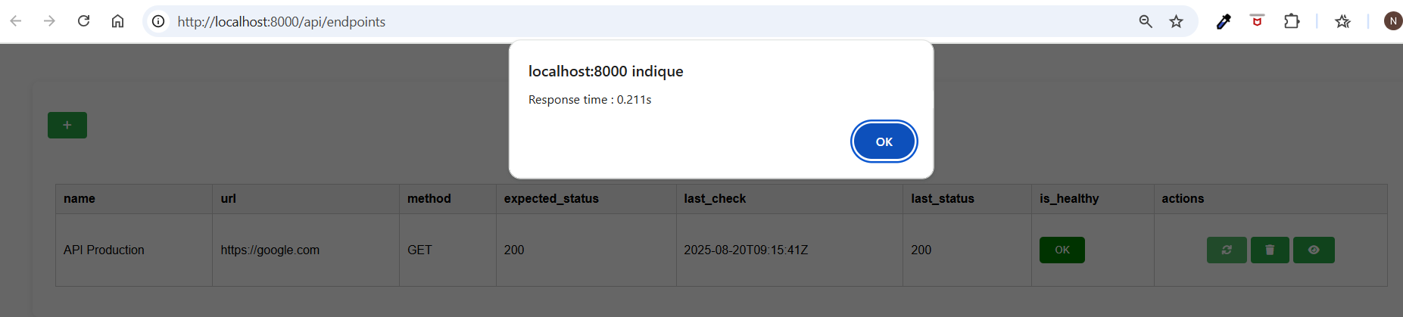

After checking, the response time appears.

Get history of an endpoint (GET /api/endpoints/{id}/history)

When clicking on eye button, the user is redirected on an other page with 10 last statuses.

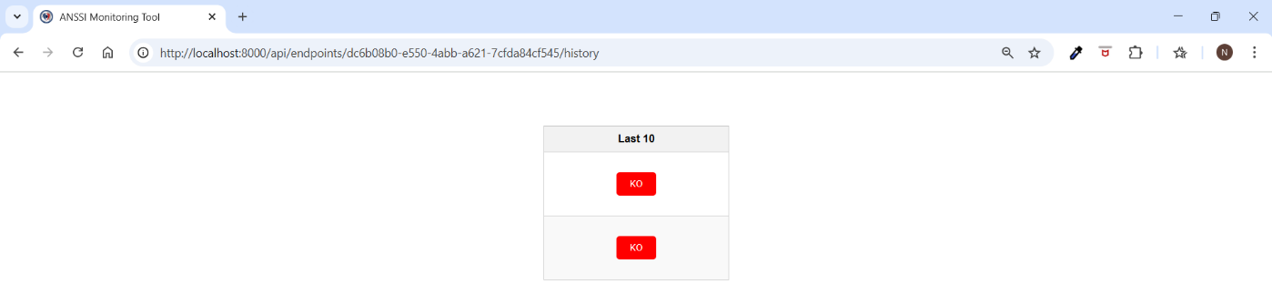

Open API Doc

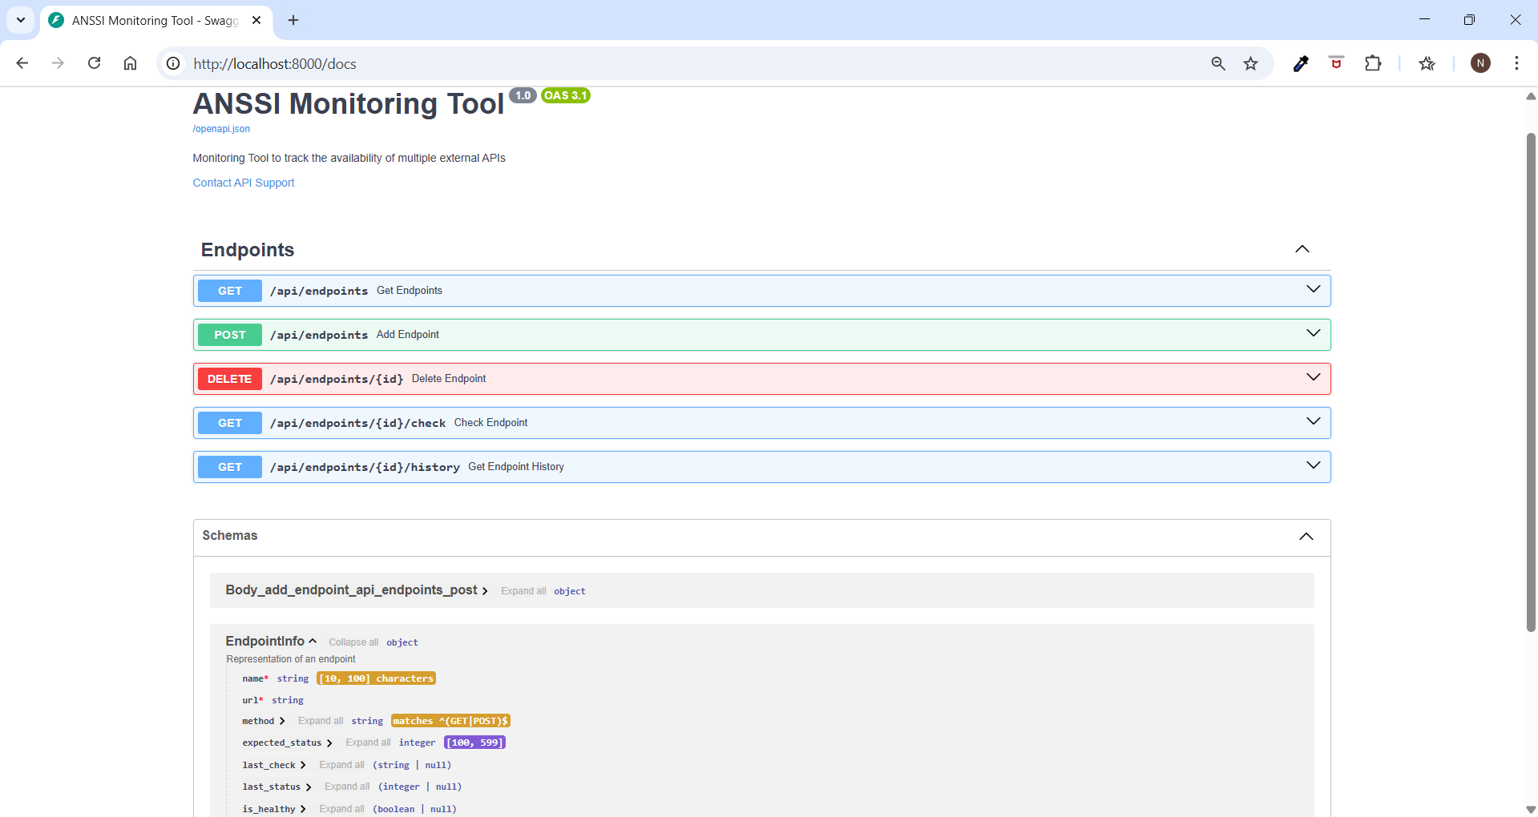Thanks to FastAPI, documentation is interactive (/docs or /redoc). The code was thinked to be a html response on direct links and model or json response while using documentation.

