Pstat 174 HW3

Kalvin Goode

2018/11/9

1. (i).

x<-arima.sim(n=100,model=list(ar=-0.6,ma=1.2))  
plot(x,xlab="t",ylab="X_t",main="ARMA(1,1) with phi=-0.6, theta=1.2")

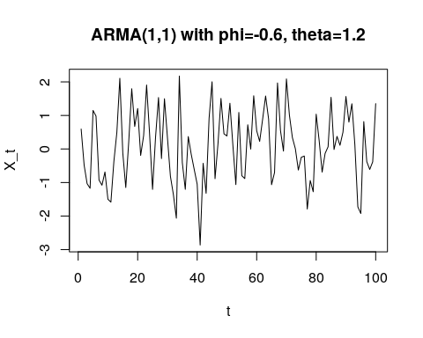

acf=ARMAacf(ar=-0.6,ma=1.2,pacf=FALSE,lag.max=5)  
pacf=ARMAacf(ar=-0.6,ma=1.2,pacf=TRUE,lag.max =5)

(ii).

plot(x=0:5,y=acf,xlab="h",ylab="ACF",type="h")  
abline(h=0)

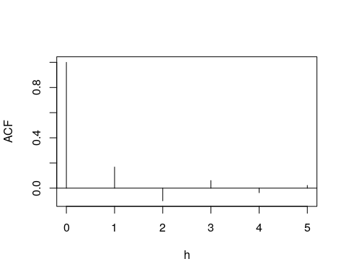

plot(x=1:5,y=pacf,xlab="h",ylab="PACF",type="h")  
abline(h=0)

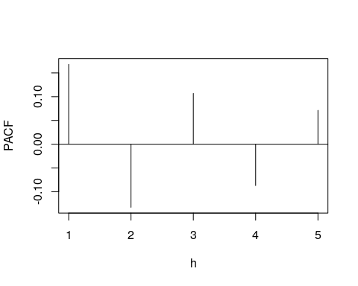

(iii).

acf(x,lag.max=5)

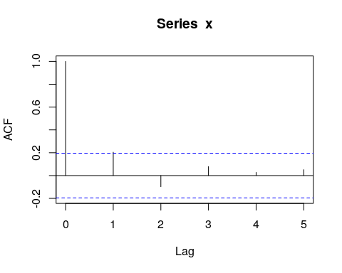

pacf(x,lag.max=5)

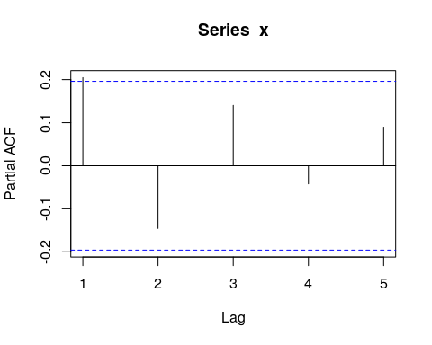

We see that after lag 1, both ACF and PACF are all in the confidence interval. These result remain the same as the theoretical calculation of ACF and PACF.

1. (i).

y<-arima.sim(n=100,model=list(ar=c(-0.2,0.48)))  
plot(y,xlab="t",ylab="X_t",main="AR(2)) with phi_1=-0.2, phi_2=0.48")

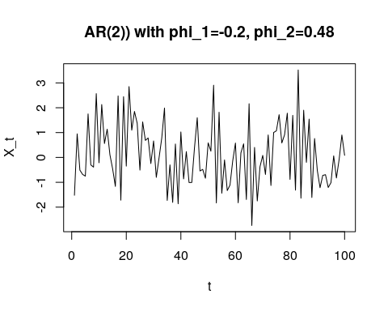

acf=ARMAacf(ar=c(-0.2,0.48),pacf=FALSE,lag.max=5)  
pacf=ARMAacf(ar=c(-0.2,0.48),pacf=TRUE,lag.max=5)

(ii).

plot(x=0:5,y=acf,xlab="h",ylab="ACF",type="h")  
abline(h=0)

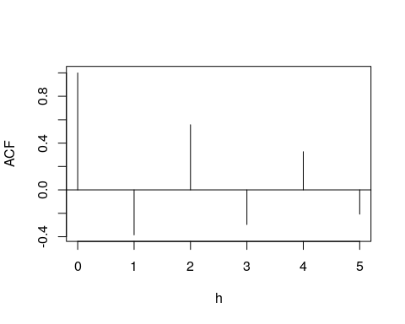

plot(x=1:5,y=pacf,xlab="h",ylab="PACF",type="h")  
abline(h=0)

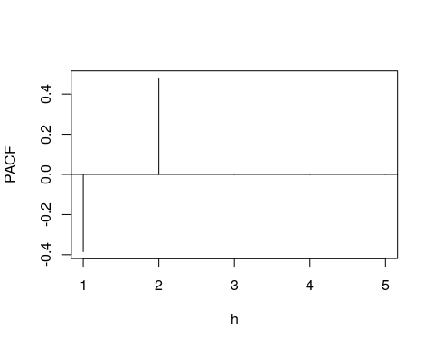

(iii).

acf(y,lag.max=5)

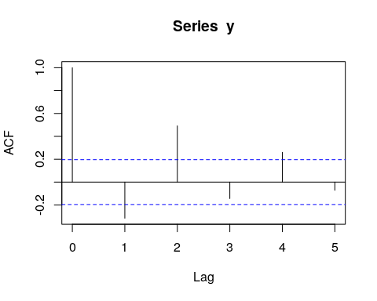

pacf(y,lag.max=5)

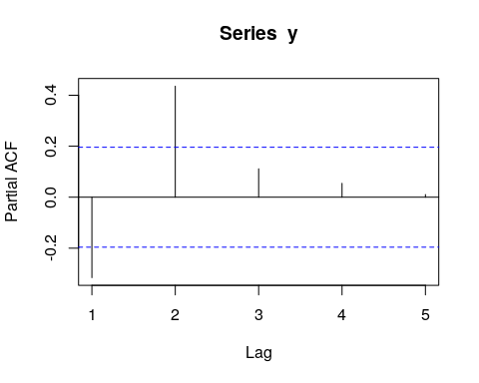

We see that after lag 2, both ACF and PACF are all in the confidence interval. These result remain the same as the theoretical calculation of ACF and PACF.