Pstat 174 HW4

Kalvin Goode

2018/11/21

deaths <-read.table("deaths.txt",header=FALSE)

death<-ts(deaths)  
plot(death,xlab="Time",ylab="Deaths")

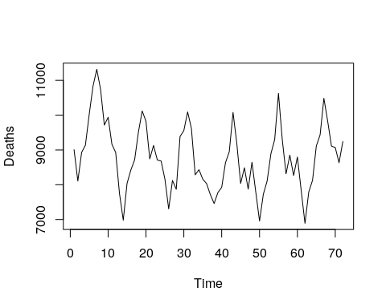

mean(death)

## [1] 8787.736

var(death)

## V1  
## V1 918411.7

We see that this pretty consistent and don’t show significant vairance throughout the time. But we do see that there may be seasonal period in this graph, roughly d=12.

acf(death,lag.max=24,main="Deaths")

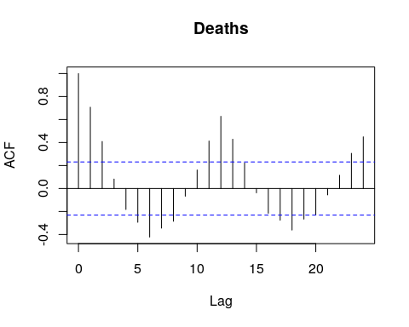

pacf(death,lag.max=24,main="Deaths")

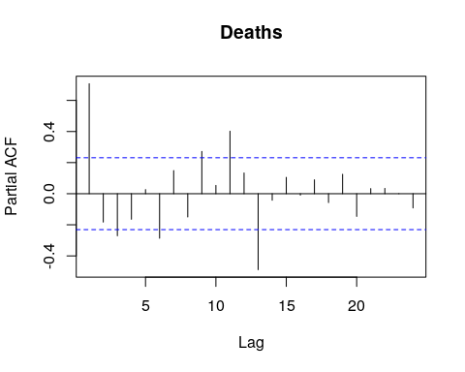

We see that from ACF, the values of lags has period of 12 between -0.4 and 0.4.

deathdif12<-diff(death,lag=12)  
var(deathdif12)

## V1  
## V1 288714.5

mean(deathdif12)

## [1] -171

plot(deathdif12, xlab="Time",ylab="d=12")

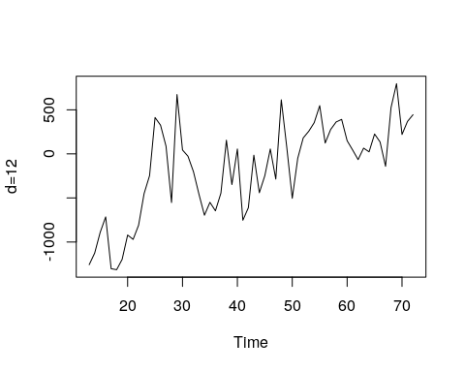

acf(deathdif12,lag.max=20,main="Deseasonalized")

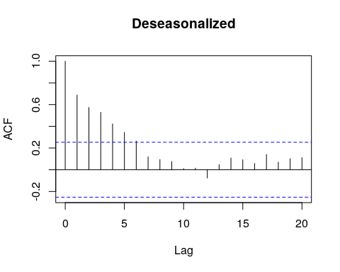

pacf(deathdif12,lag.max=20,main="Deseasonalized")

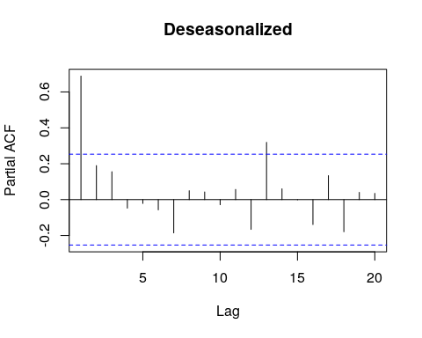

Wee see that this plot is in increasing trend, so we need to make a difference again.

deathdif12diff<-diff(death,lag=1)  
mean(deathdif12diff)

## [1] 3.28169

var(deathdif12diff)

## V1  
## V1 541522.1

plot(deathdif12diff,xlab="time",ylab="Deathsdiff")

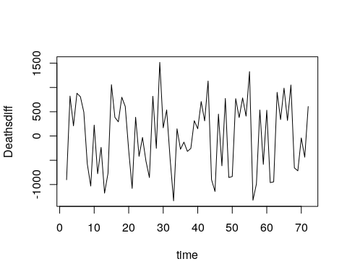

acf(deathdif12diff,lag.max=20)

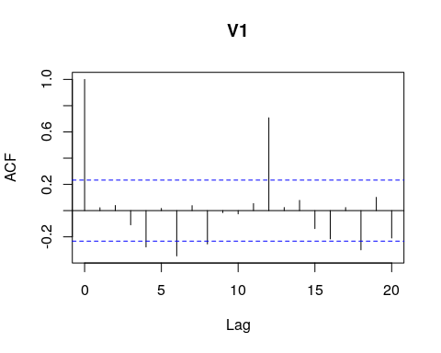

pacf(deathdif12diff,lag.max=20)

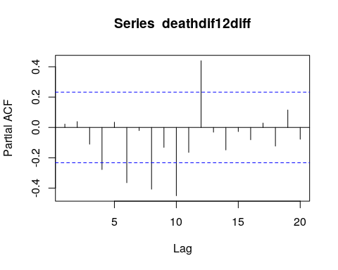

We see that after another difference, the plot has roughly constant vairance.