project-report

Research Question

Dataset Overview
group | Team-seasons | Avg. pre-March win pct | Avg. late win pct | Avg. win pct change | Avg. tanking index | Tanking-proxy seasons | Lower-left candidate seasons
Likely lottery candidates | 65 | 0.313 | 0.306 | -0.007 | 0.074 | 10 | 59
Other teams | 175 | 0.569 | 0.569 | 0.000 | 0.015 | 0 | 0

Exploratory Analysis
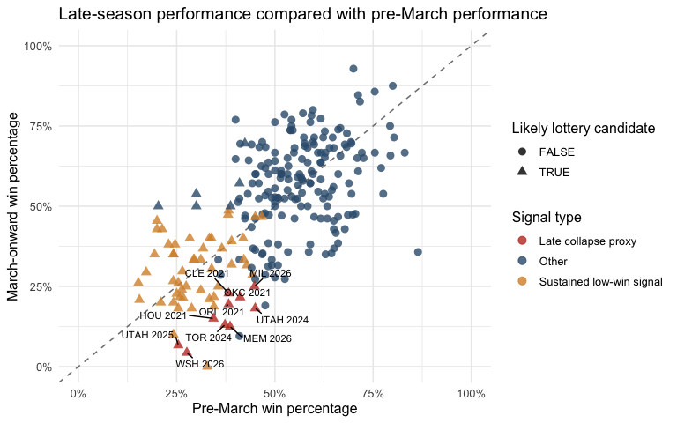
Late-season performance compared with pre-March performance.
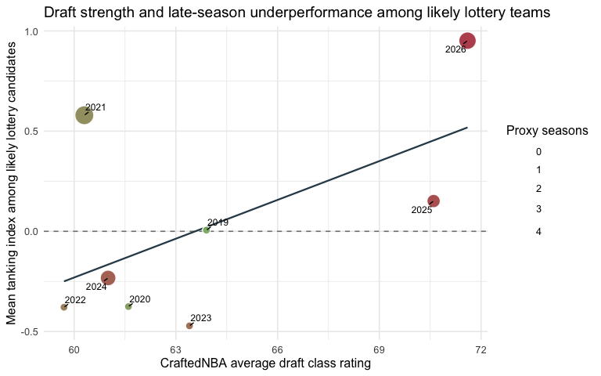
Draft strength and average late-season underperformance among likely lottery teams.

Plan Moving Forward

Anticipated Challenges

