**Group Members**

Nicodemus Opon:107057

Michelle Kiprop:104087

Alpha Musambi

Fayo Halkano :111447

This project demonstrates the use of sockets in establishing communication between two programs one being a server that requests for student details and another a client that sends the student details,the communication is done on port :5203

**Instructions**

First run socketserver.java



This will be the initial output indicating that the server is up and waiting for the client

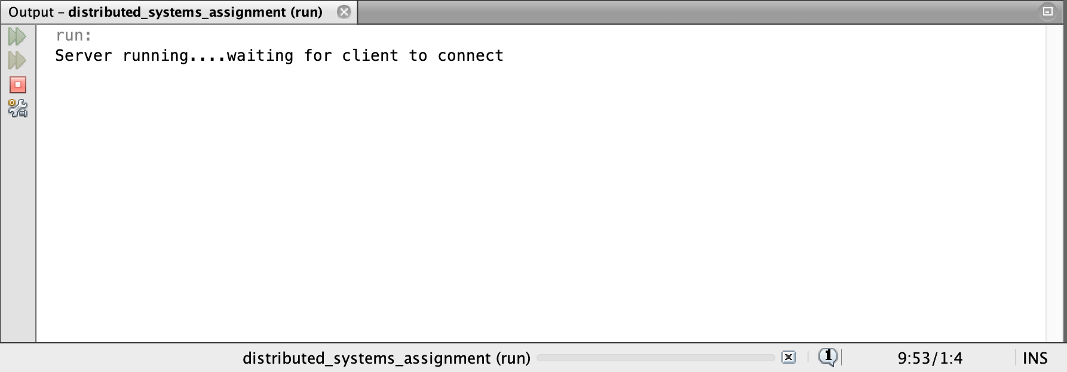

Then run the socketclient.java file



This should be the output...when the server detects a connection it immediately sends a request for the data to the client.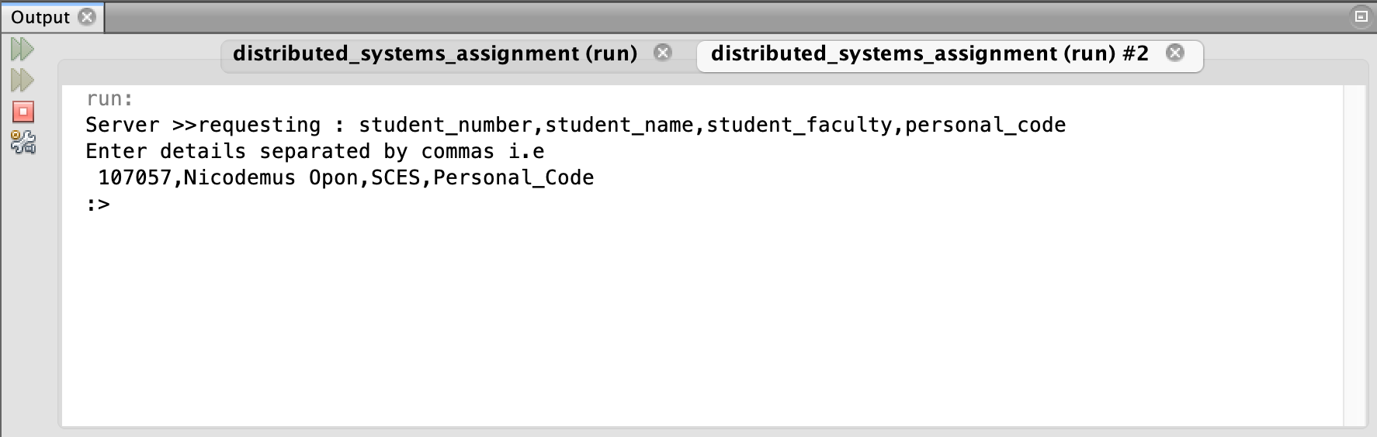

After entering the details separated by commas the client sends it to the server

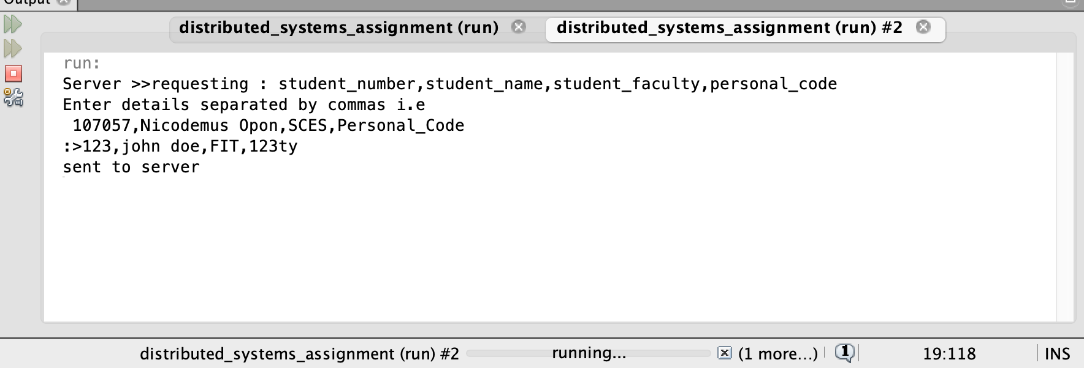

Below is the expected output from the server displaying the details received

