Output:

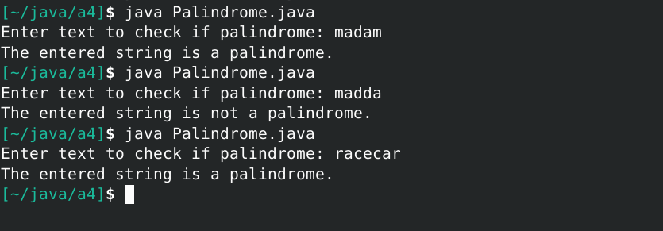

Source Code (Palindrome.java):

// Name: Nicolas Federico

// Class: CS 3305 / W04

// Term: Fall 2022

// Instructor: Sharon Perry

// Assignment: 04-Part-2-Palindromes

import static java.lang.System.out;

import java.util.*;

public class Palindrome {

public static void main(String[] args) {

// Scanner object to read and save user input into variable

Scanner scan = new Scanner(System.in);

// Declare from internal java Stack object

Stack<String> Stack_1 = new Stack<>();

Stack<String> Stack_2 = new Stack<>();

Stack<String> Stack_3 = new Stack<>();

out.print("Enter text to check if palindrome: ");

String text = scan.nextLine(); // scan the user's input

String[] arr = text.split(""); // convert input into array

// for loop iterates through every letter of the user input

// and creates two identical stacks and the tops are the

// end of the input text

for (int i = 0; i < arr.length; i++) {

Stack_1.push(arr[i]);

Stack_2.push(arr[i]);

}

// inverts the contents of Stack_1 onto Stack_3

// makes Stack_3 read the text in the opposite direction as Stack_2

while (!Stack_1.empty()) { // terminates when Stack_1 is empty

// removes end of Stack_1 and pushes onto Stack_3

Stack_3.push(Stack_1.pop());

}

// if stacks are equivalent, the text reads the same forwards and backwards

if (Stack_2.equals(Stack_3)) {

out.println("The entered string is a palindrome.");

} else {

out.println("The entered string is not a palindrome.");

}

scan.close();

}

}