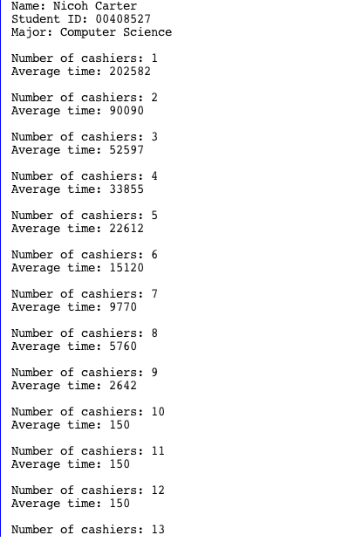

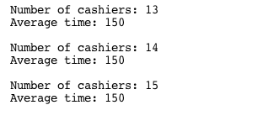



Questions:

1. How many cashiers should we open to have less than 10 minutes wait?

You have to open 10 cashiers for a 10 minute or less wait time.

1. Is it possible to have 6 cashiers or less and still have less than 11 minutes to wait?

No, it is not possible.