Deploy Your First Application
Deploy an application to a managed Kubernetes cluster.

Enable kubectl to work with your cluster
You are going to use the Kubernetes client command kubectl to obtain Kubernetes cluster information. To do that, we need to configure the kubectl first.
- In the ICp dashboard page, click admin on the top right corner and select Configure Client from the dropdown menu.
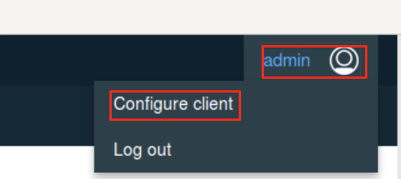
- Click the copy icon to copy all kubectl commands in the box.
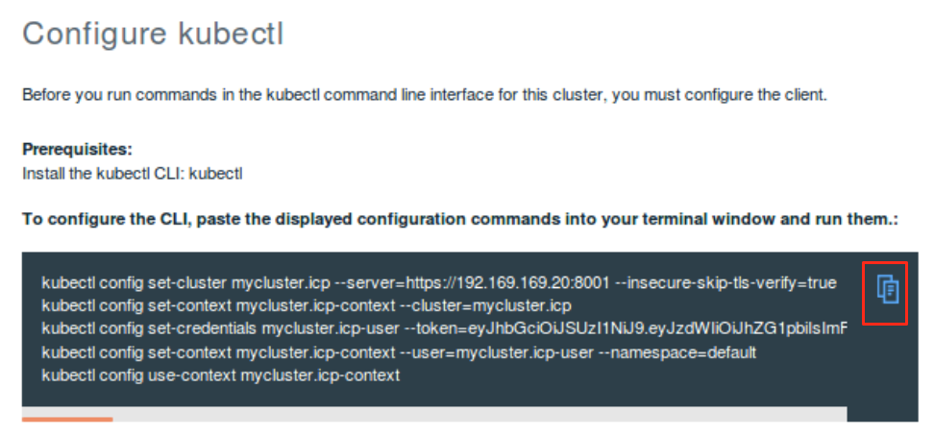
- Open a terminal window by clicking the terminal window icon.
- Paste the kubectl commands to the terminal window, and press Enter.
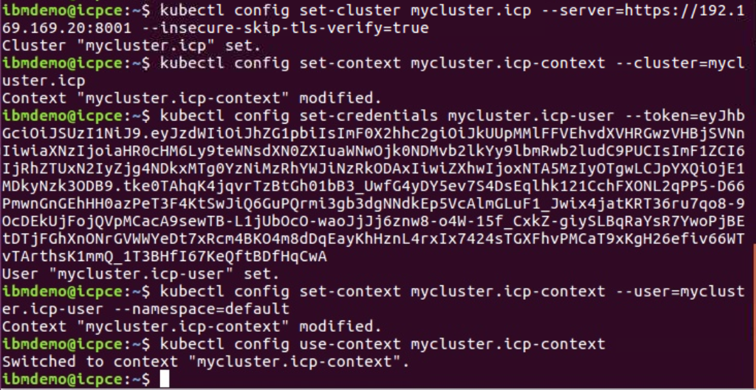
- Now the kubectl is configured, you can issue the following kubectl command to see the current cluster info:
kubectl cluster-info
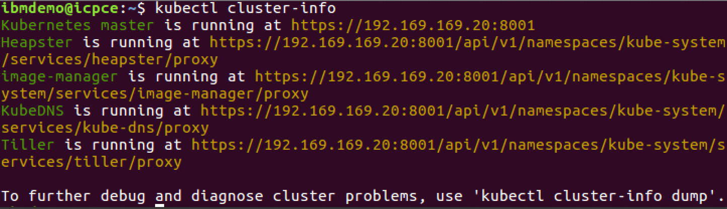
You can see that several components are created automatically for you in ICp: The master, the Heapster, the image-manager, the DNS server, and the Tiller.

Once your client is configured, you are ready to deploy your first application, guestbook.

Deploy your application
Now, you will deploy an application called guestbook that has already been built and uploaded to DockerHub under the name svennam92/guestbook:v1.
- Start by creating a deployment of guestbook:
$ kubectl create deployment guestbook --image=svennam92/guestbook:v1
This action will take a bit of time. To check the status of the pods being spun up, you can use
$ kubectl get pods –watch (Ctrl+C to exit the watch process)
You should see output similar to the following:
$ kubectl get pods
NAME READY STATUS RESTARTS AGE
guestbook-59bd679fdc-bxdg7 0/1 ContainerCreating 0 1m
Eventually, the status should show up as Running.
$ kubectl get pods
NAME READY STATUS RESTARTS AGE
guestbook-59bd679fdc-bxdg7 1/1 Running 0 1m
The end result of the run command is a Pod containing our application container.
Pro Tip: This step also created a Deployment resource. While Pods are ephemeral, Deployments continue to live on. That means even if you delete this pod (kubectl delete pod <pod_name>), Kubernetes will bring up another in its place because the Deployment enforces it!
Once the status reads Running, we need to expose that deployment as a service so we can access it through the IP of the worker nodes.
- The guestbook application listens on port 8080. Expose it as a service, run:

$ kubectl expose deployment guestbook --type="NodePort" --port=8080 service "guestbook" exposed

- To find the port used on that worker node, examine your new service:
$ kubectl get service guestbook
NAME TYPE CLUSTER-IP EXTERNAL-IP PORT(S) AGE
guestbook NodePort 10.10.10.253 <none> 8080:31208/TCP 1m
We can see that our <nodeport> is 31208. We can see in the output the port mapping from 8080 inside the pod exposed to the cluster on port 31208. This port in the 31000 range is automatically chosen, and could be different for you.
- guestbook is now running on your cluster, and exposed to the internet. You can now access the application in the web browser at <proxy-IP>:<nodeport> where <nodeport> in this example is 31208.

Congratulations, you've now deployed an application to Kubernetes!

