Help 3W-PCA

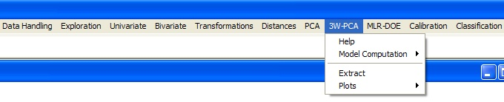

This menu allows to perform a 3-Way PCA by applying the Tucker3 model.
The only possible model size is [2 2 2].

A rotation for maximizing the superdiagonality of the core matrix is automatically performed.

The sign ambiguity is automatically resolved in order to allow direct joint interpretation of the three sets of loadings.

With i objects, j variables and k conditions, the data matrix must have i*k rows and j columns.
The rows must have the following structure:
- object 1, condition 1
- object 2, condition 1
- …
- object i, condition 1
- object 1, condition 2
- …
- object i, condition 2
- …
- object i, condition k

