HELP BIVARIATE

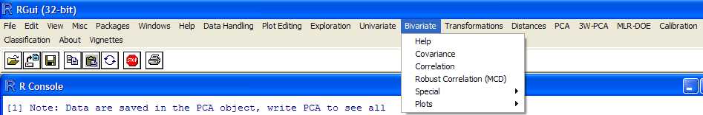

The theoretical parts quoted are taken from:
Kurt Varmuza, Peter Filzmoser, Introduction to Multivariate Statistical Analysis in Chemometrics, CRC Press, 2009 ISBN 978-1-4200-5947-2

Input Variable Name
This input box appears before each function is called and requires the name of the variable that is going to be processed. In the Bivariate Menu only matrix/dataframe are processed and their names must be typed considering that R is case sensitive. A default name taken as the previous choice is always proposed. So, if the matrix A is stored in the R memory and must be processed :

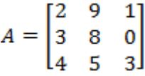

The letter “A” should be typed in the Input Variable Name box. However it is possible to process its submatrices using the R syntax. The following examples show several options:

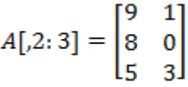
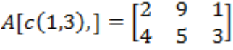
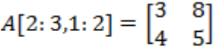
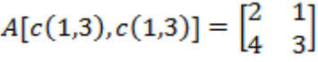

Functions
On the Univariate Menu “different possibilities were mentioned for estimating the central value and the spread, respectively, of the underlying data distribution. Also in the context of covariance and correlation, we assume an underlying distribution, but now the distribution is no longer univariate but multivariate, for instance a multivariate normal distribution. The covariance matrix ∑ mentioned above expresses the covariance structure of the underlying – unknown- distribution. Now we can measure n observations (objects) on all m variables, and we assume that these are random samples from the underlying population. The observation are represented as rows in the data matrix X (n x m) with n objects and m variables. The task is then to estimate the covariance matrix from the observed data X. Naturally, there exist several possibilities for estimating ∑. The choice should depend on the distribution and quality of the data at hand. If the data follow a multivariate normal distribution, the classical covariance measure (which is the basis for the Pearson correlation) is the best choice. If the data distributions are skewed, one could either transform them to more symmetry and apply the classical methods, or alternatively use non parametric measures (Spermann’s or Kendall correlation). If the data include outliers (univariate outliers or multivariate outliers being not visible in a single variable), a robust measure of covariance (correlation) should be preferred.
The classical measure of covariance between two variables x_{j} and x_{k} is the SAMPLE COVARIANCE, c_{Jk}, defined by :
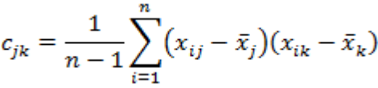
R: c_jk<-cov(xj,xk)
For mean-centered variables and written in vector notation:
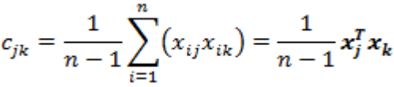
Basically , each variable j can be characterized by its ARITHMETIC MEAN, VARIANCE and STANDARD DEVIATION, . The means to 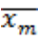 form the MEAN VECTOR ; The components are the coordinates of the centroid (center) of all the objects in the variable space. The sum of the variances of all the variables is called the TOTAL VARIANCE, 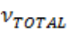 , of the data set; variances of single variables can be given in percent of total variance. Variance is considered as potential information about the objects. Consider that a constant variable for instance cannot contribute to separate objects into classes or to a model for the prediction of a property; on the other hand, a variable with a high variance is not necessarily informative but may be only noise.
Based on the definition of the covariance, c_{Jk}, in the Equation the sample covariance matrix C can be calculated for the mean-centered X by:
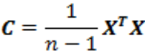
In general C is given by:
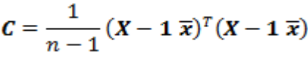
With 1 being a vector of ones of length n, and is calculated in R (mean centering of X not necessary) by:

R: C<-cov(X)
The classical correlation coefficient is the PEARSON CORRELATION COEFFICIENT, (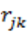,r) which is according to the definition , the sample covariance, standardized by the standard deviation s_{j} and s_{k} of the variables:
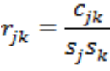
R: r<- cor(xj,xk)

The range of r_{jk} is -1 to +1 ; a value of +1 indicates a perfect linear relationship, a value of -1 indicates a perfect inverse linear relationship; absolute values of approximately <0.3 indicate a poor or no linear relationship. The Pearson correlation coefficient is best suited for normally distributed variables: however , it is very sensitive to outliers. This coefficient is the most used correlation measure; as usual also throughout this book the term “correlation coefficient” will be used for the Pearson correlation coefficient.
The correlation coefficients can be arranged in a matrix like the covariances. The resulting CORRELATION MATRIX (R with 1 ‘s in the main diagonal) is for autoscaled x-data identical to C.

R: R<-cor(X)
A robust, nonparametric (distribution free) measure for the correlation of variables is the SPEARMAN RANK CORRELATION (symbol 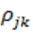, in R r_Spearman). It is not limited to linear relationships, but measures the continuously increasing or decreasing association. The data x_{j} and x_{k} are first separately replaced by their rank numbers (ranks). Next the Pearson correlation coefficient is calculated using the ranks. The matrix R_Spearman with Spearman’ s correlation values for a data matrix X can be calculated in R by.

R: R_Spearman <-cor(X,method=”spearman”)

The range of 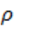,is -1 to +1; the value is invariant to variable transformations that keep the sequence of the values; that means that for instance a logarithmic transformation has no influence. Because the Spearman correlation is based on ranks, it is relatively robust against outlayers.

KENDALL TAU CORRELATION (symbol 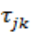, in R r_Kendall) also measures the extent of monotonically increasing or decreasing relationships between the variables. It is also a nonparametric measure of association. It is computationally more intensive than the Spearmann rank correlation because all slopes of pairs of data points have to be computed. Then Kendall ‘s tau correlation is defined as the average of the signs of all pairwise slopes. The range of τ is -1 to +1; the method is relatively robust against outliers; for many applications ρ and τ give similar answers.

R: R_Kendall<-cor(X, method=”kendall”)

A more robust correlation measure 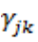, can be derived from a robust covariance estimator such as the MINIMUM COVARIANCE DETERMINANT (MCD) estimator. THE MCD estimator searches for a subset of h observations having the smallest determinant of their classical sample covariance matrix. The robust LOCATION ESTIMATOR – a robust alternative to the mean vector – is then defined as the arithmetic mean of these h observations, and the robust covariance estimator is given by the sample covariance matrix of the h observations, multiplied by a factor. The choice of h determines the robusteness of the estimator; taking about half of the observations for h results in the most robust version (because the other half of the observations could be outliers). Increasing h leads to less robusteness but high efficiency (precision of the estimators). The value 0.75 is a good compromise between robusteness and efficiency.

R: library (robustbase)
C_CMD<-covMcd(X,alpha=0.75)$cov #robust estimation of covariance matrix X

The corresponding robust correlation matrix R_MCD, containing the elements , is obtained from the robustcovariance matrix by dividing by robust standard deviations; in R by:
R: R_MCD<-covMcd(X,Alpha=0.75,cor=TRUE)$cor “

Graphics

Three types of plots are presented for bivariate set. They work only on matrices having one dimension equal to 2 (rows or columns).
PAIRS is the only one that admits square matrices with higher dimensions (limited to 7 for graphical reasons). Pairs plot makes a scatter plots of all the combinations of the matrix columns in order to detect possible correlations among variables. It is used in explorative analysis of the dataset.
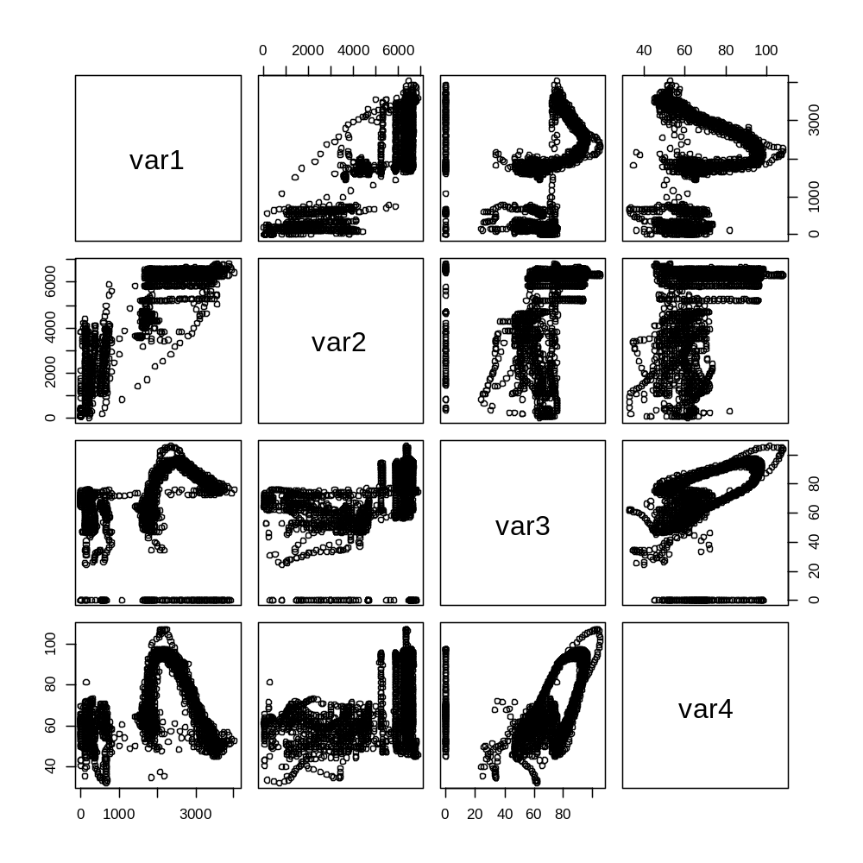

XY is the scatter plot of two rows/columns of the matrix (e.g., A[,c(1,3)]). The first row or the first column is put on the X-axis and the second on the Y-axis. The resulting plot is the same as the corresponding plot obtained in PAIRS.
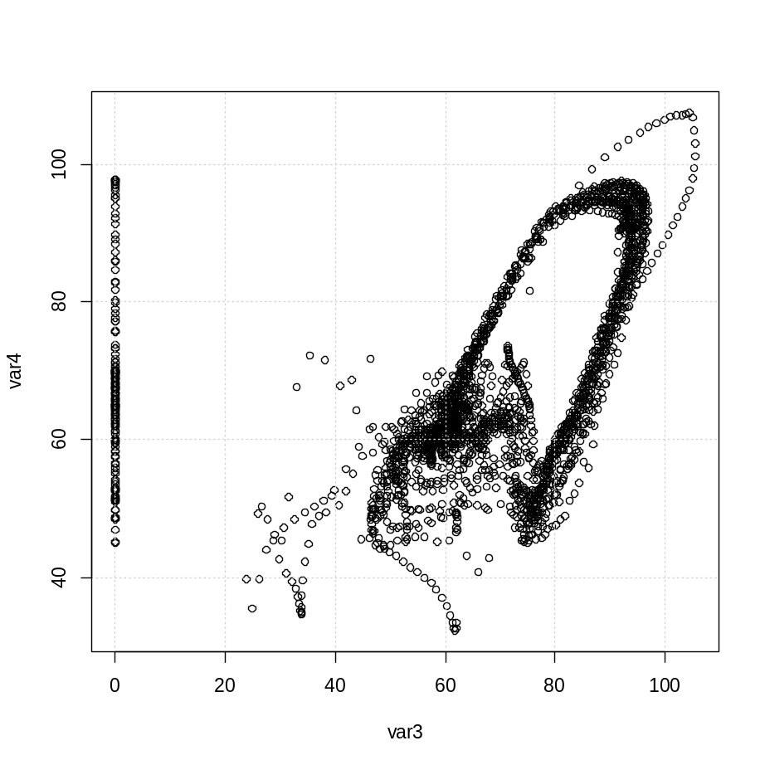

HIST 2D is the bi-dimensional histogram of two variables (e.g., A[,c(1,3)]). A 2D plot is shown with the values of the variables on the base plane and their frequency. Colors are different depending on the frequency in each cell.
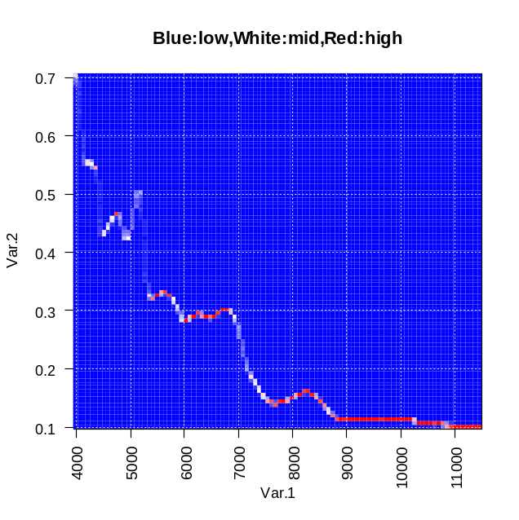

Outputs
The outputs of the required functions are displayed on the console. Moreover, results are also stored in the memory under a new variable name. A printout such as "The value is saved in: var.cor" is written on the console before displaying results. Users can use results calling the new variable

