HELP CALIBRATION
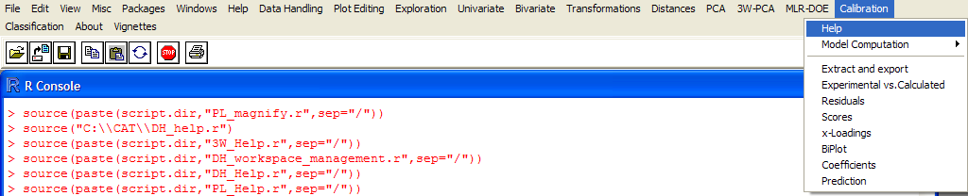

UNDER CONSTRUCTION !

