Help CLASSIFICATION

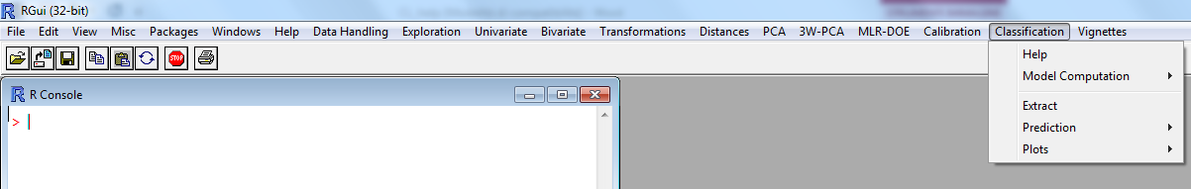

In the menu “Classification” the following options are present:
- Model Computation
- Extract
- Prediction
- Plots

Model Computation
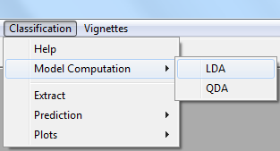

The “Model Computation” option allows the user to choose between two modeling tools, namely LDA and QDA (Linear Discriminant Analysis and Quadratic Discriminant Analysis, respectively).
Upon choosing either of the two options, the following dialogue box appears.

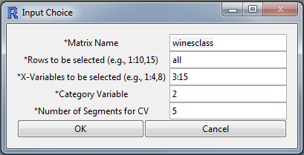

The user is thus prompted to input the dataset to be studied, and the number of segments to be used for cross validation (CV). In this example, the winesclass.xls file in the “Working” directory has been chosen to illustrate the use of the classification tools. The reader is referred to the Data Handling menu Help for the details regarding how to input the dataset in the environment of the menus and let the software read the data.
In the present example, the dataset in the working sheet “TRAIN” of the wineclass.xls file was input providing that the first row is considered as the header of the matrix, and no row names were introduced. Therefore, the dataset used for the classification model computation is made of 90 rows and 15 columns. The X-variables selected for model computation are those in the columns from 3 to 15, whereas the Category Variable is in column 2. The data in the file are used as they are, i.e. no data pretreatment is adopted (LDA and QDA are insensitive to scaling).
By clicking the “OK” button, the software computes the LDA or the QDA model and the following numerical output is printed (the figure shows the output for LDA).

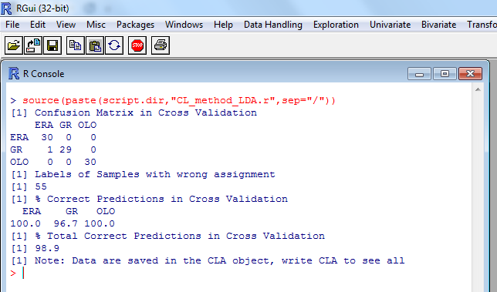

The “Model Computation” function creates an R object called “CLA” in which all the results of the computation are stored. The list of the results computed is the same for the LDA and the QDA model. These results can be printed on the screen by typing “CLA” and pressing the “Enter” button of the keyboard. The list of the groups of data contained in the CLA object is the following:
$dataset, the dataset on which the computation was carried out;
$means, the mean values computed for each column of the dataset;
$cov, the covariance matrix of the data;
$group, the classification groups of the observations;
$lev, the levels of the classification groups of the observations;
$lb.obj, the labels given to every observation in the dataset;
$MdCV, the Mahalanobis distances computed in cross validation;
$mt, the model classification results table.
The object CLA$Md.pre will be present if the prediction has been performed.

Extract
Once the model has been computed, by clicking the option “Extract” of the Classification menu the user can extract into the workspace from the CLA object specific results, as shown in the following picture.

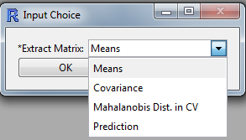
When the user selects one item of the “Extract” dialogue box, the software creates a matrix in which the data selected are stored. Therefore, by calling the “Extract” function and selecting “Means”, the “Mea matrix” is created which lists the means of the values computed.
The menu option “Covariance” will produce the creation of the “Cov matrix” in which the covariance matrix data are saved.
The option “Mahalanobis Dist. In CV” generates the “MCV matrix”, in which the Mahalanobis distances in cross validation are saved.
The option “Prediction” calls the output of the “Pre matrix” in which the Mahalanobis distances of the predicted samples are saved.

Prediction
By clicking the “Prediction” function, the user is prompted to choose the modeling tool (LDA or QDA; of course, the same method that has been used for creating the model must be selected).

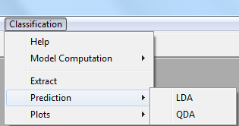

The selection of the model computed leads to the following dialogue box which prompts the user to indicate the dataset to be used for prediction. In the present example, only the LDA model is used, and the dataset used is the “TEST” dataset of the wineclass.xls file in the Working directory consisting of 88 observations and 15 variables, here named winesclass_test.

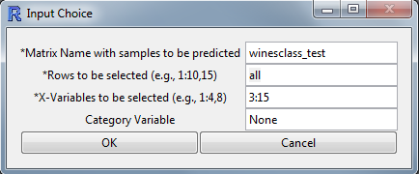

After input of the all required fields, if the “Category Variable” is left undefined as “None”, the following output is obtained, i.e. the computation of the class (“Category”) predicted by the model for each observation.
The output in the R Console is here summarized only for some selected rows out of the 88 printed.

> source(paste(script.dir,"CL_prediction_LDA.r",sep="/"))
[1] Category Prediction

1 OLO
2 OLO
3 OLO
…
29 OLO
30 GR
31 GR
32 GR
…
36 GR
37 ERA
38 GR
…
60 GR
61 GR
62 OLO
63 GR
64 GR
…
70 GR
71 ERA
72 ERA
73 ERA
…
88 ERA
>

The “Prediction” dialogue box allows the user also to specify in the “Category Variable” field which variable should be used for assessing the model quality in prediction, as shown here below (in the present example the Category Variable is in column 2).

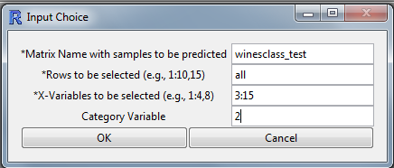

After input of the all required fields, and clicking the “OK” button, the output printed on the R Console includes the Confusion Matrix in Prediction, the samples with wrong assignments, and the % of Correct Predictions scored.

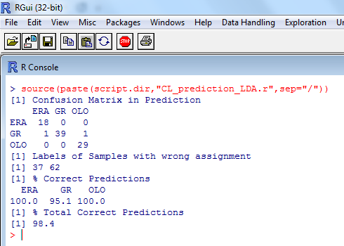

Plots
The “Plots” submenu leads to two options as shown in the figure below.

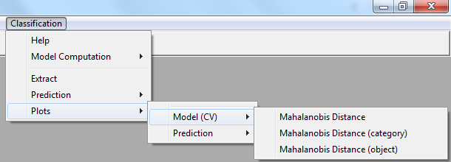

The option “Model (CV)”, provides bar graphs showing the Mahalanobis distances computed in cross validation respectively for the objects of the training set.
The next menu allows to choose what to plot:
- the distance of each object set from the closest category (i.e., to the category to which the object has been assigned);
- the distance of each object from a given specific category;
- the distance of one specific object from each category.

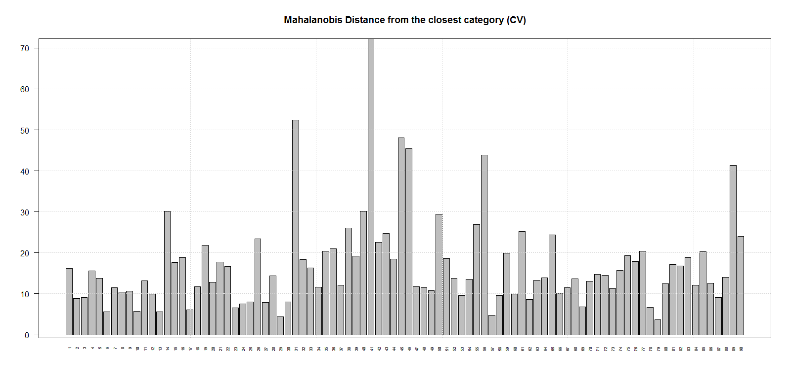
Mahalanobis Distances of the objects from the closest Category
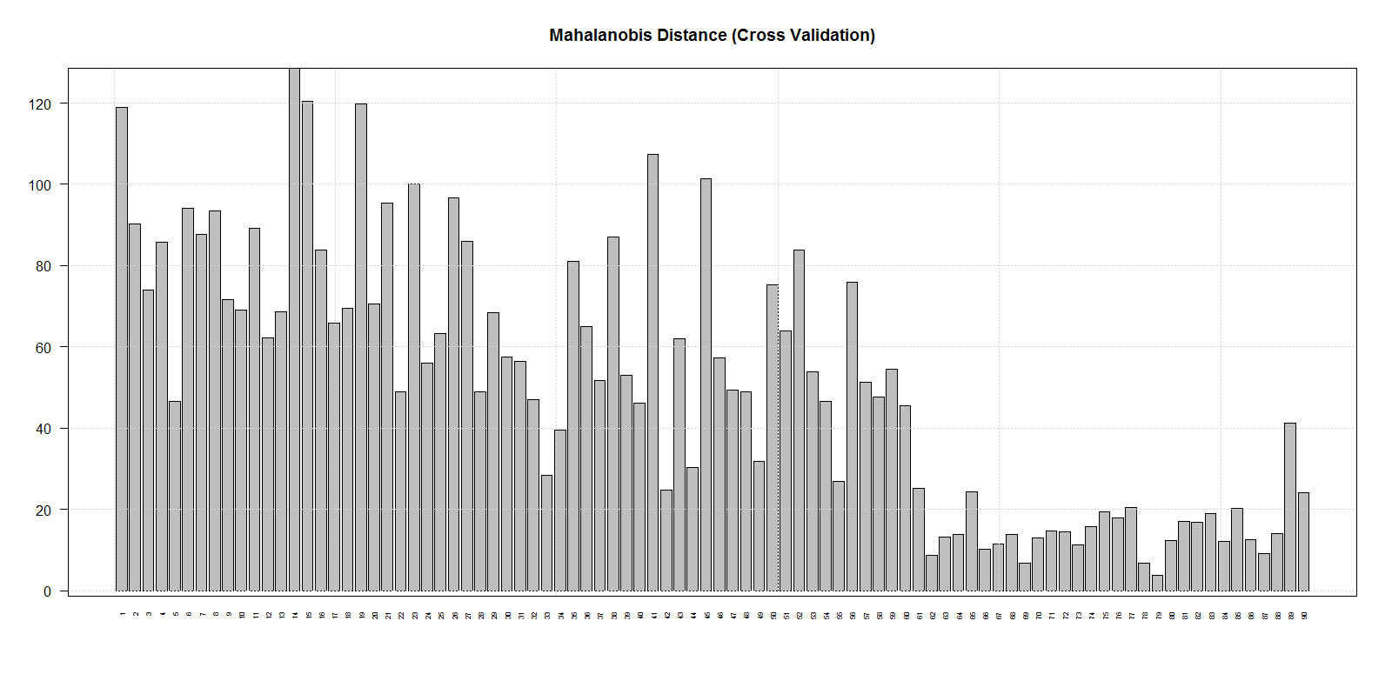
Mahalanobis Distances of the objects from the Category “ERA”
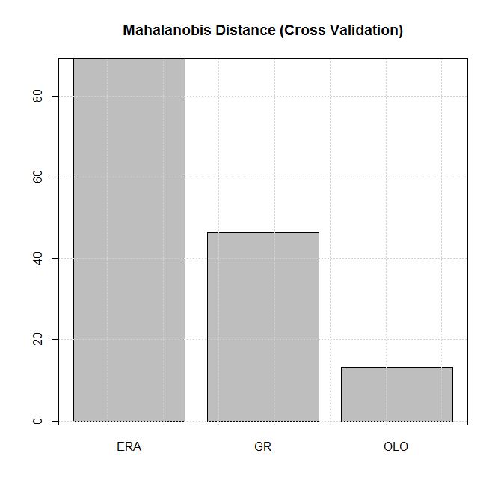Mahalanobis Distance of object 11 from the three categories

The same plots can be obtained for the prediction results, calling the function Plots/Prediction and choosing the graph of interest.

