Help DATA HANDLING

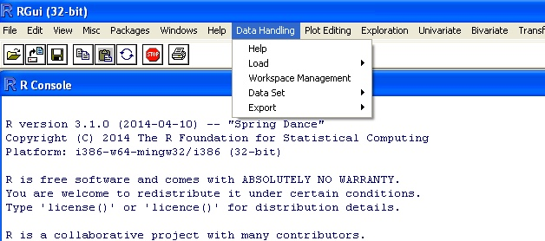

In the menu “Data Handling” the following options are present:

- Help;
- Load;
- Workspace Management;
- Data Set;
- Export.

Help
The “Help” option automatically opens the help for “Data Handling” menu; it allows the user to consult this help.

Load
The “Load” option allows the user to load a file into the workspace. The following sub-options are present:

- CSV;
- TXT;
- XLS/XLSX;
- Copy and Paste.

The choice is left to the user but a very convenient option for loading a data set is by copy/paste (see further).

Note: in all the dialogue boxes the fields marked by “*” must be filled, while the fields without the “*” can be left blank.

Cautions:

- For undetected reason it is not possible to load files having more than 700 columns. If such file has to be loaded, the following two options can be used:
  - Transpose the original data file, load it and then transpose it again (see “Workspace Management”)
  - Split the original data files into blocks of acceptable size, load them and then merge them (see “Workspace Management”)
- If a column contains both numeric and alphanumeric values, this column will be considered as alphanumeric and therefore no numeric computations will be possible on it (not even if only numerical values are selected); this characteristic will be kept also in case of modifications removing the alphanumeric data.

Load - CSV
This option is used to import data from a CSV file. A first directory box allows to select the data file.

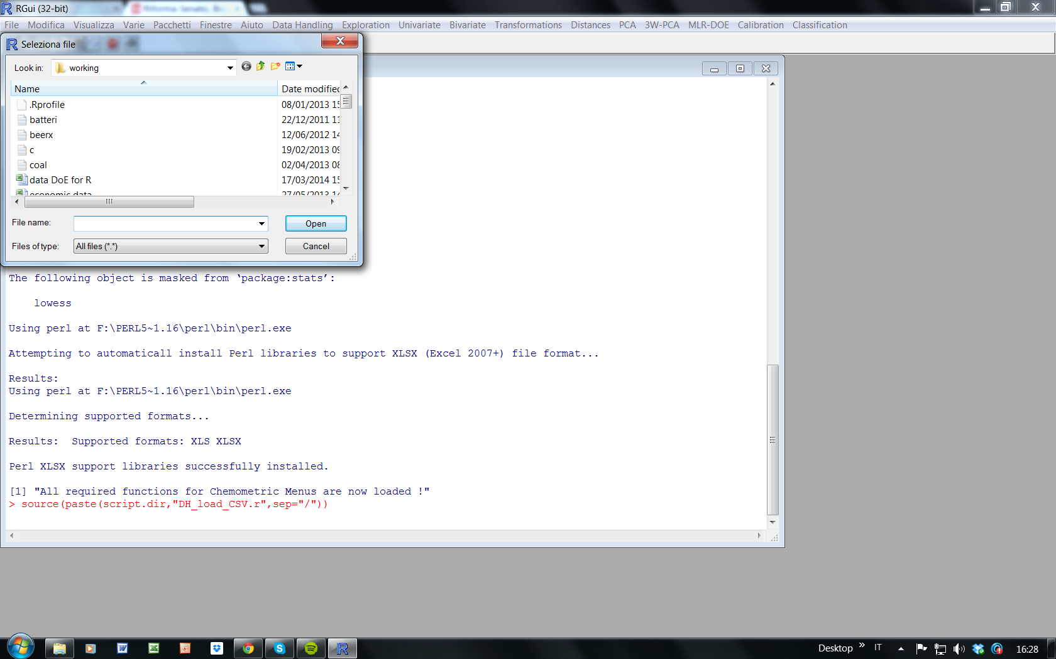

A second box allows to type the name of the variable and asks for the format of the data file.

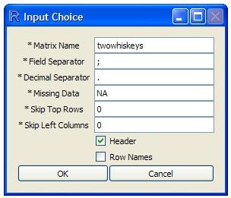

The default name proposed to the user is the name of the file (if blank characters are present, they are removed). The default settings are “;” as field separator, “.” as decimal separator, “NA” for missing value.

Note: the first character of the name must be alphabetic (e.g., “2whiskeys” is not a valid name).

Caution: when being run, several scripts will create (and then delete) temporary variables, whose name is one character long; therefore, it is suggested not to use one character names (e.g., “x”).

"Skip Top Rows" requires the input of an integer number n, and allows to skip the reading of the first n rows.
"Skip Left Columns", requires the input of an integer number m and allows to skip the reading of the first m columns.
If the first row of the file contains the names of the columns, the “Header” box should be selected (option given by default). If not, the names of the columns will be “V1”, “V2, “V3”, …
If the first column of the file contains the names of the rows, the "Row Names" box should be selected (note: in order to be selected as “Row Names”, the column must not contain duplicate values). If not, the names of the rows will be “1”, “2”, “3”, …

After pressing the “OK” button a check is made to verify whether the same name is already present in the workspace. If so, then the warning message in the Figure below appears informing the user that if he proceeds the variable to be loaded will overwrite the previous one.

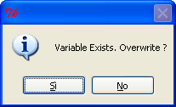

An example of a file that can be read by this option is reported. In it the first row is the header, with the names of the fields; the first field is the name of the sample and fields 2-11 contain the data. As can be seen, apart from the name, the file can contain also alphanumeric variables, as in field 10 (“appearance”)

batch;dry;pH;viscosity;nco;strength;elongation;modulus;shore;appearance;overall
B1;36.76;7.65;80;4.91;34.36;477.32;22.55;33;ok;3
B2;36.99;8.03;80;NA;33.95;459.84;92.94;35;ok;3
B3;36.89;8.03;70;4.82;40.98;462.65;30.54;42;ok;1
B4;36.88;7.69;100;4.86;26.27;414.69;65.65;31;ok;4
B5;36.85;7.69;124;4.86;26.27;414.69;65.65;31;ok;4
B6;37.14;8.02;127;4.55;37.35;471.96;74.67;40;ok;2
B7;37.5;7.77;158;4.55;37.35;471.96;74.67;40;ok;2
B8;37.37;7.83;148;NA;0;498.12;NA;NA;no;5
B9;36.86;8.2;118;NA;0;502.15;NA;NA;no;5
B10;36.89;8.18;130;4.39;22.04;454.74;32.37;42;ok;4
B11;36.97;7.9;97;4.63;33.17;493.98;62.32;43;ok;3
B12;37.19;8.24;128;NA;0;495.07;NA;NA;no;5
B13;37.39;8.23;107;5.29;25.89;397.31;134.39;42;ok;4
B14;37.16;8.68;106;4.56;15.8;191.01;132.52;40;no;5
B15;37.21;7.46;77;NA;0;505.32;NA;NA;no;5
B16;36.9;7.41;89;4.5;29.5;407.97;29.66;33;ok;4
B17;37.06;8.06;99;4.53;24.77;370.66;78.68;42;ok;4
B18;37.28;7.32;85;NA;0;487.98;NA;NA;no;5
B19;37.16;7.53;123;4.94;28.49;370.59;243.52;43;ok;4
B20;37.24;7.6;100;4.55;35.2;414.67;24.06;34;ok;3

After the file has been successfully loaded, the following message will be displayed:

“[1] xx Data loaded: r Rows & c Columns”

Note: if the “Header” and “Row Names” options have been activated, the corresponding row and column will be treated separately and will not be taken into account as row and column of the data matrix. As an example, after having loaded the previous data file (22 rows and 11 columns), the displayed message will be:

“[1] 242 Data loaded: 21 Rows & 10 Columns”

Load - TXT
This option is used to import data from a TXT file. After the selection of the file (see “Load – CSV”), the following dialogue box is shown.

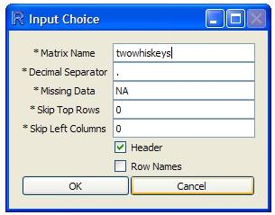

The default name proposed to the user is the name of the file (if blank characters are present, they are removed). The default settings are “.” as decimal separator and “NA” for missing value.

Note: the first character of the name must be alphabetic (e.g., “2whiskeys” is not a valid name).

Caution: when being run, several scripts will create (and then delete) temporary variables, whose name is one character long; therefore, it is suggested not to use one character names (e.g., “x”).

"Skip Top Rows" requires the input of an integer number n, and allows to skip the reading of the first n rows.
"Skip Left Columns", requires the input of an integer number m and allows to skip the reading of the first m columns.
If the first row of the file contains the names of the columns, the “Header” box should be selected (option given by default). If not, the names of the columns will be “V1”, “V2, “V3”, …
If the first column of the file contains the names of the rows, the "Row Names" box should be selected (note: in order to be selected as “Row Names”, the column must not contain duplicated values). If not, the names of the rows will be “1”, “2”, “3”, …

After pressing the “OK” button a check is made to verify whether the same name is already present in the workspace. If so, then the warning message in the Figure below appears informing the user that if he proceeds the variable to be loaded will overwrite the previous one.

An example of a TXT file that can be read by this option is reported.

G R T
a1 18 512
a2 23 514
a3 36 81.45
a4 41.85 89
a5 52.043 67

After the file has been successfully loaded, the following message will be displayed:

“[1] xx Data loaded: r Rows & c Columns”

Note: if the “Header” and “Row Names” options have been activated, the corresponding row and column will be treated separately and will not be taken into account as row and column of the data matrix. As an example, after having loaded the previous data file (5 rows and 2 columns), the displayed message will be:

“[1] 10 Data loaded: 5 Rows & 2 Columns”

Load - XLS/XLSX
This option is used to import data from .xls (or .xlsx) files of MS Excel. After the selection of the file (see “Load – CSV”), the following dialogue box is shown.

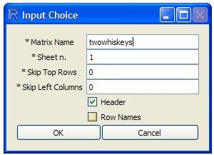

The default name proposed to the user is the name of the file (if blank characters are present, they are removed).

Note: the first character of the name must be alphabetic (e.g., “2whiskeys” is not a valid name).

Caution: when being run, several scripts will create (and then delete) temporary variables, whose name is one character long; therefore, it is suggested not to use one character names (e.g., “x”).

The “Sheet n.” box requires the input of the number of the data sheet in the Excel file (by default this number is set to 1).
"Skip Top Rows" requires the input of an integer number n, and allows to skip the reading of the first n rows.
"Skip Left Columns", requires the input of an integer number m and allows to skip the reading of the first m columns.
If the first row of the file contains the names of the columns, the “Header” box should be selected (option given by default). If not, the names of the columns will be “V1”, “V2, “V3”, …
If the first column of the file contains the names of the rows, the "Row Names" box should be selected (note: in order to be selected as “Row Names”, the column must not contain duplicated values). If not, the names of the rows will be “1”, “2”, “3”, …

After pressing the “OK” button a check is made to verify whether the same name is already present in the workspace. If so, then the warning message in the Figure below appears informing the user that if he proceeds the variable to be loaded will overwrite the previous one.

An example of an Excel file that can be read by this option is reported. In it the top row should be removed (“Skip Top Rows” set to 1).

Q | M
12 | 4
1 | 3
12 | 3
1.34 | 34.8

After the file has been successfully loaded, the following message will be displayed:

“[1] xx Data loaded: r Rows & c Columns”

Note: if the “Header” and “Row Names” options have been activated, the corresponding row and column will be treated separately and will not be taken into account as row and column of the data matrix. As an example, after having loaded the previous data file (5 rows and 2 columns), the displayed message will be:

“[1] 8 Data loaded: 4 Rows & 2 Columns”

Copy and Paste
If the user has some copied data stored in memory (e.g. Data copied from Excel or similars) a convenient way to import it into CAT is the copy and paste option.
Once the user selected the copy and paste button, this dialogue box, appears, asking for for the name of the matrix:
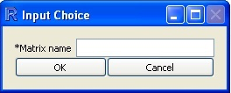

Please note that the first character of the name must be alphabetic (e.g., “2whiskeys” is not a valid name).

Caution: when being run, several scripts will create (and then delete) temporary variables, whose name is one character long; therefore, it is suggested not to use one character names (e.g., “x”).

After pressing the “OK” button a check is made to verify whether the same name is already present in the workspace. If so, then the warning message in the Figure below appears informing the user that if he proceeds the variable to be loaded will overwrite the previous one.

After the input of the name the matrix another dialogue box appears:

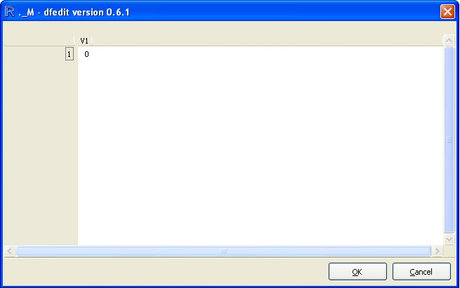

The user has to double click in the area above “1” and on the left of “V1”, CAT automatically selects the whole space (initially a 1x1 matrix).
The next step is simply a paste input (ctrl + v or cmd + v), after that a we dialogue box appears:

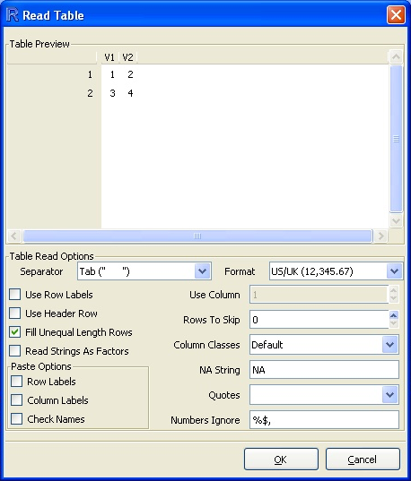

In this case, the selection was simply a 2x2 matrix composed by the numbers from 1 to 4, other informations about his dialogue box can be found in: “Workspace Management - Modify” section.

After the file has been successfully loaded, the following message will be displayed:

“[1] AAA created”
“[1] xx Data loaded: r Rows & c Columns”

Workspace Management
This option allows to perform several tasks on the objects stored in the workspace.
When selecting it, a dialogue box shows the list of the objects, their type and size.
After having selected an object, the user can perform different operations by clicking on one of the buttons at the bottom.

Note: the dialogue box can be closed only by hitting the “Close” button.

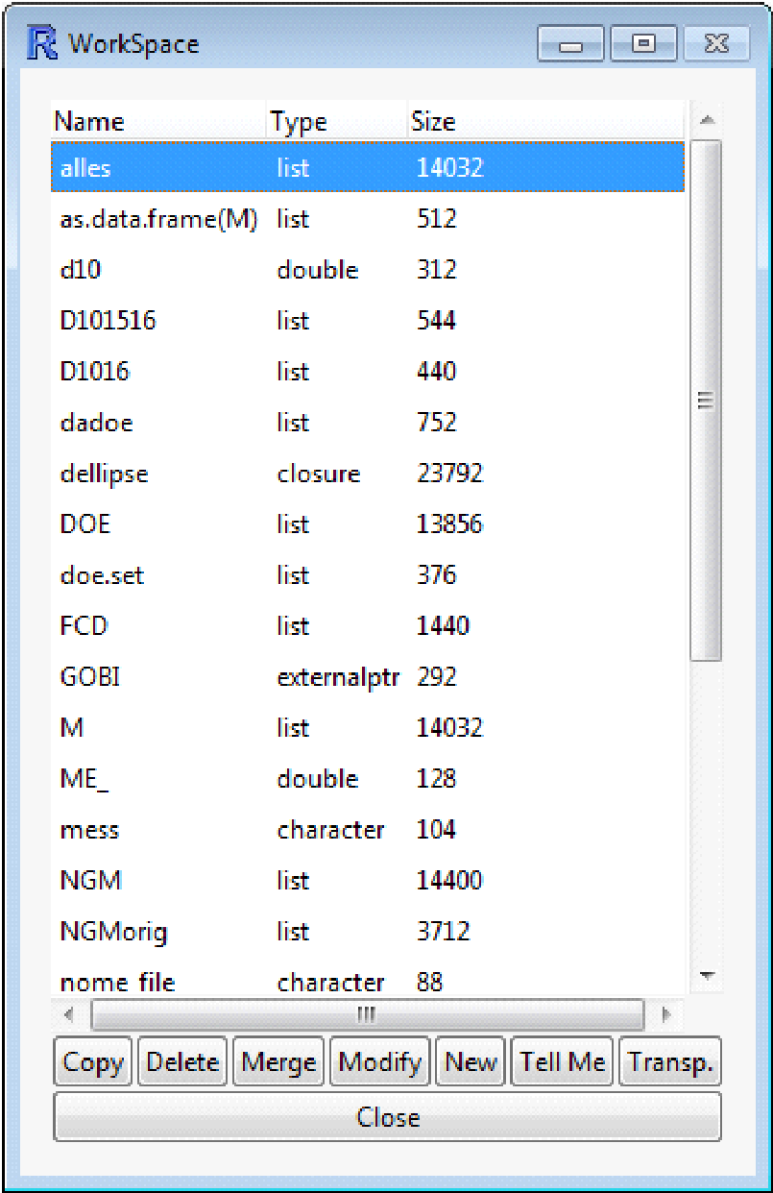

Workspace Management - Copy
A copy of the selected object is obtained under a new name (requested by a dialogue box). To rename an object, copy it under a new name, and then delete the original object.

Workspace Management - Delete
By using this function the selected object is deleted from the workspace.

Workspace Management - Merge
A dialogue box asks the name of the object to be merged with the selected one. The result of this operation will be stored under the name of the selected object.
The following three cases are possible.

- Same number of rows (r), different number of columns (c1 and c2). The merged object will have r rows and c1+c2 columns. The names of the rows will be same as those in the selected object.
- Same number of columns (c), different number of rows (r1 and r2). The merged object will have r1+r2 rows and c columns. The names of the columns must be the same in the two objects. No duplicate name must be present in the r1+r2 rows.
- Same number of rows (r) and same number of columns (c). Two different objects can be obtained, having 2r rows and c columns, or r rows and 2c columns, respectively. A dialogue box with the question “Merge vertically?” will appear. A positive answer will produce a merged object having 2r rows and c columns, while a negative answer will produce a merged object having r rows and 2c columns. In what concerns the names of the rows and the names of the columns, the same conditions/restrictions described in case 1) and 2) are applied.

Caution: the original selected object will be overwritten by the merged object.

Workspace Management - Modify
This option allows the modification of an existing object from a spreadsheet window. The user can change the values of each single cell. To delete data just press on the “Del” key, and "NA" will appear. Right clicking on the spreadsheet causes the opening of a context-sensitive menu with new functionalities. In this way the user can, for instance, change the type of data (e.g. from numeric to character), sort the data, add, delete or rename columns and rows. In order to have a modification accepted the modified cells must be not highlighted any more. When pressing the “OK” button the modifications will be saved.

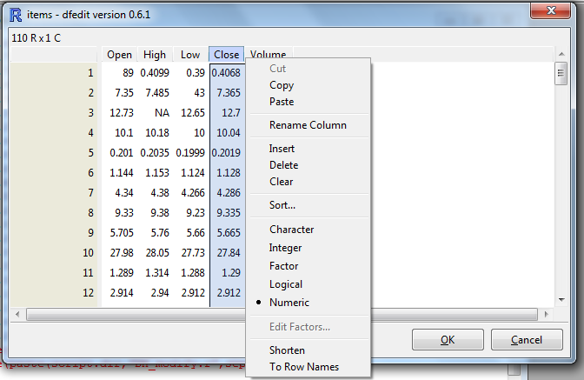

This function is intended only for minor changes. For more extensive changes it is suggested to modify the dataset by using an external editor such as a spreadsheet program, and load the file again in R after all the changes have been made.

Caution: the original selected object will be overwritten by the modified object.

Workspace Management - New
This function is used to create a new matrix. A dialogue box asks for the name of the matrix and its size (number of rows and columns).

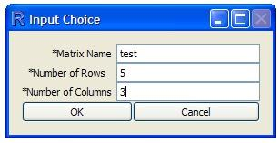

Then a spreadsheet is shown where the user can type the data. Empty cells (missing values) are automatically replaced by "NA".

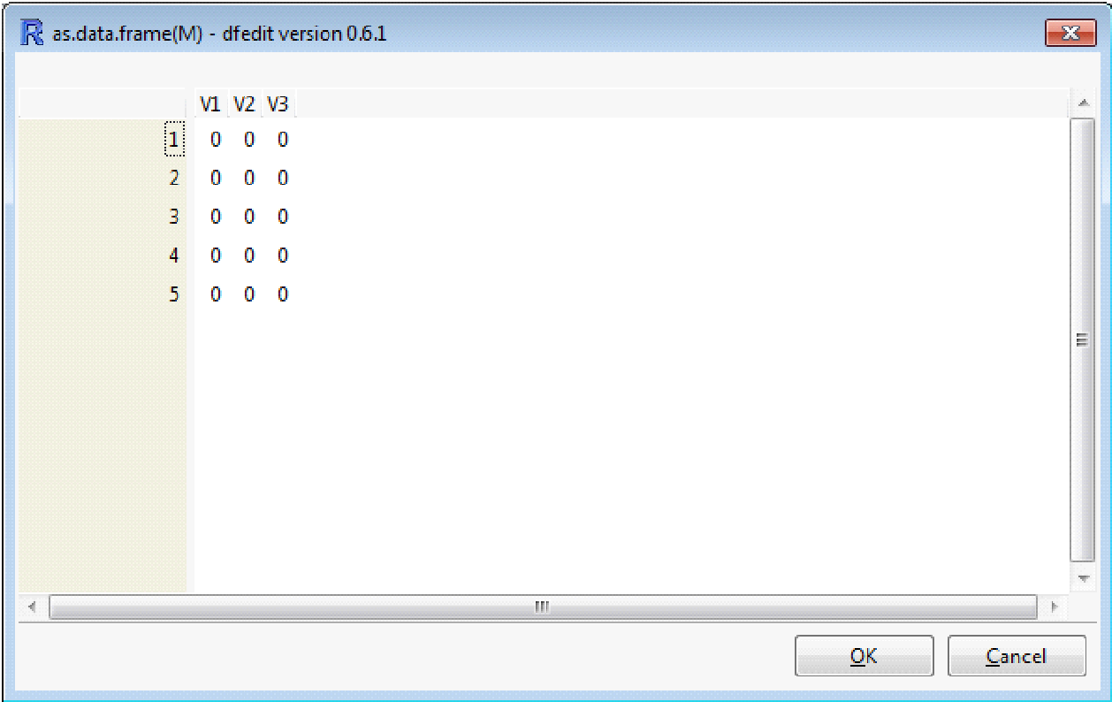

By right clicking on the name of a row (or of a column) it is possible to change the default value.
When pressing the “OK” button the new matrix will be saved.

Note: by selecting the first cell of the first row it is possible to perform copy/paste from an Excel file. In this case it is not required to declare the exact number of rows and columns, and the default values of one row and one column can be used. After having pasted the copied data, the following window appears

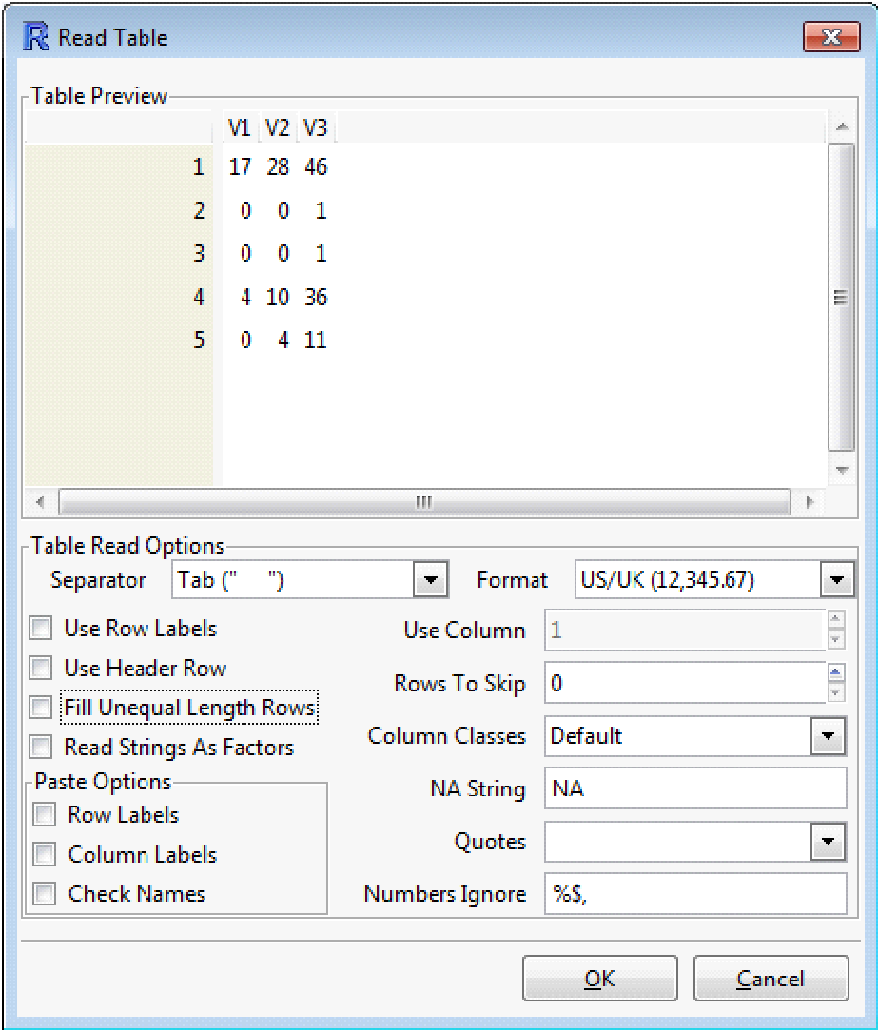

If the “Use Row Labels” box will be checked, then the first column will be considered as Row Names.
If the “Use Header Row” box will be checked, then the first row will be considered as Header.
After clicking on the “OK” button the spreadsheet for direct input will be shown again.

Workspace Management - Tell Me
An editor window opens showing the following information about the selected object:
- Name: the name of the object
- Type: the type of the object according to R
- Rows: the number of rows
- Columns: the number of columns
- NA: the number of Not Available numbers, i.e., missing data. In CSV and TXT files the missing data must be coded as NA, while in XLS/XLSX files the empty cells are directly interpreted as Not Available numbers
- %NA: the % of missing data on the total data
- Row Names: the names of each row
- Column names: the name of each column)
The editor window can be left open as long as it is necessary. Only one such window at a time can be opened.

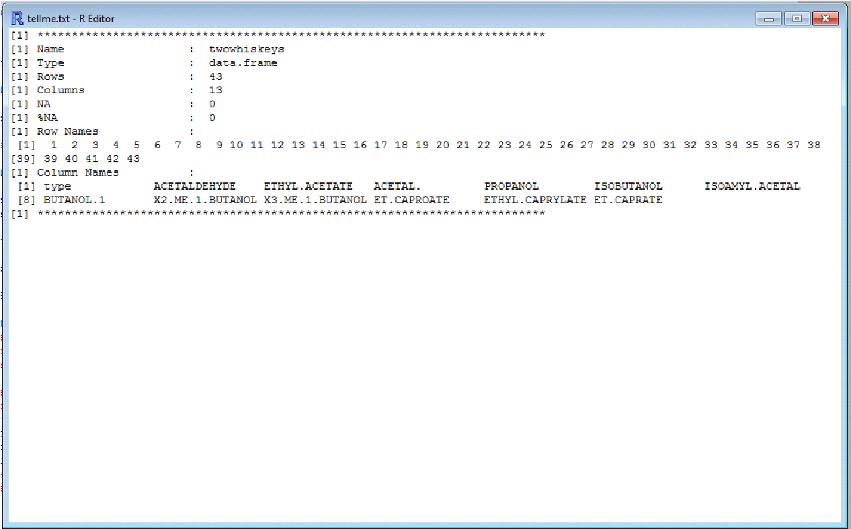

Workspace Management - Transpose
A dialogue box asks the name under which the selected object will be stored after having been transposed (i.e., the original rows will be the columns and the original columns will be the rows).

Caution: this function can only be applied on purely numeric data files, without row names and column names; in case of data sets containing missing data, alphanumeric data and/or row names and column names it is suggested to extract the non numerical part into separate vectors (see “Data Set” in this same menu) or to perform the transposition before loading the data file into R.

Data Set
The following sub-options are present:

- Row;
- Column;
- Randomize rows.

The Row and Column options allow to perform specific tasks (Delete, Extract, Column/Row Name, Copy) on specific rows or columns in a matrix. This option does not work on dataframes.
They perform one single operation (e.g., if n rows must be deleted, it has to be called n times), and are therefore useful only for minor changes; for more extensive changes it is suggested to modify the dataset by using an external editor such as a spreadsheet program, and load the file again in R after all the changes have been made.

Caution: the original selected variable will be overwritten by the modified variable.

After having selected the data matrix, the following dialogue box will be shown, in which the row/column number (or the names) and the operation to be performed must be specified:

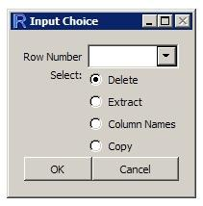

Data Set - Row/Column - Delete
The selected row/column is deleted. If more than one row/column must be deleted, it is suggested to do it in descending order (if rows 12 and 15 must be deleted, after have deleted row 12 the former row 15 will be row 14).

Data Set - Row/Column - Extract
The selected row/column is removed from the matrix and saved in the variable ex.row (or ex.col).

Data Set - Row/Column – Column/Row Names
The selected row/column is removed from the data table and its elements are considered as the column/row names. For a row being transformed into column names see the limitations about the data files reported at the beginning of this Help. For a column being transformed into row names, this option is allowed only if the column complies with the R rules of name definition (e.g., no duplicate names are allowed).

Data Set - Row/Column - Copy
The selected row/column is saved in the variable ex.row (or ex.col). It is the same as the “Extract” sub-option, with the difference that in this case the selected row/column is not removed from the matrix.

Data set – Randomize rows
This option allows to randomize the order of the rows in a data matrix. It is especially useful when performing Cross-Validation, since by modifying the order of the samples the composition of the deletion groups is also changed. The randomized data set is saved in the variable having the same name of the original variable, with the suffix .rnd

Export
The “Export” option allows the user to export an object of the workspace, saving it as a file

Export - CSV
A dialogue box asks for the name of the object, the characters to be used as field separator and decimal separator, ad the coding for the missing data.

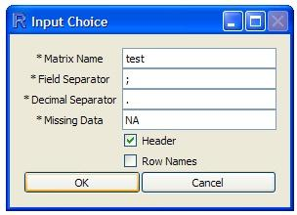

The default settings are “;” as field separator, “.” as decimal separator, “NA” for missing data.
The file, with the same name of the object and the selected extension, will be created in the “working” directory.
If neither the “Header” nor the “Row Names” boxes are checked, then only the data matrix will be saved.
If the “Header” box is checked, then the first row of the file will be the header of the columns.
If the “Row Names” box is checked, then the first column of the file will be the name of the rows.
If both the “Header” box and the “Row Names” box are checked, then the first row of the file will be the header of the columns and the first column of the file will be the name of the rows (obviously, the fist cell of the first row will be empty).

Export - TXT
A dialogue box asks for the name of the object, the character to be used as decimal separator and the coding for the missing data.
The default settings are “.” as decimal separator and “NA” for missing data.
About the “Header” and “Row Names” buttons, see “Export – CSV”.
