Help MULTILINEAR REGRESSION – DESIGN OF EXPERIMENTS

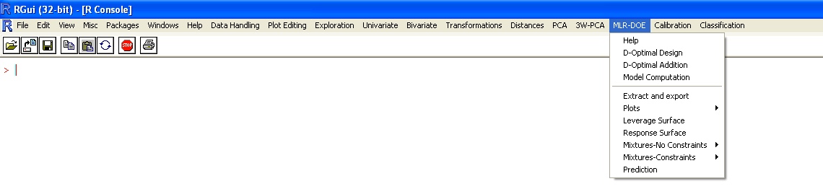

In the menu “MLR-DOE” the following options are present:

- D-Optimal Design
- D-Optimal Addition
- Model Computation
- Extract and export
- Plots
- Leverage Surface
- Response Surface
- Mixtures - No Constraints
- Mixtures - Constraints
- Prediction

D-Optimal Design
The “D-Optimal Design” option allows the user to select a D-Optimal Design.

Matrix of candidates points
This function allows the user to obtain the list of the candidate point; particularly, this function allows to obtain all the possible combination of the values assigned to each variable.
As an example, in the case variable 1 can have the levels 1, 2 and 3, variable 2 can have the levels "M" and "F" (codified as 0 and 1) and variable 3 can have the levels 20, 40 and 60,

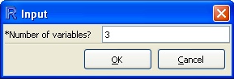
Figure 1 - Matrix of candidates points dialogue box.
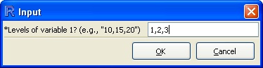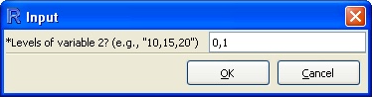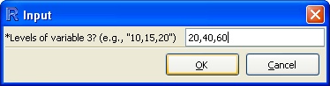
Figure 2 - Dialogue boxes appearing in sequence for the input of the variables to be computed to obtain the matrix of candidates point. From left to right: input of the levels of the several variables (in this case 3).

A matrix made by 18 rows (i.e., 3 * 2 * 3) and 3 columns will be obtained (it can be find in the workspace):

Table 1 - Matrix obtained
Var1 | Var2 | Var3
1 | 0 | 20
2 | 0 | 20
3 | 0 | 20
1 | 1 | 20
2 | 1 | 20
3 | 1 | 20
1 | 0 | 40
2 | 0 | 40
3 | 0 | 40
1 | 1 | 40
2 | 1 | 40
3 | 1 | 40
1 | 0 | 60
2 | 0 | 60
3 | 0 | 60
1 | 1 | 60
2 | 1 | 60
3 | 1 | 60

As shown in the example, both qualitative (opportunely codified) and quantitative variables can be used.

D-Optimal Design
Upon calling the function “D-Optimal Design” the dialogue box of Figure 3 appears on the screen, and the user is asked to input the candidate points matrix that here is named A. Once selected the matrix A, a model must be specified. This is done by checking the tick-boxes corresponding to the request of computation of the intercept and of the “Higher terms”. If higher terms are included in the model, these must be specified as shown in Figure 4. Setting “1” to choose the appropriate interactions and quadratic terms.

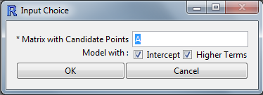
Figure 3 - D-Optimal Design dialogue box. Input of the candidate points matrix named “A”.

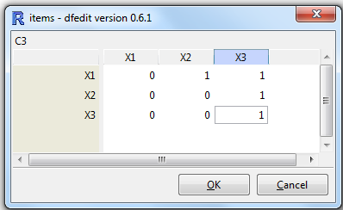
Figure 4 - Model terms selection. The model equation is defined including intercept and higher terms. Model equation: Y = b0 + b1•X1 + b2•X2 + b3•X3 + b12•X1•X2 + b13•X1•X3 + b23•X2•X3 + b33•X32.

After choosing the model, the following dialogue box prompts you to specify the lower and upper number of experiments that the operator can perform, together with the “Incremental step” and the “Number of trials” that the computation algorithm is going to use to select the subset of experiments from the candidate points set of matrix A (Figure 5). The default numbers presented in the dialogue box are the minimum number of experiments required for computing the coefficients of the model selected. The upper number of experiments is equal to the number of rows of matrix A minus 1. The Incremental step is set by default to 1, but the user can select any integer number >1.
The number of trials is set by default to 10, but the user can select any integer number >1, taking into consideration that the computation time depends strongly both on the number of trials and on the dimension of the candidate points set.

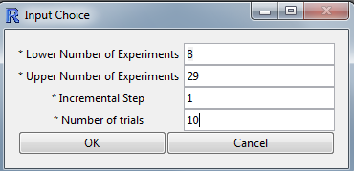
Figure 5. Setting of the parameters for computing the D-optimal set of experiments. The user is asked to input the Lower and Upper number of experiments together with the Incremental step to be and the number of trials to be used for the computation.

Once selected the parameters for the computation of the optimal set of experiments, two graphs are plotted (Figure 6) and several lines of output appear on the R console. In addition, the matrix “expt” is created (Figure 7). The rows of matrix “expt” contain the list of the selected experiments, whereas the columns correspond to the number of the experiment selected. In the example presented in Figures 4 and 5, the maximum number of experiments selected was 16, the incremental step was 1 and the number of trials was 100.
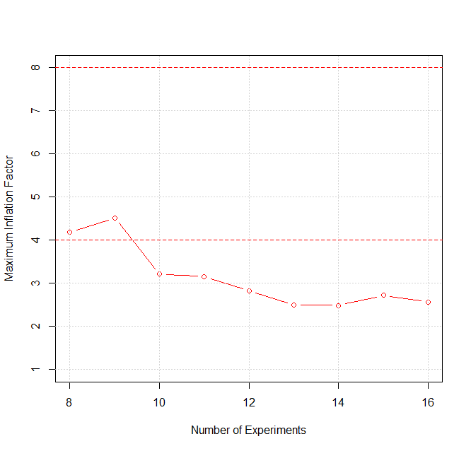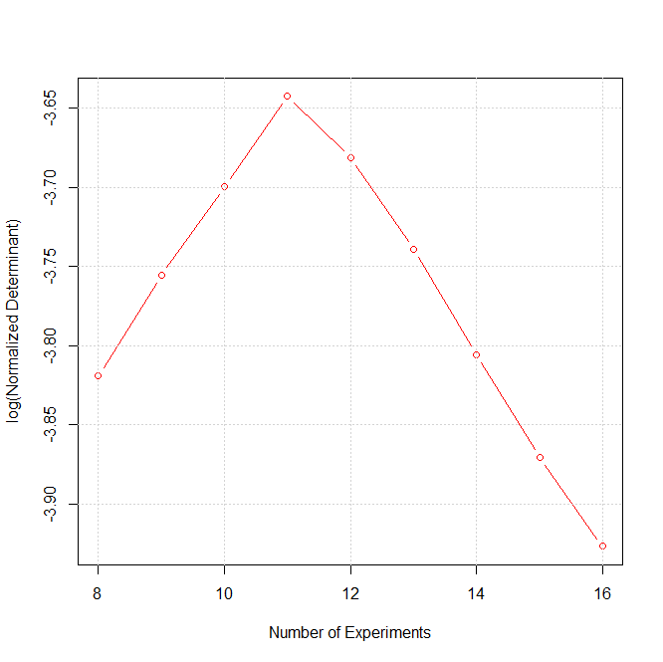
A
B
Figure 6 - A) Plot of the maximum inflation factor versus the number of experiments computed. B) Plot of the log(Normalized Determinant) values versus the number of experiments.

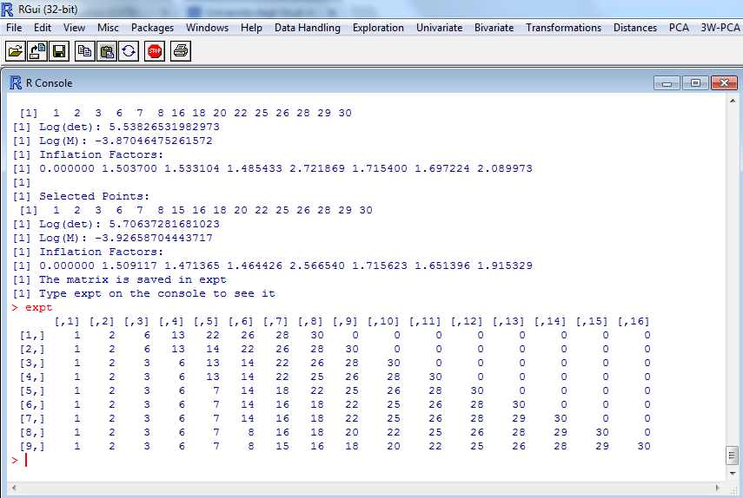
Figure 7 - Output of the D-optimal computation and print of the “expt” matrix on the R console.

D-Optimal Addition
This menu is used to find the optima set of experiments using a sub-optimal dataset and a matrix of new candidate points from which the computation algorithm will select the D-Optimal set of experiments given the model equation specified by the user.
Thus, the first dialogue box that appears on the screen when the instruction “D-Optimal Addition” is chosen is the one in Figure 8.

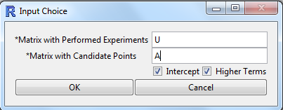
Figure 8 - First dialogue box following the D-Optimal Addition function call. The selection of the matrices of performed experiments and of the candidate points is required.

Following the input of the requested matrices, U[11,3] and A[30,3] (Tables 2 and 3) in this example, the user must specify the model equation (Figure 9) and the parameters for computing the D-optimal set of experiments (Figure 10). In the case presented in the example the postulated model has 8 coefficients. Considering the performed experiments of matrix U and the candidate set of points of matrix A (Table 2), the routine computes a minimum number of experiments requested of 1 (Figure 10).

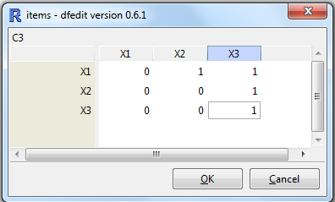
Figure 9 - The Model terms selection input dialogue box. Model equation: Y = b0 + b1•X1 + b2•X2 + b3•X3 + b12•X1•X2 + b13•X1•X3 + b23•X2•X3 + b33•X32.
Table 2 - Matrices U[11,3] and A[30,3].
Matrix U – performed experiments
X₁ | X₂ | X₃
-1 | 1 | -1
-1 | 1 | -0.6
-1 | 1 | -0.2
-1 | 1 | 0.2
-1 | 1 | 0.6
-1 | 0 | 1
-1 | 0 | 1
-1 | 0 | 1
0 | 0 | 1
0 | 0 | 1
0 | 0 | 1

Matrix A – candidate points
X₁ | X₂ | X₃
-1 | 1 | -1
-1 | -1 | -0.6
0 | -1 | -0.6
-1 | 0 | -0.6
0 | 0 | -0.6
1 | 0 | -0.6
0 | 1 | -0.6
-1 | -1 | -0.2
0 | -1 | -0.2
-1 | 0 | -0.2
0 | 0 | -0.2
1 | 0 | -0.2
0 | 1 | -0.2
-1 | -1 | 0.2
0 | -1 | 0.2
-1 | 0 | 0.2
0 | 0 | 0.2
1 | 0 | 0.2
0 | 1 | 0.2
-1 | -1 | 0.6
0 | -1 | 0.6
-1 | 0 | 0.6
0 | 0 | 0.6
1 | 0 | 0.6
0 | 1 | 0.6
-1 | -1 | 1
0 | -1 | 1
1 | -1 | 1
0 | 0 | 1
1 | 0 | 1

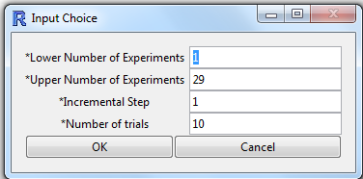
Figure 10 - Dialogue box for the input of the parameters for computing the D-optimal set of experiments. The user is asked to input the lower and upper number of experiments together with the Incremental step and the number of trials to be used for the computation.

Model Computation

To illustrate this function a step-by-step example is shown. The dataset used is reported in Table 2 and is called expdes that is a data matrix (27x5). The first four columns represent the x matrix of a Central Composite Design (CCD) with 3 replicates of the center point, and column 5 is the vector y of the responses.
The Model Computation instruction calls a routine that performs Multiple Linear Regression (MLR), in accordance with Ordinary Least Squares method (OLS).
If only the X matrix is given, then only the diagnostics of the model are computed; if also the responses are available, then also the coefficients of the model and their diagnostics are computed.

Table 3 - Dataset expdes[27,5]. Columns 1-4 are the x matrix, and column 5 contains the response values Y.

x1 | x2 | x3 | x4 | Y
-1 | -1 | -1 | -1 | 1.02
-1 | -1 | -1 | 1 | 1.05
-1 | 1 | -1 | -1 | 1.03
-1 | 1 | -1 | 1 | 0.99
-1 | -1 | 1 | -1 | 0.97
-1 | 1 | 1 | 1 | 0.95
-1 | 1 | 1 | -1 | 1
-1 | -1 | 1 | 1 | 0.93
1 | -1 | -1 | -1 | 1
1 | -1 | -1 | 1 | 1
1 | 1 | -1 | -1 | 0.98
1 | 1 | -1 | 1 | 0.98
1 | -1 | 1 | -1 | 0.94
1 | -1 | 1 | 1 | 0.94
1 | 1 | 1 | -1 | 0.96
1 | 1 | 1 | 1 | 0.92
0 | 0 | 0 | -2 | 1.01
0 | 0 | 0 | 2 | 0.96
0 | -2 | 0 | 0 | 0.99
0 | 2 | 0 | 0 | 0.96
0 | 0 | -2 | 0 | 1.03
0 | 0 | 2 | 0 | 0.91
-2 | 0 | 0 | 0 | 0.99
2 | 0 | 0 | 0 | 0.98
0 | 0 | 0 | 0 | 1
0 | 0 | 0 | 0 | 0.98
0 | 0 | 0 | 0 | 0.96

Case 1: no response (to check whether the X matrix is compatible with the postulated model).
By calling the function Model Computation the dialogue box of Figure 11 is printed on the screen.
In this case we want to evaluate only the diagnostics of the model before performing the experiments.
Therefore, the X matrix represented by all then rows and the first four columns of expdes is input and the Y-values vector, which makes the fifth column of expdes instead, is omitted for the moment. In the present case, we must specify that “None” (make sure that “N” is written in capital letter, more info here) Y-variable is to be selected in the computation. In addition, we must also specify whether the intercept and higher terms beyond the linear ones must be included in the model.

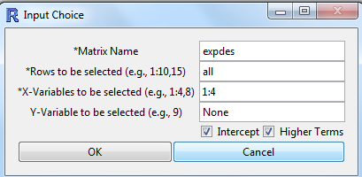
Figure 11 - Only the X matrix is input. The “Y-Variable to be selected” line must be filled writing “None”.

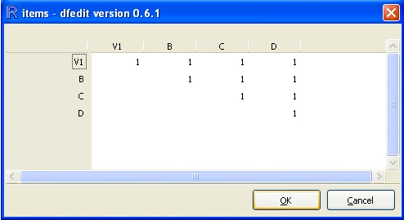
Figure 12 - Dialogue box for model equation definition.

This dialogue box defines the higher terms of the model. In this case, we have 4 linear terms (there is no question about them, since they must be present), 6 cross terms (all the possible pairs of variables), 4 quadratic terms and 1 constant (15 terms in total).
If not all the cross-terms (or the square terms) are required, then input “0” in the corresponding cell of the matrix presented in the dialogue box. In this case all the possible cross-terms (or square terms) are requested and will be shown.

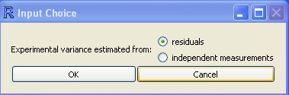
Figure 13 - Dialogue box for the estimation of variance.

This dialogue box allows the user to choose how to estimate the experimental variance:

- Residuals: the experimental variance will be estimated from residuals (if there is a proper number of degrees of freedom);
- Independent Measurements: experimental variance can be estimated with some external measurements of from previous knowledge of the problem.

In this case, “residuals” method has been chosen, the output is as follows:
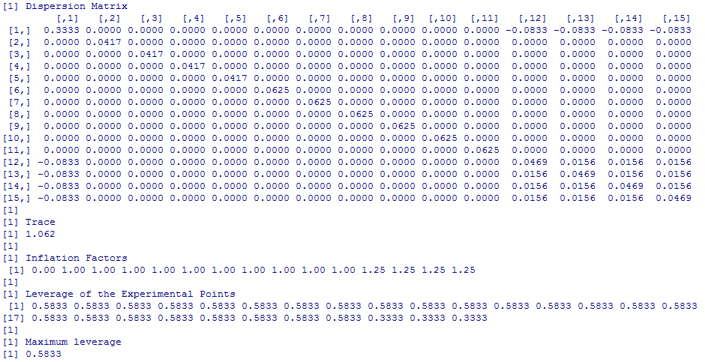
Figure 14 - Dispersion matrix, trace, inflation factors, leverage of the experimental points.

The dispersion matrix (X’X)⁻¹ is a square matrix, with as many rows and columns as terms in the model. Each element of its diagonal, multiplied by the experimental variance, gives the variance of the corresponding term, while each off-diagonal element, multiplied by the experimental variance, gives the covariance of the corresponding terms. A good X matrix produces a dispersion matrix having 0’s (or very small values) for all the off-diagonal elements (thus meaning that the terms can be estimated independently) and values as small as possible on the diagonal (thus meaning that the variance of the coefficients is very small, and therefore the coefficients can be estimated with a good precision.
The trace of the dispersion matrix (i.e., the sum of the elements on the diagonal) is reported at the bottom of the dispersion matrix and provides a more “compact” indicator of the quality of the X matrix.
The inflation factors show the quality of each term of the model. Values <4 are considered as good, between 4 and 8 as acceptable, >8 as not good.
The leverage of each point, multiplied by the experimental variance, corresponds to the variance of the prediction in that point. This means that in the points having a leverage <1 the prediction error will be smaller than the error one could get from actually performing one experiment in that point.
Since we are dealing with a CCD in which the number of variables is 4 and the value of α is 2, the design is completely symmetrical and all the points (except the three centre points) lie on a hypersphere. Therefore, all these points have the same leverage.
The maximum leverage, corresponding to an experimental point, is also given.

Case 2: a response is given (to compute the coefficients).
In the present case now the values of the responses are input (Figure 12). 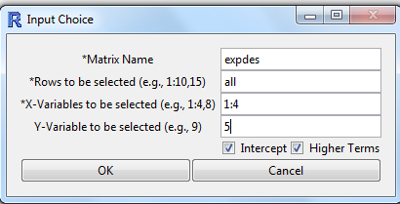
Figure 15 - The X matrix is input as in the previous case. Now the “Y-Variable to be selected” line is filled with the input of the number of the column of the dataset that contains the responses.

The user is expected to see, once again, the input window of figure 13 (Estimation of the experimental variance).

The model equation is specified as described previously in Figure 12. The Model Computation function now computes the dispersion matrix (X’X)⁻¹ , its trace, the leverage of the experimental points, the maximum leverage, and several other numerical outputs and plots (Figures 14 and 16).
In the following the output of the function is described point by point.
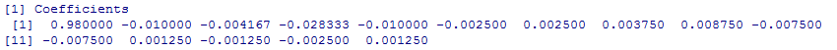
The model coefficients are computed and listed column-wise starting from the intercept. The coefficients will always be listed in the following order:

- constant
- linear terms
- cross-terms (in the order X₁X₂, X₁X₃, …, X₁X_{v}, X₂X₃, …, X_{v-1}X_{v})
- quadratic terms

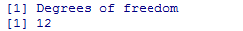
The degrees of freedom correspond to the number of experiments minus the number of terms of the model (in our case 12 = 27-15).
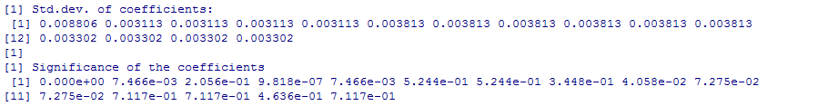
Standard deviation and significance of the coefficients. Remember that the lower the value of significance the higher the “importance” of the coefficient.
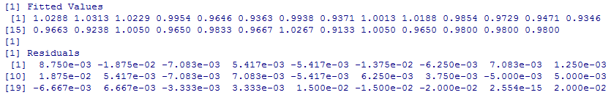

The Fitted Values (these are the values obtained in fitting, i.e. by simply replacing the x values of the samples in the model) and Residuals (these are the differences between the experimental values and the fitted values) are printed on the screen to allow a rapid check of the values generated by the model and possible outliers.
A series of diagnostics parameters for appraising the quality of the model computed are then printed.
As far as the fitting of the experimental points is concerned, the variance of the Y experimental values, the Standard Deviation of the Residuals in fitting (i.e. the square root of the ratio of the squared difference between model fitted Y-values and experimental Y values to the degrees of freedom of the model), and the percent of Explained Variance are reported.

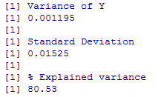

For assessing the theoretical quality in prediction, the Cross Validation Values of the Y-values by the leave-one-out method are computed together with some indicators of the model quality, namely the Residuals in Cross Validation, the Root Mean Square Error in Cross Validation (that corresponds to the Standard Deviation of the Residuals in fitting quoted above) and the percent of Explained Variance in Cross Validation.

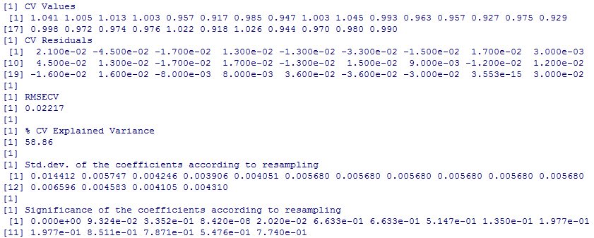

The computation of the coefficients and of their standard deviations according to resampling is an alternative way to compute the significance of the coefficients, suggested by Martens. It takes into account the variation of the coefficients in the different models computed during cross-validation. Of course, the more stable a coefficient is, the more probable it is that it is significant.

Extract and Export
This command will show the menu shown in Figure 15 and provides the user with the options to extract several items from the results of the Model Computation function. These items are the Dispersion Matrix, the model Coefficients, the Fitted Values), the predicted values in cross-validation (“CV predicted”) and their residuals (“CV Residuals”).

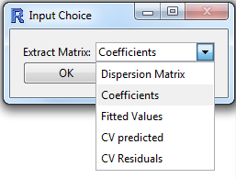

Figure 16 - The Extract and Export dialogue box menu.

Plots
The Plots command opens a submenu as shown in Figure 17. The user can select to print the graphs of the coefficients (Figure 18), the scatter plots of the experimental data versus the model fitted values (Figure 20) and versus the cross-validation predicted values (Figure 19), as well as the residuals in fitting and in cross validation (Figures 21, 22).

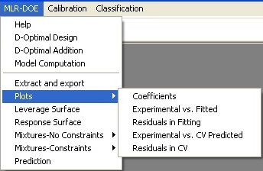
Figure 17 - The Plots submenu options.

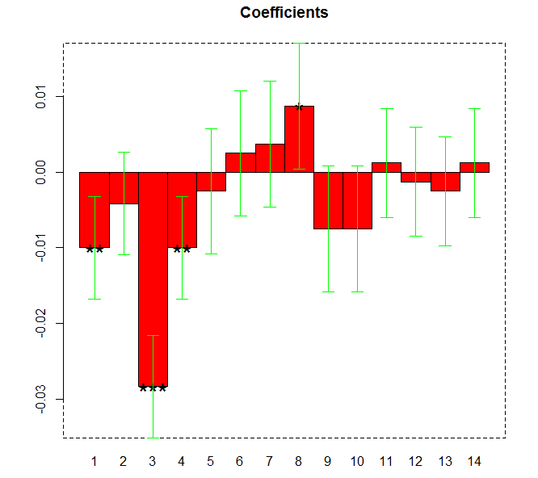
Figure 18 - The option “Coefficients” prints the plot of the model coefficients together with their confidence interval at p=0.05 (the constant is not shown). For the significant coefficients (in our case b₁, b₃, b₄ and b₂₃) the level of significance is shown by using the star code (* = p<0.05, ** = p<0.01, *** = p<0.001)

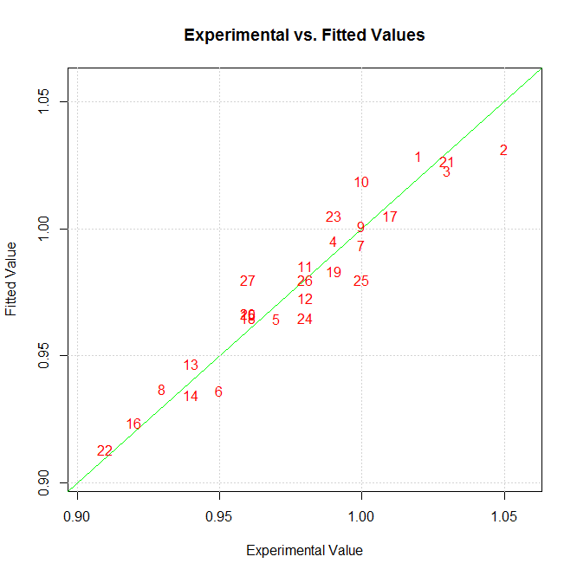
Figure 19 - The option “Experimental vs. Fitted” prints the plot of the experimental Y values versus the values fitted by the model. The plot of the residuals vs. the experimental value can be helpful in detecting systematic departures from the model (e.g., when fitting a linear model to a quadratic behaviour).

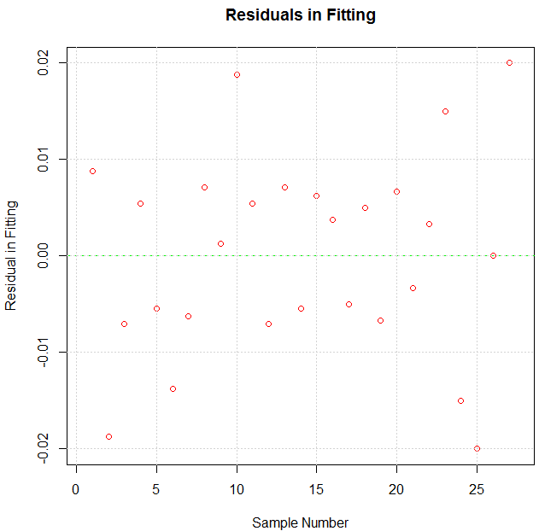
Figure 20 - The option “Residuals in Fitting” prints the plot of the values of the residuals between the experimental values and the values computed in fitting by the model.

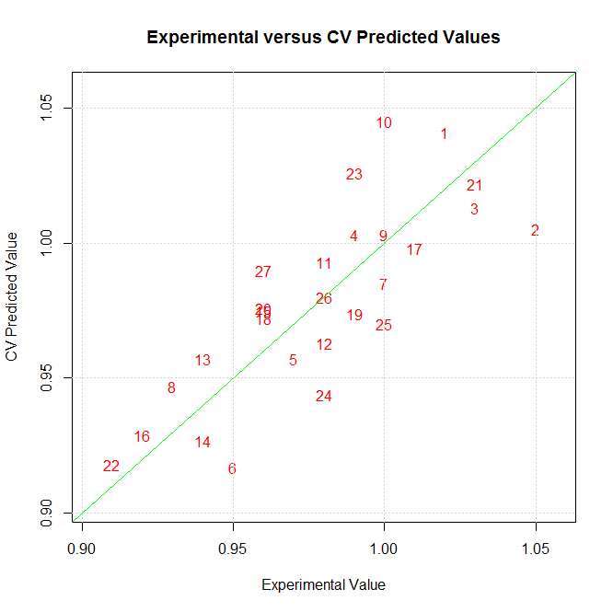
Figure 21 - The option “Experimental vs. CV Predicted” prints the plot of the experimental Y values versus the values predicted in cross-validation by the model.

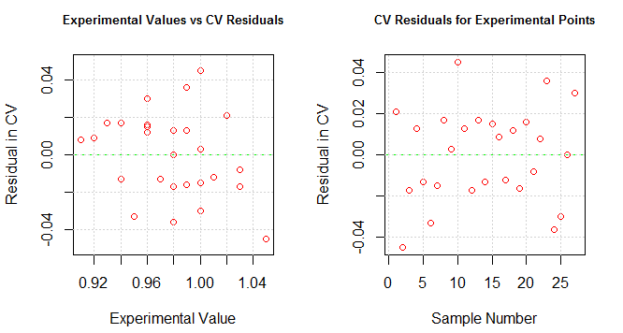
Figure 22 - Plot of the residual values in cross validation. The left plot allows to evaluate the distribution of the residuals in CV compared to the experimental y values. The right plot evidences absence of error structure related to the sample number.

Leverage Surface
The leverage can also be visualized as a plot in either of the two cases described.
By calling the Leverage Surface function, a dialogue box appears prompting the user to input the minimum and maximum values of the range to be defined (Figure 20). In the present example the two values are -2 and +2 (See Table 3).
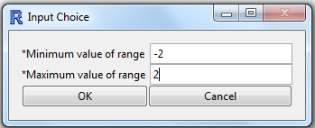
Figure 23 - Dialogue box for the input of the minimum and maximum values for leverage surface plot.

The variables plotted on the X and Y axes have to be defined, and thus after pressing the “OK” button
of the dialogue box of Figure 20 the following dialogue box is printed (Figure 23).

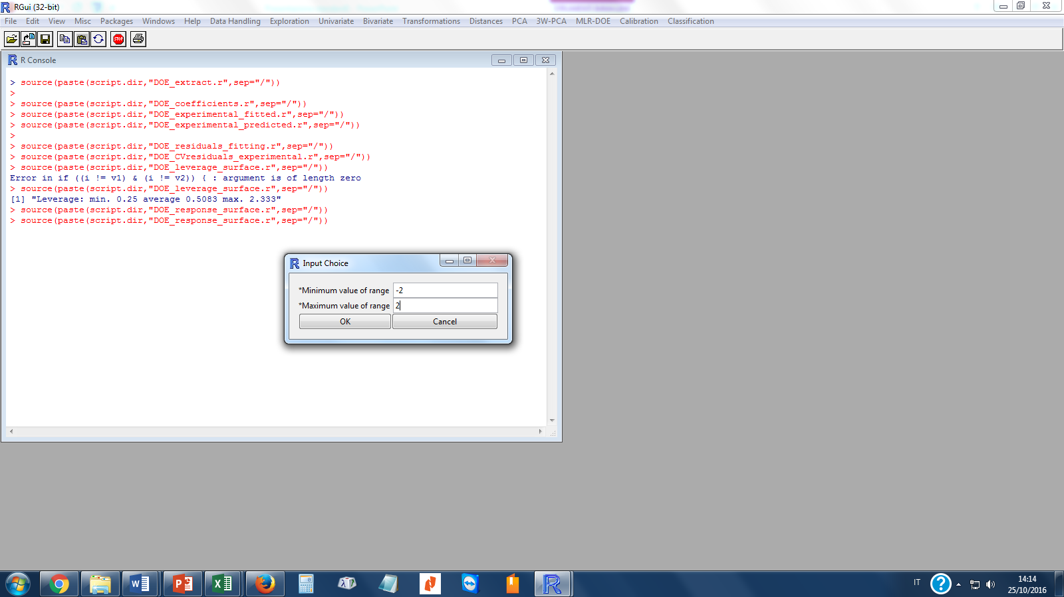
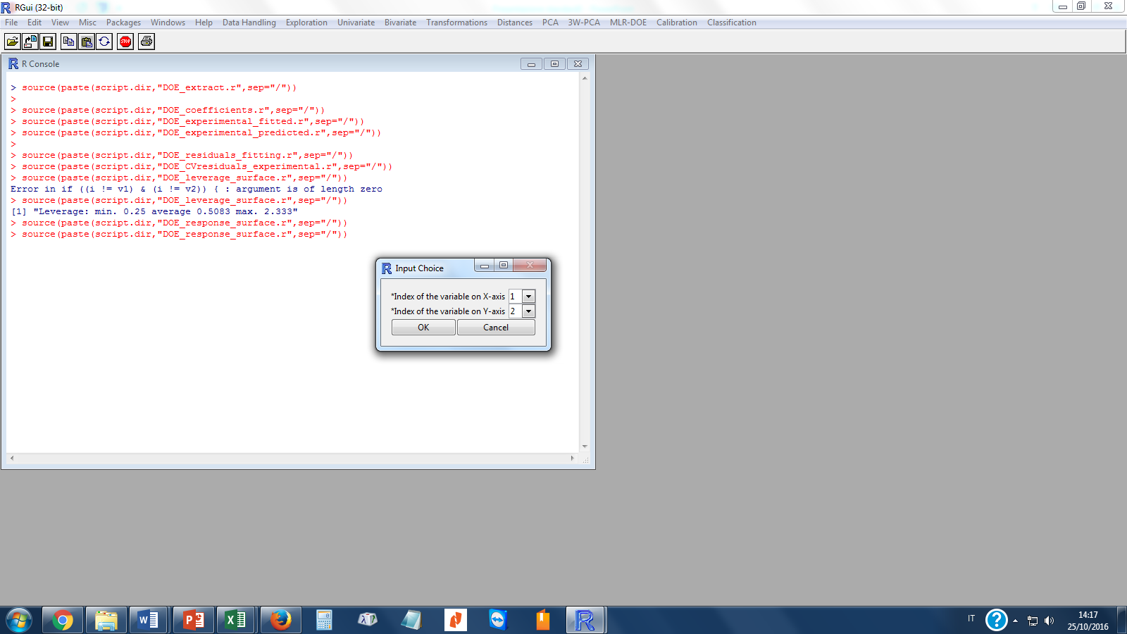
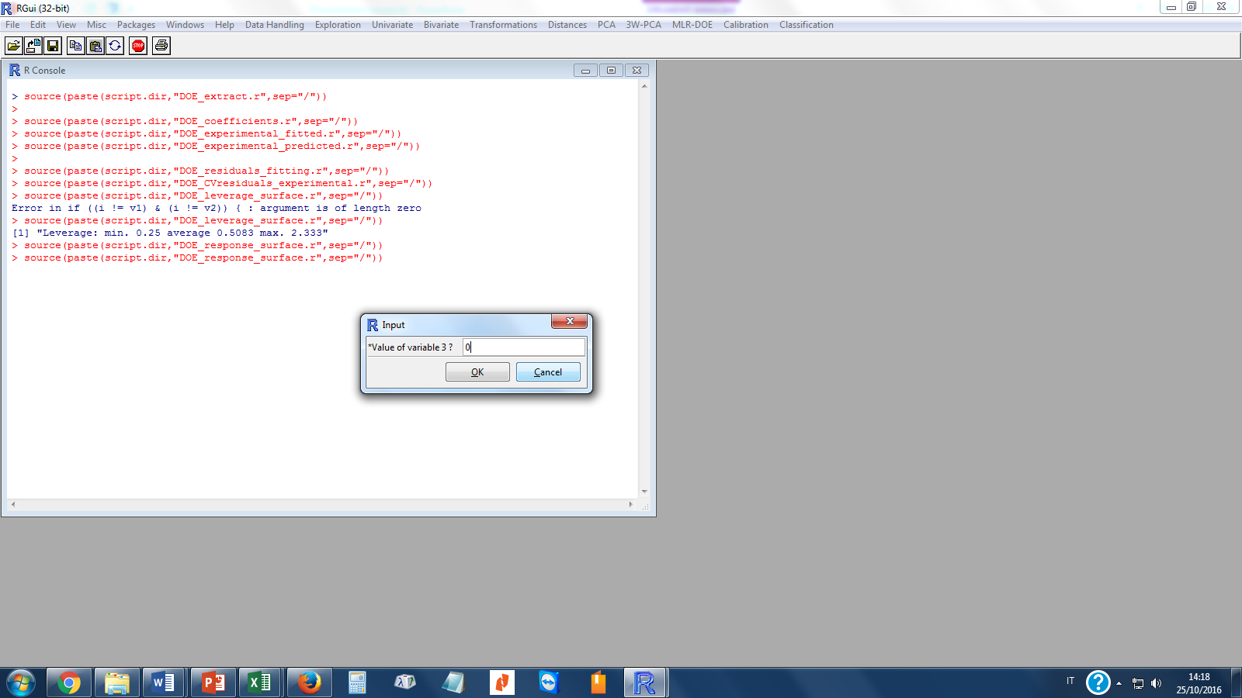
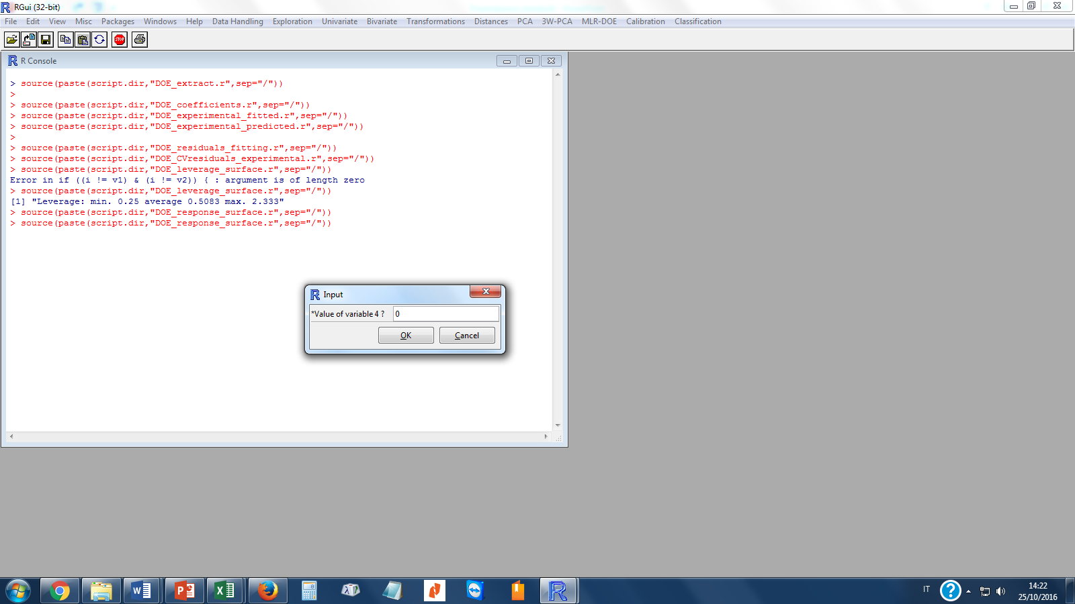
A
B
C
D

Figure 24 - Dialogue boxes appearing in sequence for the input of the variables to be computed for plotting the leverage surface. From left (A) Input of the X- and Y-axes of the leverage surface plot. Center (B) in this case variable 1 will be printed on the X-axis and variable 2 on the Y-axis. Right (C) and (D) input of the values for variables 3 and 4.

The values of the variables not corresponding to the plotted plane have to be defined. Therefore, in this case two other dialogues boxes will be printed to let the user input the values of the other two variables that are not plotted. After completing the input of the variable values, the plots of Figure 22 are printed on the screen and the minimum, average, and maximum value of the leverage in the defined domain are reported on the R console as shown here below.
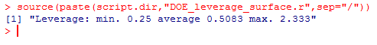
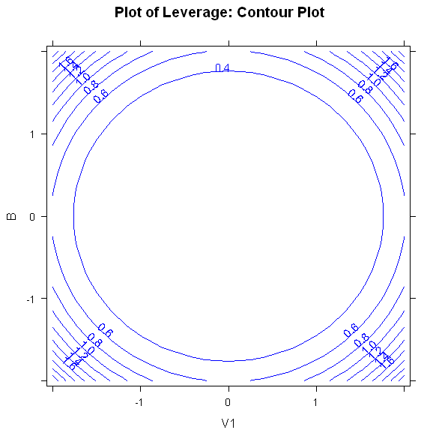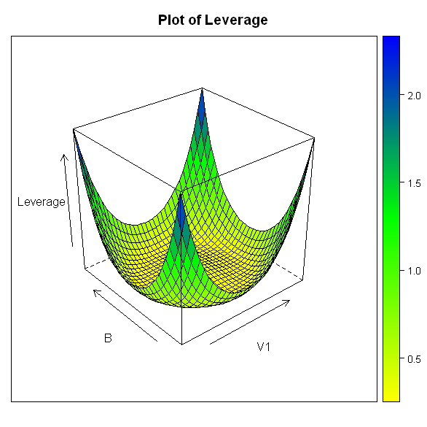

Figure 25 - Contour plot of the leverage and 3D plot of the leverage surface.

Response Surface
The Response Surface command allows to plot the response surface computed following the same sequence of instructions illustrated for the Leverage Surface plots and reported in Figure 23.
In Figure 26 the Response surface plots are reported.

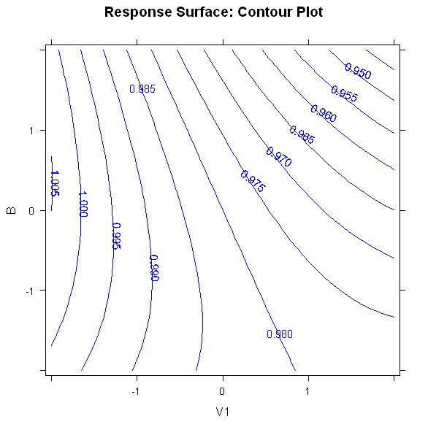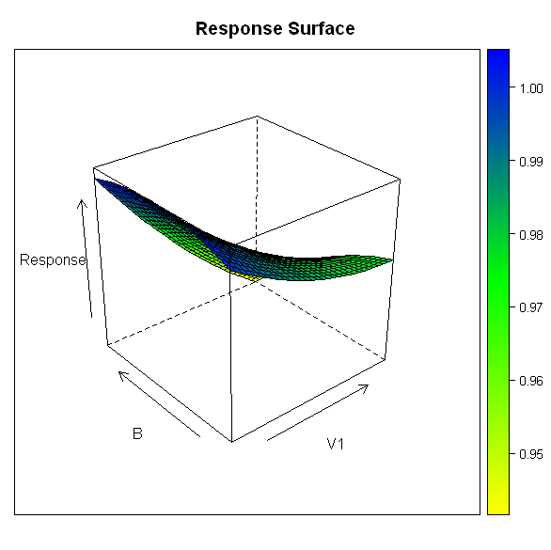
Figure 26 - Contour plot and 3D plot of the model response surface. The selection of the variables is the same as that shown in the sequence of boxes reported in Figure 21.

Mixtures – No constraints
Mixture with “No constraints” means that, in this design, there no limits for the variable, except for the ratio between them (i.e. every variable can vary, in respect with the other from 0 to 1, along his edge).
Keep in mind that, in this kind of designs, there is no intercept and be careful with higher terms.
To illustrate this function a step-by-step example is shown. The dataset used is reported in Table 4.
The first three columns represent the x matrix of a mixture model and column 4 is the vector y of the responses.
This example is taken from the ACE case study from the school of experimental design, particularly, only the first response is considered and no higher terms.

Table 4 - Dataset used for the example of mixtures; Columns 1-3 are the x matrix, and column 4 contains the response values Y.
V1 | V2 | V3 | R
1 | 0 | 0 | 7
0 | 1 | 0 | 6
0 | 0 | 1 | 4
0.5 | 0.5 | 0 | 8
0.5 | 0 | 0.5 | 5
0 | 0.5 | 0.5 | 6
0.333 | 0.333 | 0.333 | 5

All you have to do is just make another “model computation” (as the same way for a non-mixture DOE) but make sure you unflag the check-box for the intercept.
The output of the software is shown:

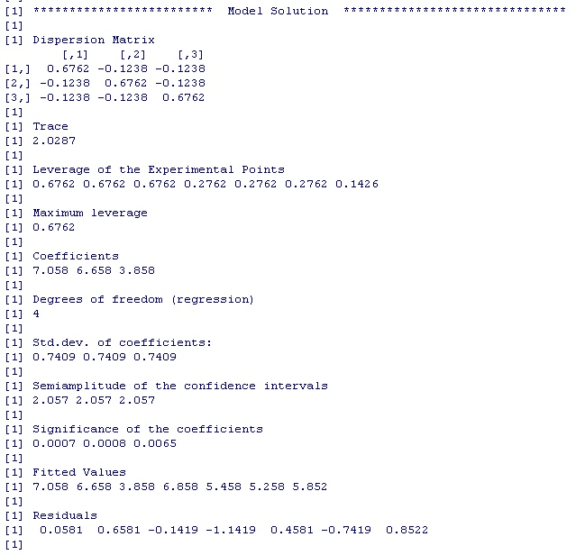
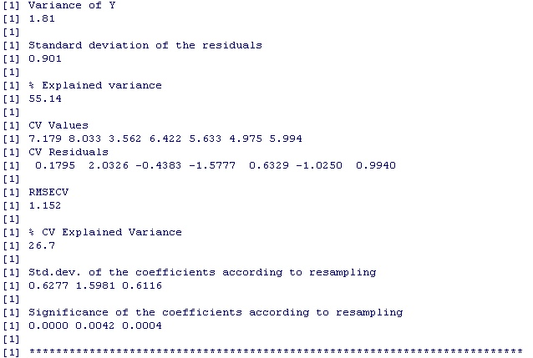
Figure 25 - Contour plot of the leverage and 3D plot of the leverage surface.

Leverage Surface
By calling the Leverage Surface function, a plot appears and the output of the software is shown below (Figure 27 and 28):

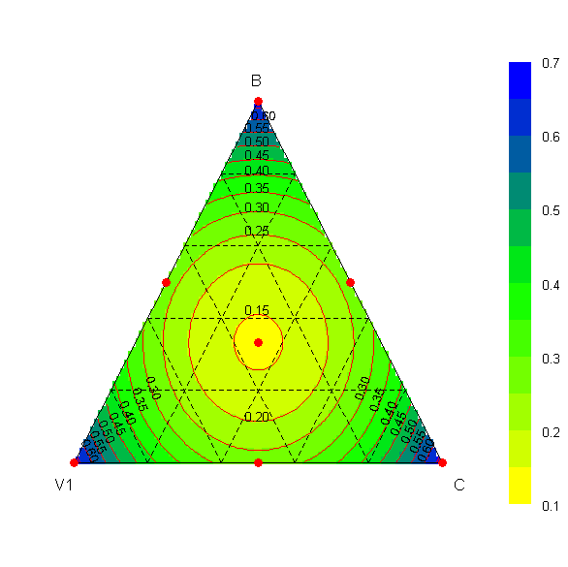
Figure 27 - Contour plot of the leverage.

Response Surface

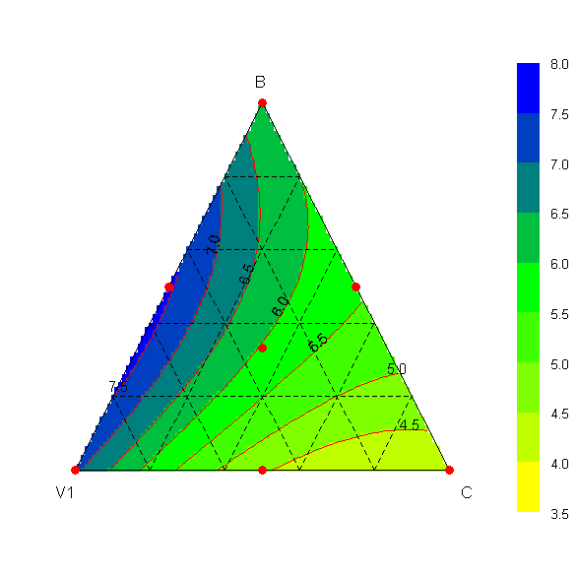
Figure 28 - Contour plot of the response.

The interpretation of the leverage and response surfaces is as the same as non-mixtures designs.

Mixtures – Constraints
The necessity of constraints arises when not the whole space of the variable available (cost, experimental constraints, …)

Constraints settings
By calling the Constraint settings function, a dialogue box appears prompting the user to input the lower, the upper constraints and the grid steps.

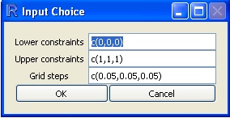
Figure 29 - Constraints settings dialogue box.

The output shown is a grid showing the pseudo-components system:
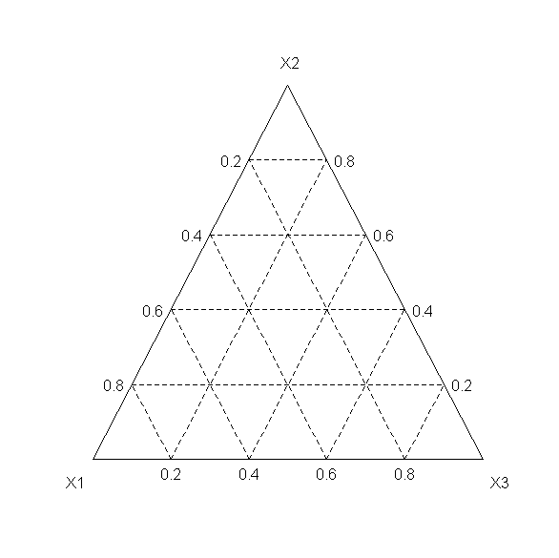
Figure 30 – Grid of the pseudo-components

Leverage Surface

Computed as the same as “No constraints”

Response Surface

Computed as the same as “No constraints”

Prediction
The Prediction function computes values of the response using a given set of x values.
This function can be used in two ways. If no experimental y-values are input, then the Prediction function will provide the fitted values for the given set of x values.
If experimental y-values are input, then the Prediction function plots a graphical comparison between values computed by the model and the experimental values.
The dataset used for showing this function is a 4x5 matrix called pred and is presented here below.

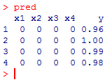

Case 1. No y-values are input.
By calling the Prediction function the dialogue box of Figure 31 is printed on the screen.
After pressing the button OK, the output that appears on the R console is the computation of the y-values fitted.
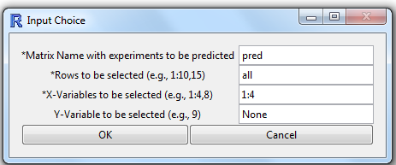
Figure 31 - Prediction dialogue box. No Y-Variable is input.

The output on the R console is represented by four values of y computed given the input values of the x-variables.

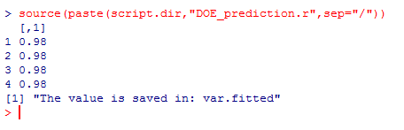
Case 2. The y values are also input
By calling the Prediction function the dialogue box of Figure 31 is printed on the screen. The column of the y-values is input (Figure 32, upper box). After pressing the button OK, the graphical comparison between predicted and experimental values is presented together with the corresponding residuals (Figure 32, lower box).

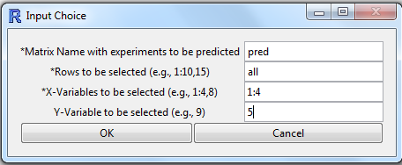
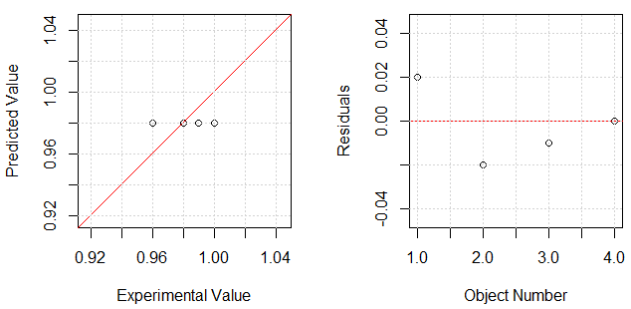
Figure 32 - Prediction dialogue box. The Y-Variable is input (Upper box), the graphical comparison between experimental and fitted y values together with a residuals plot are printed (lower box).

