HELP DISTANCES
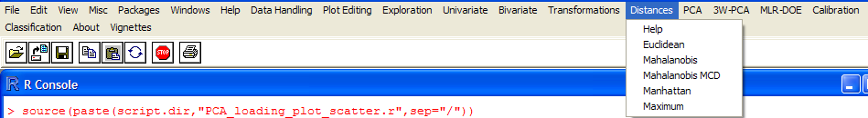

The theoretical parts quoted are taken from:
Kurt Varmuza, Peter Filzmoser, Introduction to Multivariate Statistical Analysis in Chemometrics, CRC Press, 2009 ISBN 978-1-4200-5947-2

Outliers Overview
"A fundamental idea in multivariate data analysis is to regard the distance between objects in the variable space as a measure of the similarity of the objects. Distance and similarity are inverse: a large distance means a low similarity. Two objects are considered to belong to the same category or to have similar properties if their distance is small. The distance between objects depends on the selected distance definition, the used variables and on the scaling of the variables. Distance measurements in high dimensional space are extension of distance measures in two dimensions."
Distance definition
Given two vectors: X_{a}=[x_{a1},x_{a2},...x_{an}] and X_{b}=[x_{b1},x_{b2},...,x_{bn}] their distance is:
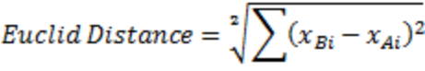
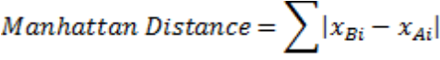
The Mahalanobis Distance is defined for two objects of a population taking in count all the population structure. So its definition is:
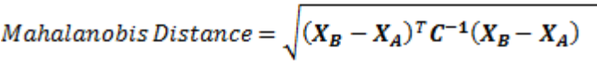
Where C is the covariance matrix of the whole population.In case we want a robust determination we can use the robust covariance matrix MCD instead of C.
The Distances can also be computed from each obeservation to the data center of the all samples. " Points with a constant Euclidian distance from a reference point (like the center) are located on ahypersphere (in two dimensions on a circle); points with a constant Mahalanobis distance are located on a hyperellipsoid (in two dimension on a ellipse) that envelops the cluster of object points. That means that Mahalanobis distance depends on the direction."
Distance Calculation
To calculate the distance of a population contained in a data set given by a matrix (n x m) where n is the number of the samples and m is the number of the properties, chose the topic Distance and from it choose one of the different kind of distance you like (e.g. Euclid). In any case an input box will appear as shown:
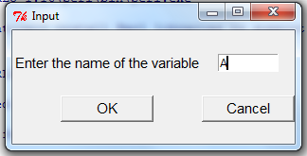
Type the name of the matrix in the full form (e.g A) or in the submatrix synthax (e.g. A[,1:3] or A[,c(5,7)]). After OK is clicked the distance of each single point is evaluated. The output is a symmetrical matrix with dimension (n x n) with 0 on the main diagonal. Each element (i,j) represents the distance between the sample i and sample j.
The outputs of the required functions are displayed on the console. Moreover, results are also stored in the memory under a new variable name. A printout such as "The value is saved in: var.dist" is written on the console before displaying results. Users can use results calling the new variable :
1) in a following Input Box;
2) typing on the console to redisplay results.
If results are graphics, they can be printed, saved and copied on the clipboard using the menu of the window where they are displayed.
Outliers for 2D space
Considering a population in a two dimensional space, it is possible to:
- graph all the points in the plane of the two variables,
- find the center of the population,
- calculate the distance of each point from the center,
- compare each distance with a limit value that is commonly the value of X²_{(2,0.975)}=7.38,
- plot the circle (or ellipse) of limiting values
- detect which data points are further away from the center out of the circle. These are outliers.

To plot the result of this procedure, choose the 2D Graph submenu. Type the name of your data set where matrix is requested. Take care of the matrix dimension: one of the dimension must be 2 since it is a 2D space. In case you have a data set with different groups, type the name of the vector in the factor field. In this case different markers will be used for different groups of samples.
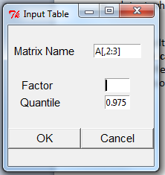
The typical output of this menu is a double plot as in the following. Outliers are the points ouside the circle/ellipse with the confidence of 5% (double side). See example without group defined :
Example data set can be load writing on the console : data(glass);data(glass.grp)
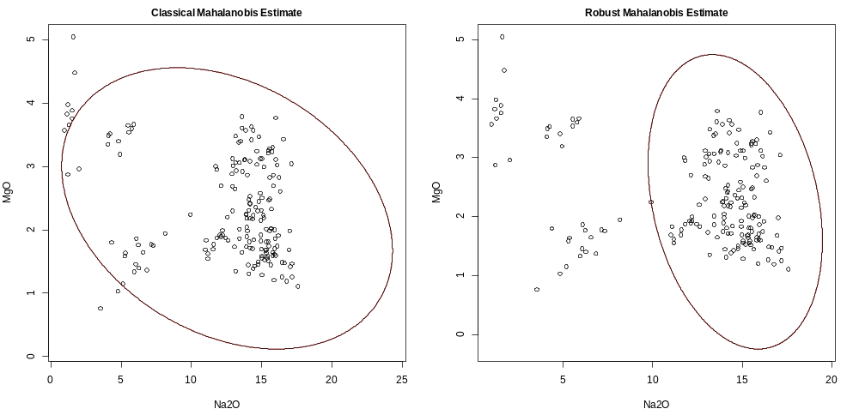
See example with group defined:
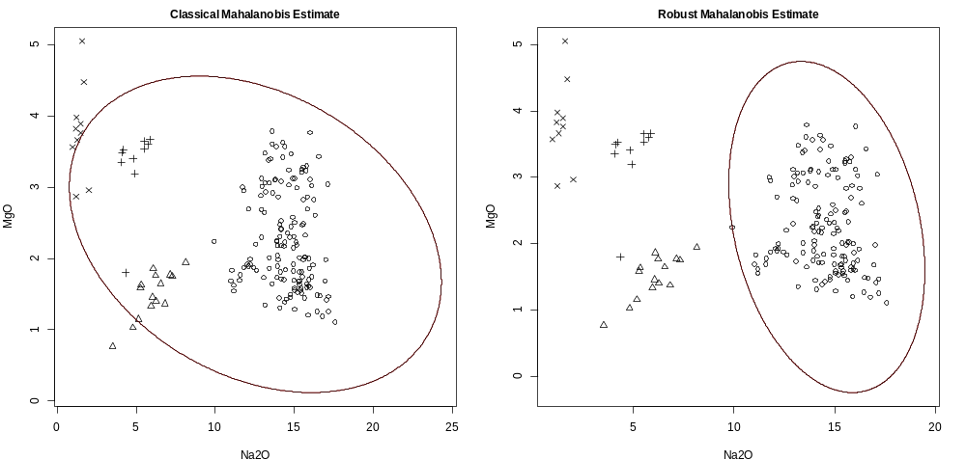

Outliers for nD space
"For high dimensional data, it is no longer possible to show an ellipse and as a cutoff value. However, in this case, it is possible to compute the Mahalanobis distances which are always univariate, and to show them in a plot. "
Results are shown in the next figure using as a input a matrix data set with more than 2 columns. The orizontal line indicates the cutoff value (X²_{(2,0.975)})^{0.5}=2.72. Be aware that the definition of outliers is not a unique procedure. In fact the two techniques presented (Classical and Robust measure of Mahalanobis Distance) show different results.
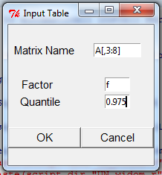
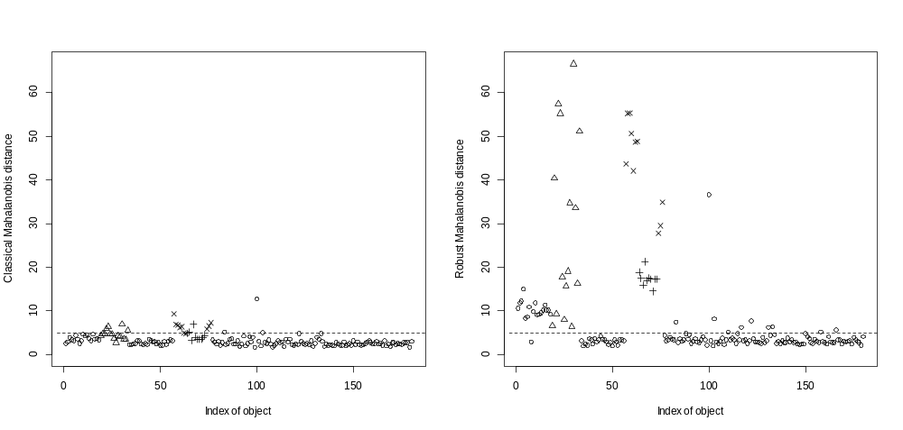
Robust PCA Graph
"The Mahalanobis distanceused for multivariate outlier detection relies on the estimation of a covariance matrix., in this case preferably a robust covariance matrix. However, robust covariance estimators like the MCD estimator need more objects than variables, and thus for many applications with m>n this approach is not possible. For this situation, other multivariate outlier detection techniques can be used like a method based on robustified principal components (Filzmoser P.,Maronna R., Werner M., Comput. Stat. Data Anal. 52, 2008,1694-1711). The method is very fast to compute and can deal with large data sets, ranging into thousands of objects and/or variables."
A typical output is reported below. For the use and explanation see reference.
