HELP PCA
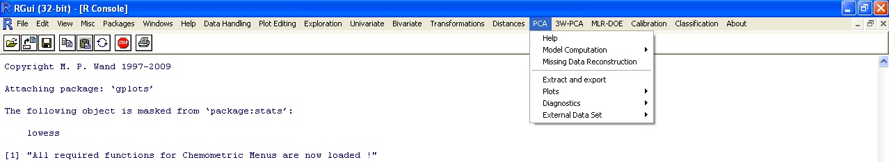

In the menu “PCA” the following options are present:
- Model Computation
- Missing Data Reconstruction
- Extract and export
- Plots
- Diagnostics
- External Data Set

In this help the file “two whiskeys” (present in the “working” directory) will be used.
This data set is made by 43 rows and 13 columns.
Each row corresponds to a sample of whiskey, on which 12 variables have been measured.
The first row contains the header of the variables, while the first column is the category of the sample (“A” or “B”).

Model Computation
The following sub-options are present:
- PCA
- Varimax

For both of them the same “Input Choice” dialogue box will be shown, requiring the name of the matrix, the rows and the columns to be taken into account for the computation and the number of components to be computed. The user can also select whether to apply centering and/or scaling (more “advanced” pretreatments, such as SNV, should be performed previously in the “Transformations” menu).

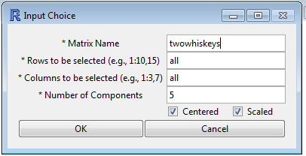

The previous figure shows the default values (all rows, all columns, 5 components, autoscaled data).
In the data set twowhiskeys the first column is not a numerical variable, and therefore only columns 2-13 will be taken into account, as shown in the following figure.

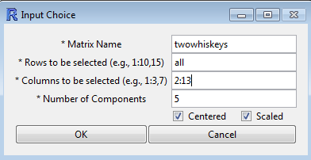

If missing data are present the following message will be shown, reporting the number of missing data:

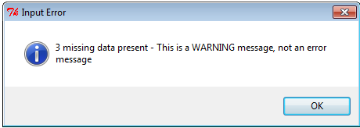

PCA
A numerical output with the explained variance (total and by component) is produced:

[1] Note: Data are saved in the PCA object, write PCA to see all
[1] Variance explained by 5 components: 91.22%
[1] % Variance explained by each component:
[1] 38.40 26.39 11.11 10.74 4.57

Varimax
After the computation of the required number of components the user must select the number of components that will undergo the Varimax rotation. The selection, that will be made by clicking the required number of components in the input box, will be guided by the explained variance of each component, shown both numerically and graphically:

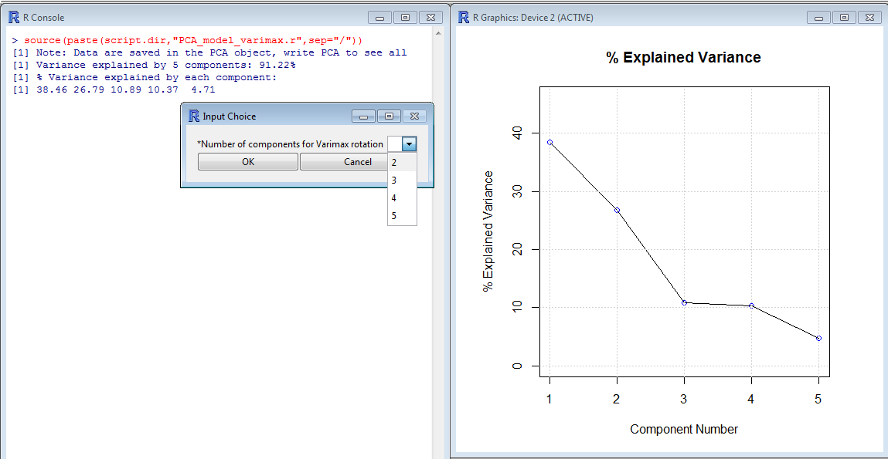

In the case of 2 components being selected, the following numerical output is obtained:

[1] VARIMAX: Variance explained by 2 components: 64.79%
[1] % Variance explained by each component:
PC1 PC2
37.58 27.21

Missing Data Reconstruction
The “Missing Data Reconstruction” function allows to reconstruct missing data.
Note: missing data are coded as “NA” in R; in Excel files the corresponding cells can either be filled with “NA” or left blank.
As previously described, PCA can be performed also with missing data. Their reconstruction is done by multiplying the score matrix time the loading matrix. To do this, the number of significant components must be declared by the user.
In the present example, 20 data have been removed randomly from the dataset “two whiskeys.xls”.
Once the function Missing Data Reconstruction is called, the following dialogue box is shown:

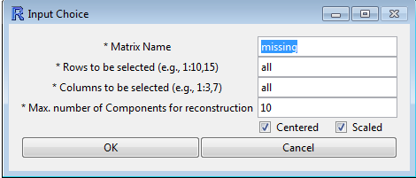

In it, the maximum number of components to be used for data reconstruction must be specified.
A plot is then shown reporting the % Explained Variance computed by performing PCA on the data set with the missing data. On this basis, the user can select the appropriate number of components to be used for data reconstruction (in this case, 2 or 4 are reasonable solutions).

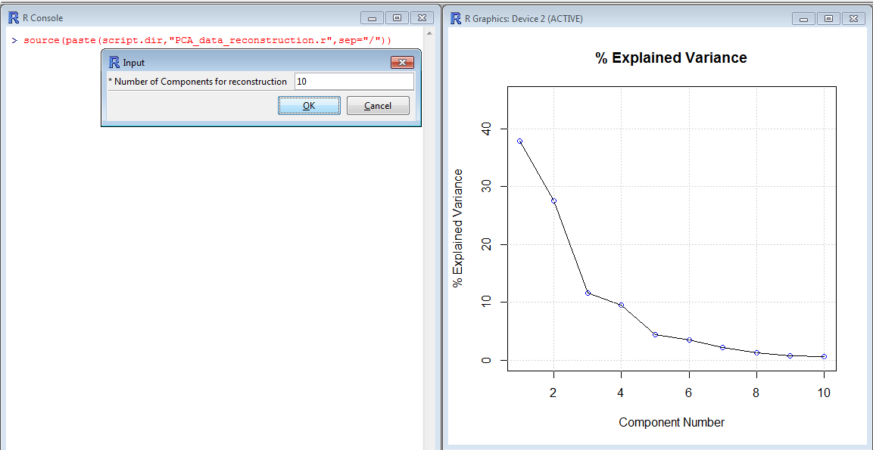

At the end of the procedure the following output is shown:
[1] "Matrix with recomputed data is saved in: missing.full"

The matrix with the recomputed data is saved with the same name of the original matrix, with the extension .full.
Note: the matrix with the recomputed data only has the rows and the columns that have been used for data recomputation, and preserves the row names and the headers of the original matrix. In the previous example it will have 43 rows and 12 columns (to add back the column with the category use the Merge option from the Data Handling – Workspace Management menu).

Extract and export
The results of the model computation are stored in the object PCA.
In some cases, it would be useful to have them as independent variables in the workspace, in order to use them as new variables or to export them.
This function allows to select which one (Loadings, Scores , Explained Variance, % Explained Variance, Cumulated % Explained Variance) will be extracted from the object PCA and stored in the workspace.

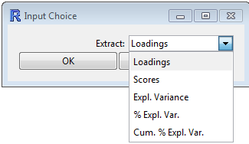

The extracted data will be stored in the workspace as a matrix (for loadings and scores) or a vector having a default name (“loadings”, “scores”, “expvar”, “percexpvar”, “cpercexpvar”, respectively).

Plots

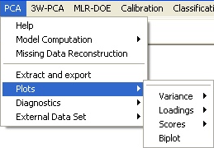

Now the menus are organized by thematic area:

- Variance;
- Loadings;
- Scores;
- Biplot.

Variance plots

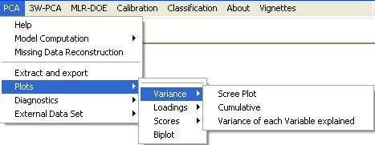

The following sub-options are present:
- Scree plot;
- Cumulative;
- Variance of each variable explained.

Scree plot
This plot shows the % variance explained by each component.

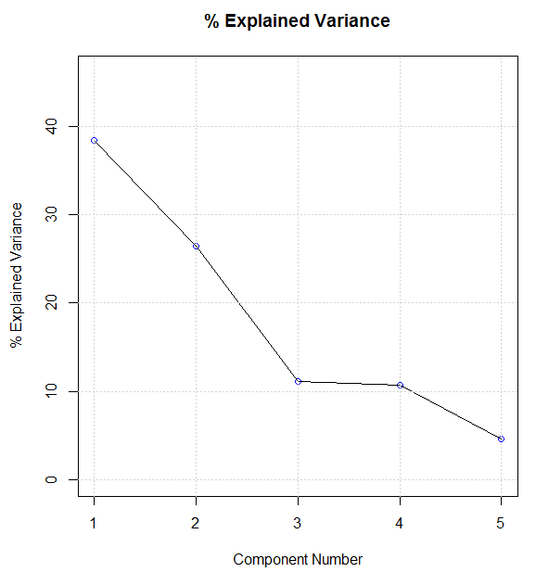
This plot is very important to determine the number of significant components, according to the “broken stick” rule.

Cumulative Variance Plot
This plot shows the % variance explained cumulatively by the first n components.

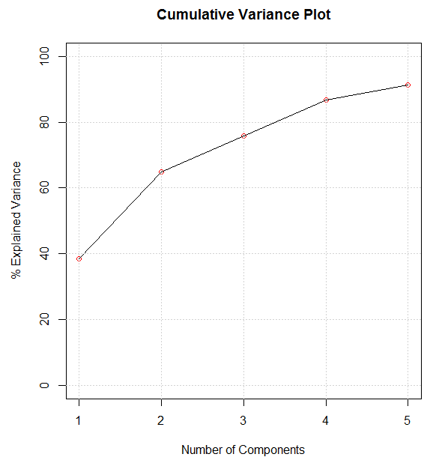

Variance of each Variable explained
This plot shows the fraction of variance of each variable explained by a defined number of components (selected by the user by means of a dialogue box)

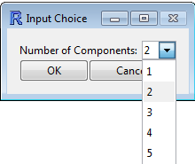

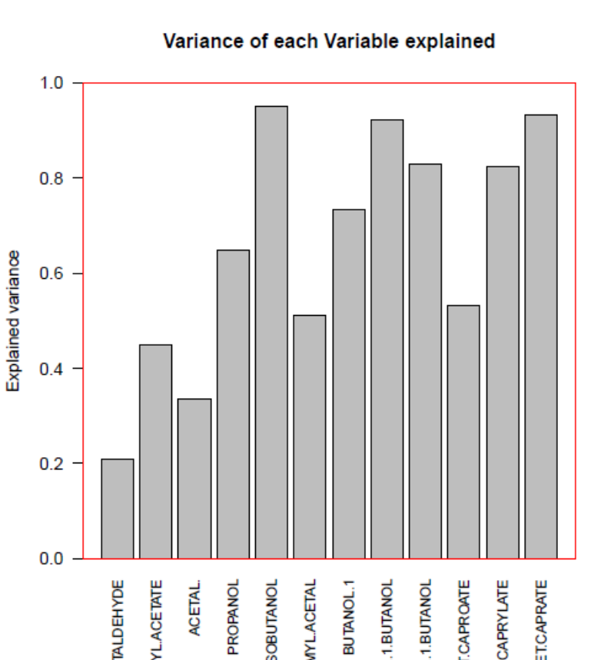

It can be seen that the name of some variables is cut. It is therefore suggested to give names as short as possible.
Loading Plots

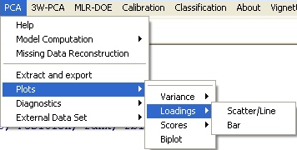

From this submenu it is possible to show:
- Scatter/Line plot;
- Bar plot.

The choice is made by selecting the type of the plot in the following dialogue box, prompted when the user clicks on the “Scatter/Line” option:

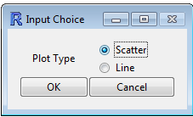

- Scatter plot
This is the most common plot, by which the loadings of the variables on two components are displayed on a plane.

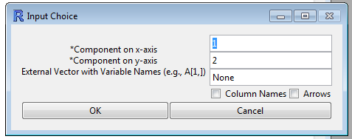

The dialogue box requires to specify the components corresponding to the x and to the y axis.
If the box “Column Names” is left unchecked (as in the default case), then the variables will be coded by a number corresponding to their order in the data set used for computing the PCA model (which could be a subset of the original data set). This option has to be selected especially when the number of the variables is quite high, in order to avoid overcrowding in the plot.
If the box “Column Names” is checked, then the variables will be displayed with the header of the corresponding column in the original data set (of course this option is meaningful only when working with a data set in which the columns have a header). Note: the actual position of the variable in the plane corresponds to the center of the name.
If the box “Arrows” is checked, then the position of each variable in the plane is connected to the origin by an arrow.
The variables can be given a different name from the one present in the header. To do this, a vector having as many elements as the variables must be specified in the field “External Vector with Variable Names” (it can be from the same matrix or from a different matrix)
The following figures show the scatter plot of the same loadings under different options (no names, no arrows; names, no arrows; names, arrows).
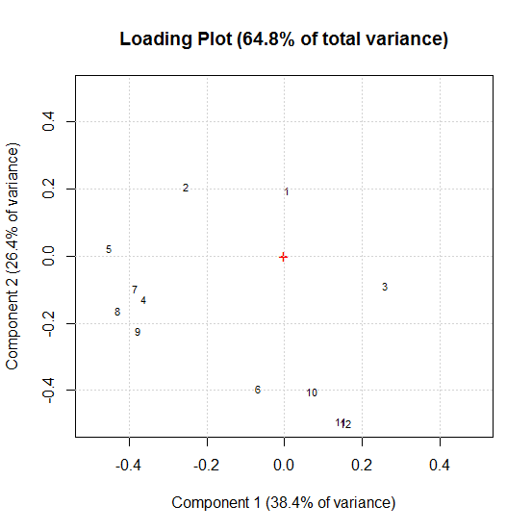

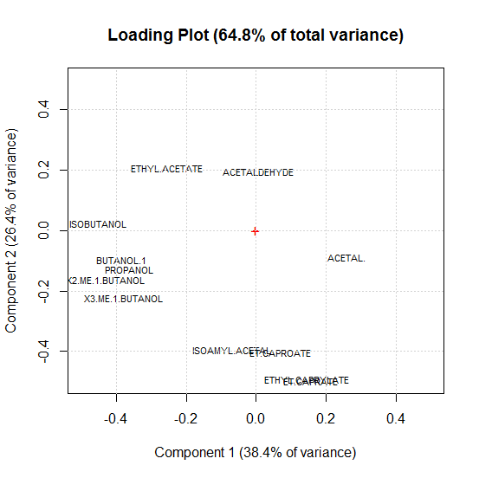
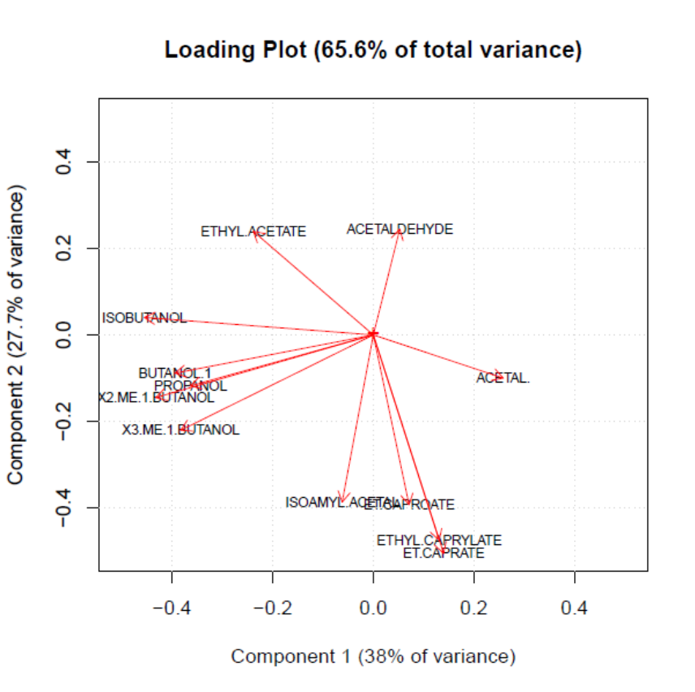
It can be seen that long variable names can produce overcrowding (and sometimes do not fit inside the plot area)

Note: some graphical parameters of the plots can easily be modified by changing the script “PCA_loading_plot_scatter.r” (in the “myscript” folder).
- Font size: in the line “text(T[,n1],T[,n2],tex,cex=0.7)” the value of cex corresponds to the font size;
- Arrow size and color: in the line
“arrows(rep(0,dim(T)[1]),rep(0,dim(T)[2]),T[,n1],T[,n2],0.1,col='red')” the second to last parameter corresponds to the length of the edges of the arrow head, while the last one corresponds to the color
Remember that in order to make the changes effective the modified script must be saved before being run.

- Line plot
If a lines plot is chosen, the dialogue box of Figure PCA 16 appears on the screen. The components to be plotted are requested, and these are specified by input of their number. When the components are specified, the lines plot is printed and represents the loadings values (on the y-axis) corresponding to each variable (on the x-axis), for each component chosen. The lines are overlaid in the different colors as illustrated in Figure PCA 16 (bottom box). The values of the loadings are printable as detailed in the section describing the function “Extract”.

Mid
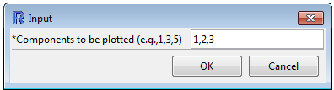
Bottom
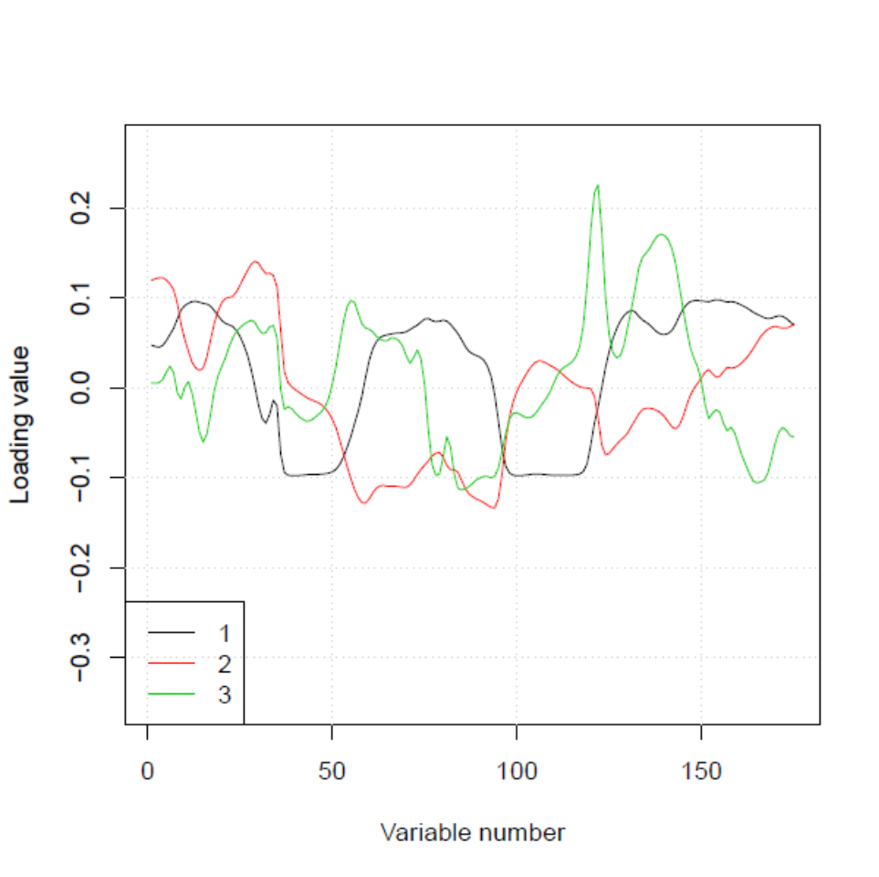
Figure PCA 16 -Output of the “Loading Plot (Scatter – Line)” function. Plot Type “Lines”.
Mid. Second dialogue box, selection of the number of the components to be plotted in the Lines plot. In this case PCs 1 and 2 were selected out of the 5 computed.
Bottom. Lines plot of the loadings values for the 3 PCs. The loadings values are printed in the “Extract” section, see matrix Lm.

The “Loading Plot (Bar)” function prints the loadings for each component in bar plot as shown in Figure PCA 17. As in the cases of the functions described previously, by default the variables plotted are indicated with numbers that correspond to the column numbers of the matrix. However,it is possible to print the name of the variables on the x-axis of the graph. In case the dataset matrix has oneheader rowcontaining the names of the variables, just flag the option "Colum Names" in the dialogue box. If no header is available in the data set, a vector of the names of the variables can be created by using the “c()” function as described in the previous section.

Choose of the component to be plotted first.
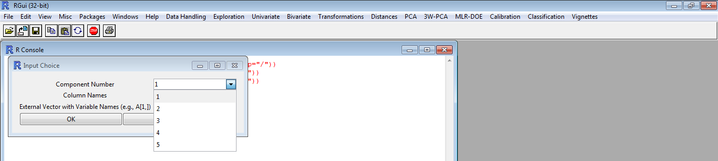

Then specify if the column names should be printed.
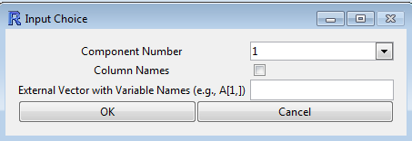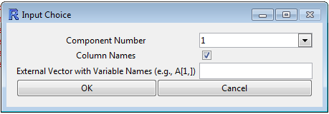
No column names… Column (variable) names printed

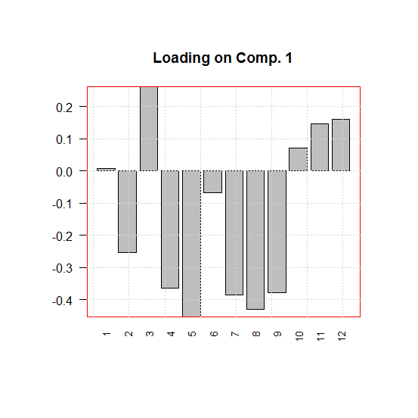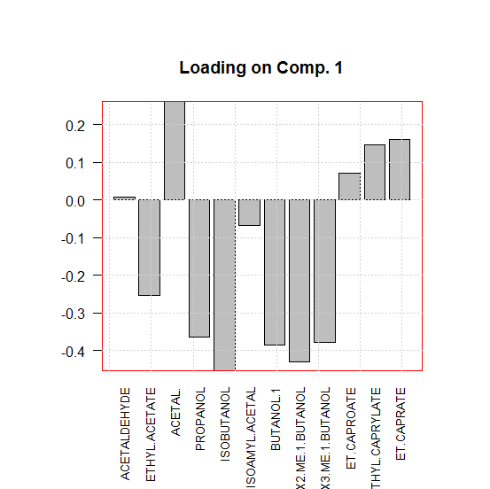

Figure PCA 17 - Output and flow-chart of the function “Loading Plot (Bar)”.

Scores Plot

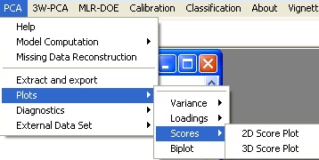

The “Scores Plot” submenu it is possible to choose between:
- 2D Score Plot;
- 3D Score Plot.

2D score Plot
By selecting “2D Score Plot” the software prints the scores for each couple of components chosen by the user as shown in Figure PCA 18. By default, the scores are plotted in black and white and without tags. However, the row numbers of the matrix can beadded to the plot by flagging the box “Row Names” in the “Input Choice” dialogue box that appears calling the function from the menu. It is also possible to printon the plot an Ellipse representing the critical T^2 value at p = 0.05.
A label vector can also be specified to label the points with specific names. A“Color Vector” can be specified in the dialogue box (the vector must havesame number of elements as the rows of the dataset)with a code (factor level) for each point. Each point or group of points will thus be drawn with a different color (Figure PCA 19).
to print the tagged scores and discriminating them using different colors. These vectors can be created by using the “c()” function as described in the previous sections.

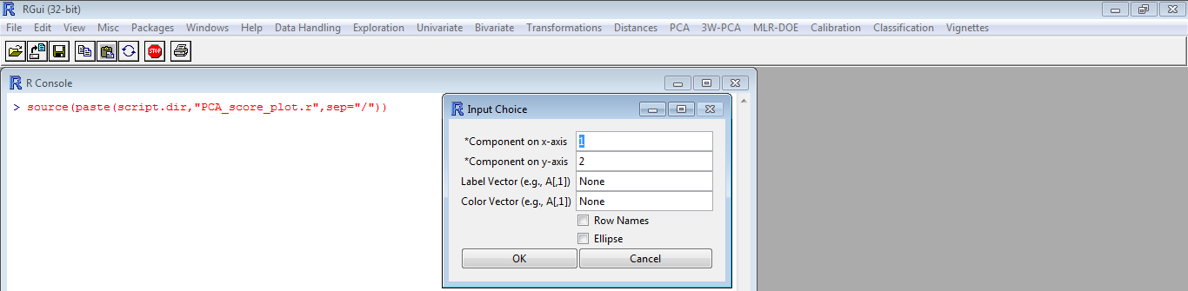
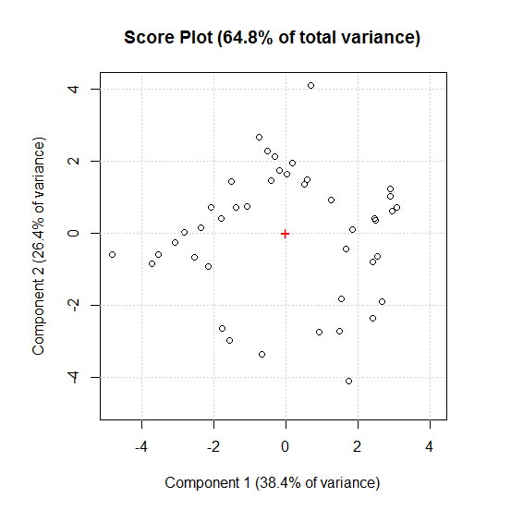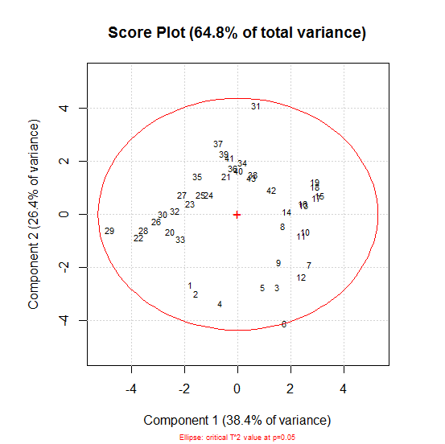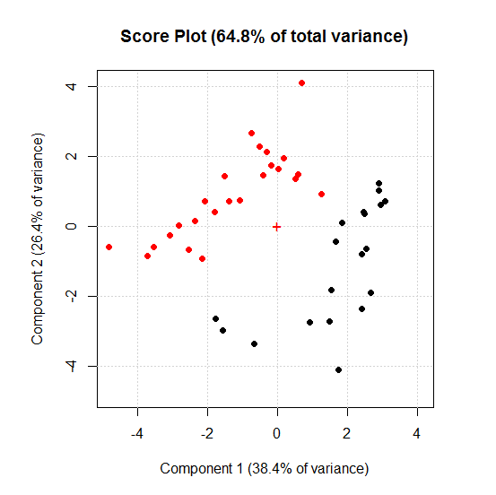
A
B
C

Figure PCA 18 - Output of the function “Scores Plot”.
Top. The “Input Choice” dialogue box, requires to input the number of the components for which the scores should be plotted.
Bottom.
A) Default print of the scores for the first two components.
B) Plot of the scores of first two components after flagging the boxes “Row Names” and “Ellipse”.
C) Plot of the scores of the first two component filling the line “Color Vector“ with the instruction A[,1] (if you are uncertain of the meaning of this command, please refer to the previous sections, “Data Handling” and “Univariate”).

3D score Plot
By selecting “3D Score Plot” the software shows this dialogue box:

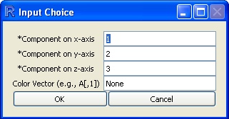

The use is allowed to choose which component the software will print on the set of the axis; a “Color Vector” can be specified in the dialogue box (the vector must have the same number of elements as the rows of the dataset) with a code (factor level) for each point. Each point or group of points will thus be drawn with a different color (as the same as the the 2D score plot).

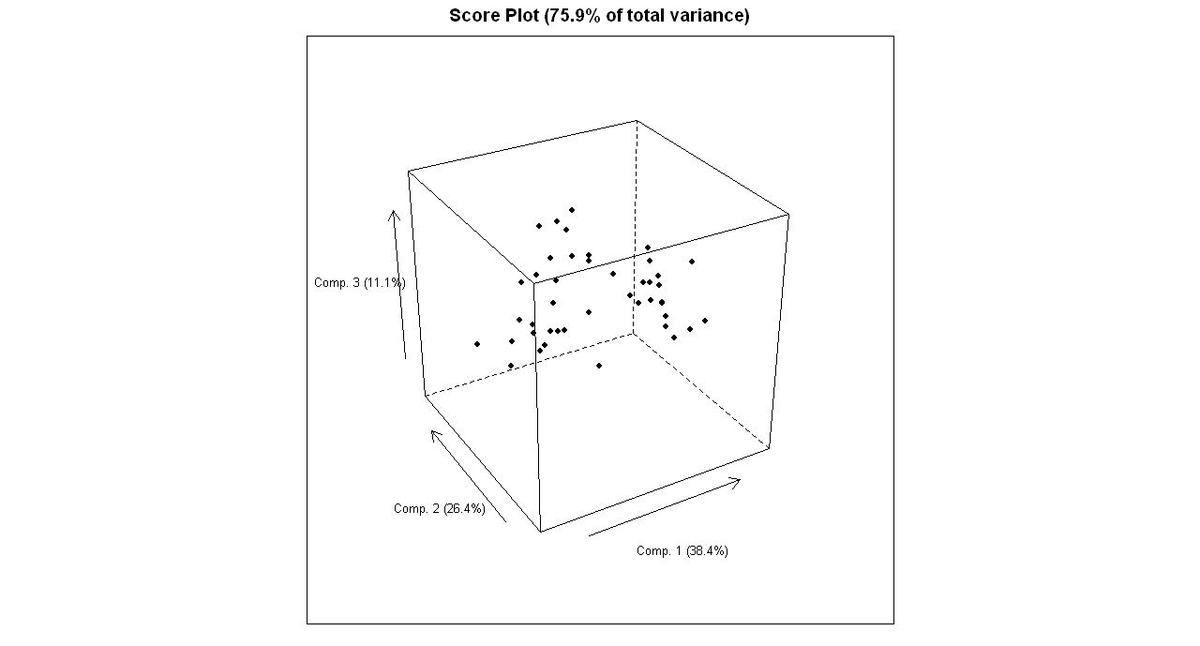

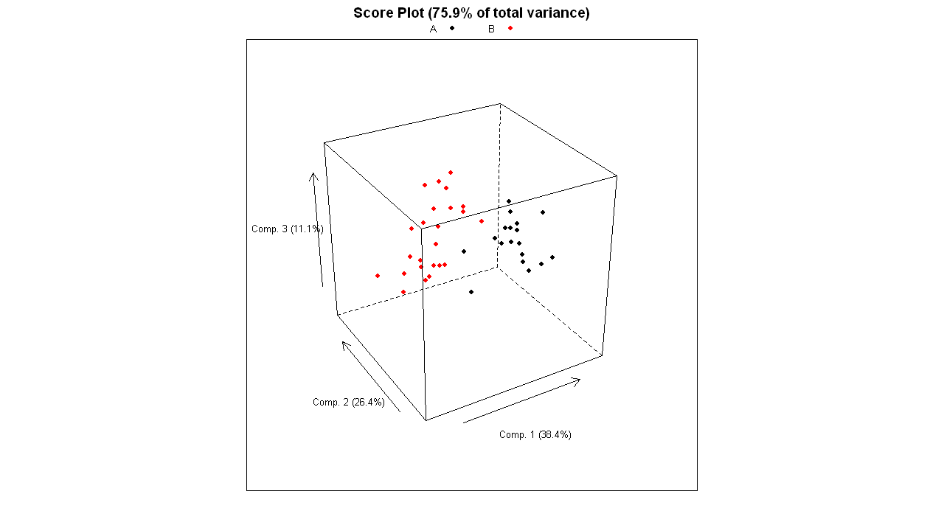

The previous two images show the two 3D plots: the difference is that, in the second one there is selected a color vector (the first column of the dataset) while in the first one not.

The “Biplot” function prints the overlaid graphs of the loadings and of the scores in a biplot. When the function is called the “Input Choice” dialogue box shown in Figure PCA 19 appears requiring to input

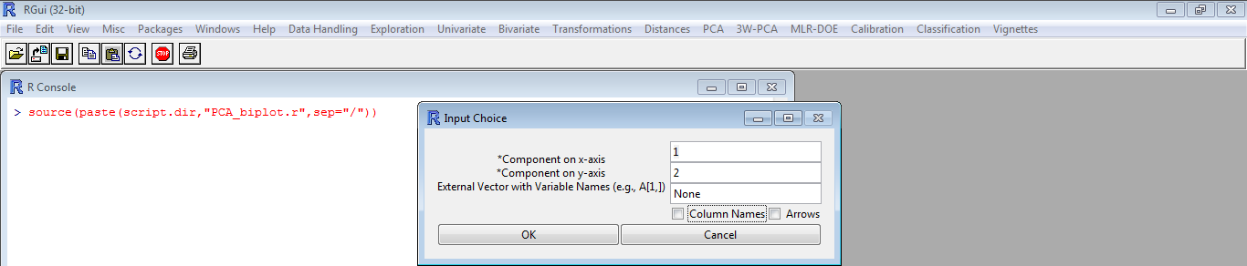
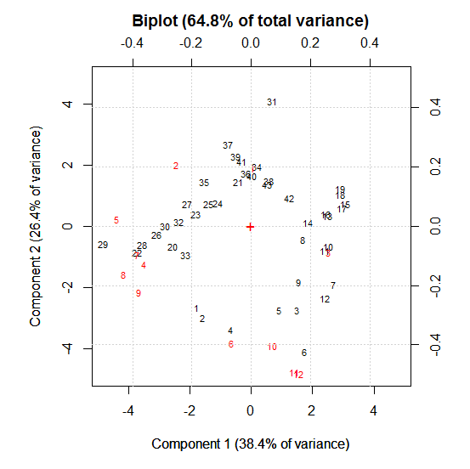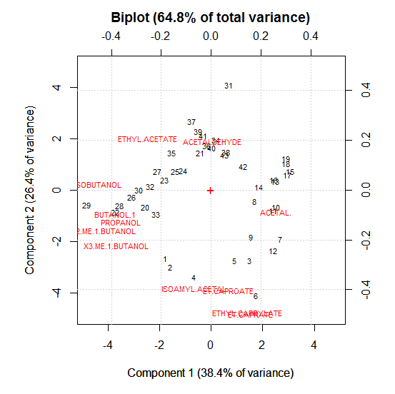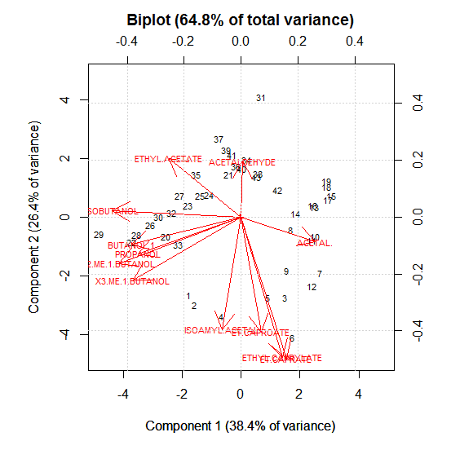
A
B
C
Figure PCA 19 – Output of the function “Biplot”.
Top. “Input Choice” dialogue box appearing when calling the function “Biplot”.
Bottom.
A) Default biplot of the scores and loadings of the first two components.
B) Biplot of the scores and loadings of the first two components when the Column Names box is flagged (for details on the data set A, see section PCA).
C) Biplot of the scores and loadings of the first two components when the Column Names box and the Arrows boxes are flagged (for details on the data set A, see section PCA).

Diagnostic Plots
PCA is sensitive with respect to outlying observations, since outliers can modify the estimation of the PCs. Therefore, it is important to test the PCA model computed and see if the data set contains outliers. The diagnostics of the PCA can be studied computing the residuals, and orthogonal distances of the loadings for each object and plotting them together with critical boundaries. Thesetests can provide clues to distinguish regular observations from outliers. Two parameters are commonly used to this aim: the Q index or Squared Predicted Error (SPE), andthe HotellingT^2 index.
The Q-statistic is used to see how well each observation fits into the PC model.The Q index is based on the residual data matrix, which is used to measure the variability of the data projection in the residual subspace.The Q parameter value geometrically represents the Euclidean distance between each observation vector and its projection onto the hyperplane defined by the PCs of the model. If we have a group of observations containing one or more observations whose Q value is outside the limits of confidence obtained from the PCA model (usually at the 95% confidence levelor p=0.05), this can be considered as an evidence that these are outlying observations since their distance from the PCA model hyperplane is greater than the distances of the other observations.
The Hotelling T^2index is another statistic for determining the significance of multivariate distances.
It is a generalization of the univariate t-statistics. The test checks whether each observation belongs to the multivariate group of observations used to build the PCA model. The T^2 indextest is based on analyzing the score matrix Sm to check the variability of the projected data in the new space of the PCs. In this case too, if the T^2 index for a given observation exceeds the level of confidence(usually at the 95% confidence level or p=0.05) obtained from the PCA model, this can be considered an indication that the observation is different from those used to build the model.
In the submenu Diagnostic Plots the tools shown in Figure PCA 20 are available.

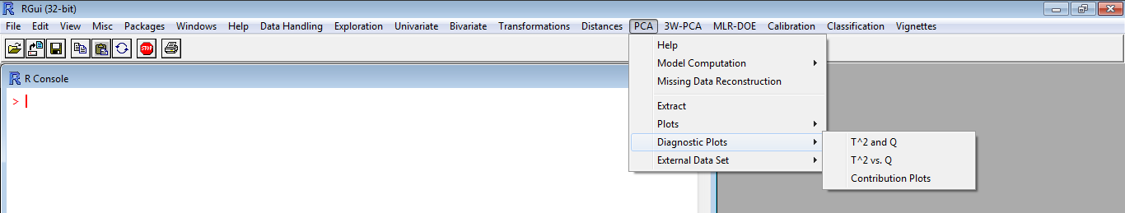
Figure PCA 20 -Tools available in the Diagnostic Plots submenu.

The tools are available only for PCA models and are
T^2 and Q plots
T^2 vs. Q plot
Contribution Plots

The call of the functions “T^2 and Q plots” and “T^2 vs. Q” will make appear the same “Input Choice” dialogue box requiring the specification of the number of components to be studied (Figure PCA 21).

Top
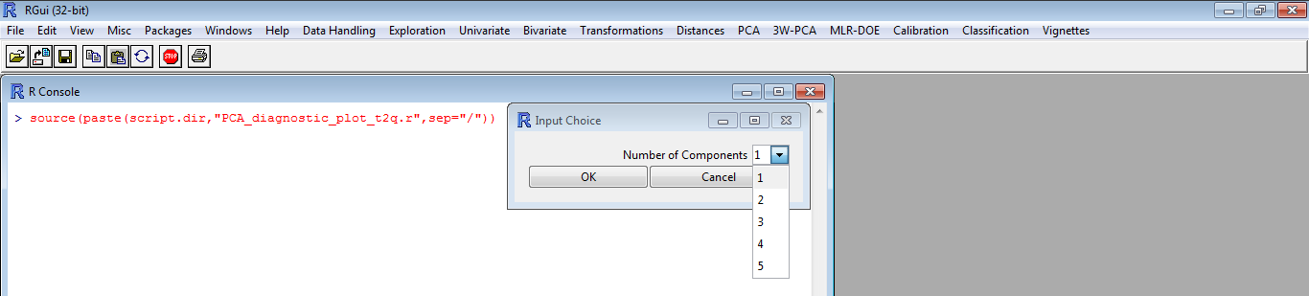
Mid
A
B
C
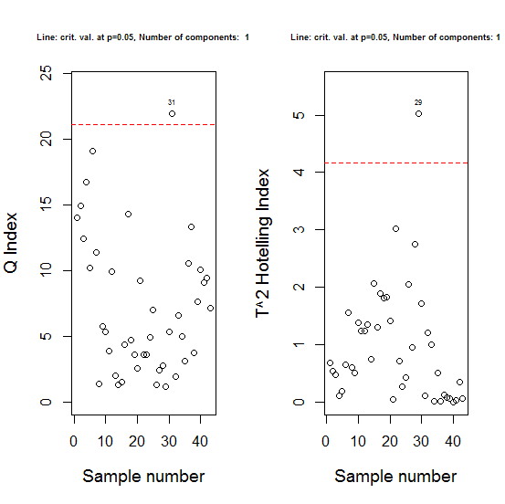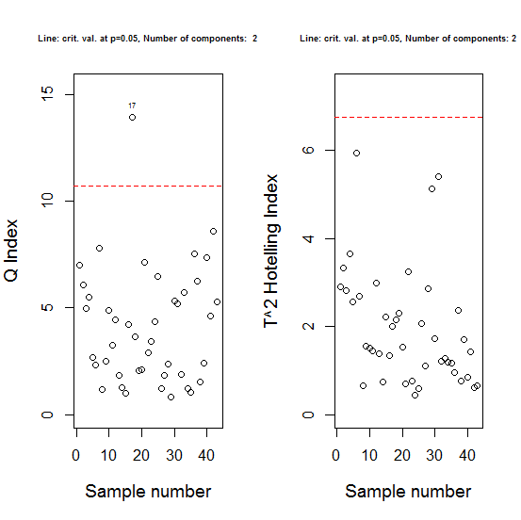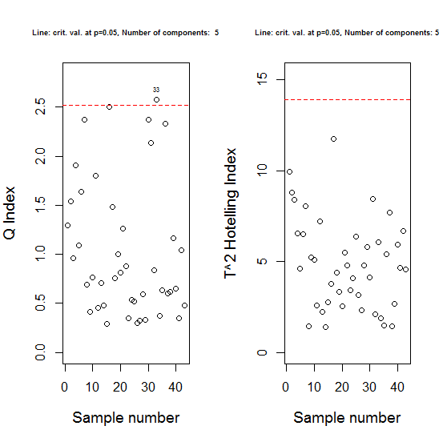
Bottom
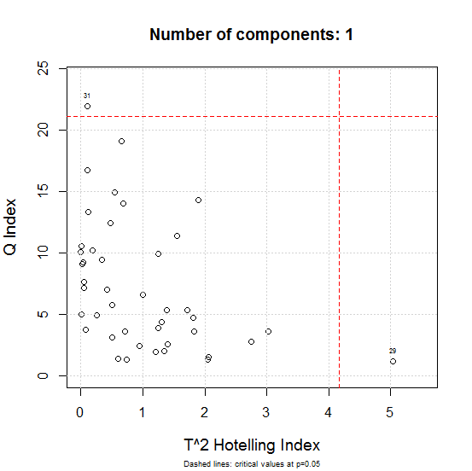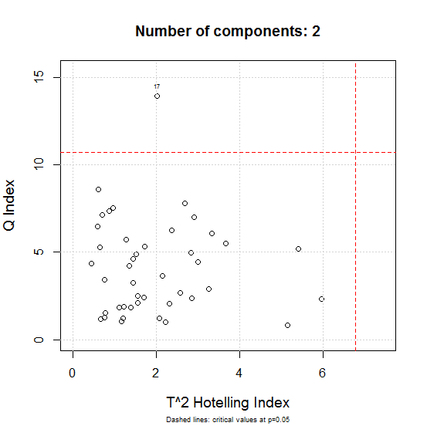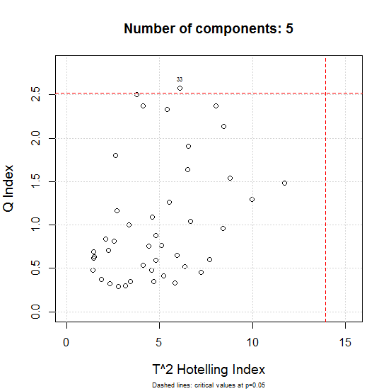
A
B
C
Figure PCA 21 – Output of the functions “T^2 and Q” and “T^2 vs. Q”.
Top. When either of the functions is called, the “Input Choice” dialogue box appears requiring the input of the number of components to be evaluated for the T^2 and Q index tests.
Mid. Output of the function “T^2 and Q” for (A) 1 PC, (B) 2 PCs, and (C) 5 PCs.On the x-axis the sample number is printed, whreas on the y-axis it is reported the value of the index. Passing from one PC (A) to 5 PCs (C), the scale of the y-axis decreases.
Bottom.Output of the function “T^2 vs. Q” for (A) 1 PC, (B) 2 PCs, and (C) 5 PCs. On the x-axis the T^2 parameterand on the y-axis the Q index value areprinted, respectively. Passing from one PC (A) to 5 PCs (C), the scales of the both axes are automatically adapted to the decreasing values of the parameters.

Contribution Plots
The presence of outliers can be evidenced also by contribution plots.
If the function “Contribution Plots”is called, the “Input Choice” dialogue box shown in Figure PCA 22 appears requiring to input the row number of the observation to be evaluated and the number of the component to be tested.
The first graph draws the contribution of each variable to the Q index measured for the observation under examination. To provide further detailson the component, the sign of the residuals is maintained.
The second graph shows theobservation contribution plot for the given component using theT_{i}²Hotelling Index.

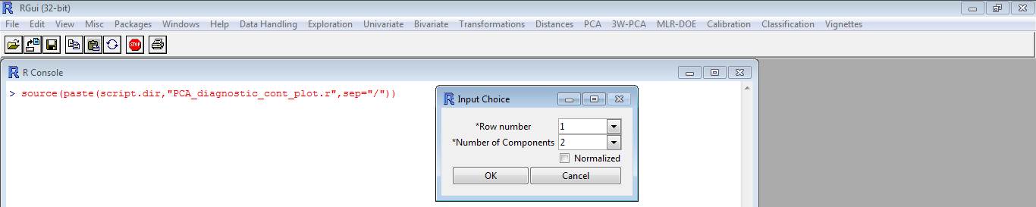
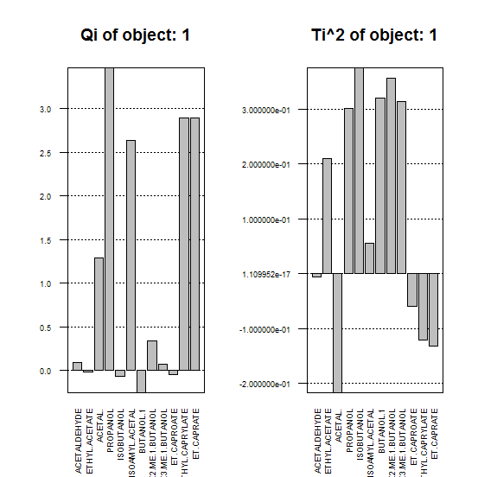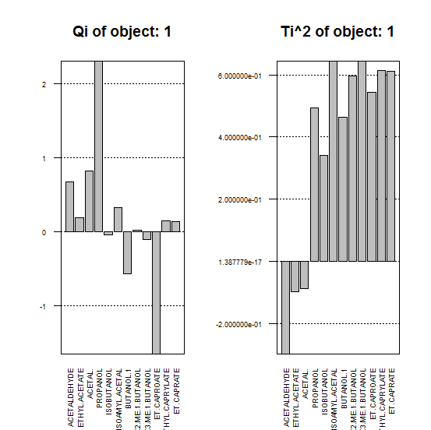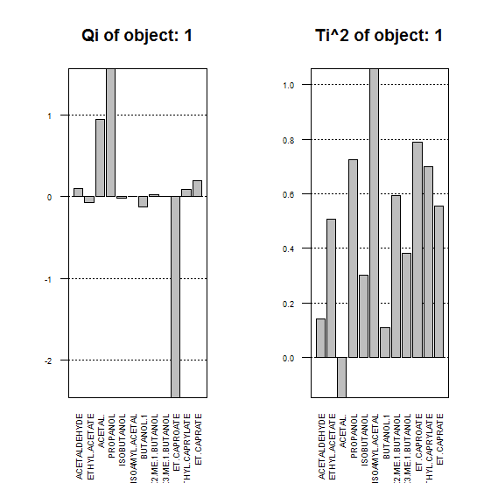
A
B
C
Figure PCA 22 -Output of the functions “Contribution Plots.”
Top. When the function is called, the “Input Choice” dialogue box appears requiring to input the observation number (Row number) of the data set and the Number of Components to be evaluated by their contribution plot using the Q and the T^2 indices tests.
Bottom. Contribution plots of row 1 for 1 PC (A), 2 PCs (B), and 3 (PCs).

References

Varmuza K., Filzmoser P., Introduction to Multivariate Statistical Analysis in Chemometrics. CRC Press, 2009 ISBN 978-1-4200-5947-2.

Vandeginste, B.G.M., Massart, D.L., Buydens, L.C.M., De Jong,S., Smeyers-Verbeke, J., Handbook of Chemometrics and Qualimetrics: Part B. Elsevier, Amsterdam, The Netherlands,1998.

Brereton R.G., Chemometrics for pattern recognition. J.Wiley& Sons, Chichester, UK, 2009.

