Help PLOT EDITING

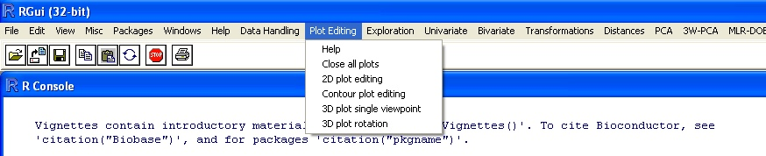

In the menu “Plot Editing” the following options are present:

- Close all plots
- 2D plot editing
- Contour plot editing
- 3D plot single viewpoint
- 3D plot rotation

Help
The “Help” option automatically opens the help for “Plot Editing” menu; it allows the user to consult this help.

Note: in order to use the following options the user must have plots object in the workspace; plots can be generated, for example while doing a PCA (score plot, loading plot, …) or in a DoE (contour plot, surface plot, …)

Close all plots
The “Close all plots” option allows to close simultaneously all the plots.

2D plot editing
The “2D plot editing” option allows the user to modify and/or see in details one plot.
After the selection of this option a dialogue box appears:

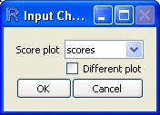

The software automatically search for a plot object in the workspace; if no object is detected, the score plot box will not be available.
As an example, the object selected in the image is a score plot made with the PCA method.
After the selection of a plot object this dialogue box appears:

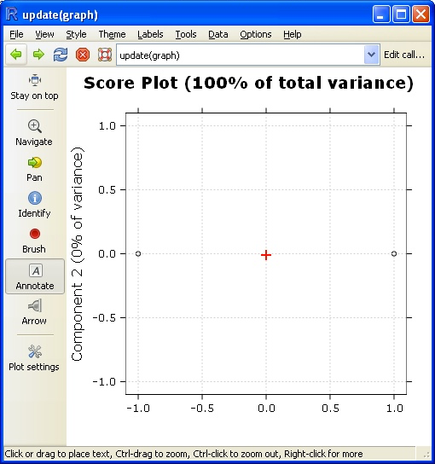

In this window there are many options that can modify the plot, the user can, for example:

- Annotate;
- Add arrows;
- Modify the main theme;

Contour plot editing
The instructions written into “2D plot editing” section, in order to obtain the “Update(graph)” window, are valid also for this section.

The “Contour plot editing” option allows to modify the color of the line such as the color and the size of the labels of a contour plot obtained in the MLR-DOE menu.

3D plot single viewpoint
The “3D plot single viewpoint” option allows to select a specific viewpoint for the 3D plots (response or leverage surface obtained in the MLR-DOE menu and 3D score plot obtained in the PCA menu).

After the selection of this option a dialogue box appears:

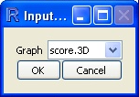

The software automatically search for a plot object in the workspace; if no object is detected, the “Graph” box will not be available.
As an example, the object selected in the image is a score plot made with the PCA method.
After the selection of a plot object this dialogue box appears:

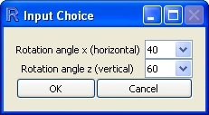

Default values are 40 and 60 but the user is free to select any value.
In the next image values are setted 20 (x) and 60 (z):

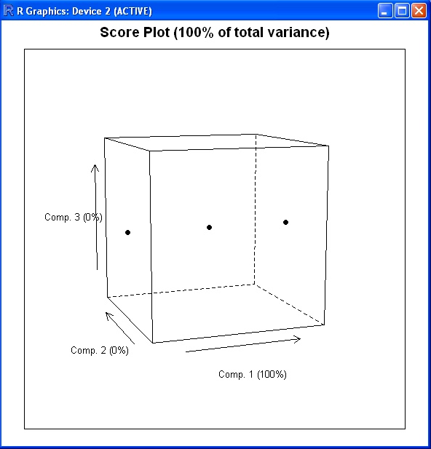

3D plot rotation
The “3D plot rotation” option allows to perform a full 60 degrees rotation, at the desired height, of a 3D plot.

After the selection of this option a dialogue box appears:

The software automatically search for a plot object in the workspace; if no object is detected, the “Graph” box will not be available.
As an example, the object selected in the image is a score plot made with the PCA method.
After the selection of a plot object this dialogue box appears:

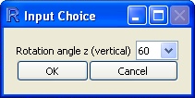

After the selection of the height a plot automatically appears and a rotation of 360° is made (it is not possible to stop the rotation)
In the following image, the rotation angle is set at 90°; in the left part of the image, above the plot, it is possible to see the rotation angle (in this case 360° i.e. the end of the rotation):

