HELP TRANSFORMATIONS
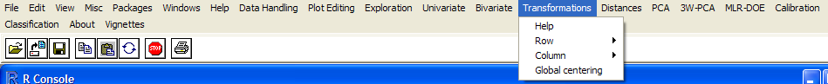

The theoretical parts quoted are taken from:
Kurt Varmuza, Peter Filzmoser, Introduction to Multivariate Statistical Analysis in Chemometrics, CRC Press, 2009 ISBN 978-1-4200-5947-2

Input Variable Name
This input box appears before each function is called and requires the name of the variable that is going to be processed. In the Trasformation Menu only matrices/dataframes are processed and their names must be typed considering that R is case sensitive. A default name taken as the previous choice is always proposed. So, if the matrix A is stored in the R memory and must be processed :
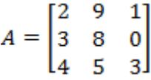
The letter “A” should be typed in the Input Variable Name box. However it is possible to process its sub matrices using the R syntax. Following examples shows several alternatives:

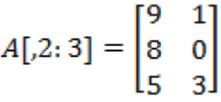
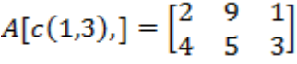
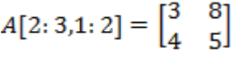
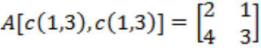

Normalization
“ Normalization refers to row-wise transformations of a matrix X. Usual transformations are normalization to a CONSTANT SUM of the variables (for instance for concentration data) , a CONSTANT MAXIMUM value of the variables (as common for mass spectra), or normalization to a CONSTANT VECTOR LENGTH (constant sum of squared variables). A graphical representation of these transformations makes clear that the dimensionality of the data is reduced and that the distances of the data points are modified. Such data are called to be CLOSED and may give artifacts in some methods of data analysis; “
R: X_sum100<-X/apply(X,1,sum)*100 # data sum 100
X_max100<-<-X/apply(X,1,max)*100 # data maximum 100
X_length<-X/sqrt(apply(X^2,1,sum)) # data length 1

Sometimes it is also useful that data vary in a closed range. A linear transformation can be imposed in order to scale them in a defined interval such as 0 /+1 or -1 / +1.
Centering and Scaling
Centering and scaling are usually applied after data transformation. They refers to column-wise manipulations of a matrix X with the purpose that all columns have zero mean (centering) and the unit variance (scaling). Depending on the task, only centering but not scaling can be applied. Let be the mean and the standard deviation of a variable j. After MEAN-CENTERING, the variable has zero mean; the data are shifted by and the center of the data becomes the new origin – consequently the information about the origin is lost; the distances between the data points remain unchanged. Mean-centering simplifies many methods in multivariate data analysis. Notation in R is given for a matrix X.
R: X_cent<-scale(X, center=TRUE, scale=FALSE)
VARIANCE SCALING standardizes each variable j by its standard deviation ; usually , it is combined with mean-centering and is then called AUTOSCALING (or z-transformation).
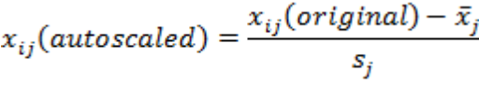
R: X_auto<-scale(X,center=TRUE,Scale=TRUE)
Autoscaled data have zero mean and unit variance, thereby giving all variables an equal statistical weight. Autoscaling shifts the centroid of the data points to the origin and changes the scaling of the axes, consequently the relative distances between the data points are changed (except the original variances of all variables are equal). Autoscaling is the most used preprocessing in chemometrics; a disadvantage is a blow-up of variables with small values (for instance originating from less precise measurements near the detection limit).
If the data include outliers, it is advisable to use robust versions of centering and scaling. The simplest possibility is to replace the arithmetic means of the columns by the column medians, and the standard deviations of the columns by the median absolute deviations(MAD), as shown in the following R-code for a matrix X .
R: X_auto_robust<-scale(X,center=apply(X,2,median),scale=apply(X,2,mad)) “
“As already noted, many statistical estimators rely on symmetry of the data distribution. For example, the standard deviation can be severely increased if the data distribution is much skewed. It is thus often highly recommended to first transform the data to approach a better symmetry. Unfortunately, this has to be done for each variable separately, because it is not sure if one and the same transformation will be useful for symmetrizing different variables. For right–skewed data, the LOG-TRANSFORMATION is often useful (that means taking the logarithm of the data values). More flexible is the POWER TRANSFORMATION which uses a power p to transform values x into x^{p}. The value of p has to be optimized for each variable; any real number is reasonable for p, except p=0, where a log-transformation has to be taken. A slightly modified version of the power transformation is the BOX-COX TRANSFORMATION, defined as:
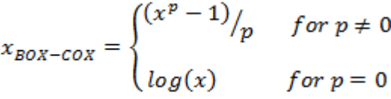
The optimal parameter p can be found by maximum-likelihood estimation, but even the optimal p will not guarantee that the Box-Cox transformed values are symmetric. Note that all these transformations are only defined for positive data values. In case of negative values, a constant has to be added to make them positive. Within R, the Box-Cox transformation can be performed to data of a vector x as follow:
R: library(geoR) # load library geoR
P<-boxcox.fit(x)$lambda # determine optimal p
Library (car) # load library (car)
X_boxcox<-box-cox(x,p) # Box-Cox transformation

Especially for data which are proportions in the range 0-1, the LOGIT TRANSFORMATION can be useful to approach a normal distribution It is defined for a data value x as:

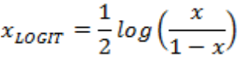
R: x_logit<-0.5 log(x/(1-x)) “

Transformation for Compositional Data
“ While there are transformations that normalize a data matrix X to row sum equal to 1, some data sets are originally provided in this form that the values of an object sum up to for instance 100%, like relative concentrations of chemical compounds in a mixture. Such data are called COMPOSITIONAL DATA or CLOSED DATA. Because of the constrain, the matrix X has not full rank; for instance with three compositions (x-variables), the object points are in two-dimensional subspace. If the value of one variable is increased, the other variable values must decrease in order to keep the constraint of 100%. This can lead to “forced” correlations between the variables. Different transformations were introduced to reveal the real underlying data variability and variable associations. The ADDITIVE LOGRATIO TRANSFORMATION is defined as:
R: library(chemiometrics)
X_alt<-alr(X,divisor=3) # column 3 of matrix is used as divisor variable

In words, the value of one variable (divisor, index K) are used to divide the remaining variables of each object. Thus the transformed values are related to one variable (which is lost for further analysis), and consequently they have a different interpretation. Moreover, it is rather subjective which variable is used as divisor, and subsequent results will depend on this choice.
A more objective way to treat compositional data is the CENTERED LOGRATIO TRANSFORMATION, defined as:
whit 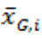 being the geometric mean of all m variables in object i. One can show that the transformed data again have not full rank because the rows sum up to 0.
The ISOMETRIC LOGRATIO TRANSFORMATION repairs this reduced rank problem by taking an orthonormal basis system with one dimension less. Mathematical details of these methods are out of the scope of the book; however, use within R is easy.
R: library (chemiometrics)
X_ilr<-ilr(X) # isometric logratio transformation
X_clr<-clr(X) # centered logratio transformation

Derivatives First and Second

The derivative transformation is made by difference on the values versus their column or row order. User may chose it checking the corresponding menus. In case of calculation by column the output is a matrix with one row less than the original (the first row is missing). Calculation by row causes the loss of the first column. The result is saved in the var.trans variable and shown on the console.

Outputs
The outputs of the required functions are displayed on the console. Moreover, results are also stored in the memory under a new variable name. A printout such as "The value is saved in: var.trans" is written on the console before displaying results. Users can use results calling the new variable. The result variable in memory , var.trans, is the same for all the transformations so only the last one is saved.

