HELP UNIVARIATE

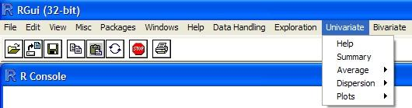

In the menu “Univariate” several tools and plots typical of univariate data analysis are available.
The following options are present:
- Summary
- Average
- Dispersion
- Plots

General Information

Missing Data
All the functions present in this menu can be performed also with missing values (they are ignored and calculations are performed without considering them). In such cases the message ">>NA found and ignored<<" will be shown on the console.

Matrix Name
With any of the options, the following dialogue box is shown:

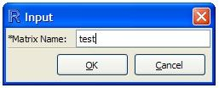

The name suggested by default is the last name used (R is case sensitive).
When only a part of the matrix has to be processed, this information must be given according to the R syntax.

As an example, let’s suppose we want to work on the matrix test, made by 3 rows and 3 columns:
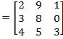
test

If we want to work on the whole matrix, “test” should be typed in the dialogue box (without quotation marks).
It is possible to process its sub matrices using the R syntax.
We have the following general cases:

- test[r,]: row r, all the variables;
- test[r1:r2,]: rows from r1 to r2, all the variables;
- test[c(r1,r2,r3),]: rows r1, r2 and r3, all the variables (in the R jargon, “c” stays for “concatenate”);
- test[c(r1,r2:r3),]: rows r1, from r2 to r3, all the variables;
- test[,v]: all the rows, variable v;
- test[,v1:v2]: all the rows, variables from v1 to v2;
- test[,c(v1,v2,v3)]: all the rows, variables v1, v2, v3;
- test[,c(v1,v2:v3),]: all the rows, variables v1, from v2 to v3 plus the possible combinations;
- test[r1:r2,v1:v2]: rows from r1 to r2 and variables from c1 to c2.

Some examples on the above mentioned matrix:

Row 2, all the variables: test[2,]
Rows 1 and 3, all the variables: test[c(1,3),]

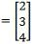
All the rows, variable 1: test[,1]

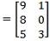
All the rows, variables 2 to 3: test[,2:3]

Rows 2 to 3, variables 1 to 2: test[2:3,1:2]

Caution: if a column contains both numeric and alphanumeric values, this column will be considered as alphanumeric and therefore no numeric computations will be possible on it (not even if only numerical values are selected); this characteristic will be kept also in case of modifications removing the alphanumeric data.

Summary
Five different inputs are possible, and different results will be obtained according to the type of data.
To better explain them, let us take into account the two following matrices, having 6 rows and 5 columns.

Matrix A1: all the variables are numerical; 3 missing data.

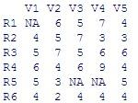

Matrix A2: variables 1 to 4 are numerical, while variable 5 is alphanumeric; 3 missing data.

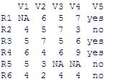

1) Only the name of the matrix is given (“A1”): the following six parameters are returned, computed on all the data (all the rows and all the columns):

- minimum;
- 1st quartile;
- median;
- mean;
- 3rd quartile;
- maximum.

This operation is possible only if all the variables are numerical variables, i.e., only if the data matrix does not contain any alphanumeric value.
This operation is logical only if all the variables have the same unit (it would be a nonsense to compute an average of grams, meters and peak areas...).
In case of missing values, the total number of missing values is also reported.

With matrix A1:
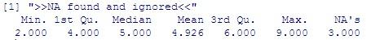

With matrix A2 this operation is not allowed, since variable 5 is alphanumeric:

2) Rows are specified (e.g., “A1[1:5,]”): the six parameters are returned, computed on any of the specified rows.

This operation is possible only if all the variables are numerical variables, i.e., only if the data matrix does not contain any alphanumeric value.
This operation is logical only if all the variables have the same unit.
In case of missing values, the number of missing values for each row is also reported.

With matrix A1:
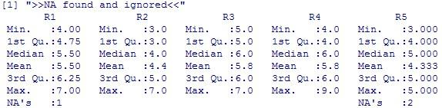

With matrix A2 this operation is not allowed, since variable 5 is alphanumeric:

3) Columns are specified (e.g., “A1[,3:5]”):

- For the numerical variables the six parameters are returned, computed on any of the specified columns;
- For the alphanumeric variables the summary of the frequency of each alphanumerical value is given (if more than 6 alphanumeric values are present, only the 6 most frequent ones are shown).

In case of missing values the number of missing values for each column is also reported.

With matrix A1:
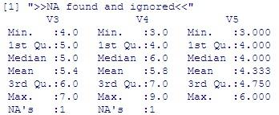

With matrix A2:
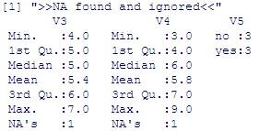

4) Rows and columns are specified (e.g., “A1[3:5,2:5]”): the six parameters are returned, computed on any of the specified rows, limited to the specified columns.

This operation is possible only if all the selected variables are numerical variables, i.e., only if the specified columns do not contain any alphanumerical value.
This operation is logical only if all the variables have the same unit.
In case of missing values the number of missing values for each row is also reported.

With matrix A1:
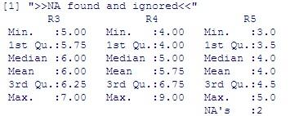

With matrix A2 this operation is not allowed, since variable 5 is alphanumerical:

5) Brackets are opened and closed after the name of the matrix, without any specification of rows and columns (“A1[,]”):

- For the numerical variables the six parameters are returned, computed on any column;
- For the alphanumerical variables the summary of the frequency of each alphanumerical value is given (if more than six alphanumerical values are present, only the six most frequent ones are shown).

In case of missing values the number of missing values for each column is also reported.

With matrix A1:
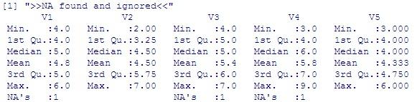

With matrix A2:
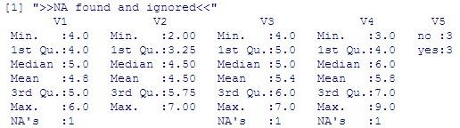

Note: pay attention to the difference between “A1[1:6,1:5]” and “A1[,]”. Though apparently the two different notations are equivalent (meaning “all the 6 rows and all the 5 columns”), the former will return the six parameters computed on each row, while the latter will return the six parameters computed on each column.

Average
The “Average” option allows to compute different types of estimators of the central value. The following sub-options are present:

- Arithmetic;
- Geometric;
- Median.

The results obtained by using this options will be stored in the variable var.mean.

All the operations performed in this option are possible only if all the selected variables are numerical variables, i.e., only if the selected variables do not contain any alphanumerical value.
If this constraint is not respected, the following message will appear:

For each sub-option five different inputs are possible, and different results will be obtained according to the type of data. The results will be shown by using the matrix A1 (see the option “Summary”).

Average - Arithmetic
The ARITHMETIC MEAN (mean(x) in R notation) is the most used estimator for the central value in normal or approximately normal distributions.

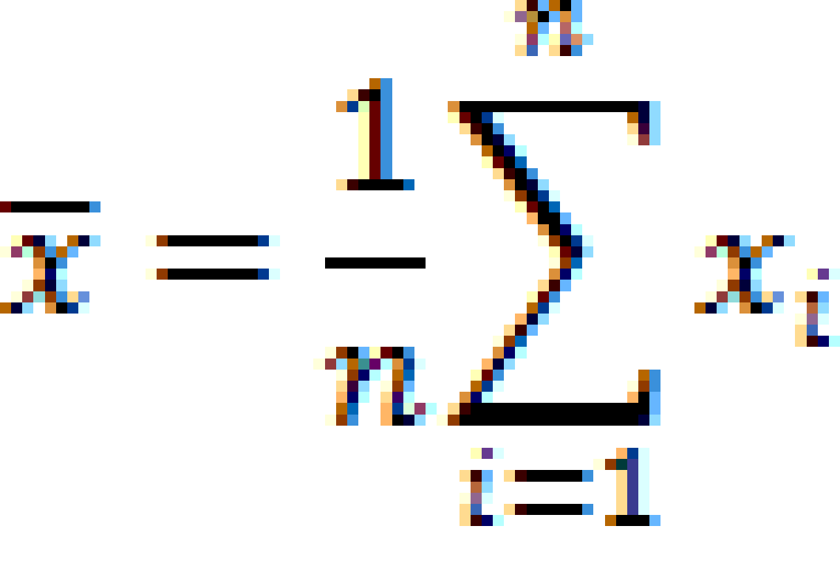

1) Only the name of the matrix is given (“A1”): the average is computed on all the data (all the rows and all the columns).

This operation is logical only if all the variables have the same unit (it would be a nonsense to compute an average of grams, meters and peak areas...).

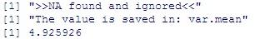

2) Rows are specified (e.g., “A1[1:5,]”): the average is returned, computed on any of the specified rows.

This operation is logical only if all the variables have the same unit.

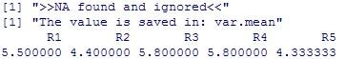

3) Columns are specified (e.g., “A1[,3:5]”): the average of each column is returned.

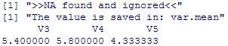

4) Rows and columns are specified (e.g., “A1[3:5,2:5]”): the average is returned, computed on any of the specified rows, limited to the specified columns.

This operation is logical only if all the variables have the same unit.

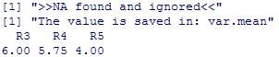

5) Brackets are opened and closed after the name of the matrix, without any specification of rows and columns (“A1[,]”): the average is returned, computed on any column.

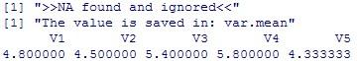

Note: pay attention to the difference between “A1[1:6,1:5]” and “A1[,]”. Though apparently the two different notations are equivalent (meaning “all the 6 rows and all the 5 columns”), the former will return the average computed on each row, while the latter will return the average computed on each column.

Average - Geometric
The GEOMETRIC MEAN  can be used for right skewed distributions (e.g. lognormal distributions).

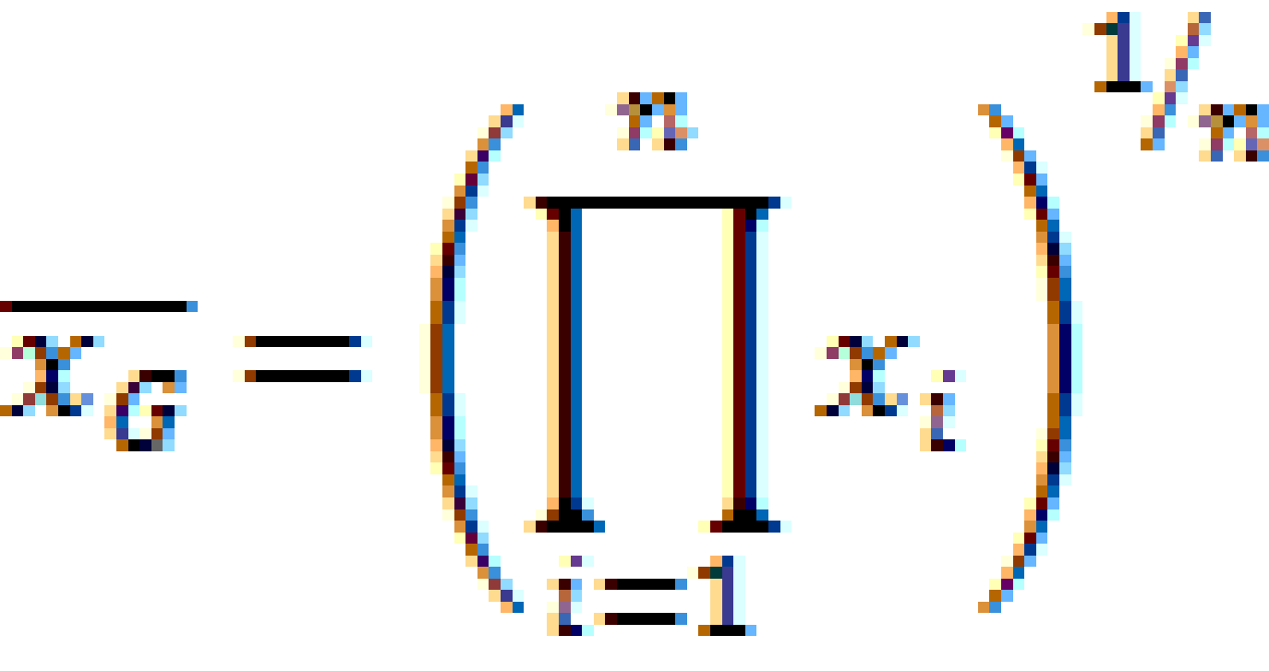

Caution: geometric mean cannot be computed with negative values

1) Only the name of the matrix is given (“A1”): the average is computed on all the data (all the rows and all the columns).

This operation is logical only if all the variables have the same unit (it would be a nonsense to compute an average of grams, meters and peak areas...).

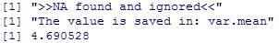

2) Rows are specified (e.g., “A1[1:5,]”): the average is returned, computed on any of the specified rows.

This operation is logical only if all the variables have the same unit.

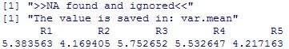

3) Columns are specified (e.g., “A1[,3:5]”): the average of each column is returned.

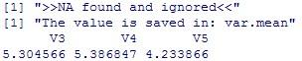

4) Rows and columns are specified (e.g., “A1[3:5,2:5]”): the average is returned, computed on any of the specified rows, limited to the specified columns.

This operation is logical only if all the variables have the same unit.

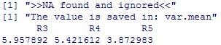

5) Brackets are opened and closed after the name of the matrix, without any specification of rows and columns (“A1[,]”): the average is returned, computed on any column.

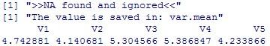

Note: pay attention to the difference between “A1[1:6,1:5]” and “A1[,]”. Though apparently the two different notations are equivalent (meaning “all the 6 rows and all the 5 columns”), the former will return the average computed on each row, while the latter will return the average computed on each column.

Average - Median
The MEDIAN  (median(x) in R notation) is a robust (i.e., less influenced by outliers) estimation of the central value.
Let us have a vector of N values, ordered from the minimum to the maximum. If N is odd, then the median is the central value of the series, while if N is even, then the median is the arithmetic mean of the two central values.
The median divides the data distribution into two equal halves (it corresponds to the 50th percentile); the number of data with values higher than the median is equal to the number of data with values lower than the median.

1) Only the name of the matrix is given (“A1”): the median is computed on all the data (all the rows and all the columns).

This operation is logical only if all the variables have the same unit (it would be a nonsense to compute the median of grams, meters and peak areas...).

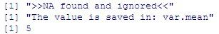

2) Rows are specified (e.g., “A1[1:5,]”): the median is returned, computed on any of the specified rows.

This operation is logical only if all the variables have the same unit.

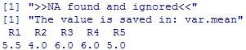

3) Columns are specified (e.g., “A1[,3:5]”): the median of each column is returned.

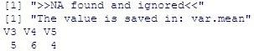

4) Rows and columns are specified (e.g., “A1[3:5,2:5]”): the median is returned, computed on any of the specified rows, limited to the specified columns.

This operation is logical only if all the variables have the same unit.

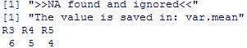

5) Brackets are opened and closed after the name of the matrix, without any specification of rows and columns (“A1[,]”): the median is returned, computed on any column.

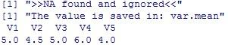

Note: pay attention to the difference between “A1[1:6,1:5]” and “A1[,]”. Though apparently the two different notations are equivalent (meaning “all the 6 rows and all the 5 columns”), the former will return the median computed on each row, while the latter will return the median computed on each column.

Dispersion
The “Dispersion” option allows to compute different types of estimators of the dispersion. The following sub-options are present:

- Standard Deviation;
- Coeff. of Variation (RSD);
- Robust Estimators.

The results obtained by using this options will be stored in the variable var.dispersion.

All the operations performed in this option are possible only if all the selected variables are numerical variables, i.e., only if the selected variables do not contain any alphanumeric value.
If this constraint is not respected, the following message will appear:

For each sub-option five different inputs are possible, and different results will be obtained according to the type of data. The results will be shown by using the matrix A1 (see the option “Summary”).

Dispersion - Standard Deviation
The STANDARD DEVIATION s (sd(x) in R notation) is the most used measure for the spread of data.
The software computes the standard deviation of the sample:
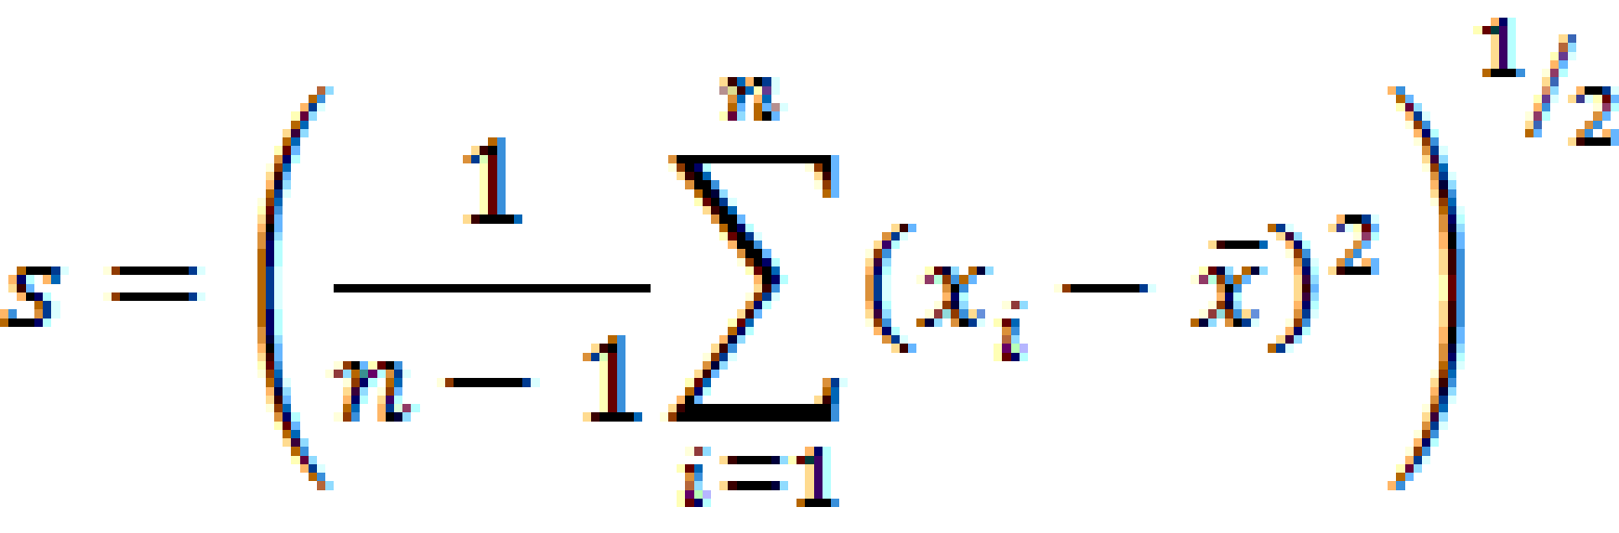

The standard deviation is very sensitive to outliers and should be used only in case of normal distributions, for which s is the most precise estimator for σ (the standard deviation of the population); unfortunately in practice the standard deviation is often uncritically used instead of other more robust estimators (see sub-option “Robust Estimators”).

1) Only the name of the matrix is given (“A1”): the standard deviation is computed on all the data (all the rows and all the columns).

This operation is logical only if all the variables have the same unit (it would be a nonsense to compute the standard deviation of grams, meters and peak areas...).

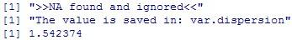

2) Rows are specified (e.g., “A1[1:5,]”): the standard deviation is returned, computed on any of the specified rows.

This operation is logical only if all the variables have the same unit.

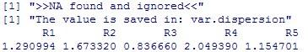

3) Columns are specified (e.g., “A1[,3:5]”): the standard deviation of each column is returned.

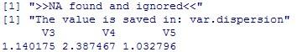

4) Rows and columns are specified (e.g., “A1[3:5,2:5]”): the standard deviation is returned, computed on any of the specified rows, limited to the specified columns.

This operation is logical only if all the variables have the same unit.

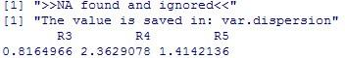

5) Brackets are opened and closed after the name of the matrix, without any specification of rows and columns (“A1[,]”): the standard deviation is returned, computed on any column.

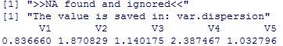

Note: pay attention to the difference between “A1[1:6,1:5]” and “A1[,]”. Though apparently the two different notations are equivalent (meaning “all the 6 rows and all the 5 columns”), the former will return the standard deviation computed on each row, while the latter will return the standard deviation computed on each column.

Dispersion - Coeff. of Variation (RSD)
The standard deviation is expressed in the same unit as the data. To better compare the dispersion of different variables or to evaluate the dispersion of a variable compared to its average the COEFFICIENT OF VARIATION (CV), or RELATIVE STANDARD DEVIATION (RSD), is generally used.
The Coefficient of Variation is the standard deviation expressed as percentage of the average:



1) Only the name of the matrix is given (“A1”): the CV is computed on all the data (all the rows and all the columns).

This operation is logical only if all the variables have the same unit (it would be a nonsense to divide the standard deviation computed on grams, meters and peak areas by the average computed on grams, meters and peak areas ...).

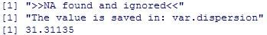

2) Rows are specified (e.g., “A1[1:5,]”): the CV is returned, computed on any of the specified rows.
This operation is logical only if all the variables have the same unit.

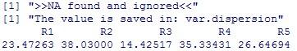

3) Columns are specified (e.g., “A1[,3:5]”): the CV of each column is returned.

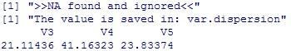

4) Rows and columns are specified (e.g., “A1[3:5,2:5]”): the CV is returned, computed on any of the specified rows, limited to the specified columns.

This operation is logical only if all the variables have the same unit.

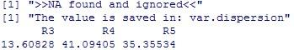

5) Brackets are opened and closed after the name of the matrix, without any specification of rows and columns (“A1[,]”): the CV is returned, computed on any column.

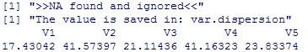

Note: pay attention to the difference between “A1[1:6,1:5]” and “A1[,]”. Though apparently the two different notations are equivalent (meaning “all the 6 rows and all the 5 columns”), the former will return the CV computed on each row, while the latter will return the CV computed on each column.

Dispersion – Robust Estimators
When the distribution is not normal and/or outliers are present robust estimators of the dispersion should be used instead of the standard deviation. The following third level options are present:

- InterQuartile Range (IQR);
- Median Absolute Deviation (MAD);
- MAD Standard Deviation (sMAD).

Dispersion – Robust Estimators - InterQuartile Range (IQR)
The INTERQUARTILE RANGE (IQR) is the difference between the 3rd quartile and the 1st quartile (as computed in the option “Summary”).

1) Only the name of the matrix is given (“A1”): the IQR is computed on all the data (all the rows and all the columns).

This operation is logical only if all the variables have the same unit (it would be a nonsense to put together grams, meters and peak areas ...).

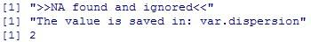

2) Rows are specified (e.g., “A1[1:5,]”): the IQR is returned, computed on any of the specified rows.
This operation is logical only if all the variables have the same unit.

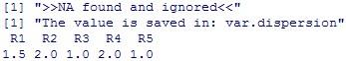

3) Columns are specified (e.g., “A1[,3:5]”): the IQR of each column is returned.

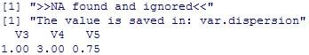

4) Rows and columns are specified (e.g., “A1[3:5,2:5]”): the IQR is returned, computed on any of the specified rows, limited to the specified columns.

This operation is logical only if all the variables have the same unit.

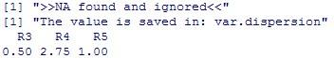

5) Brackets are opened and closed after the name of the matrix, without any specification of rows and columns (“A1[,]”): the IQR is returned, computed on any column.

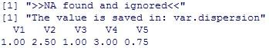

Note: pay attention to the difference between “A1[1:6,1:5]” and “A1[,]”. Though apparently the two different notations are equivalent (meaning “all the 6 rows and all the 5 columns”), the former will return the IQR computed on each row, while the latter will return the IQR computed on each column.

Dispersion – Robust Estimators - Median Absolute Deviation (MAD)

The MEDIAN ABSOLUTE DEVIATION (MAD) is computed as follows:

- Compute the median;
- For each datum compute the absolute difference from the median ();
- The median of the absolute differences computed in the step 2 is the MAD.

1) Only the name of the matrix is given (“A1”): the MAD is computed on all the data (all the rows and all the columns).

This operation is logical only if all the variables have the same unit (it would be a nonsense to put together grams, meters and peak areas...).

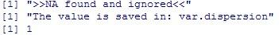

2) Rows are specified (e.g., “A1[1:5,]”): the MAD is returned, computed on any of the specified rows.
This operation is possible only if all the variables are numerical variables, i.e., only if the data matrix does not contain any alphanumerical value.

This operation is logical only if all the variables have the same unit.

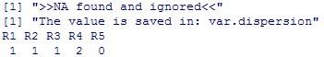

3) Columns are specified (e.g., “A1[,3:5]”): the MAD of each column is returned.

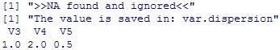

4) Rows and columns are specified (e.g., “A1[3:5,2:5]”): the MAD is returned, computed on any of the specified rows, limited to the specified columns.

This operation is logical only if all the variables have the same unit.

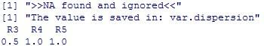

5) Brackets are opened and closed after the name of the matrix, without any specification of rows and columns (“A1[,]”): the MAD is returned, computed on any column.

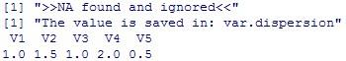

Note: pay attention to the difference between “A1[1:6,1:5]” and “A1[,]”. Though apparently the two different notations are equivalent (meaning “all the 6 rows and all the 5 columns”), the former will return the MAD computed on each row, while the latter will return the MAD computed on each column.

Dispersion – Robust Estimators – Robust Coefficient of Variation
In the case of a normal distribution, the MAD can be used for a robust estimation of the theoretical standard deviation σ: s_{MAD} = 1.483 MAD
As the standard deviation expressed as percentage of the mean is the Coefficient of Variation, the sMAD expressed as percentage of the median can be considered a robust estimation of the Coefficient of Variation.

1) Only the name of the matrix is given (“A1”): the robust CV is computed on all the data (all the rows and all the columns).

This operation is logical only if all the variables have the same unit (it would be a nonsense to put together grams, meters and peak areas...).

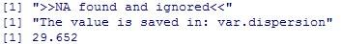

2) Rows are specified (e.g., “A1[1:5,]”): the robust CV is returned, computed on any of the specified rows.

This operation is logical only if all the variables have the same unit.

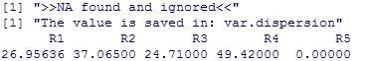

3) Columns are specified (e.g., “A1[,3:5]”): the robust CV of each column is returned.

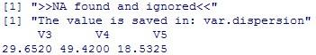

4) Rows and columns are specified (e.g., “A1[3:5,2:5]”): the robust CV is returned, computed on any of the specified rows, limited to the specified columns.

This operation is logical only if all the variables have the same unit.

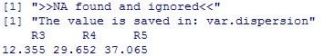

5) Brackets are opened and closed after the name of the matrix, without any specification of rows and columns (“A1[,]”): the robust CV is returned, computed on any column.

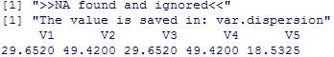

Note: pay attention to the difference between “A1[1:6,1:5]” and “A1[,]”. Though apparently the two different notations are equivalent (meaning “all the 6 rows and all the 5 columns”), the former will return the robust CV computed on each row, while the latter will return the robust CV computed on each column.

Plots
The “Plots” option allows to draw different univariate plots. The following sub-options are present:

- Box and Whiskers Plot;
- Histogram;
- Probability Density Plot;
- Scatter Plot;
- EDA Plot;
- Y Plot.

In the current version of the software it is possible to plot only one variable in each plot.

In all the options (except “Y Plot”) the following dialogue box is shown:

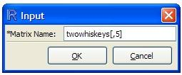

In it the variable to be plotted must be input, according to the R syntax.

Plots – Box and Whiskers Plot
The BOX AND WHISKERS plot gives a fast overview of the main characteristics of a variable (median, Interquartile Range, presence of outliers). It is made by one box, two whiskers and (if any) some individual points.
The limits of the box correspond to the 1st and the 3rd quartile, and therefore the size of the box is the IQR.
The line inside the box corresponds to the median.
The lower whisker extends from the first quartile to the smallest data value present in the interval between Q₁ and Q₁-1.5 IQR.
The upper whisker extends from the third quartile to the largest data value present in the interval between Q₃ and Q₃+1.5 IQR.
Samples present outside the range between Q₁-1.5 IQR and Q₃+1.5 IQR (if any) are plotted as individual points.

In the example shown in the figure the 1st quartile is 0.4, the 3rd quartile is 0.7 (the limits of the box) and the median is 0.5 (the line inside the box). The IQR is 0.3, and therefore the lower whisker goes from 0.4 to the lowest value in the range between 0.4 and -0.05, this value being 0.1. The upper whisker goes from 0.7 to the highest value in the range between 0.7 and 1.15, this value being 1.0. The points outside the interval between 0.1 and 1.0 are plotted as individual points.

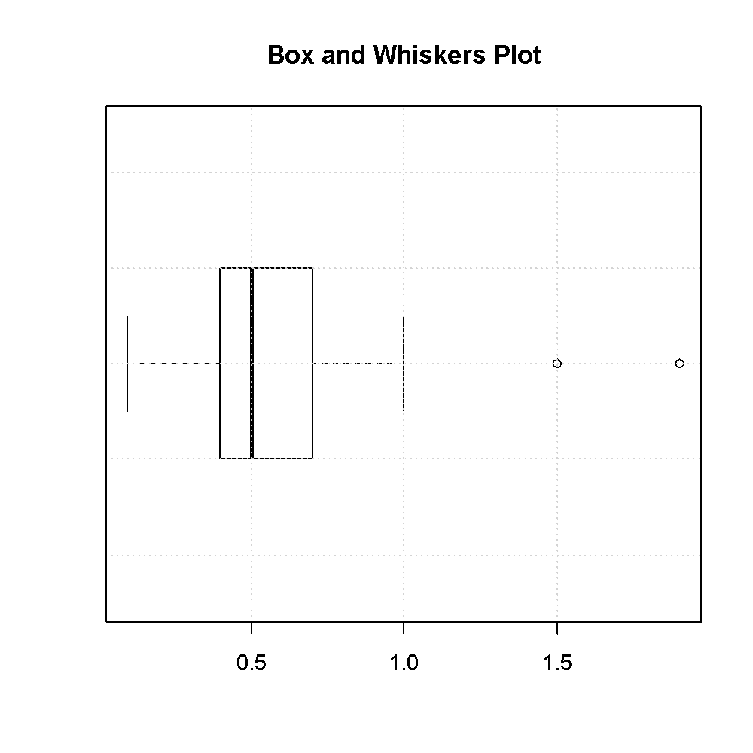

Caution: if more than one point have the same value, they will be plotted as a single point.

Plots - Histogram
The HISTOGRAM is the most frequently used graphic for frequency plots.
The number of class intervals k is automatically determined by the software, according to Sturges’ formula (k = log₂(n) +1, where n is the number of data points). The result obtained is a suggestion only, since the limits of the class intervals will be automatically set to “logical” values.
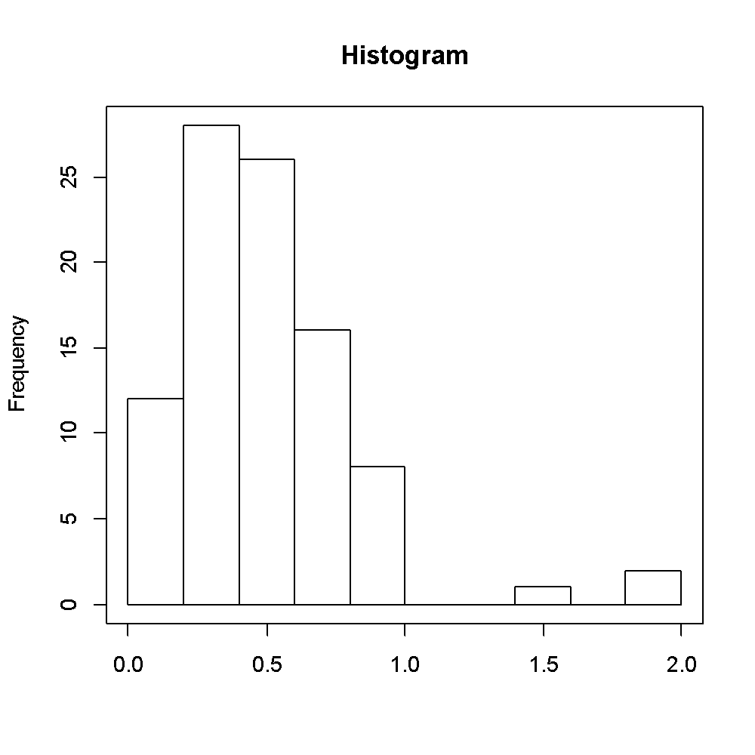
In the example shown n = 93, and therefore log₂(93) = 6.54. The suggested number of class intervals is therefore 8. Since the range of the variable is 0.1 – 1.9, splitting this range into 8 class intervals would have produced class intervals having a width of 0.225. Therefore the software increases the number of class intervals to 10 and the range to 0.0 – 2.0, in such a way that the width of the class intervals is 0.2.
As a consequence of that, it is possible that when plotting histograms of different variables of the same data set (and therefore with the same number of data points) a different number of class intervals is selected.
In the following plot (from the same data set as the previous one) the number of class intervals is 9, in such a way that the width of each of them is 5.
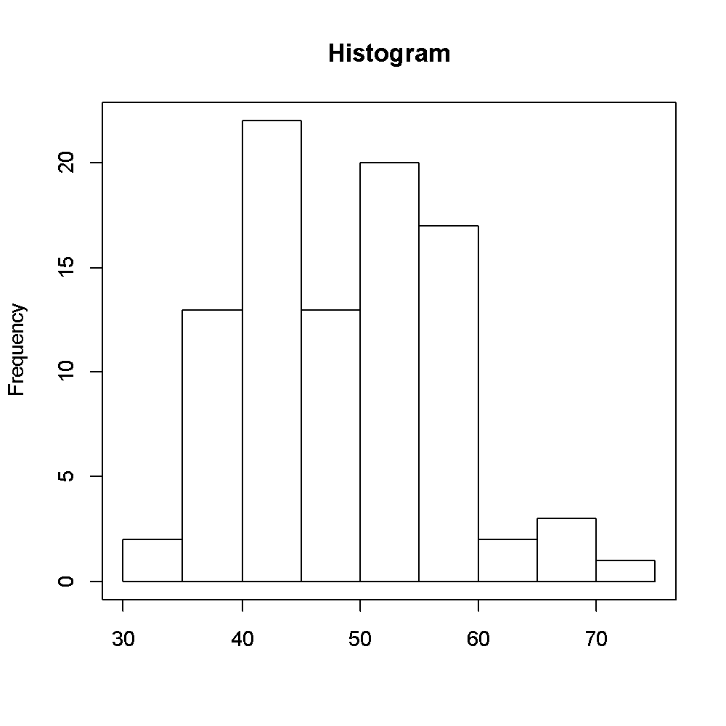
To modify the number of class intervals the user must change a line of the script “UN_plot_hist.r”. In the original line

hist(variable.value,xlab='',main='Histogram');box()

the number of desired class interval must be added. If 20 class intervals are desired, the line will be

hist(variable.value,xlab='',main='Histogram',breaks=20);box()

and the following result will be obtained
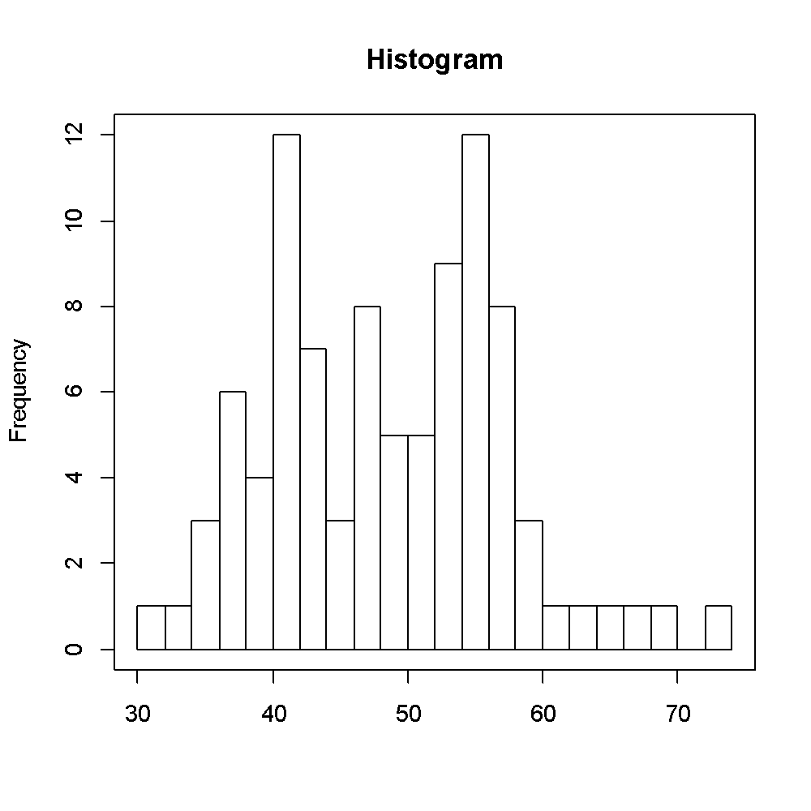
If counting the class intervals, it can be seen that they are 22, instead of the 20 required. This because by setting the number of class intervals to 22 a width of 2 has been obtained.

Plots – Probability Density Plot
The function for the PROBABILITY DENSITY PLOT computes kernel density estimates. The algorithm used disperses the mass of the empirical distribution function over a regular grid of at least 512 points. The fast Fourier transform is used to convolve this approximation with a discretized version of the kernel and the density at the specified points is evaluated by linear approximation.
The ordinate is scaled to give an area of 1 under the curve.
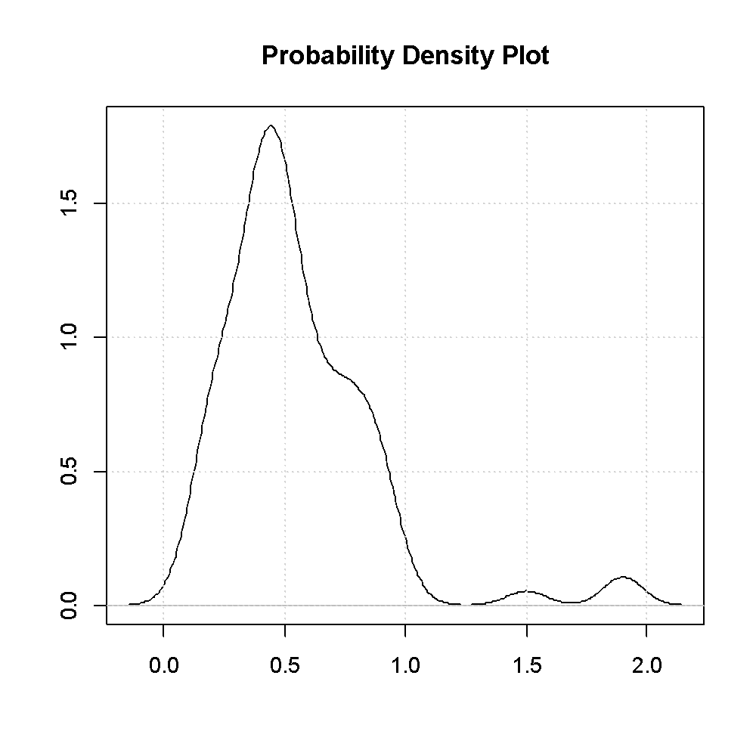

Plots - Scatter Plot
A univariate SCATTER PLOT plots the data along an axis, with each data point represented as a box. To avoid total overlapping in case of data with equal value they are randomly scattered around the ideal line.
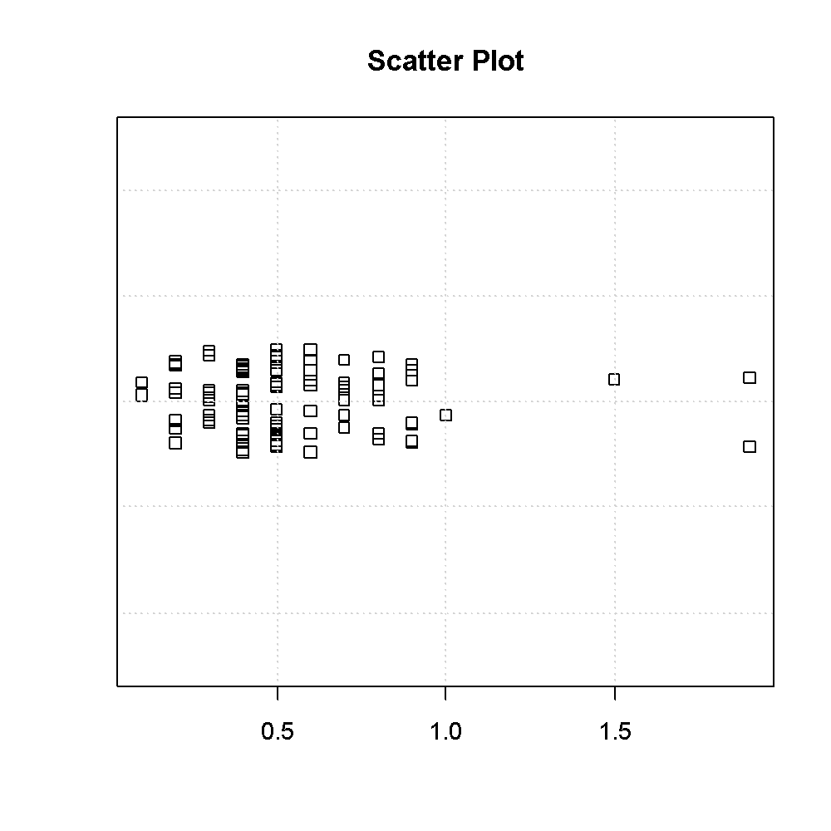
Since the position on the (meaningless) Y axis is randomly determined, performing this option on the same variable different times will produce different plots:
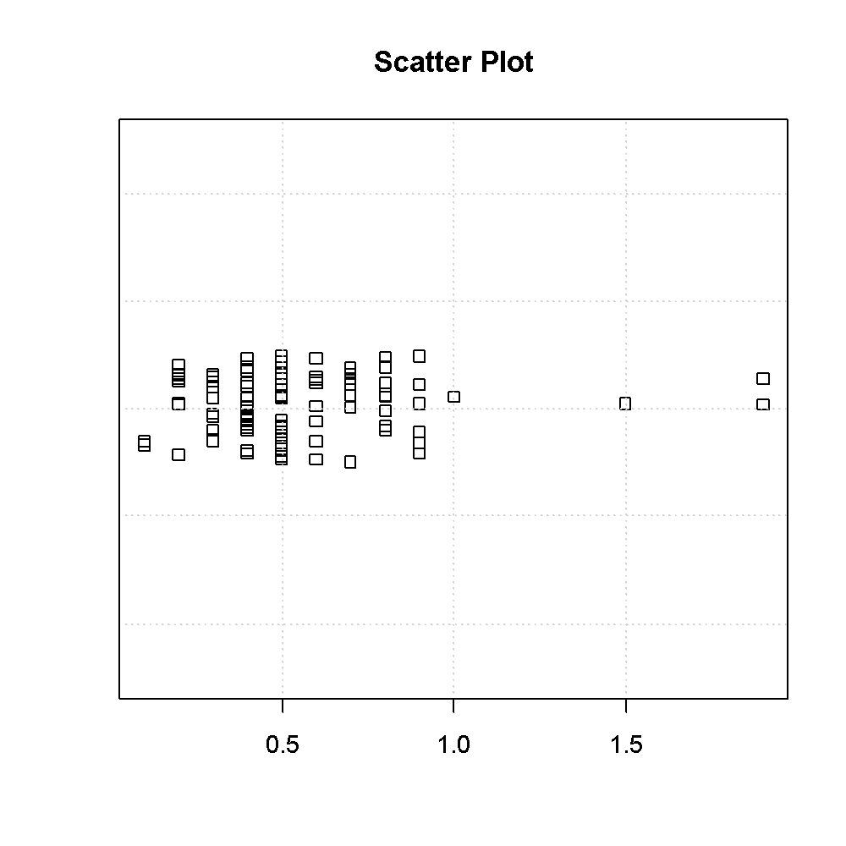
To remove the scattering and have all the boxes aligned on the same line the user must change a line of the script “UN_plot_stripchart.r”. In the original line

stripchart(variable.value,method="jitter",jitter=0.05,vertical=FALSE,ylab='',xlab='',main='Scatter Plot')

“jitter” must be replaced by “overplot”.

Plots – EDA Plot
EDA Plots (EDA stands for Exploratory Data Analysis) shows the four previous plots (Box and Whiskers, Histogram, Probability Density and Scatter) together.
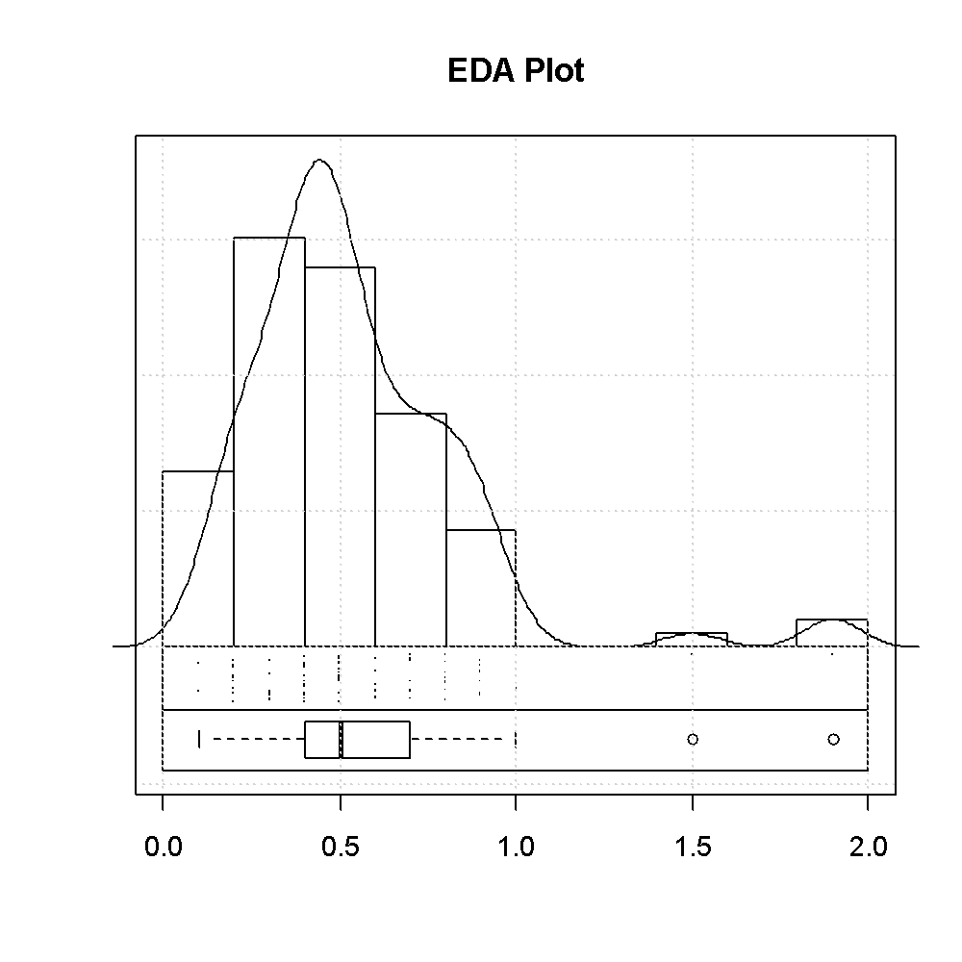

Plots - Y plot
This option plots the values of a variable as a function of the row index, as scattered points or as a line. By properly using the different combinations of labels and colors it will be possible to detect time trends or differences among groups.

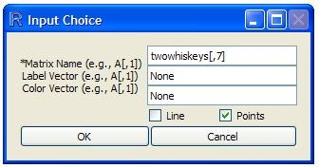

In the first field of the dialogue box the variable to be plotted must be defined.
If neither the Label Vector nor the Color Vector are specified, the following plots can be obtained (depending if one of the buttons, or both, are selected) .

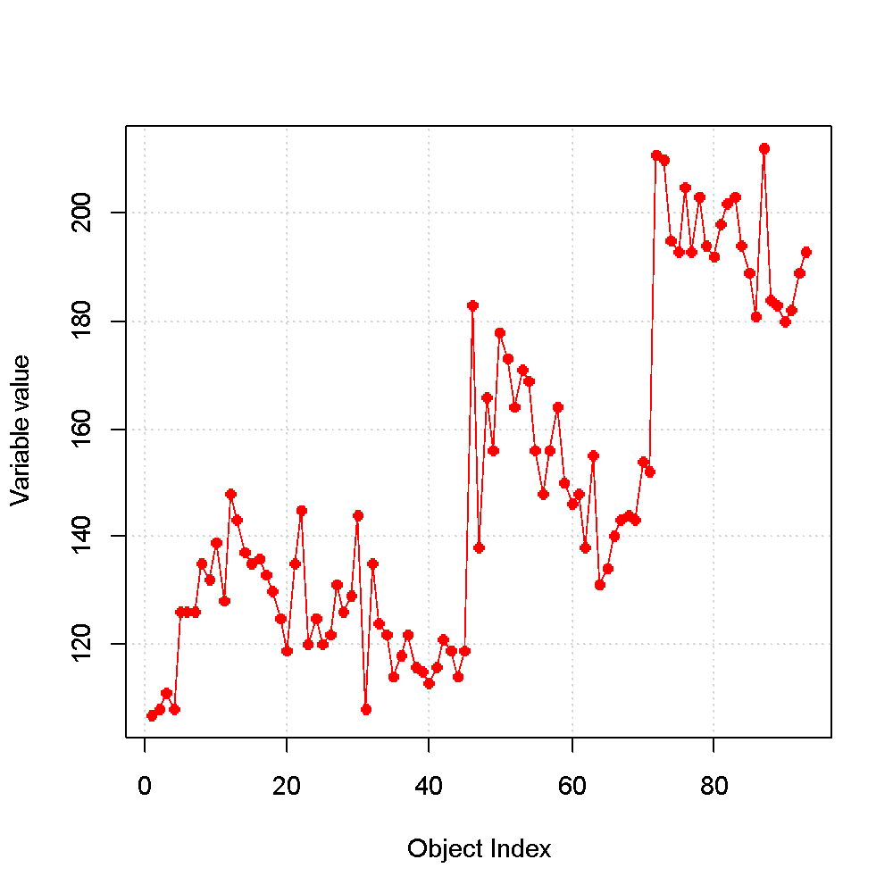
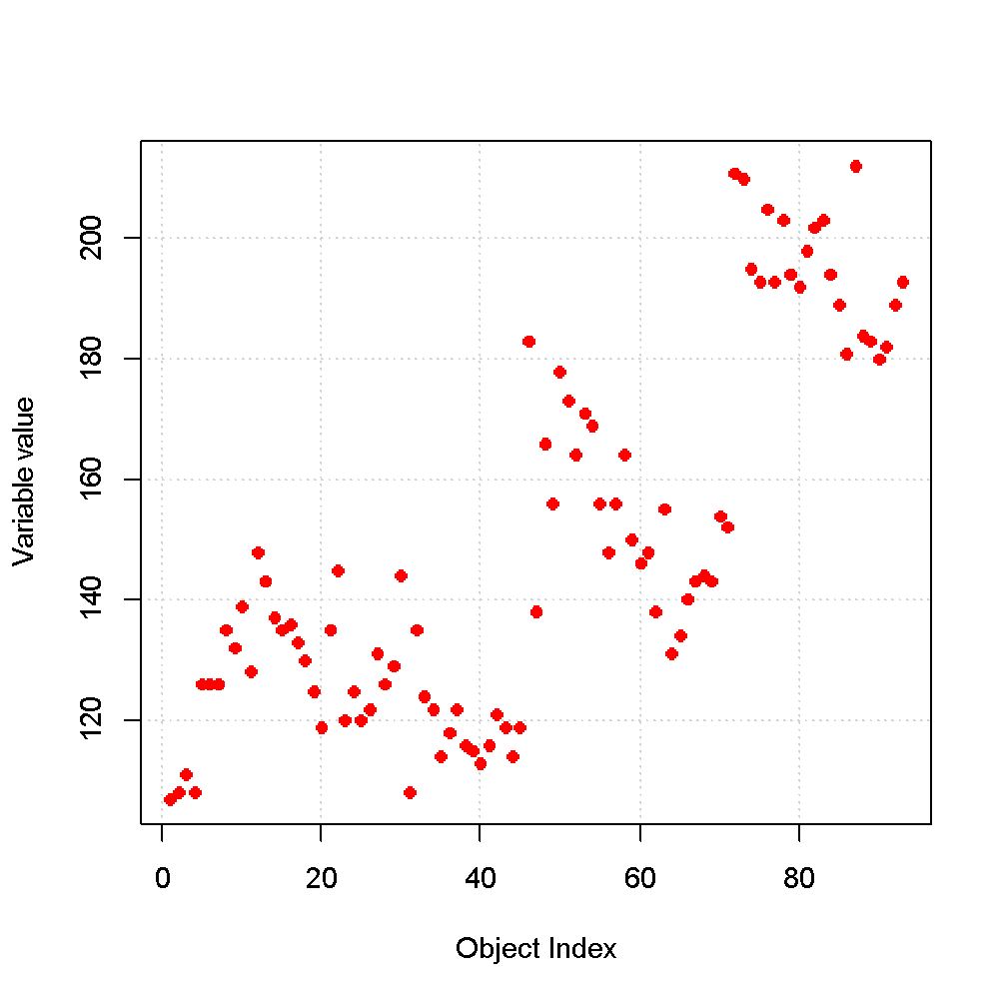
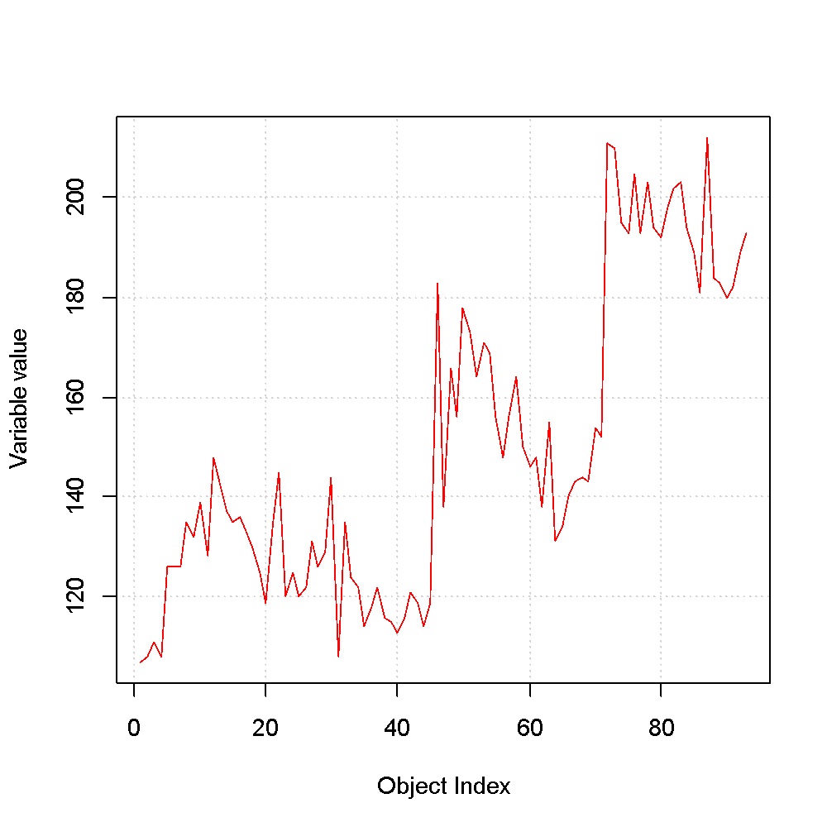
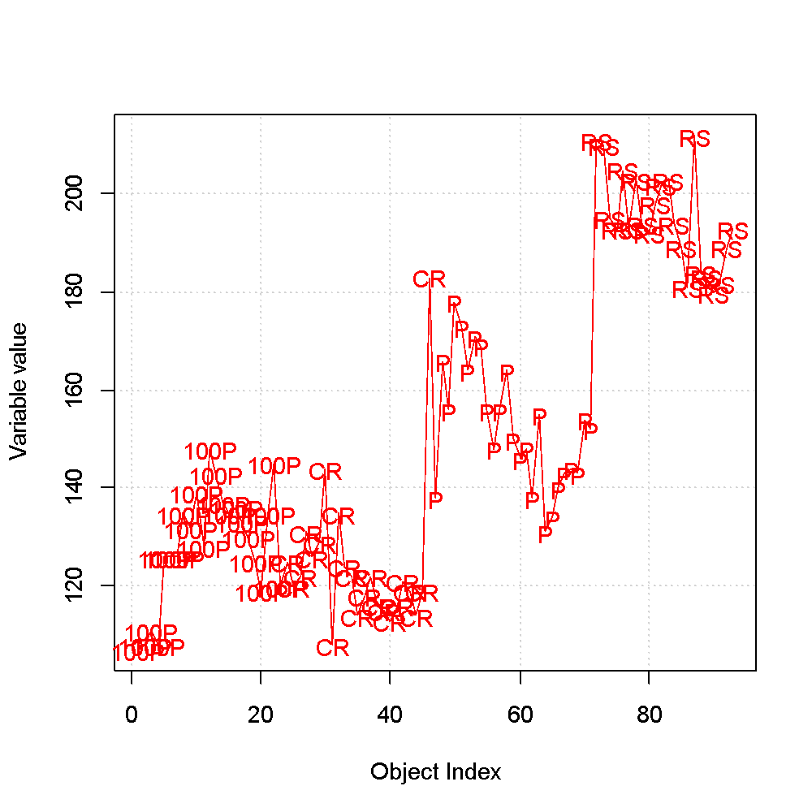
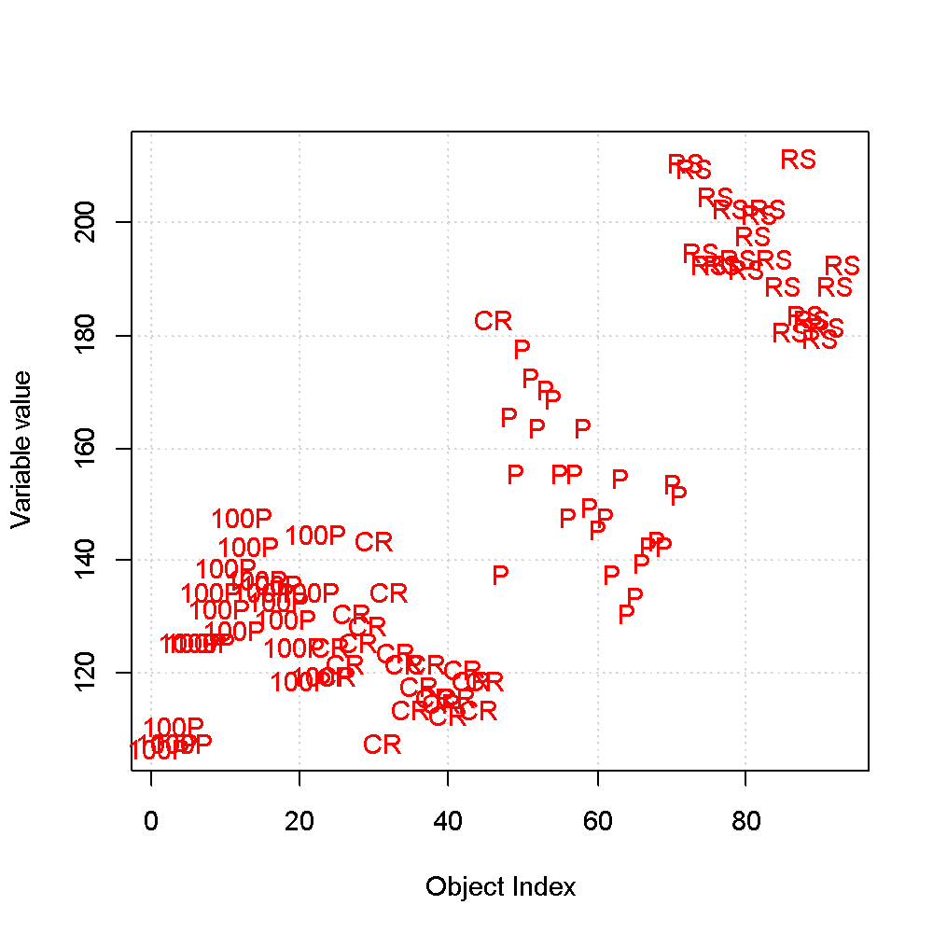
When a Label Vector is specified the objects are labeled according to the values present in the vector. The Label Vector must have the same size as the vector specified in the first field and can contain both numerical and alphanumerical data. If a Label Vector is defined, then the “Points” button will not affect the aspect of the plot.
It is not possible to define as Label Vector the vector containing the names of the objects. In order to do so, the Row Names must be extracted as an independent vector by using the Data Handling – Data Set – Column – Extract procedure. The so obtained vector (whose name by default is “vname”) will be subsequently defined as Label Vector.

When a Color Vector is specified the points are colored according to the values present in the vector. The Color Vector must have the same size as the vector specified in the first field and can contain both numerical and alphanumerical data. The Color Vector will not affect the color of the line.
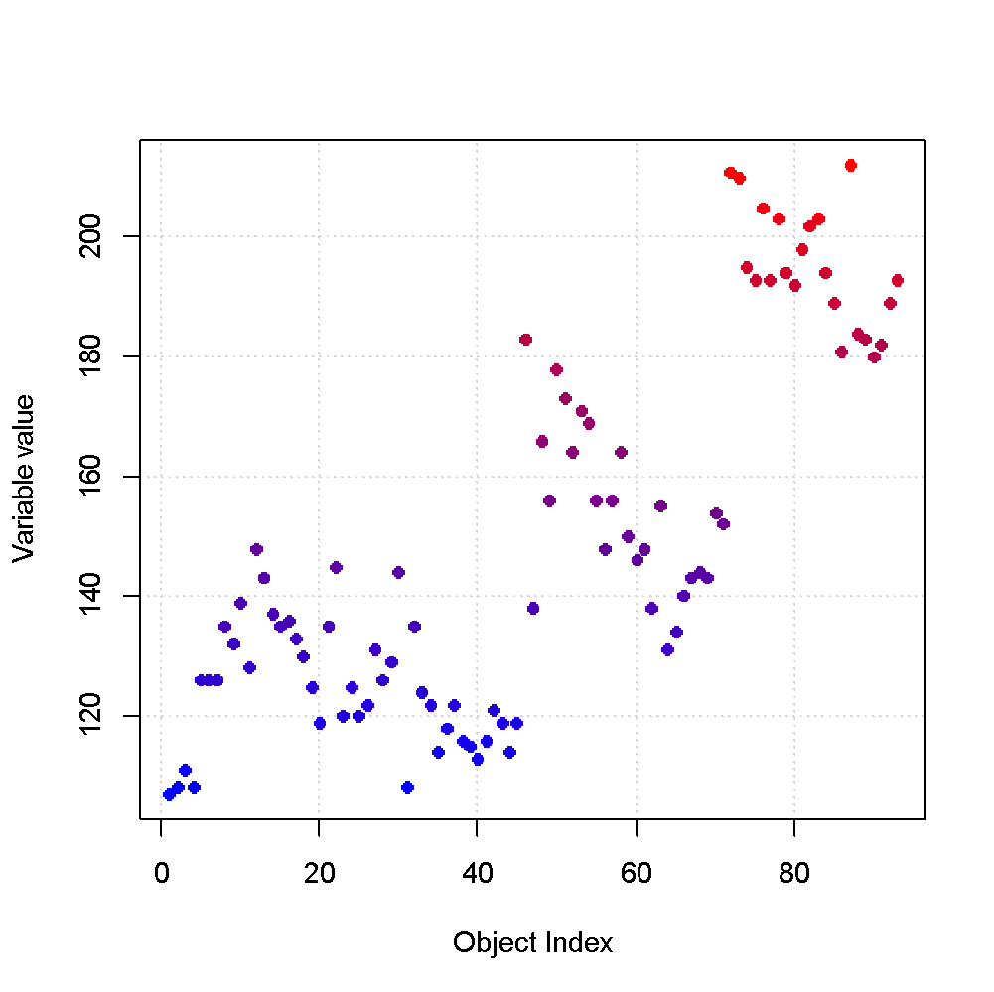
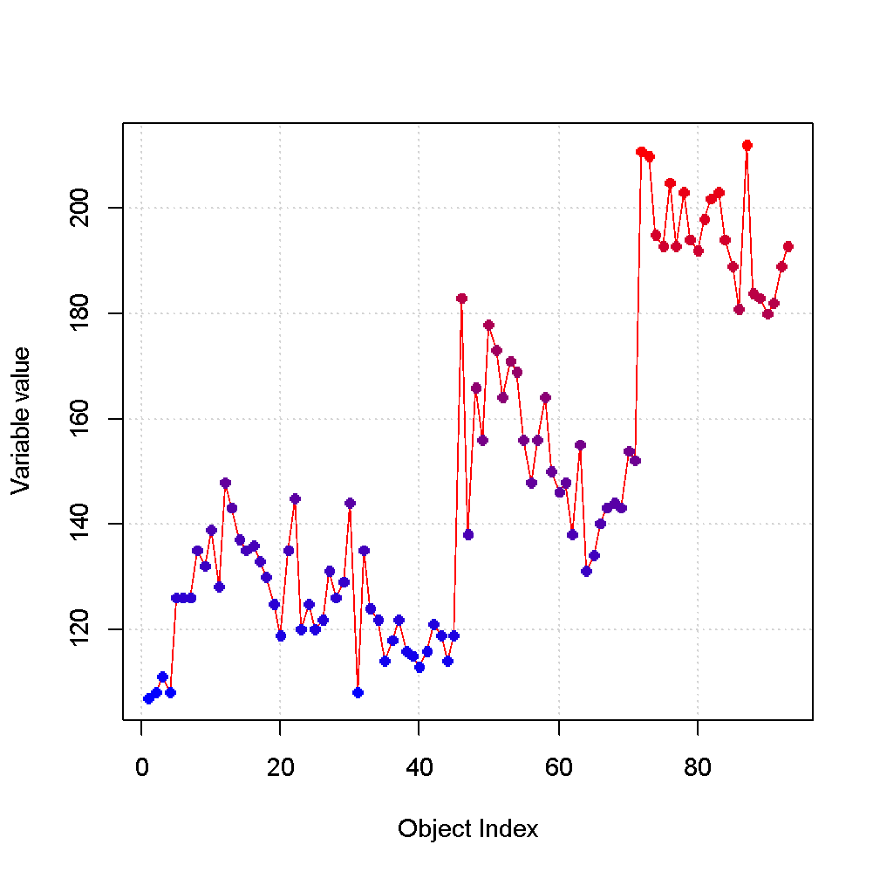
The following plots shows the results when the Color Vector is the same as the variable to be plotted.

If the Color Vector is a numerical variable, then the samples are colored according to a continuous chromatic scale, ranging from pure blue (low values) to pure red (high values).
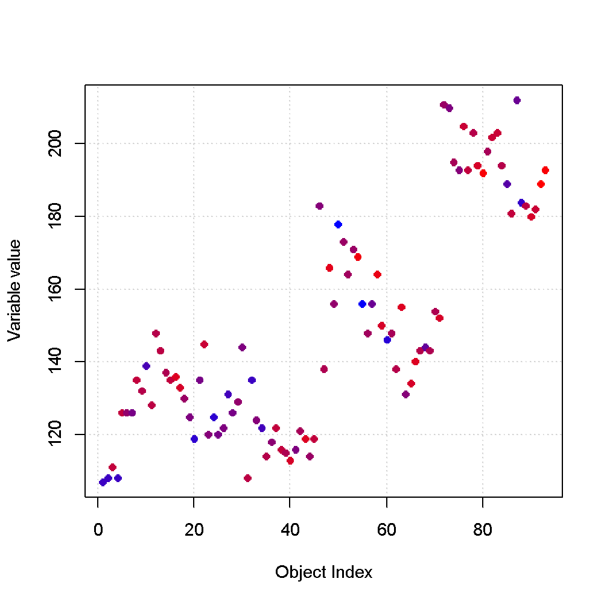
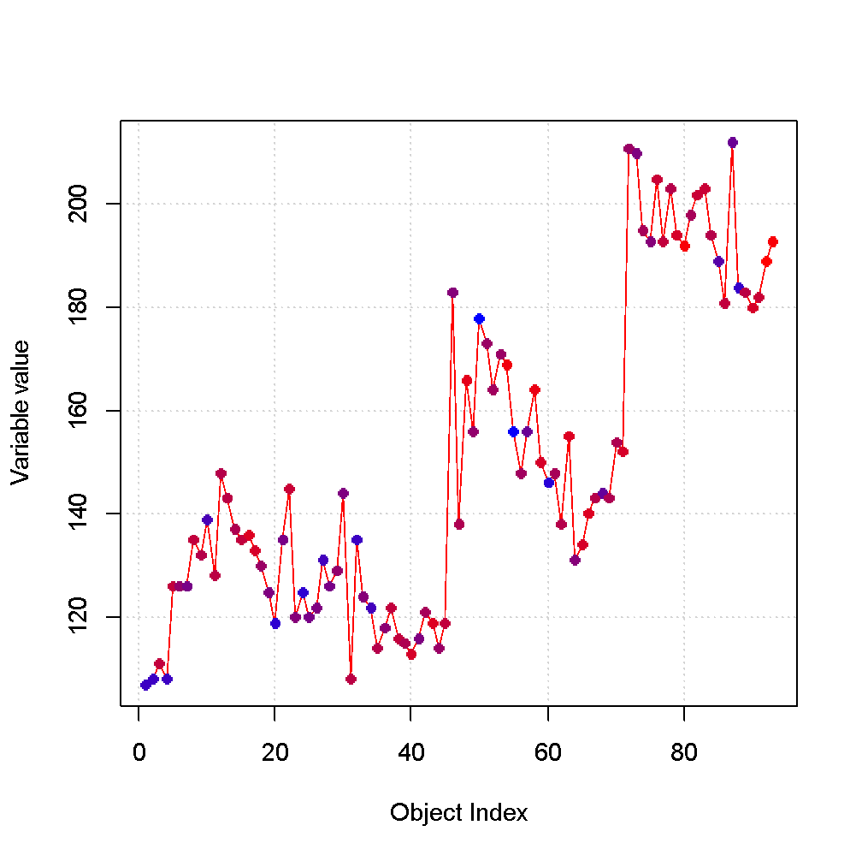
The following plots shows the results when the Color Vector is different from the variable to be plotted. In this way it is possible to have information from two variables at the same time.
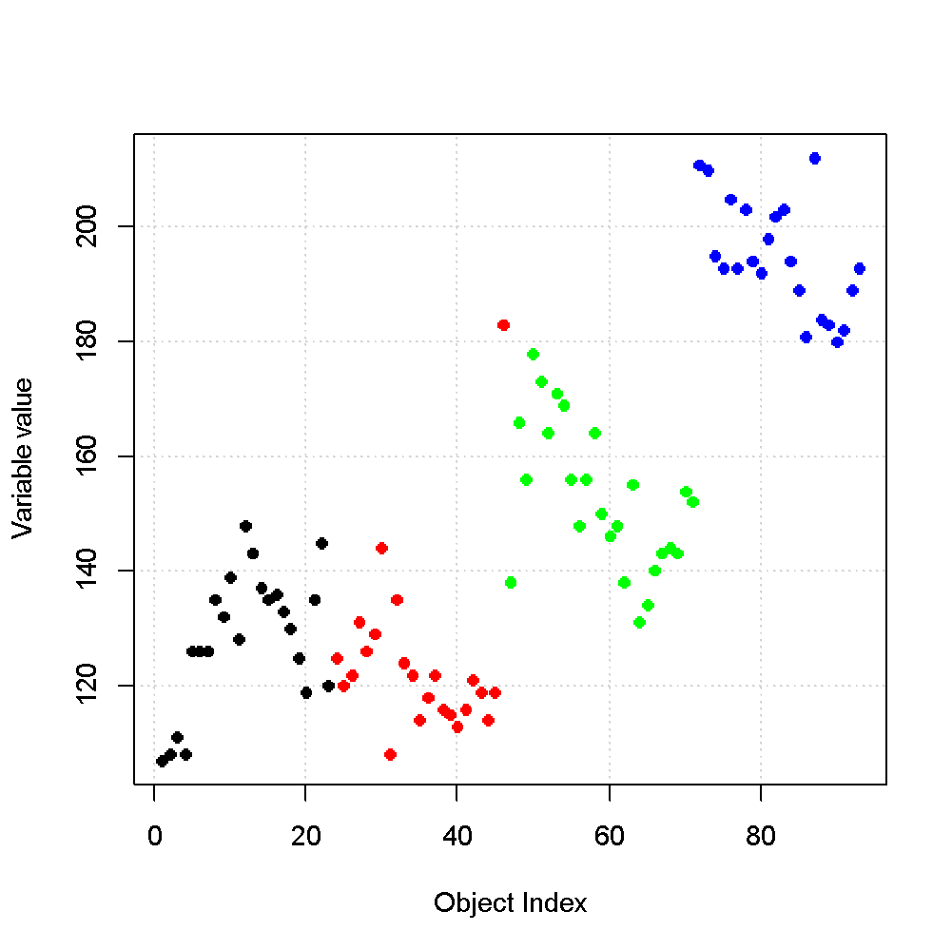
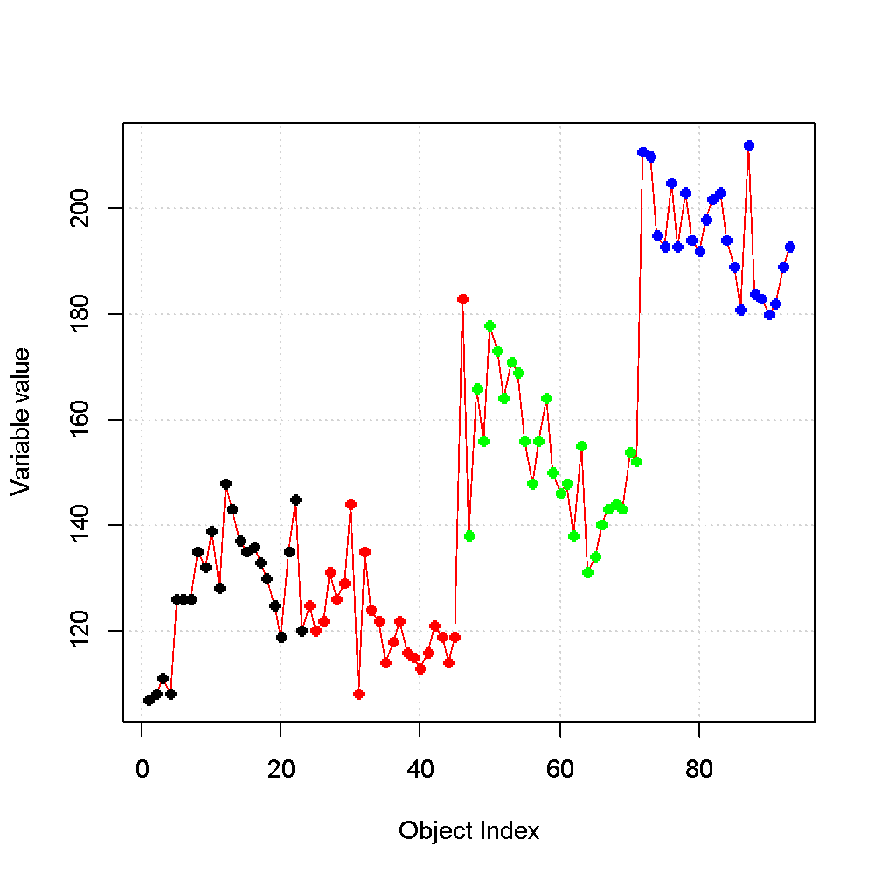
If the Color Vector is an alphanumerical variable, then the samples are colored according to “discrete” colors.

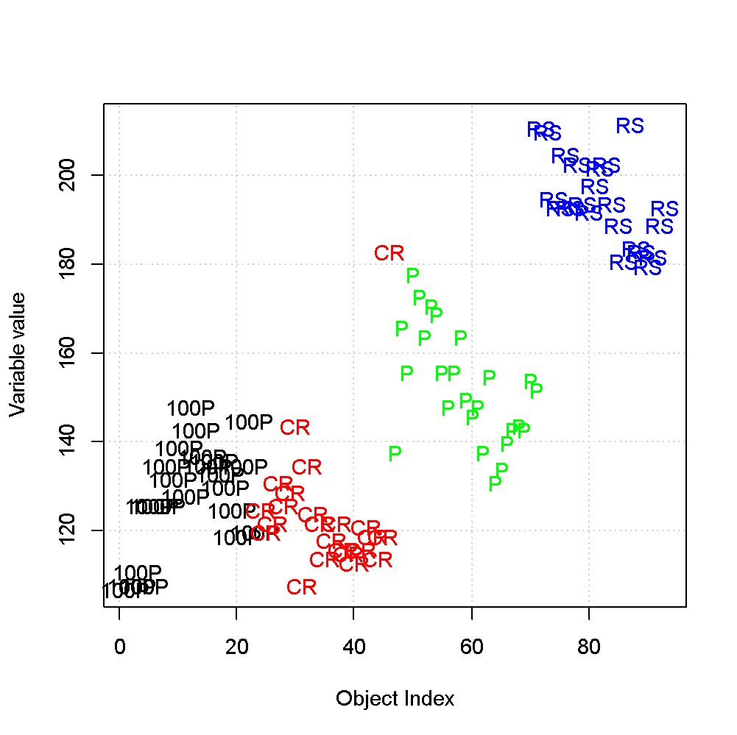
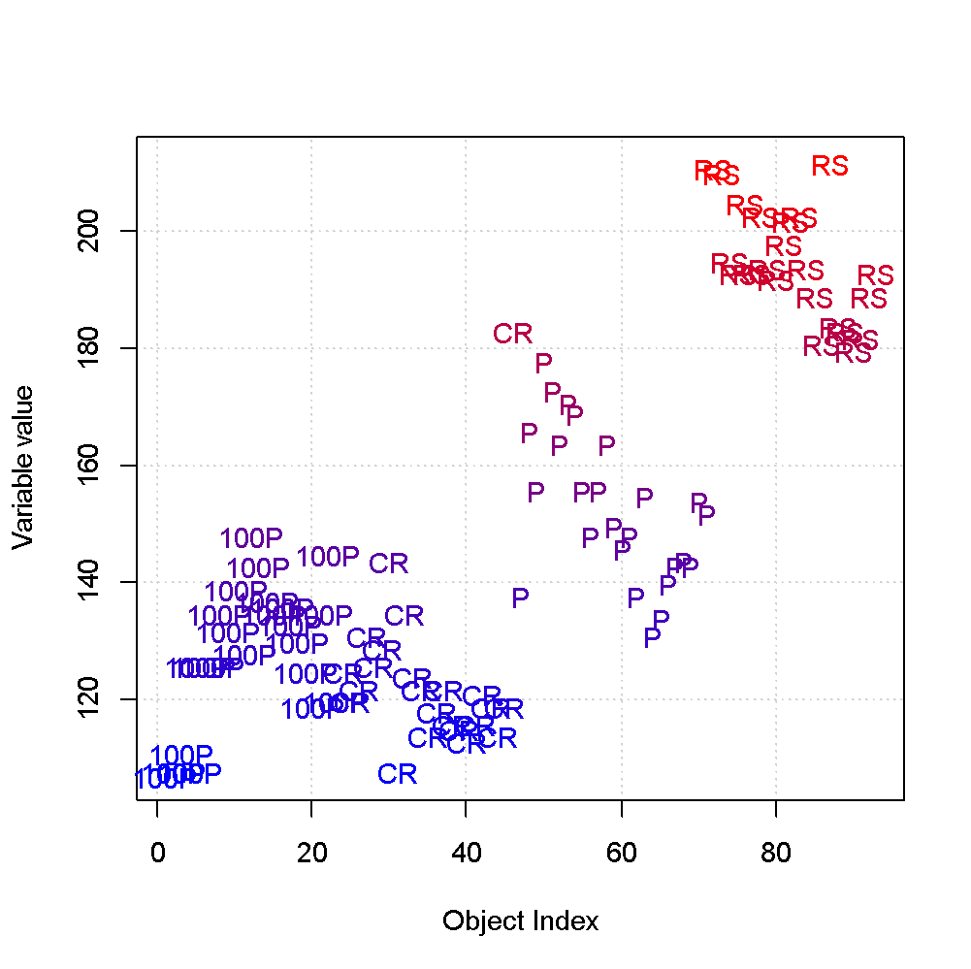
A Label Vector and a Color Vector can also be specified simultaneously (they can be the same or different).
The chromatic scale and the order of the colors for the alphanumerical variables are defined in the file gvfib (in the directory mylib).
These are lines defining the order of the colors:

vcb<-c( "black",
"red",
"green",
"blue",
"brown",
"cyan",
"orange",
"pink",
"yellow",
"turquoise",
"purple",
"navy",
"magenta",
"khaki",
"ivory",
"grey",
"gold",
"coral",
"beige",
"azure")

From it, it can be seen that the first color to be used is black, followed by red, then by green, etc. The assignment of the color to the alphanumeric label follows the alphabetical order (e.g., if the labels are “France”, “Spain” and “Austria”, “Austria” will be black, “France” red and “Spain” green). In order to change the assignment of the colors it is enough to change the order of the colors in the file.

The chromatic scale is defined in the following line.

C<-colorpanel(256,low="blue",high="red")[findInterval(d,seq(min(d),max(d),length.out=256))]

To change it, it is enough to change the definition of the colors corresponding to the lower end and to the upper end of the scale.
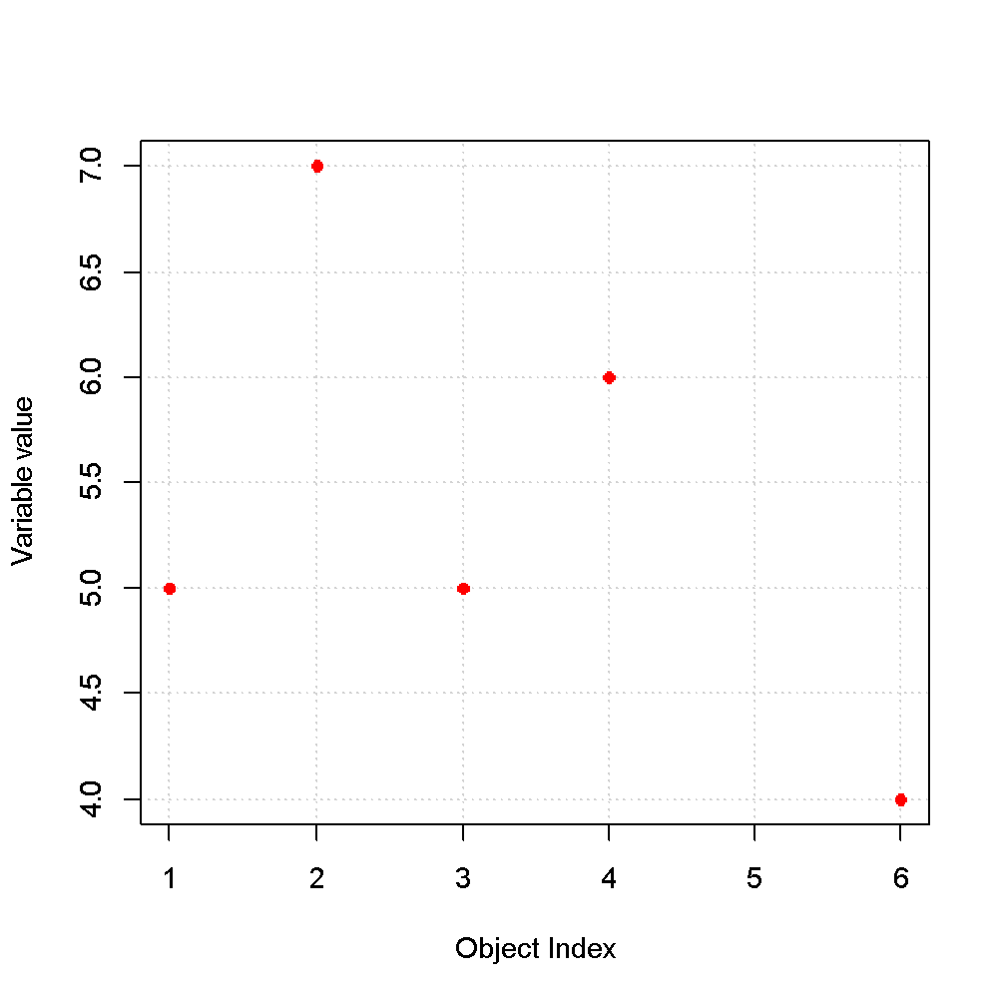
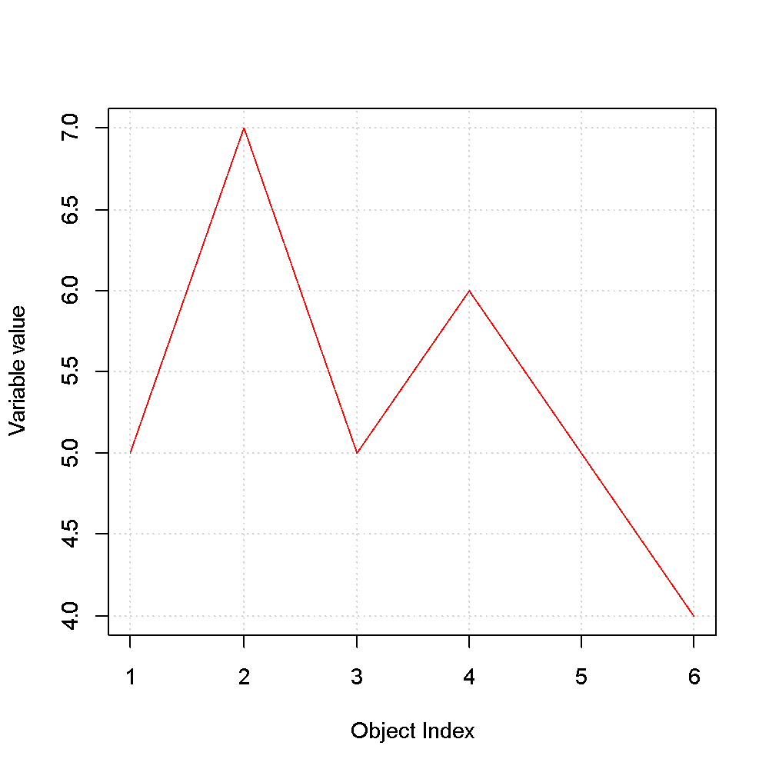
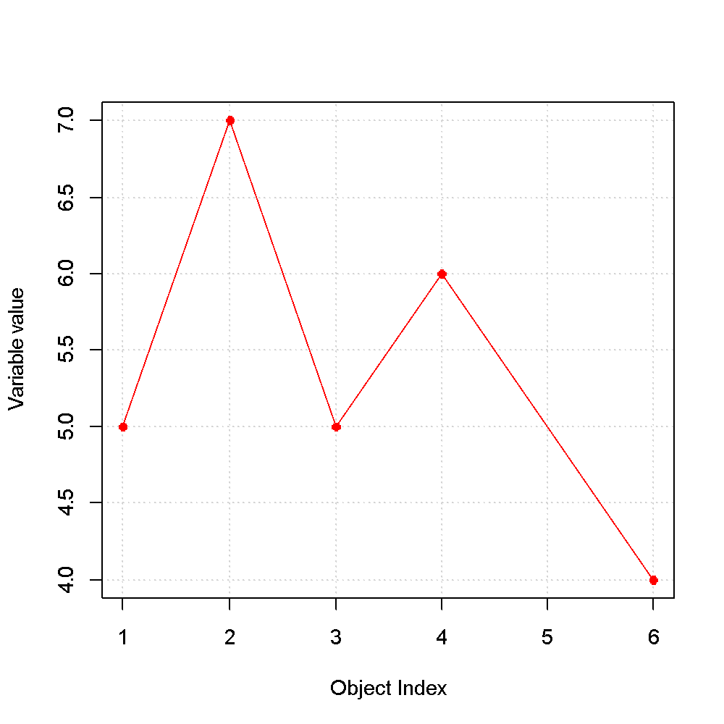
In case of missing data, the corresponding positions is skipped. If the “Line” button is selected, then the line passes through the void positions.

