Data Engineering Project : Pipeline ELT IMDb

Practicant: Nicola Diana Rădeanu

Dataset: IMDb Bulk Datasets (date $≥2020$)



Table of contents
1. Executive Summary 3
2. Dataset Description & Scoping 3
3. Architecture Overview 4
4. Data Modeling & Dimensional Design 6
5. Slowly Changing Dimensions (SCD Type 2) 6
6. Airflow Orchestration Pipeline 7
7. Data Quality & dbt Testing 7
8. How to Run 8
9. Answers to the Deliverable Questions 9
10. Challenges & Lessons Learned (Provocări întâmpinate) 11

1. Executive Summary

This project implements an end-to-end ELT data pipeline dedicated to the processing, historical tracking, and analytical modeling of the IMDb dataset. The pipeline extracts compressed raw data, stores it in the columnar Parquet format within DuckDB, captures changes over time using Slowly Changing Dimensions (SCD Type 2) snapshots, and builds an optimized Star Schema for business querying using dbt. The entire workflow is orchestrated via Apache Airflow in Docker containers and includes a rigorous suite of automated data quality tests. Ultimately, the architecture is designed to address core analytical questions, such as director performance, runtime-to-rating correlations, and the ratio of "hidden gems" to "overrated" titles.

2. Dataset Description & Scoping
Data Source: Official compressed files provided by IMDb (datasets.imdbws.com).
Processed Files:
- title.basics.tsv.gz: Title metadata (title type, primary title, release year, runtime, genres).
- title.ratings.tsv.gz: Average ratings (averageRating) and vote counts (numVotes).
- title.crew.tsv.gz: Identifiers for directors and writers.
- title.principals.tsv.gz: Principal cast and crew members per title (actors, directors, producers, etc.).
- name.basics.tsv.gz: Person metadata (primary name, birth year, primary professions, known-for titles).
- title.akas.tsv.gz: Alternative titles and regional localizations.
Data Filtering & Constraints:
Because the complete IMDb dataset contains tens of millions of records and requires significant computational resources in a local development environment, a deliberate constraint was applied at the staging layer: filtering for titles released from 2020 onward (startYear >= 2020). All downstream models (ratings, bridge tables, and cast/crew mapping) were aligned to maintain referential integrity strictly within this filtered subset.

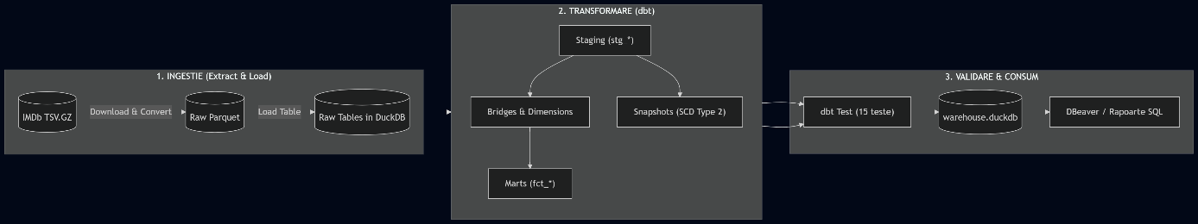
3. Architecture Overview

The diagram illustrates the sequential data flow across four tasks orchestrated by Apache Airflow within a Docker container:

First, extract_and_load_raw_data ingests the compressed IMDb files, converts them into the Parquet format, and loads them into DuckDB as raw tables. Next, dbt_snapshot applies SCD Type 2 logic to track historical changes across titles and ratings over valid time intervals. The dbt_run task then executes the dbt transformation pipeline, processing data from the staging layer through intermediate bridge tables (to resolve many-to-many relationships across titles, genres, and cast/crew members) and materializing the final Star Schema inside the local warehouse.duckdb database. Finally, dbt_test runs an automated data quality validation suite (verifying key uniqueness, referential integrity, and rating domain ranges), ensuring data consistency before the warehouse is queried for analytical reporting in DBeaver.

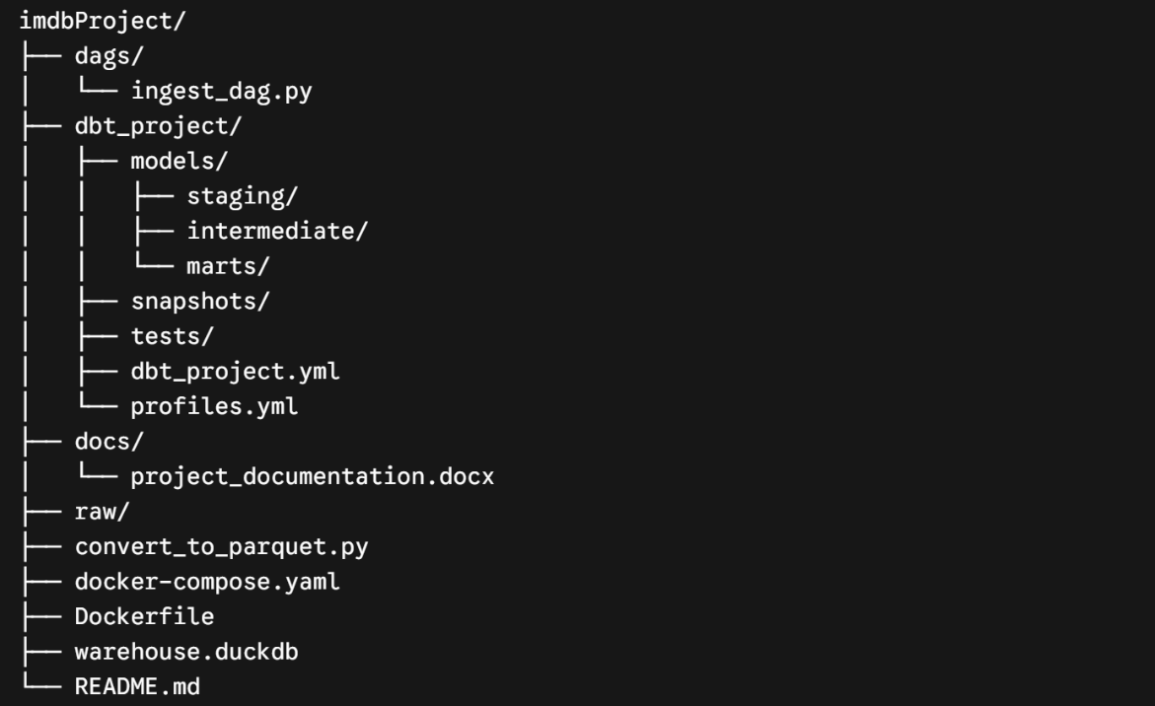
Project Structure Walkthrough

- dags/ingest_dag.py: The primary Apache Airflow DAG orchestrating the end-to-end workflow: raw data download, Parquet conversion, SCD Type 2 snapshots, dbt modeling, and automated testing.
- dbt_project/: Modular transformation layer built with dbt (data build tool):
  - models/staging/: 1:1 data cleaning, type casting, and filtering on raw IMDb records (startYear >= 2020).
  - models/intermediate/: Relational remodeling and many-to-many bridge tables for genres and cast/crew mapping.
  - models/marts/: Final Star Schema models (dim_*, fct_*) and pre-aggregated analytical marts (q1_*, q2_*, q3_*).
  - snapshots/: dbt snapshot definitions tracking historical changes via SCD Type 2 across title attributes and ratings.
  - tests/: Custom SQL data quality tests validating domain-specific business rules (e.g., rating boundaries, valid release years).
  - dbt_project.yml & profiles.yml: Project configurations and DuckDB connection settings.
- docs/: Project documentation and reports (project_documentation.docx).
- raw/: Local storage directory containing the converted Parquet files.
- convert_to_parquet.py: Standalone Python script for converting raw TSV archives into compressed, columnar Parquet files.
- docker-compose.yaml & Dockerfile: Docker container recipes and environment configurations for running the Apache Airflow service stack.
- warehouse.duckdb: Local analytical OLAP warehouse file (DuckDB).
- README.md: Setup guide containing end-to-end instructions for reproducing and running the entire pipeline.

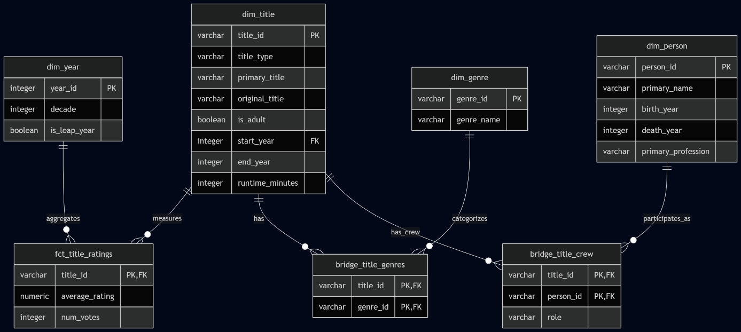
4. Data Modeling & Dimensional Design

The central fact table, fct_title_ratings, stores the project's quantitative measures (average rating and total vote count) at a strict granularity of one row per unique title (title_id) to prevent skewed numerical aggregations. Surrounding the fact table are the descriptive dimension tables:
- dim_title: Each row represents the current version of a title's attributes (title_type, primary_title, is_adult, start_year, runtime_minutes).
- dim_person: Defined at the granularity of one unique individual in the film industry (person_id, primary_name, birth_year).
- dim_genre: Contains one row per distinct film genre.
- dim_year: Each record corresponds to a calendar year and its derived temporal attributes (decade).

To resolve complex many-to-many relationships without inflating numerical metrics in the fact table, the schema incorporates two bridge tables: bridge_title_genres (one row per title–genre association) and bridge_title_crew (one row per unique combination of title, individual, and credit role: director, writer, or principal cast).

5. Slowly Changing Dimensions (SCD Type 2)

In the IMDb dataset, title information changes over time: runtimes can be adjusted, genres reclassified, and ratings alongside vote counts continuously evolve as users cast new votes. To prevent losing historical data during pipeline reloads, two dbt snapshots were implemented using the SCD Type 2 mechanism, tracking changes over time through validity intervals (dbt_valid_from and dbt_valid_to):

snap_dim_title: Tracks updates to movie metadata (primaryTitle, runtimeMinutes, genres). When an attribute changes at the source, the prior version is flagged as expired and the updated record is inserted as a new row, preserving historical context for retrospective analysis.

snap_title_ratings: Tracks fluctuations in average ratings (averageRating) and total votes (numVotes), enabling longitudinal analysis of how a title's audience reception and popularity shift over time.

6. Airflow Orchestration Pipeline

The imdb_ingest_transformation_dag pipeline executes sequentially across four distinct tasks:

- extract_and_load_raw_data: Ingests the raw IMDb source files, converts them into Parquet format for optimal storage and I/O efficiency, and loads them into DuckDB as raw tables.

- dbt_snapshot (BashOperator): Identifies updates in titles and ratings compared to prior runs, persisting historical states via SCD Type 2 snapshots.

- dbt_run: Compiles and executes the dbt SQL transformation pipeline, sequentially building the staging views, intermediate bridge models, and final Star Schema marts within DuckDB.

- dbt_test (BashOperator): Runs the automated data quality test suite (verifying primary keys, referential integrity, and domain constraints); if any test fails, the pipeline halts immediately to prevent corrupted data from reaching downstream analytics.

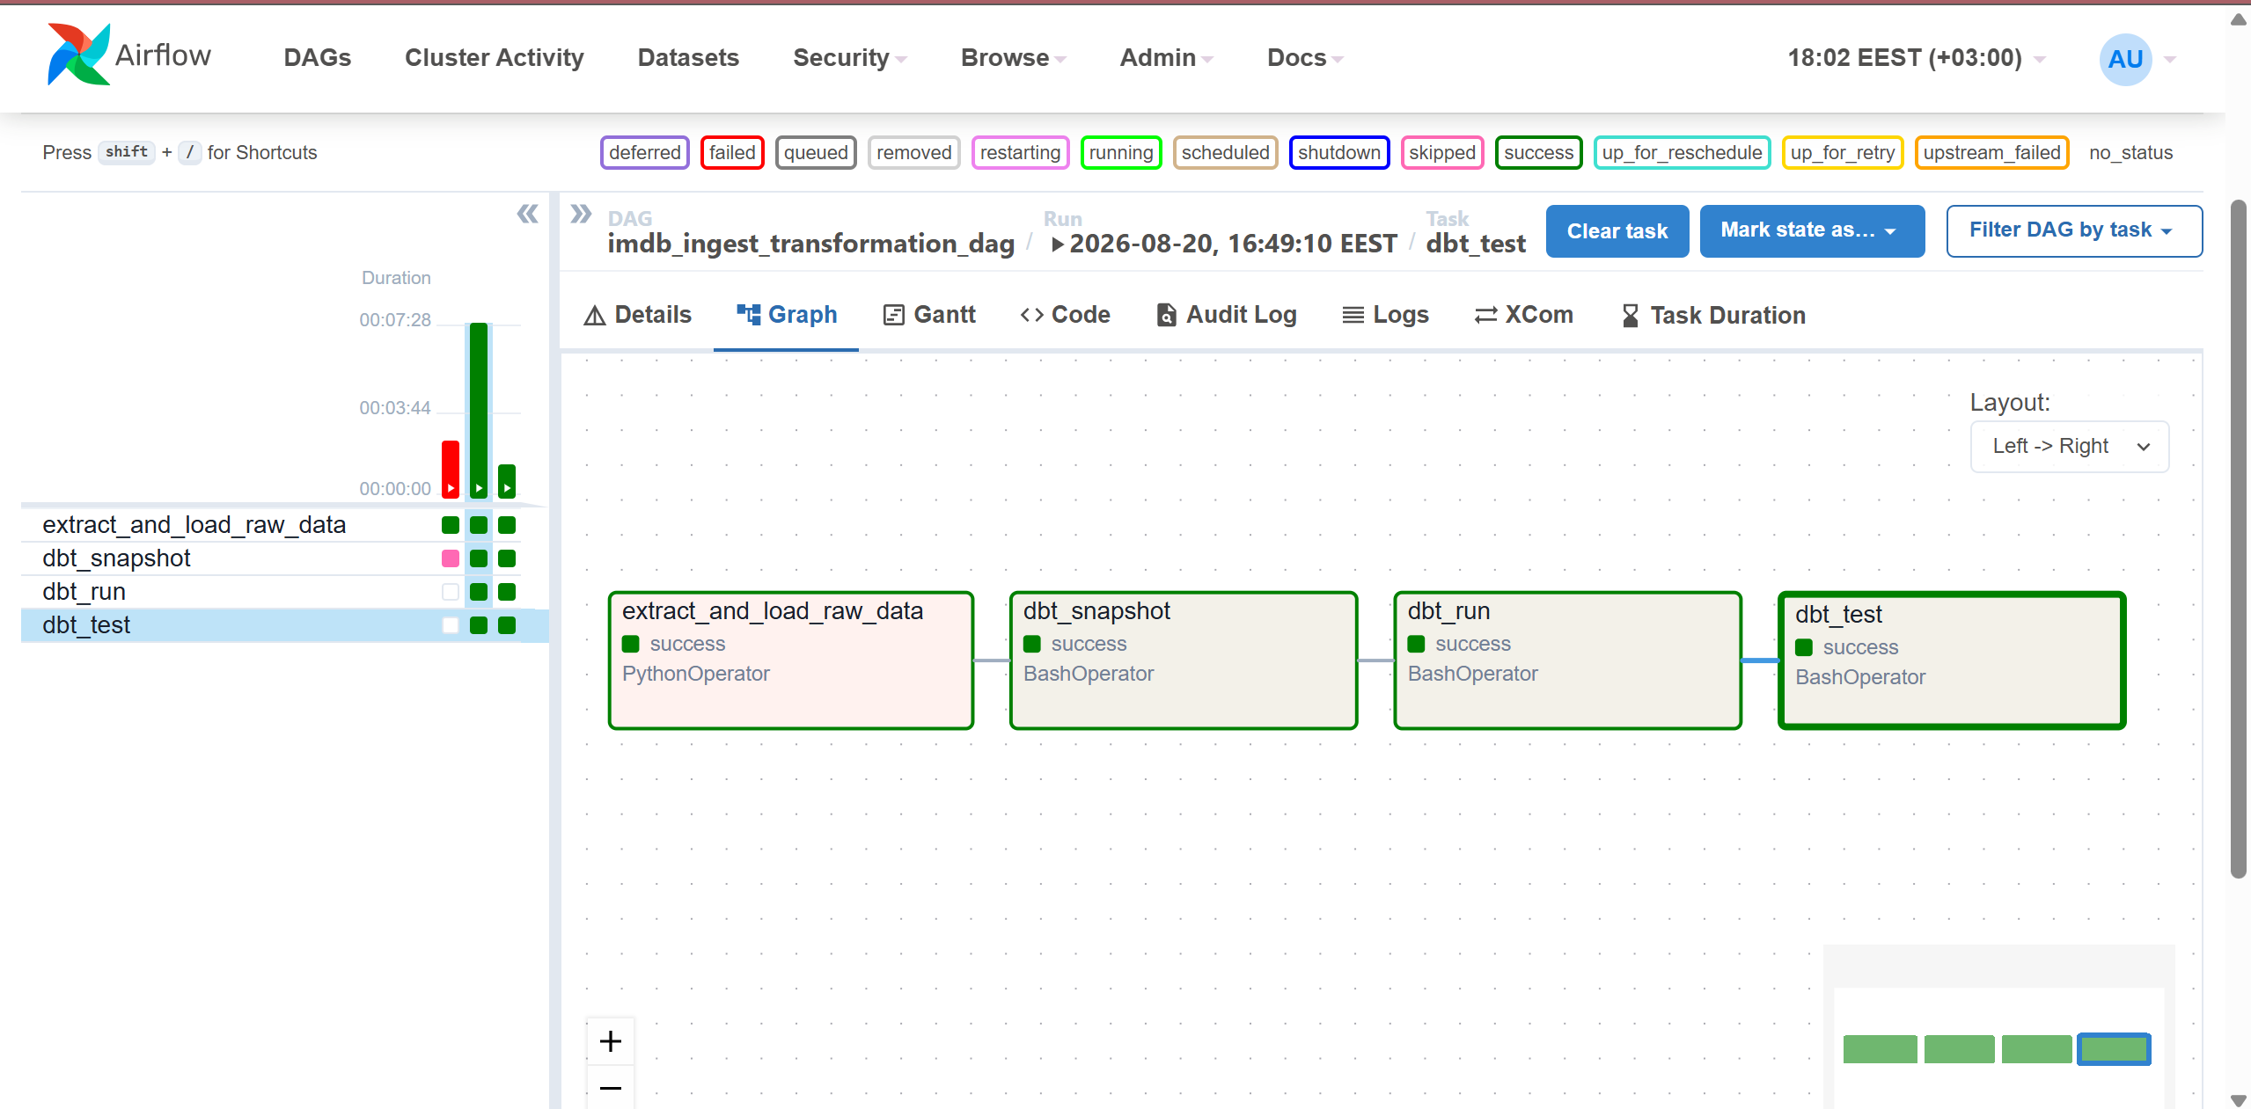

7. Data Quality & dbt Testing

Data quality is validated automatically through four primary categories of dbt tests applied systematically across the Star Schema tables:
- Uniqueness and Non-Null Constraints (unique, not_null): Enforced on all primary keys across dimension tables (dim_title, dim_person, dim_genre, dim_year) and the central fact table (fct_title_ratings), ensuring no duplicate records or missing entity identifiers exist.
- Referential Integrity (relationships): Foreign key integrity tests executed on the fact table and bridge models (bridge_title_genres, bridge_title_crew), guaranteeing that every associative reference maps directly to a valid parent record in the respective dimension.
- Rating Boundary Validation (average_rating_range): A custom domain-specific assertion test ensuring all calculated average ratings fall strictly within the valid IMDb scoring range of 0.0 to 10.0.
- Release Year Boundary Check (test_start_year_not_future): A custom business logic test configured with a warning threshold (severity: warn), flagging pre-production titles announced for future release dates without interrupting pipeline execution.
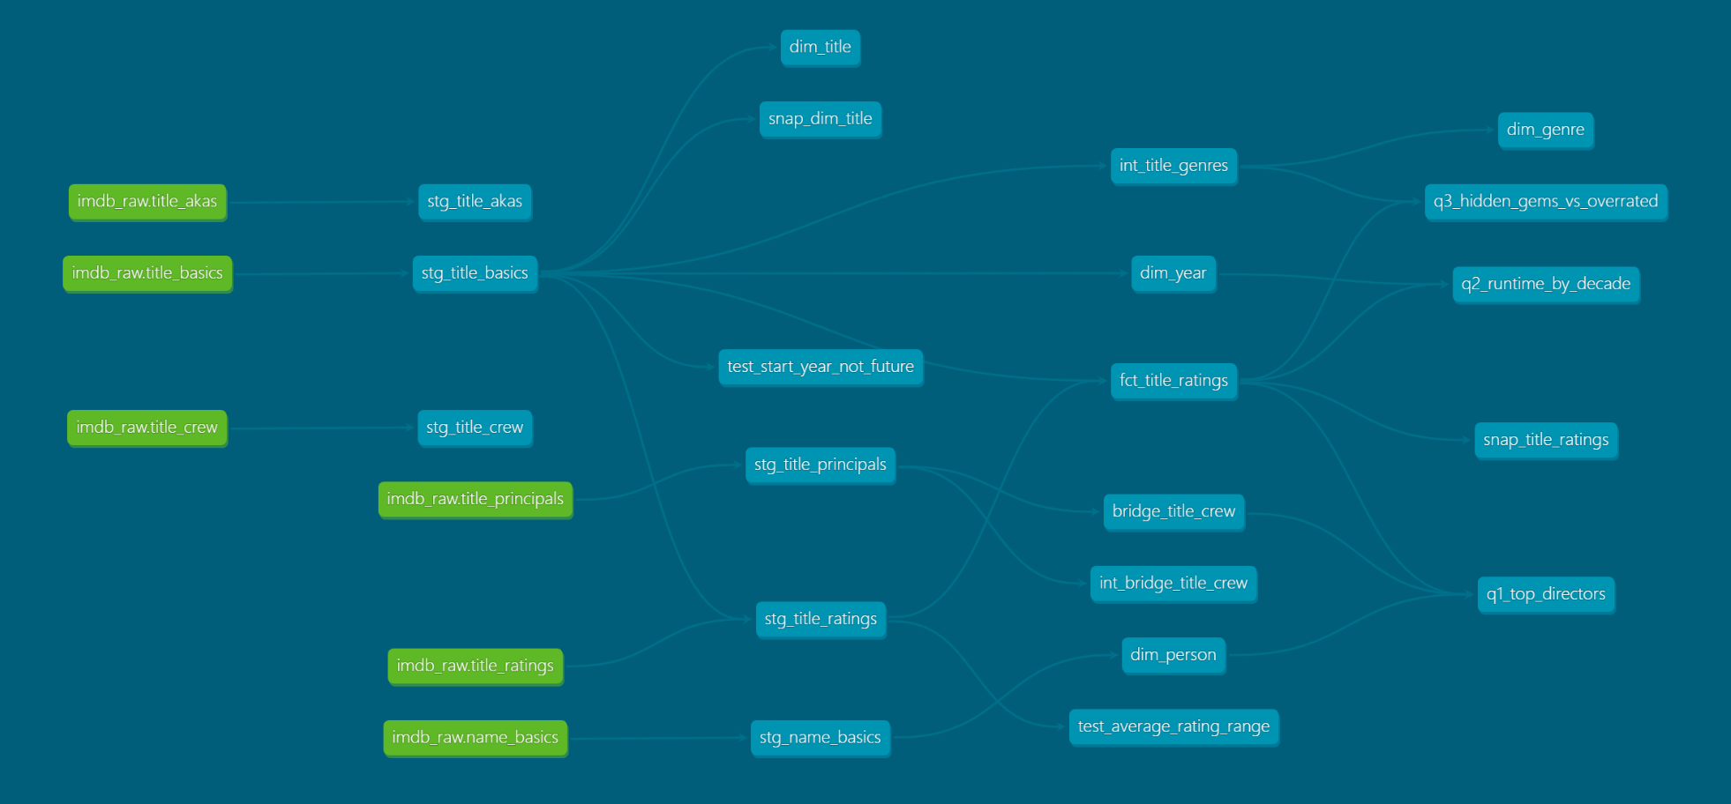

8. How to Run
To rebuild the entire data warehouse on a clean instance, follow these steps:

- Project Setup:

  - Clone the source repository and navigate to the project root directory:

git clone <link_repo>
cd imdbProject

  - Initialize a fresh, empty DuckDB warehouse file:

python -c "import duckdb; con = duckdb.connect('warehouse.duckdb'); con.execute('CREATE TABLE _init (id INT); DROP TABLE _init;'); con.close()"

- Launching Containers:

docker compose up -d –build

- Pipeline Execution:

  - Access the Apache Airflow web UI via browser at http://localhost:8080 (Credentials: admin / admin).

  - Unpause the imdb_ingest_transformation_dag DAG and trigger a manual run via the Trigger DAG button.

  - The pipeline will sequentially execute all four tasks: raw IMDb archive ingestion and Parquet conversion, SCD Type 2 snapshot generation, dbt model compilation (staging, intermediate, and marts), and automated data quality validation.

- Results Verification:

  - Once all tasks finish successfully (status turns green), connect DBeaver or any DuckDB-compatible client to warehouse.duckdb to query the production marts (dim_*, fct_*, q1_*, q2_*, q3_*).

  - Generate the interactive dbt documentation and data lineage graph inside the container:

docker exec -it airflow_imdb bash -c "cd /opt/airflow/dbt_project && dbt docs generate --profiles-dir ."

9. Answers to the Deliverable Questions
Question 1: Who are the top-rated directors based on average rating, with at least 5 directed titles and a minimum of 1,000 votes per title?
- dbt Model Used: models/marts/q1_top_directors.sql
- DBeaver Validation Query:
SELECT * FROM main.q1_top_directors;
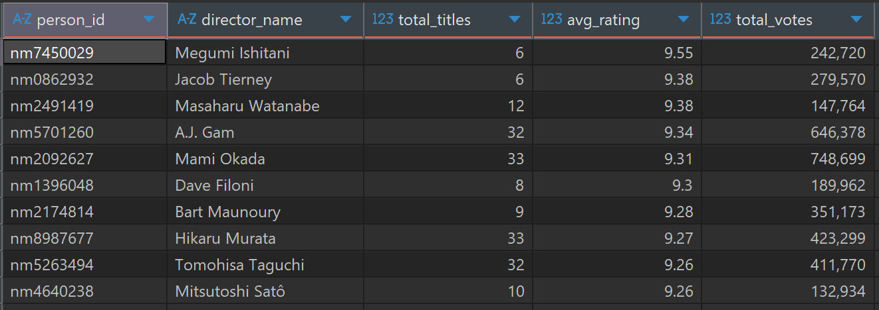
Interpretation:
The ranking highlights directors demonstrating exceptional and consistent quality across recent productions (2020+). Megumi Ishitani holds the top position with an average rating of 9.55 across 6 titles (242,720 total votes), followed by Jacob Tierney (9.38) and Masaharu Watanabe (9.38 across 12 productions). The data demonstrates that directors involved in high-caliber animated formats and established franchise projects maintain exceptionally high and stable audience appreciation.

Question 2: How has the average runtime of film and television productions evolved across decades?
- dbt Model Used: models/marts/q2_runtime_by_decade.sql

DBeaver Validation Query:
SELECT * FROM main.q2_runtime_by_decade;

Interpretation:
For the 2020s (937,881 titles), the average runtime is 45.5 minutes, heavily weighted toward episodic streaming content, whereas for the 2030s it is 78.8 minutes (consisting exclusively of announced feature films). The Pearson correlation coefficient of 0.064 confirms that runtime has no significant linear relationship with audience ratings. The NULL value for the 2030s is mathematically expected: because these unreleased titles share identical default ratings ($0$), rating variance is zero ($σ=0$), resulting in a division by zero.

Question 3: What is the distribution of "Hidden Gems" compared to "Overrated / High Exposure" titles across genres?
- dbt Model Used: models/marts/q3_hidden_gems_vs_overrated.sql
- DBeaver Validation Query:
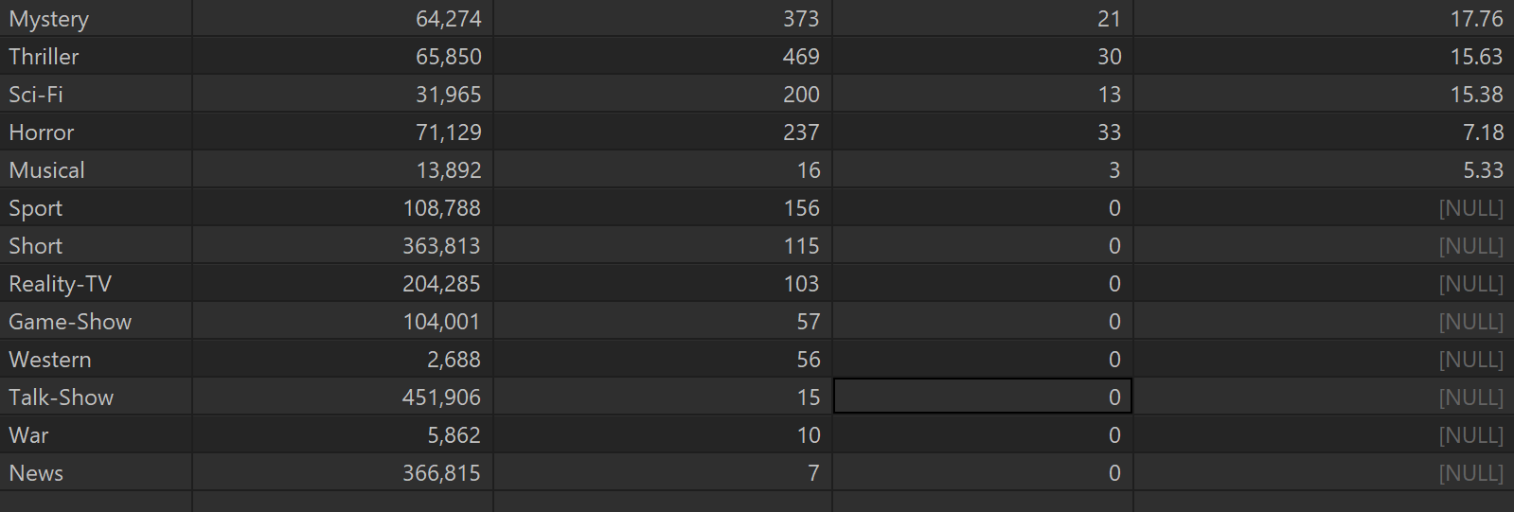
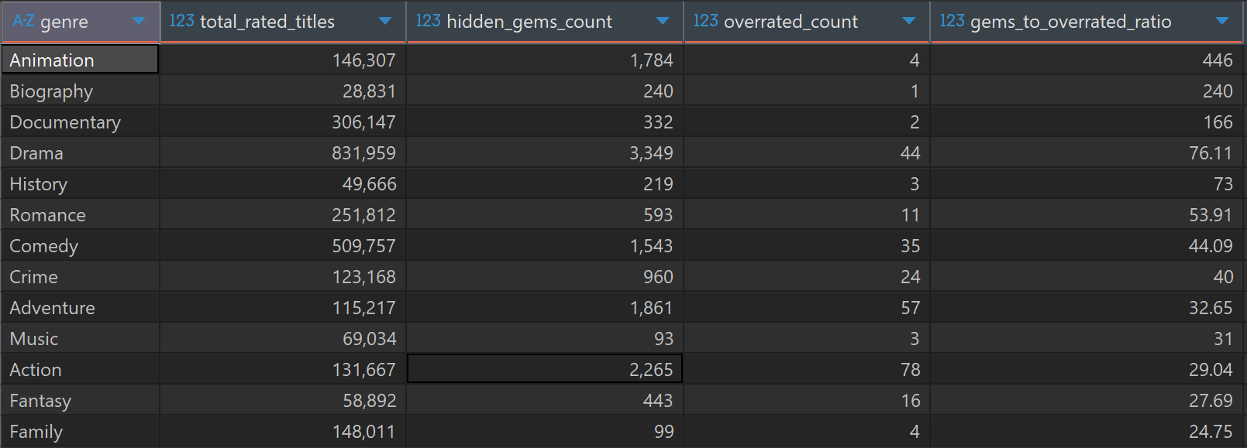
- SELECT * FROM main.q3_hidden_gems_vs_overrated;

- Interpretation:
The analysis reveals a pronounced quality disparity across film and television genres:
Top Genres by Hidden Gems to Overrated Ratio:
- Animation leads by a wide margin with a ratio of 446.0 (1,784 hidden gems compared to only 4 overrated titles).
- Biography reaches a ratio of 240.0 (240 hidden gems vs. 1 overrated).
- Documentary achieves a ratio of 166.0 (332 hidden gems vs. 2 overrated).
Mass Commercial Genres: Broad-audience categories such as Action (ratio of 29.04, 78 overrated titles) and Horror (ratio of 7.18, 33 overrated titles) concentrate the largest volume of heavily marketed yet critically underperforming productions.
Significance of NULL Values: Niche genres such as Sport, Short, Western, and War return NULL for their ratio because they register exactly $0$ overrated titles (overrated_count = 0). The use of NULLIF(..., 0) shields the query from a division-by-zero runtime error, indicating an optimal positive skew (a complete absence of overrated productions).

10. Challenges & Lessons Learned (Provocări întâmpinate)
- Docker Volume Mount Collision (Directory vs. File):

  - Issue: During container initialization, the absence of the warehouse.duckdb file on the host machine caused Docker to automatically create a directory with that name, triggering the runtime failure IO Error: Is a directory when dbt attempted to connect.

- Dependency Ordering on Initial Runs (Snapshots on Non-Existent Tables):
  - Issue: The SCD Type 2 snapshots depended on upstream staging models (stg_title_basics), but the Airflow DAG executed dbt_snapshot before dbt_run, triggering a Catalog Error: Table does not exist on cold starts.

- Referential Integrity in Staging Under Scoping Constraints:
  - Issue: Applying the release year constraint (startYear >= 2020) strictly to stg_title_basics caused the dbt relationships test on stg_title_ratings to fail due to over 1.2 million orphaned rating records referencing filtered historical titles.

- RAM Constraints and Resource Optimization (Memory Pressure & OOM):

  - Issue: The massive volume of raw IMDb datasets (millions of records) created continuous memory pressure inside the Docker containers, leading to frequent bottlenecks and Out Of Memory (OOM) risks when parsing large source files directly.

