Southeast: Coal Free by 2030?

Group 14

Megan Cavalieri, Andres Garcia, Nicolaas Justice, Fariz Kabir, Max Mendoza, Stephanie Terhaar

**Table of Contents**

**Introduction** **3**

Motivation 3

Southeast Region Background/Literature Review 5

Included states 5

State Energy Profile Analysis 5

Average Coal consumption vs. national average 7

General Methodology 10

Install renewable energy sources to meet current coal consumption 10

Wind vs. Solar categories 10

Role of Nuclear beyond 2030 11

**Wind Focus** **12**

Background 12

Included states 12

State Energy breakdowns by source 12

Methodology 14

Wind focus strategy 14

How do we determine the required wind capacity? 14

How do we determine how much space we need? 18

How do we determine the cost? 18

Other considerations 18

Example calculation 20

Results 20

**Solar Focus** **24**

Background 24

Included states 24

State Energy breakdowns by source 25

State Energy policy overview 27

Methodology 29

Solar focus strategy 29

Example Calculation 30

Results 30

**Conclusion** **32**

Overall feasibility of strategy 32

Overall feasibility of 2030 coal free goal 33

What’s Next? 34

**Appendices** **36**

Sources 36

Programs 38

# Introduction

## Motivation

We were tasked with determining a way for the Southeast region of the US to become coal free for electricity generation by 2030. Although this seems like an out of reach project, it is not too far off from some of the actual US government and international goals. Following COP26, Biden has announced a plan for the US to have 100% carbon pollution free electricity by 2035. There have also been incentives set in place for residents to make the switch to renewable energy. The Federal Solar Investment Tax Credit program allows homeowners to claim 26% of the total project costs of buying equipment/permits and installing solar panels as credit in their federal tax returns if done in either 2021 or 2022. Incentives like these are promising and show a trend that our country is making a move toward renewable energy. Many countries have full intentions of phasing out domestic coal and others have planned to end large public support for fossil fuels. These goals come from the need to reduce greenhouse gas emissions, which are largely contributed to by fossil fuels including coal.

Studies have shown that human activities are responsible for climate change to an extent and the global temperature is rising at an alarming rate. Currently, electricity generation contributes the most to carbon dioxide emissions, being responsible for about 40% in the United States, as well as contributing to 25% of the global greenhouse gas emissions.

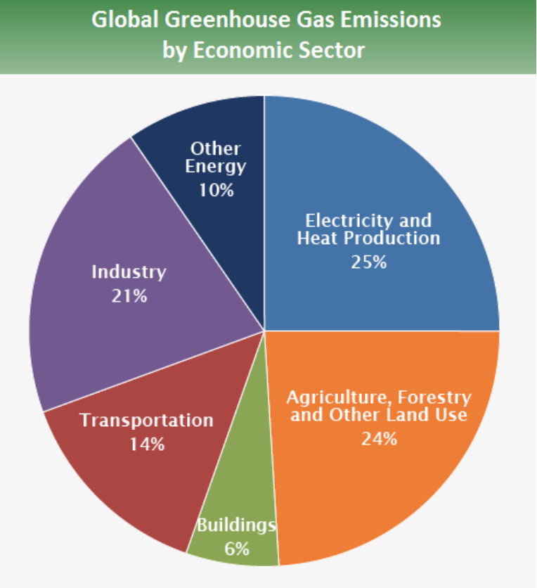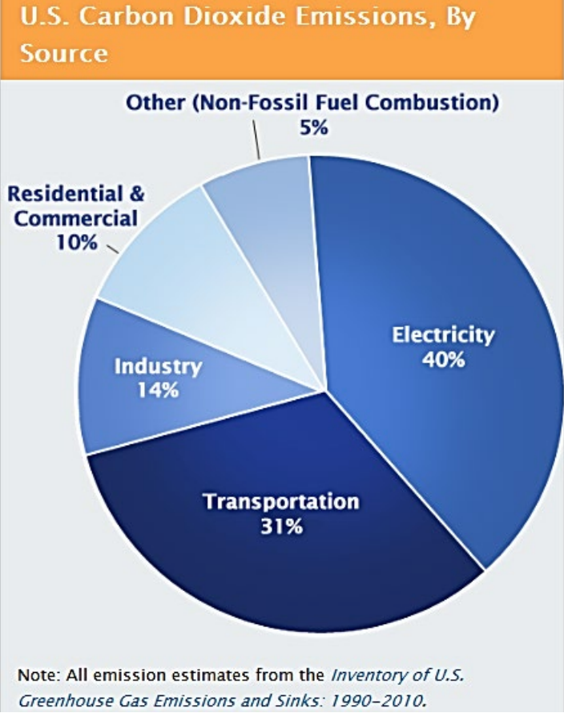

Electricity Generation Contribution to Greenhouse Gas Emissions (“Climate Change Lecture”, 2022)

The Paris Climate Agreement, between 197 countries, was formed to reduce greenhouse gas emissions and maintain a low global temperature increase of less than 2 degrees Celsius. Many countries submit Nationally Determined Contributions (NDCs) which are their carbon reduction targets for the next 5 to 10 years. After those goals are set, the governments set new energy standards and policies to work towards those goals. These policies need to account for the fact that the population and therefore energy demand are only going to increase. With current policies, the expected energy demand in 2040 will correlate to 42.5 Gt of CO2 emissions. With new policies focused around green energy, that number could be reduced to 17.5 Gt CO2 by 2040. Clearly, we need to make a change to protect the environment. Due to the high contribution from electricity generation, that seems like a fair place to start to move towards green and renewable energy.

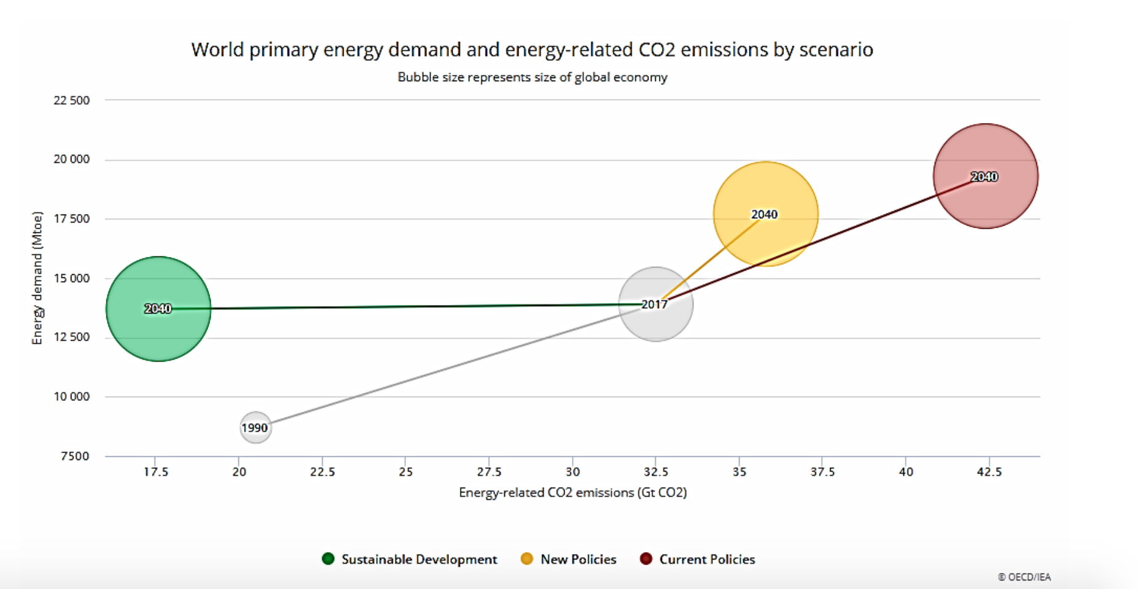

Impact of Sustainable Policies to Future Energy Demand and CO2 Emissions (“Climate Change Lecture”, 2022)

Our intention is to create a solution to replace all of the electricity generated from coal in the Southeast with renewable energy by 2030. This idea faces a lot of challenges, not limited to economics, financial responsibility, existing energy policies, local and federal government support, existing natural resources, feasibility, and land distribution.

## Southeast Region Background/Literature Review

### Included states

The Southeast region was defined differently by varying sources and included fragments of some states, but ultimately we included Alabama, Florida, Georgia, Kentucky, Mississippi, Missouri, North Carolina, South Carolina, and Tennessee.

### State Energy Profile Analysis

Currently, the Southeast is heavily dependent on fossil fuels, specifically coal and natural gas. We read literature from EIA (EIA, 2022) that broke down the current distribution of energy sources in each state and gave some insight into their future electricity generation plans. We wanted to get a better understanding of which states relied the most heavily on coal, which were moving towards greener energy sources, which were exporters or importers of electricity, and what the generation versus consumption looked like. Some of the states that concerned us more due to their coal reliance were Kentucky, Missouri, and Tennessee.

Kentucky has major coal deposits and is 5th in the country for coal reserves and production. In 2020, about 69% of the state’s electricity net generation was coal-fired, which is the 4th largest percentage of all the states. The state also has high energy consumption and sends coal to 20 other states. They are starting to shift over towards natural gas, and Kentucky has multiple river dams which allows for some hydroelectric power, which is currently essentially their only renewable source. Missouri also relies majorly on coal and natural gas. In 2020, 70% of the state’s electricity net generation was coal-based. Missouri uses a lot more energy than it produces, but their per capita consumption is not much higher than the national average. The state has moved over to renewable energy, including biodiesel (3rd largest biodiesel production in the country) and nuclear energy, totaling about 29% of the state's net electricity generation. In the last few years, Tennessee has moved to nuclear energy. During 2020, 47% of the state’s electricity generation came from nuclear while coal’s share was about 18%. The nuclear percentage is increasing. Natural gas had finally surpassed coal that year at 20%. Kentucky, Missouri, and Tennessee are the states with the largest coal dependence in the Southeast region.

Alabama, Florida, Georgia, Mississippi, North Carolina, and South Carolina have a much lower dependency on coal-fired electricity, but they do have a high reliance on natural gas. Since our project focuses on making the region coal free, we had less to worry about with changing these states. Alabama is a large electricity producer and exporter. Coal-fired plant usage has dropped to about 16% of the share of the state’s electricity generation as of 2020. Alabama has shifted to generating electricity by nuclear energy, and the state has potential for offshore wind. Florida is a big electricity importer, consuming much more than it generates. The state has a growing population and energy demand, so they should be generating more electricity in the future. They rely on coal mainly from other states, but their coal consumption “fell from 29 million tons in 2008 to less than 7 million tons in 2020.” As the sunshine state, there is great potential for more solar consumption towards electricity generation. Georgia currently has no active coal mines and their coal consumption has declined from 35 million tons annually to 8 million tons in the last decade. They are only reliant on coal-fired power plants for 4.5% of the state’s electricity generation. Nuclear and natural gas constitute a big majority of the electricity generation, totaling about 84% in 2020. The rest comes from renewable resources, specifically biomass, solar, and hydropower.

Mississippi has 1% of the nation’s coal reserves, but only 8% of the state’s electricity generation is coal-fired as of 2020. About 10% is attributed to nuclear power as of 2020, but that number is on the rise, and Mississippi has the largest single-reactor nuclear power plant by generating capacity in the US. The state currently has no electricity generation from wind power, but they have some from solar power. North Carolina is among the top 10 states for highest electricity consumption. Around 35% of their net electricity generation comes from nuclear power, and they are ranked 3rd in the country for total installed solar generating capacity and 4th for actual solar power generation. North Carolina currently has a somewhat low dependence on coal-fired power plants for electricity generation, about 17% of their total electricity generation. North Carolina depends on electricity from other states transported by the regional grid. South Carolina also has a lot of its electricity generated by nuclear power, roughly 56% as of 2020. Natural gas is the second most prominent source as it passed coal-fired plant production in 2018. Over the last decade, total electricity generation from coal-fired plants decreased by more than half, only accounting for 13% in 2020. The rest comes from solar panels, biomass, or hydropower facilities, and the state is an exporter of electricity across the grid (EIA, 2022).

### 

### 

### 

### Average Coal consumption vs. national average

|  | AL (%) | FL  (%) | GA (%) | KY (%) | MS (%) | NC (%) | SC (%) | TN (%) | MO (%) | US avg. (%) |
| --- | --- | --- | --- | --- | --- | --- | --- | --- | --- | --- |
| Petroleum-Fired | NM | 0.2 | 0.2 | 0.4 | NM | NM | 0.2 | 0.3 | 0.4 | 0.9 |
| Natural Gas-Fired | 41.1 | 74.4 | 44.2 | 27.5 | 74.8 | 36.7 | 21.3 | 20.9 | 8.4 | 36 |
| Coal-Fired | 18.5 | 5.8 | 18.6 | 65.6 | 6.9 | 21.7 | 16.7 | 21.7 | 69.2 | 23.1 |
| Nuclear | 28.8 | 12.5 | 26.1 | 0 | 15.9 | 29.5 | 55.3 | 43 | 10 | 18.6 |
| Renewable | 11.6 | 5.5 | 11 | 6.6 | 2.3 | 11.8 | 7.2 | 14.9 | 12 | 20.9 |

Comparison of Coal Consumption for Electricity Generation Between Southeast States and the National Average (NM = not meaningful data)

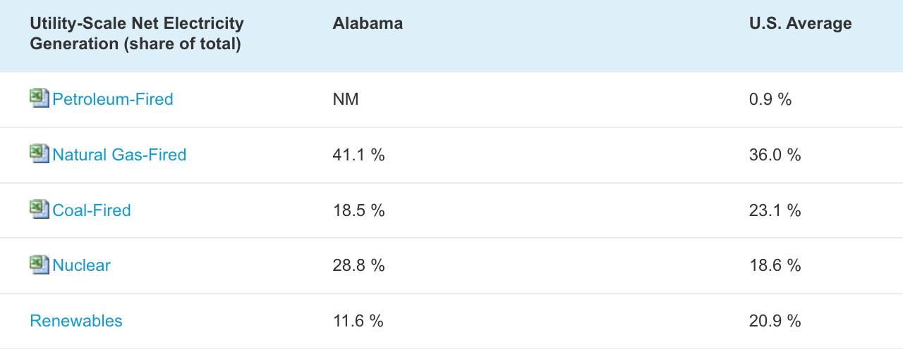

Alabama Electricity Generation Breakdown by Source Jan 22

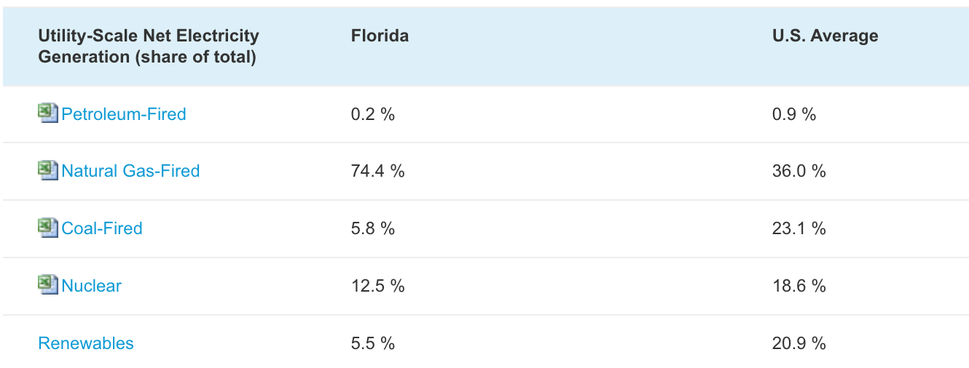

Florida Electricity Generation Breakdown by Source Jan 22

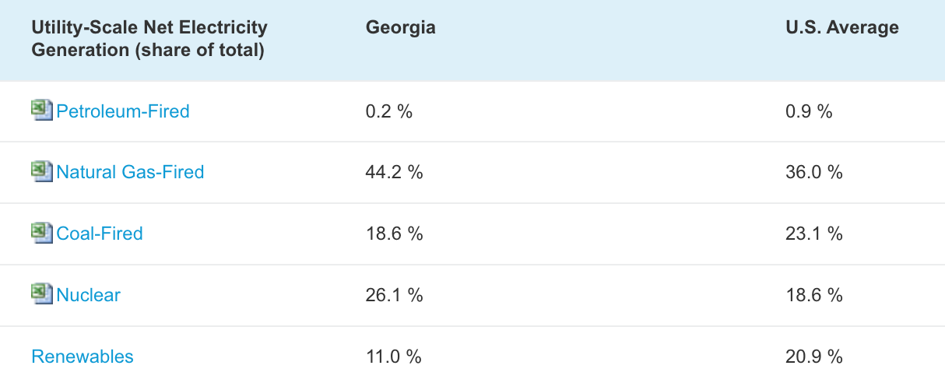

Georgia Electricity Generation Breakdown by Source Jan 22

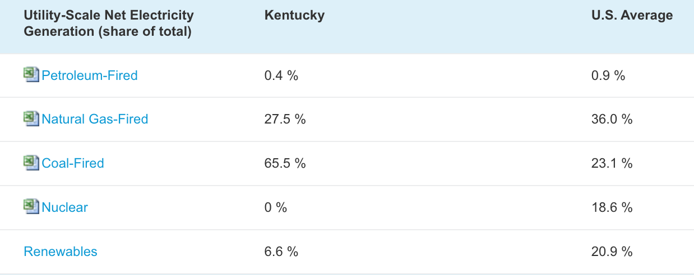

Kentucky Electricity Generation Breakdown by Source Jan 22

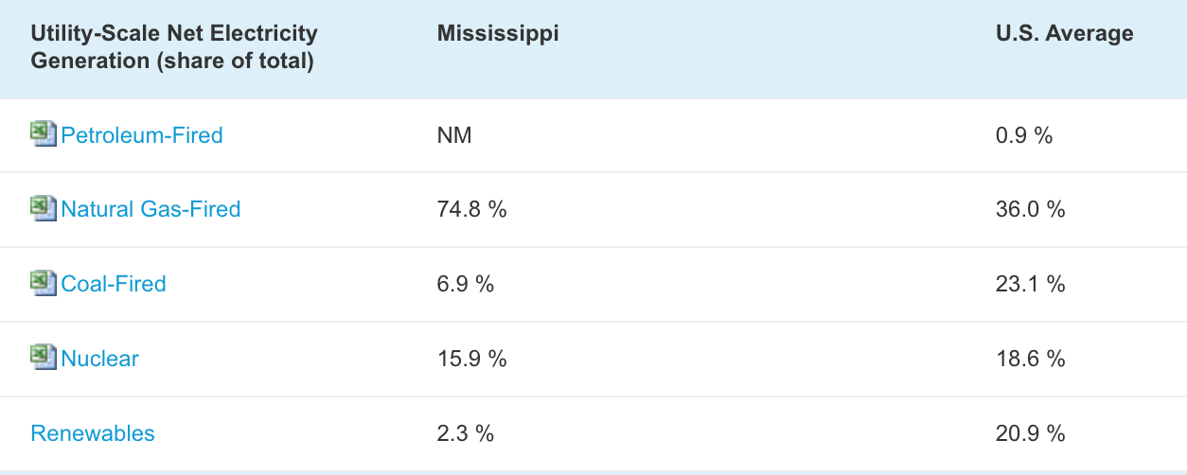

Mississippi Electricity Generation Breakdown by Source Jan 22

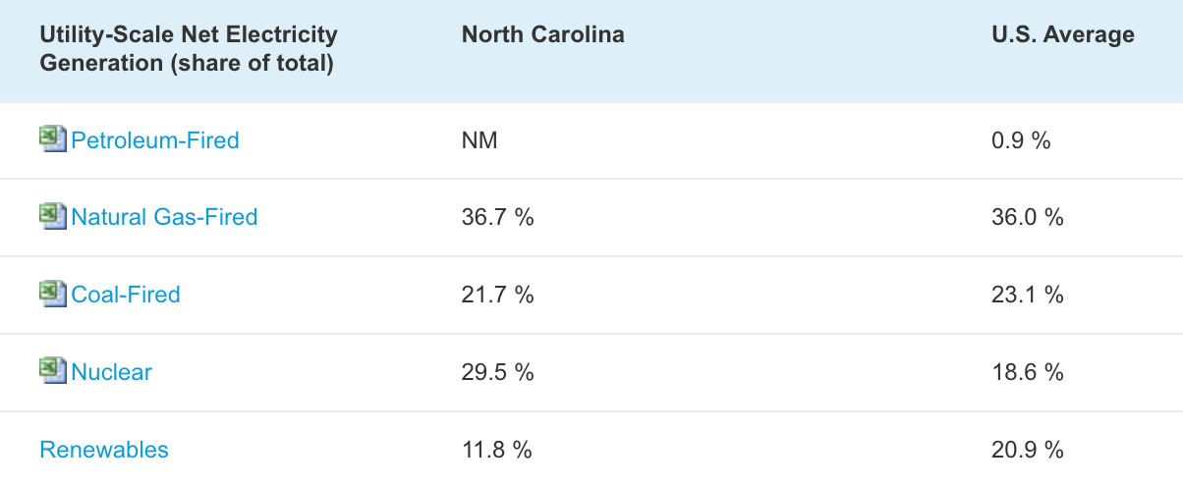

North Carolina Electricity Generation Breakdown by Source Jan 22

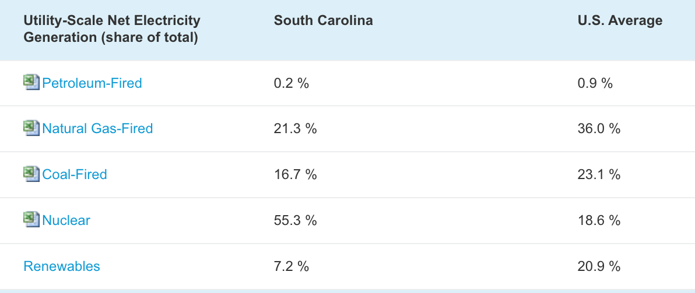

South Carolina Electricity Generation Breakdown by Source Jan 22

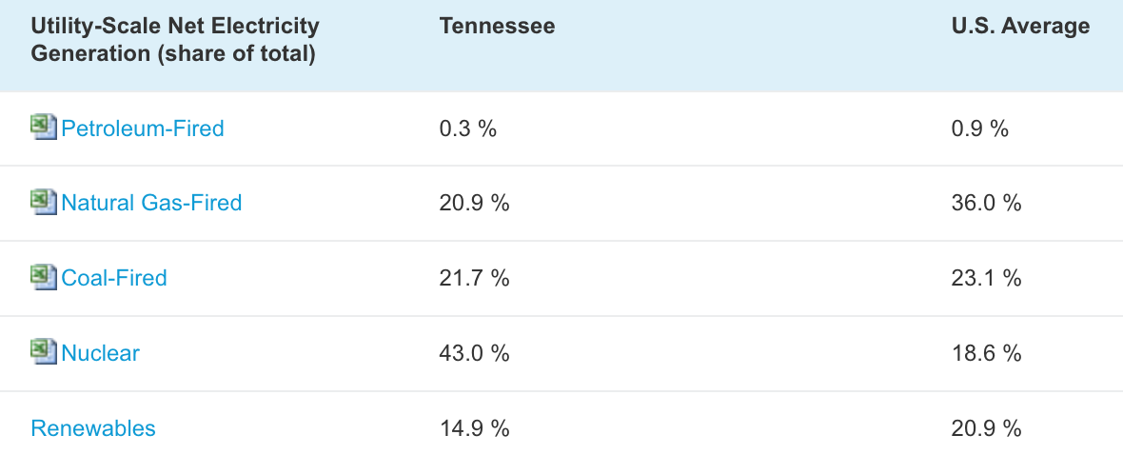

Tennessee Electricity Generation Breakdown by Source Jan 22

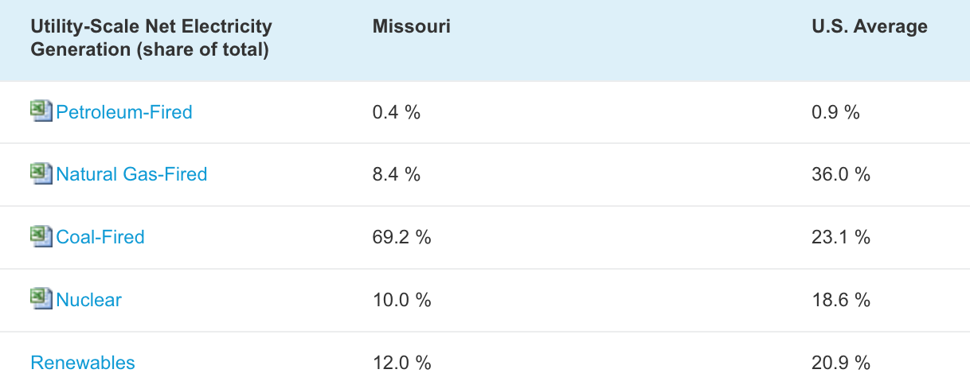

Missouri Electricity Generation Breakdown by Source Jan 22

All state electricity generation break-downs provided by EIA.

## General Methodology

### Install renewable energy sources to meet current coal consumption

The overall strategy applied to replace coal by the 2030 deadline in the southeast region of the United States has been to first determine the most appropriate renewable energy device for the state based on available environmental resources. Some states may receive a large amount of sunlight on a day to day basis with flat grounds suitable for solar panels while others have hills and are exposed to large amounts of wind, ideal for wind turbines. The idea is to extract an amount of energy from such renewable sources that is equivalent in numerical value to the amount of energy extracted from coal for each southeast state. This essentially allows us to meet the overall energy demand for the states while phasing out fossil fuels in exchange for clean energy from the sun.

### Wind vs. Solar categories

The preferred form of clean renewable energy to replace coal energy is the untapped energy from our gigantic nuclear reactor, the sun, which is in incredibly high abundance in one form or another whether it is solar radiation or kinetic energy from the wind. Certain southeast states of concern such as Missouri, North Carolina, Tennessee, and Alabama have sufficient average wind speeds and more energy available from wind compared to solar such that wind turbines were selected as the renewable energy production device. Other southeast states such as South Carolina, Georgia, Florida, Mississippi, and Kentucky received a lot of solar energy and had enough flat lands such that there was more potential for solar energy extraction over wind energy to generate electricity. Decisions regarding the grouping of solar and wind states were made using a qualitative and quantitative approach by looking at the combination of state topography, average amounts of sunlight received and average wind speed. This doesn’t mean that wind energy isn’t an option in states like South Carolina and Georgia. In fact, these two states have both been seriously looking into building off-shore wind turbine farms and have great off-shore potential. However, for our goal of taking the Southeast region coal-free we found that we could achieve this with solar farms in those states.

### Role of Nuclear beyond 2030

Nuclear energy on its own is quite popular in the southeast region and quite efficient due to the usage of waste heat to drive a secondary turbine, depicted in the figure below, reaching efficiency up to 60% (Laughlin, 2012). This coupled with the fact that nuclear power plants are able to generate large quantities of energy makes them an attractive option to the region. However, they are not suitable for meeting the 2030 deadline for replacing coal energy with renewable energy due to the large upfront cost and long build time relative to solar panels or wind turbines. In a 2020 report, the average overnight cost to build a nuclear plant was around $6041/kWe, and this doesn’t include the fuel costs (roughly above $1600/kg) or any other external expenses that might be had. Not only that but building one nuclear plant will take about five or more years from pouring the first concrete to being connected to the grid and generating electricity (World Nuclear Association, 2022). Even if we began construction of nuclear plants in each state, not only would there be immense costs, we wouldn’t start producing electricity from them until at least 2027, and that’s assuming that there are no problems with construction and that everything runs smoothly. Even then, construction can take longer depending on the size of the plant. While these states could (and should) start to design and build some nuclear plants between now and 2030, we aren’t going to factor this into our report due to the fact that any significant benefits we would see would most likely come after our deadline of 2030.

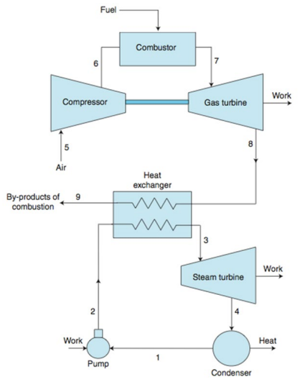

# Wind Focus

## Background

### Included states

The states considered for wind energy were Missouri, North Carolina, Tennessee, and Alabama. Many of these states have pre-existing wind energy generation infrastructure, albeit quite small, indicating some level of interest for further development. These states also have adequate wind profiles making them viable for onshore wind turbines handling low to medium wind speeds. These states have more potential for wind turbines than solar panels due to topology and a larger presence of wind energy compared to solar energy.

### State Energy breakdowns by source

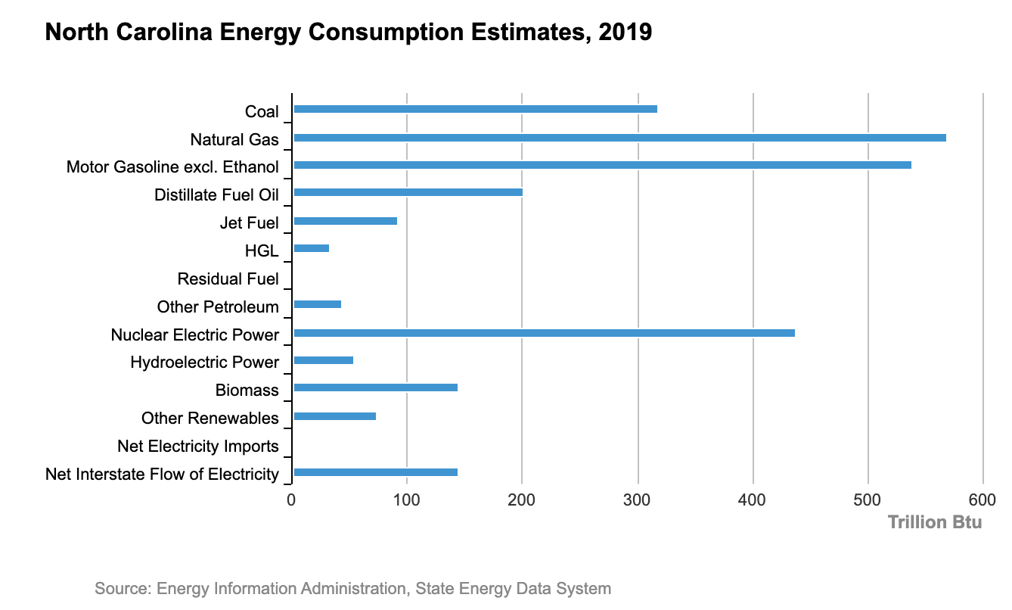

Coal consumption in North Carolina: 318.2 Trillion BTU

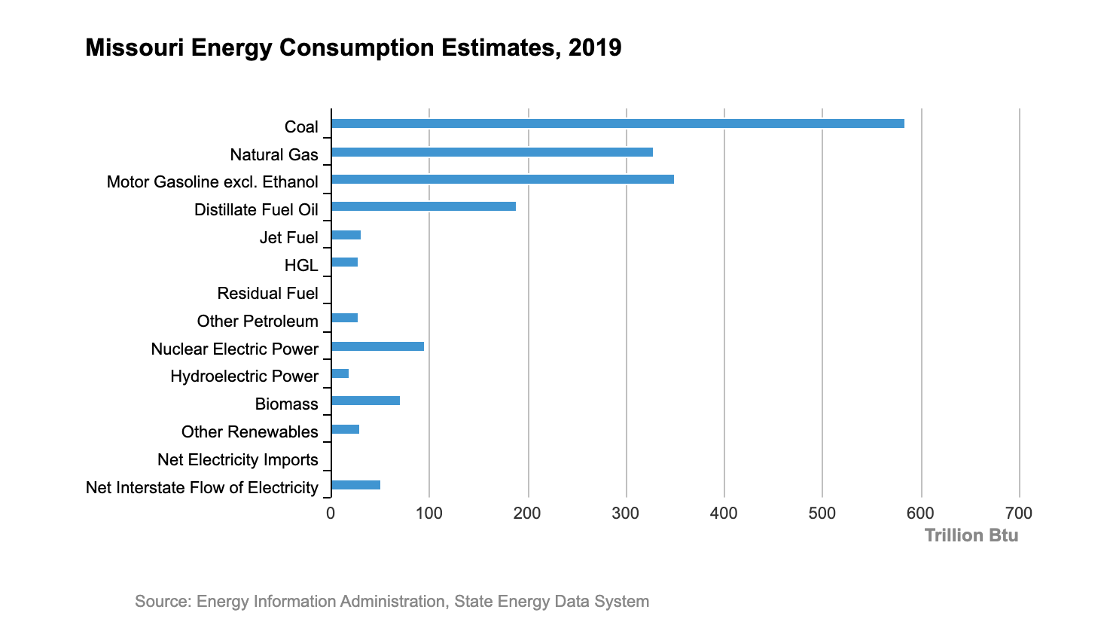

Coal consumption in Missouri: 584.7 Trillion BTU

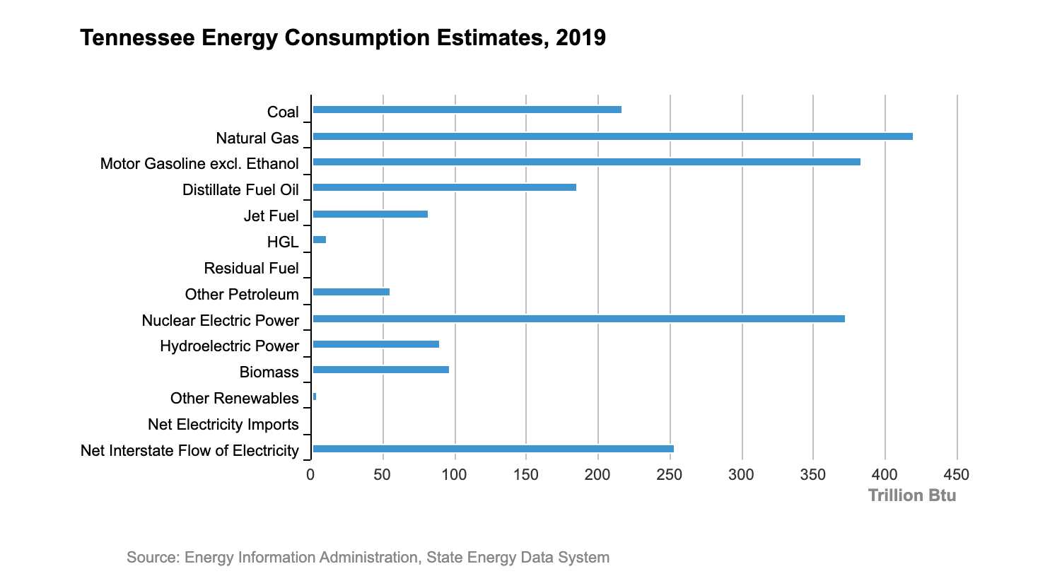

Coal consumption in Tennessee: 161 Trillion BTU

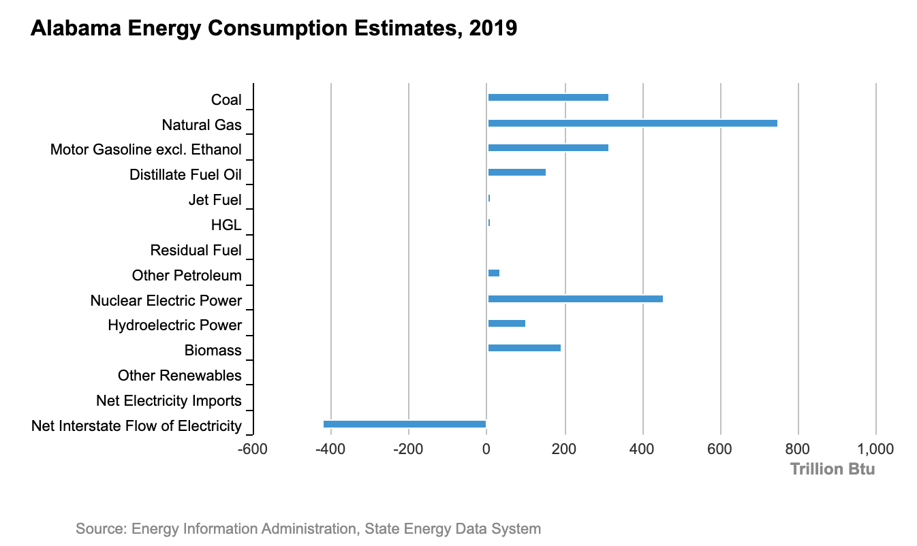

Coal consumption in Alabama: 317.2 Trillion BTU

The average coal consumption for the Southeast region is 297.1 Trillion BTU’s. With the exemption of Tennessee, all of these states are above this average, with Missouri consuming almost twice as much as the regional average. It will be challenging to replace all of this coal with just wind farms, luckily the US has been implementing nation wide policies to help the change to renewable energy. Although demand for energy is rising, as more people begin to power their own homes with renewable energy, hopefully we’ll see coal consumption will decrease and we will need to build less wind farms. Making our coal free by 2030 goal a bit easier.

## Methodology

### Wind focus strategy

#### How do we determine the required wind capacity?

In order to determine the required number of wind turbines per farm it is necessary to define the target quantity of coal energy consumption for each state along with its average wind speed, which has been summarized in the following table.

To find the estimated power produced from wind by each state, we used the monthly average wind speed, cubed them and found the average value for each state. Some of the state data was more reliable and accessible than others, but, in general, the data sets are assumed to be an accurate representation of longer time span trends. Also, wind data was taken from certain sites in the state, so the assumption is also being made that that site can at least decently represent the wind speed trends of the state as a whole. The figures below show how the wind data for each state was acquired.

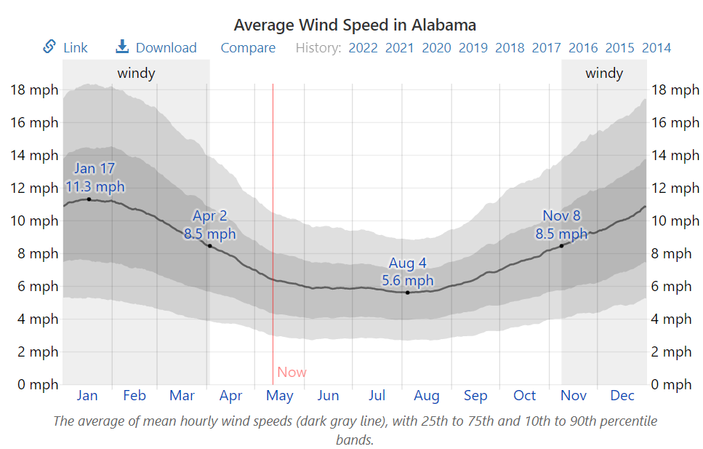

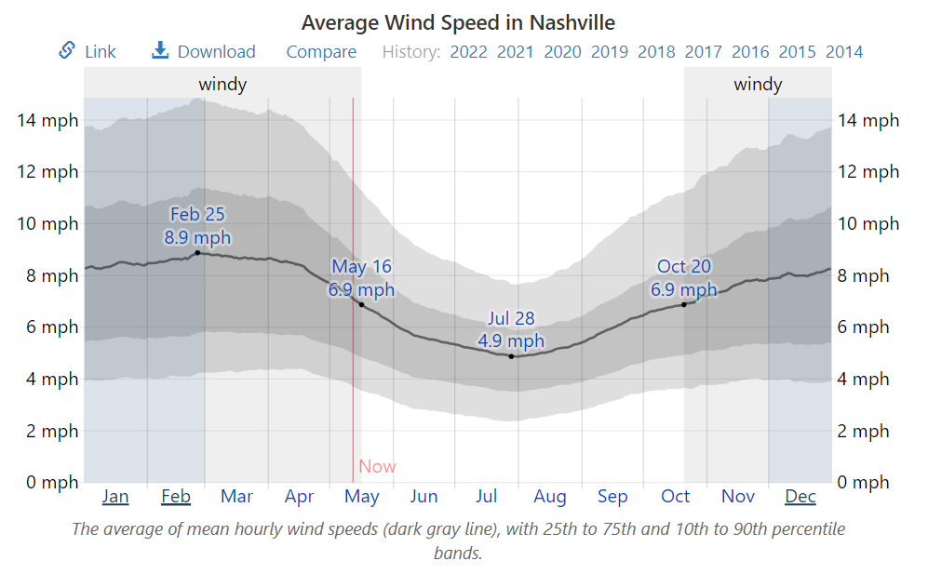

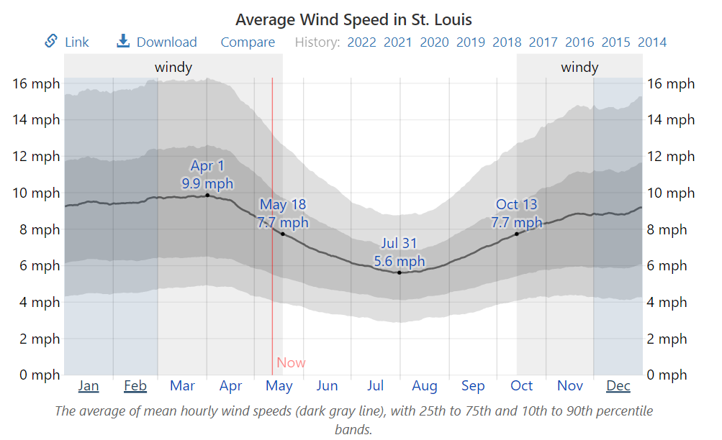

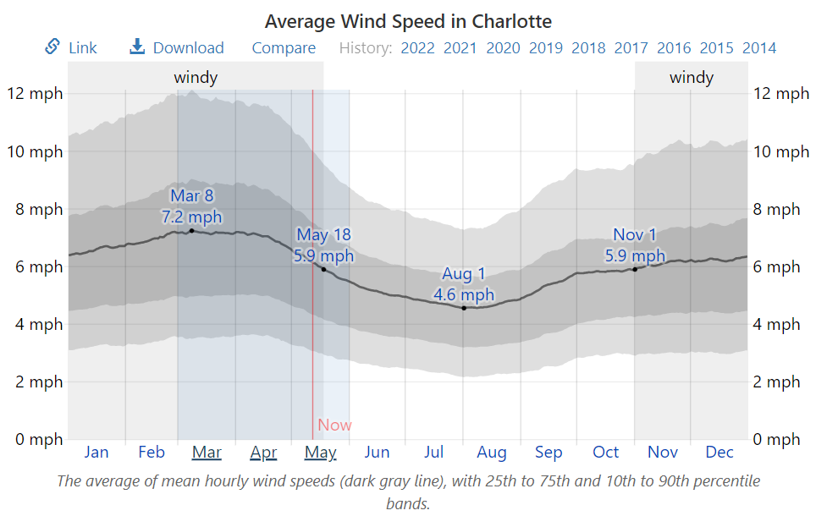

**Table 1: Wind states annual energy consumption**

| State | Annual Coal Energy Consumption [GJ/yr] |
| --- | --- |
| Missouri | 6.169×10^8 |
| North Carolina | 3.357×10^8 |
| Tennessee | 1.699×10^8 |
| Alabama | 3.3466*10^8 |

The wind turbine is simplified and modeled using the actuator disk model shown in the figure below.

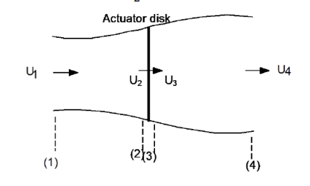

The freestream velocity of the wind is given by U1, the velocity at the inlet of the wind turbine is given by U2 which is equal to U3, and the velocity at the outlet of the wind turbine is given by U4. The axial induction factor can be introduced based on the velocities depicted above which represents the fractional decrease in velocity between the freestream and rotor plane.

Rearranging the above equation gives, and . The power coefficient, which determines wind turbine efficiency, can be represented based on the axial induction factor as follows.

The instantaneous power generated by a wind turbine is governed by the following equation

where as for a=⅓, is what the wind turbine will operate at for its coefficient of power as determined from the betz limit, which is the theoretical maximum efficiency of a wind turbine in terms of the kinetic energy it is able to extract from air. This is a reasonable estimate as many wind turbines operate near the betz limit. The value of is 1.21 kg/m^3 at standard sea level, which is a reasonable estimate for air density at wind turbine height. A is the area swept by the wind turbine rotor and is given by where R is the rotor radius. U^3 is the average of velocity values cubed, which may be taken as a periodic measurement with time. In order to determine the rotor radius several wind turbine candidates were looked at that are appropriate for the states at hand. A Siemens onshore 2.9 MW turbine fulfilled all the requirements and has a rotor diameter of 129 m. These values are sufficient to calculate the instantaneous power produced by the turbine at the state being considered, which can be converted to energy produced over a year per turbine by simply multiplying the result by 8760 hrs/yr*3600s/hr. Dividing the value of the annual coal energy consumption for the state being considered, outlined in the above table, by the annual wind energy generation per turbine for that state gives the total number of turbines required to meet the annual coal energy consumption requirement. This calculation assumes that the coal energy consumed is uniformly distributed over time throughout the year, which isn’t the case as there are peak loads. This is something critical that is addressed further in the study.

#### How do we determine how much space we need?

The space needed for installation of wind farms in each state is determined via a MATLAB code that is detailed in the results section below.

#### How do we determine the cost?

The cost is determined on a per MW basis as given in one of Professor Barthelmie’s wind power lectures (Barthelmie, 2021). The elements that go into the cost can be broken down as follows:

Principal (buy manufactured product from siemens) + operation and maintenance (self explanatory) + transportation (trucks will have to carry parts for such a large structure over a long distance) + installation (self explanatory) = $1.11 million/MW.

#### Other considerations

There are a few limitations to this analysis model for the wind solution. One limitation of this calculation is that it assumes that coal usage per year is stagnant despite growing energy demand. An accurate model would account for the fact that more wind turbines would need to be installed as energy demand increases yearly. Another improvement would be using a Weibull distribution rather than the average wind speed values, which may better account for variabilities in wind speed and power generation at such speeds to better predict the number of turbines needed. The average wind speed values used here are still quite representative and should be a good estimation.

It is also important to consider peak loading during summer months where indoor cooling needs are at an all time high in the southeast region. This is handled by building additional wind turbines in North Carolina, the southeast state with the highest average wind speeds and using that energy to meet North Carolina’s own peak loading as well as peak loading of other nearby wind states, taking the difference with power produced from the number of already planned wind turbines above. Transmission loss occurring during export from North Carolina is not accounted for and is a limitation to this analysis. The peak loading has been outlined in the table below for each wind state. This is to be treated as a modification to the analysis above to correct for non-uniform energy usage with time.

**Table 2: Peak Load considerations for Wind Power**

| State | Peak Loading [MW] | Power Produced from Wind Turbines Planned Above (no wake) [MW] | Difference (to meet peak load) [MW] |
| --- | --- | --- | --- |
| Missouri | 37,984 | 19,563 | 18,421 |
| North Carolina | 22,301 | 10,645 | 11,656 |
| Tennessee | 6,978 | 5,387.3 | 1,591 |
| Alabama | 21,574 | 10,613 | 10,961 |

Tennessee was the only state that provided reliable peak loading data of 30,340 MW, knowing that 47% of this generation comes from nuclear energy and assuming every state has 30% of its peak load coming from natural gas, as southeast states have a strong reliance on natural gas, except for Missouri for which we take 60% due to exceptionally low reliance on nuclear, taking 23% of this 30,340 MW value yields 6978 MW as the value of peak load from coal usage. The ratio between 6978 MW, and the total power produced from the planned number of turbines is (6978*10^6 W)/(5850 turbines*2.986*10^6 W/turbine) = 1.25. This ratio tells us that the planned number of wind turbines above is producing power that needs to be multiplied by 1.25 to meet peak power loading over summer due to coal consumption. The peak load value in Alabama, North Carolina, and Missouri is unavailable so since Tennessee and the other southeast wind states are quite similar from an energy usage composition and policy perspective, peak loading values of coal consumption for North Carolina, Alabama and Missouri are proportionally scaled based on values for Tennessee.

The total difference in peak load energy due to coal consumption to be met by North Carolina is [18,421+11,656+1,591+10,961] MW = 42,629 MW. Knowing that each wind turbine in North Carolina is able to produce on average, adding an additional 23,423 wind turbines to North Carolina in addition to the planned 5850 wind turbines will help meet peak demands due to coal for the entire south east region not accounting for wake losses and transmission losses.

### Example calculation

An example calculation of the number of turbines and cost to install wind in North Carolina is done below for thoroughness. The other states were calculated by the same method and streamlined into the MATLAB code for this solution. Given the number of wind turbines needed for the state including wake losses, the number and cost can be calculated as such:

Instantaneous power generated by one single wind turbine in North Carolina (for only one wind speed) is given by:

Energy produced over a year by this wind turbine:

1.820*10^6 J/s*8760 hrs/yr*3600s/hr =5.7390*10^13 J/yr =

Number of wind turbines required to replace annual energy consumption from coal:

## Results

Looking at the wind turbine numbers for each state, some states clearly have an advantage with resource and number of farms needed over others. Taking into account the different needs to replace coal, states were evaluated using the number of turbines needed to generate the amount of energy needed to replace coal. These turbines needed to be placed in farms in order to harvest energy in the SE wind states, so a code was used to generate broad estimates for both the cost, land, and general infrastructure needed in order to implement the wind solution. Using a Siemens onshore 2.9 MW turbine as described in the section above, the turbines were put into wind farms by number, at first not accounting for the wake losses. The turbines were spaced to minimize the wake losses that occur but can not completely do away with them. The below accounting for a wind farm shows the process by which the results are presented.

Spacing for the wind farm will be a rectangle with rotor diameter spacing between the turbines. On the row length (horizontal direction perpendicular to the wind direction), each turbine will be separated by 3 rotor diameters. However, on the column length (which is in the direction of the wind), the spacing will be 7 rotor diameters in order to be on the safe side and account for the turbulent wake velocity of the wind exiting one turbine to another (Barthelmie, 2021). This spacing should allow the wind speeds to return to about their average value by the time the next turbine along the column is hit. Based on the average size of wind farms in the SE (mainly NC and MO because that is where the area data for these farms is), the average area of wind farms is around 56 km2 (source). The specific rotor diameter of the Siemens turbine and a MATLAB code (see appendix) were used to calculate the number of turbines per row and column to get a farm size around this average value. Then, the wind farm size and number of turbines per wind farm were standardized from these initial estimates. From this calculation, the profile of each wind farm was established. Note that it is assumed there are the same number of turbines along the row and column of the farm (rectangular farm structure). Now, there were remaining turbines that did not cleanly fit into each state's farm count (as each state had a different number of turbines needed), so these were accounted for and are to be placed into one extra (smaller scale) wind farm in the state. Below is the table of data for this first round of fully onshore solutions with no wake losses accounted for yet.

**Table 3. SE Wind Farm Results: Onshore, no wake**

|  | Turbines per farm (#) | Turbine farm area (km2) | Number of farms (#) | Number of turbines in remainder farm (#) | Remainder farm area (km2) | Total area covered (km2) | Cost (billions of dollars) |
| --- | --- | --- | --- | --- | --- | --- | --- |
| AL | 144 | 50.32 | 238 | 21 | 7.34 | 11,983.50 | 110.39 |
| TN | 144 | 50.32 | 226 | 10 | 3.49 | 11,375.81 | 104.79 |
| MO | 144 | 50.32 | 161 | 27 | 9.43 | 8,110.95 | 74.72 |
| NC | 144 | 50.32 | 40 | 90 | 31.45 | 2,044.25 | 18.83 |

As seen in Table 2, North Carolina is in much better shape for wind energy than the rest of the southeast. They would only need 40 total farms at a cost of 18.83 billion to fund. These numbers are a bit staggering, but not even nearly the most compared to other states in the southeast. Looking at the logistics of land settlement, only 1.47% of North Carolina would need to be covered by wind farms for this solution to work. Again, this does not even take into account the offshore potential of this coastal state to its fullest potential. Missouri is in a middle ground area for wind solutions in the southeast. It takes more than 150 wind farms needed and about four times what it costs to set up the necessary wind farms to replace coal in North Carolina. It would need around 4.49% of total land coverage to be fully wind powered.The final two states of consideration, Alabama and Tennessee, both have pretty bleak numbers when it comes to attempting to implement wind as a sole source of coal replacement. Alabama and Tennessee both would require more than 200 wind farms and cost more than $100 billion to set up. In order for us to meet our goal by 2030, states like Tennessee and Alabama would need North Carolina and some of the other states in the region to send them their surplus energy. The political state motive for a massive development into Green energy will most likely be met with opposition, so it is not the most reliable to rely on rapid change from that front. Local communities in the states would need to work with private companies or the government to be able to reach these lofty estimates from the wind data. For example, Tennessee would need to have 10.4% of its total land mass covered with farms. This is over a tenth of the state's space filled with these farms, and this analysis does not dive into the regions that might not even be suitable for wind, which could rule out even more of the state and make this percentage higher in reality.

Using a basic model for the wake region behind a wind turbine (assuming a thrust coefficient [CT] of 1), the number of turbines per farm and farm profiles can be recalculated to account for these losses onshore (Barthelmie, 2021). Below is an equation that demonstrates how the wind speed is affected. It is assumed that the loss in speed from the ratio would affect the annual power production of that state proportionally from the cube factor for speed in the power equation. D0 in this equation is the rotor diameter of the turbine, X is the downwind spacing of turbines (standardized by the length of 7*D0), and k is a wake constant that has a value of 0.075 on land. It is noted that this version of the equation is the proportion of speed lost to the wake, so in order to get the ratio to provide the actual wake velocity of the wind, subtract this equation from 1.

From this downscaling from the wake losses being accounted for, the same procedure outlined above is done to calculate a rough estimate of the wind farms needed in each state for the wind solution - taking wake losses into account this time. It is noted that this assumes that each turbine is affected equally by the wake loss, which is not entirely true since the first row of wind turbines in each farm would not be affected by wake losses. However, this is a small percentage of the total wind turbines in each farm. This means the numbers generated below are slightly more pessimistic about the situation than reality. Below is the table generated from this part of the analysis.

As seen in table 4, the states now need a lot more infrastructure and cost to support a fully onshore wind solution. North Carolina is still the front runner with less than 50 billion dollars needed in funding, the only state to do this. Also, it has the least number of farms, only totaling around 3.3% of the state's total landmass. This clearly puts it as the leader of wind in the southeast and the state that will most likely have to export wind energy to other wind states. Tennessee would most definitely be a state in need of help from North Carolina based on the staggering amount of land these wind farms would take up. Being one of the worst case scenarios, around 23.6% of the state’s total land would need to be filled with wind farms.

**Table 4. SE Wind Farm Results: Onshore, wake**

|  | Turbines per farm (#) | Turbine farm area (km2) | Number of farms (#) | Number of turbines in remainder farm (#) | Remainder farm area (km2) | Total area covered (km2) | Cost (billions of dollars) |
| --- | --- | --- | --- | --- | --- | --- | --- |
| AL | 144 | 50.32 | 538 | 20 | 6.99 | 27,079.15 | 249.45 |
| TN | 144 | 50.32 | 510 | 122 | 42.63 | 25,705.83 | 236.80 |
| MO | 144 | 50.32 | 364 | 34 | 11.88 | 18,328.36 | 168.84 |
| NC | 144 | 50.32 | 91 | 115 | 40.12 | 4,619.24 | 42.55 |

Looking at how each state meets peak energy demand with the wake solution is another important factor in developing this wind solution. Based on initial estimates seen in the methodology section, the number of wind turbines in each state would need to be at least increased by around 25-30% in order to meet the peak demand. Using North Carolina to also account for all other southeast wind states' peak loads, we would need to quadruple the amount of wind turbines needed from the no wake estimate shown in Table 3. This means that resources should be allocated into energy storage to optimize how the wind energy is used and to minimize the economic and geographic stresses of installing a large amount of additional wind farms in each state.

Given all of the assumptions and factors that went into the wind solution, it is safe to state that a full conversion of coal to wind energy in the southeast states explored in this section would take around 30 years on average (assuming that each state starts installing 10 wind farms per year now, which in it of itself seems to be a bit of an overestimate). This is a long timescale (one that could not reach Biden’s goal with wind alone), and even longer for some of the individual states, but it is not necessarily impossible to implement given the absolute best scenario on the political and technical side for the wind farm installation. Solar energy would be necessary in these states, working alongside wind farms as they are being installed. This wouldn’t be much of an issue given how solar farms are easier to install. There are also more incentives for residents to go solar, such as the Federal Solar Investment Tax Credit program mentioned in the introduction. This means that there would be more support for a move towards clean renewable energy since residents would be saving money.

# Solar Focus

## Background

### Included states

We chose to replace coal consumption with solar energy in South Carolina, Georgia, Florida, Mississippi and Kentucky. These southern states get large amounts of year round sunshine while also ranking among the least windy states in the nation, with the exception of Kentucky, making solar energy more preferable to wind energy. Some of these states don’t rely heavily on coal as it is, so solar energy is a cheaper and more cost effective way to phase out coal. While there will be a costly installation fee, solar farms will be much easier to maintain than wind farms. Federal and state renewable energy policies will help to reduce this installation fee, making this proposition more feasible.

### State Energy breakdowns by source

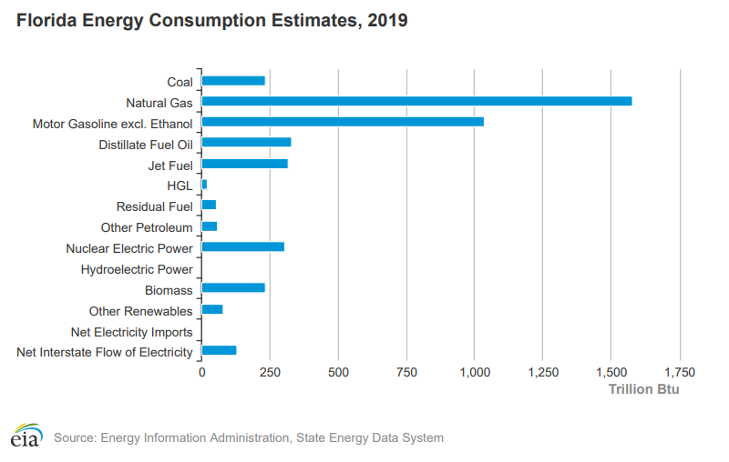

Coal Consumption in Florida: 233.5 Trillion BTU

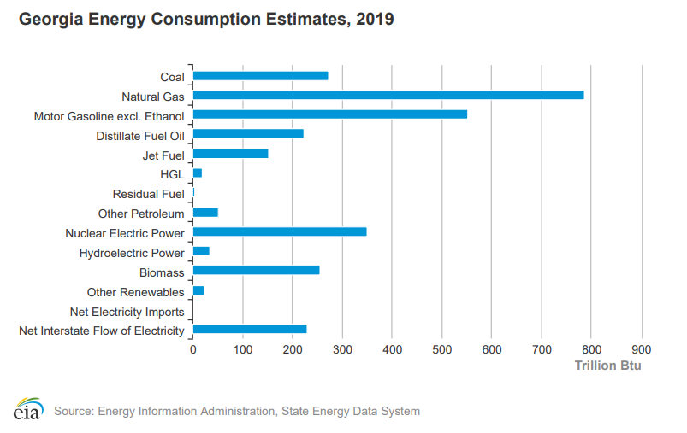

Coal Consumption in Georgia: 273.1 Trillion BTU

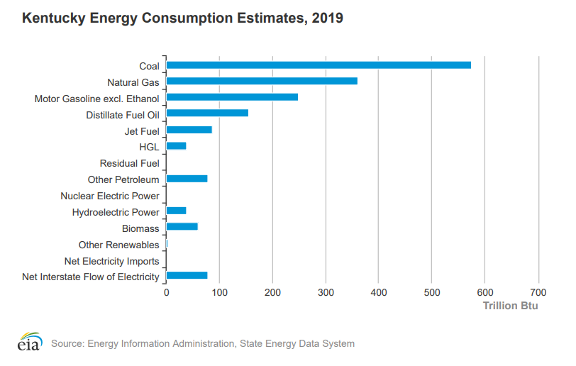

Coal Consumption in Kentucky: 574.5 Trillion BTU

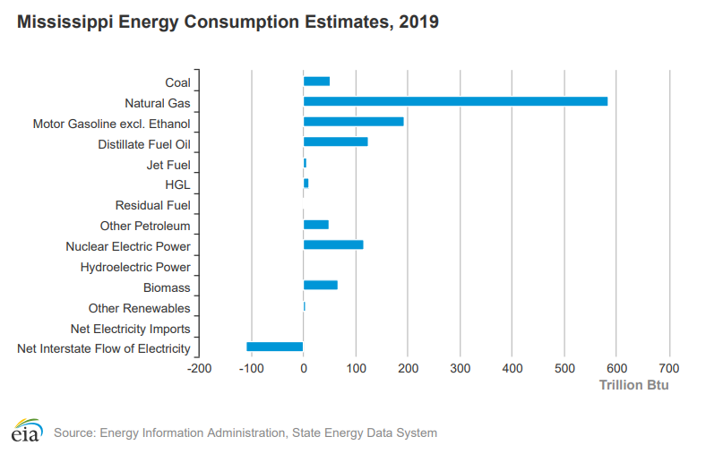

Coal Consumption in Mississippi: 51 Trillion BTU

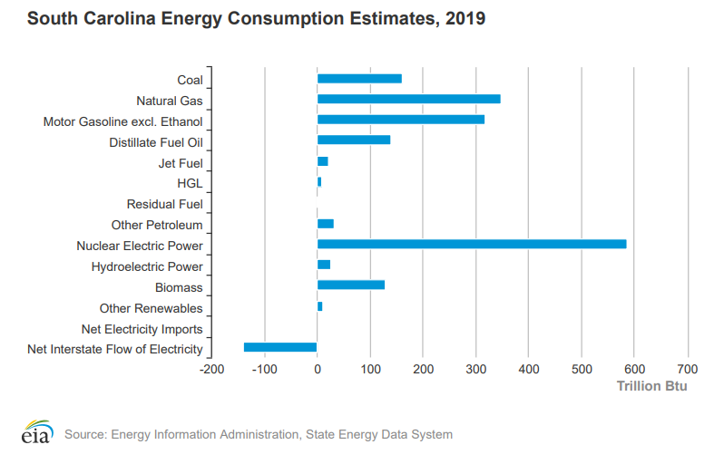

Coal Consumption in South Carolina: 160.7 Trillion BTU

As mentioned earlier, the regional average for the southeast region is 297.1 Trillion BTU. Except for Kentucky, every state in which we chose to use solar energy is below this average. Solar is a good option as we need to generate less energy to meet our goal and solar is easier to implement. Once our goal is met, nuclear and off-shore wind farms are energy sources that need to be implemented. Not only to reduce other fossil fuels but also to generate a surplus of energy that can be sent to other states in this region like Kentucky and Missouri that use much more coal than other states. This will greatly decrease the amount of coal that they use and will help to stop using coal as an energy source in the southeast.

### State Energy policy overview

Many of these states have great incentives for going solar, such as tax rebates, making solar energy very affordable. The South Carolina Solar Tax Credit allows residents of the state to claim 25% of the total cost of installing solar energy systems for their homes as credit in their state tax returns with a max of $3,500 (S. 549 124, 2021-2022) Some local utility companies have also offered tax rebates like Santee Cooper. Santee Cooper offers eligible customers a cash rebate for every KWh of solar energy produced, with a cap at 6kW (Santee Cooper, 2022). These multiple incentives show how solar energy systems are becoming much more affordable for residents, making it easier for our proposed transition of coal based energy to solar energy. Florida has also established incentives for solar energy.

The Florida Solar System Property Tax Exemption allows for a complete 100% property tax exemption on added value to residential property due to a solar energy system, and an 80% property tax exemption for non-residential properties. Solar energy systems are exempt from sales taxes in Florida due to the Home Solar System State Sales Tax Exemption that was implemented in 1997 and made permanent in 2005 (Solar United Neighbors).

Kentucky offers funding through their Department of Agriculture to give out grants to help farms switch to renewable forms of energy through their On-Farm Energy Efficiency Incentive Program. They offer up to 50% reimbursement for the cost of set-up (max of $10,000) and will also reimburse for a $150 third party energy audit (Kentucky Department of Agriculture, 2022). The Tennessee Valley Authority Utility offers $1000 rebates to customers who go solar and also gives customers a feed-in tariff of the retail price with an extra $0.02/kWh added to it (Solar Nation, 2015).

Mississippi has had some tax incentives such as the Mississippi Clean Energy Incentive in April 2010 which offered renewable energy system manufacturers a 10 year tax exemption from state income and franchise taxes and sales taxes (H.B No. 1701). Many of Mississippi’s incentives have expired but due to their history of providing such benefits, we’re hopeful that they will be renewed in the near future.

Georgia doesn’t have very many current incentives. In 2020 they offered reimbursements that covered half of the total cost ($50,000 max) of installing up to a 60 kilowatt solar energy system for cities, counties or k-12 public schools (Georgia Environmental Finance Authority). We’re hopeful that in the near future Georgia will begin to implement new incentives to help lessen the cost to make the switch to solar power.

Net metering, residents being paid for any excess energy that they produce and sell back to the grid, occurs in Missouri, South Carolina, and Kentucky. Missouri Power offers its customers $0.025 / kWh, with an extra 2 cents offered to low-income customers (Mississippi Power, 2022). South Carolina Electric & Gas offers customers $0.10712/kWh (EnergySage, 2022) and in Kentucky the Kentucky Utilities company offers $0.07366/kWh and Louisville Gas and Electric company offers customers $0.06924/kWh (LG&E and KU, 2022).

## Methodology

### Solar focus strategy

Given the current annual coal consumption in BTUs for each state, we can convert this into a delivered capacity by converting to MWh and dividing by 8760 hours. Next we can divide this delivered capacity by the capacity factor to get our actual system capacity in MW. We take the average capacity factor for the US to be 24.5% (Freeing Energy, 2021).

Once we have the system size, using an average solar panel density of 15 watts per square foot, we can simply divide this from our system capacity to get total land use for each state.

According to Lazard’s Levelized Cost of Energy, the average capital cost of solar PV at a utility scale is between $1200 and $1450 per kW capacity (Lazard, 2021). We can multiply this by our total capacity to get a total cost estimate.

Due to the nature of solar PV, there is infrequently enough energy coming in to meet instantaneous demand. Thus, a robust energy storage system is required in order to make solar a viable replacement for coal. Using a levelized cost of storage from Lazard’s Levelized Cost of Storage, we can choose a storage capacity and multiply by the levelized cost to get an annualized cost of storage. The unsubsidized levelized cost of storage for in-front-of-the-meter wholesale (PV+storage) is $85 to $158 per MWh (Lazard, 2021). We can model this as follows:

Because our solar capacity is sized to meet the total energy demand of coal throughout the entire year, sufficient storage capacity will allow this system to adequately supply energy at peak demand as well as during the times of day and of the year where incoming solar energy is reduced by storing extra energy when incoming supply exceeds demand to be used at later times when demand exceeds incoming supply.

Using all of the established values above, all we need for each state is the total annual coal consumption and total land area to estimate solar installation costs, storage costs, and land usage percentages.

### Example Calculation

Working through South Carolina as an example, we input 134 trillion BTU as coal consumption in our capacity formula as follows:

.

Next, we use this capacity in our land area formula to determine the required land area:

.

This area represents only 0.13% of South Carolina’s total area. Concurrently, we can input our capacity value into our capital cost formula to estimate the cost range:

,

.

Finally, to estimate storage costs, we choose to install enough storage for the total annual output of the solar farms. This choice will oversize the storage capacity on a yearly basis, but will allow energy captured in one year to be used in a later year if there is an unexpected change in total energy supply or demand.

,

.

## Results

In total it will cost between $84 and $102 billion to install 70 GW of solar capacity to replace coal in South Carolina, Georgia, Florida, and Mississippi, and the total annualized storage cost will be between $13 and $24 billion. Over the 20 year lifetime of the storage, this comes out to between $260 and $480 billion for the total cost of storage. The charts below depict how this capacity and cost would be distributed across each state assuming all the energy generated by these installations will be used in the same state they originate in.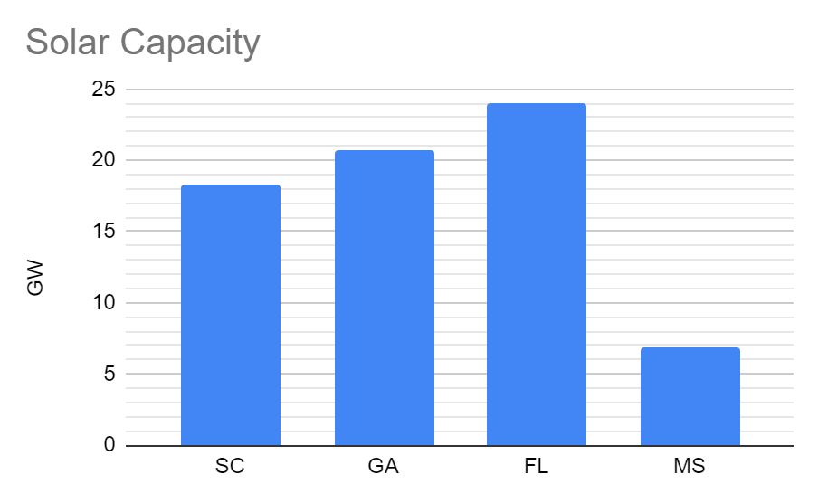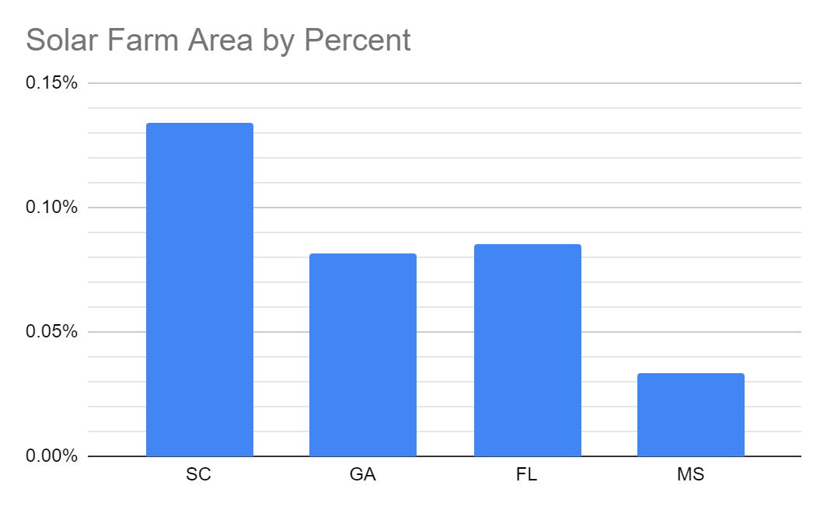

Provided that it takes 3 months to build a single 2 MW farm, there would need to be about 100 solar farms under construction at a time in each state in order to reach the full 70 GW capacity by 2030. This does not take into account additional time needed to prepare a flat and level landscape and secure construction equipment. Taking into account additional time needed to install storage capacity, it would be difficult for a system of this size to be fully operational by 2030.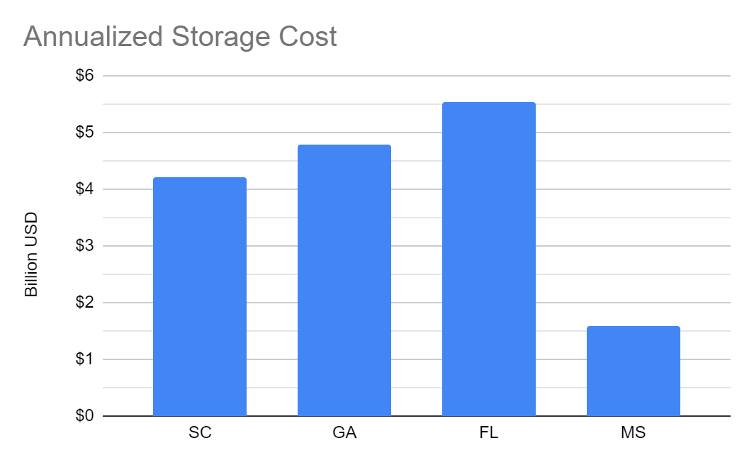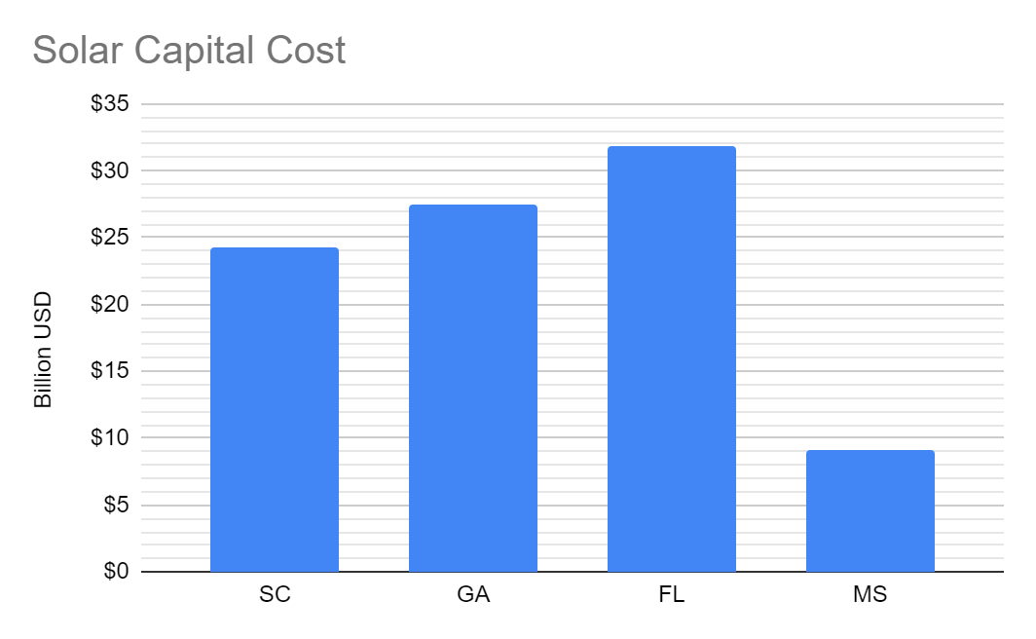

Overall, solar is a financially viable option for the majority of states in this set. Solar PV is fairly inexpensive on a per MW basis when comparing capital costs to coal or nuclear plants, and is on par with other cost effective sources such as natural gas or wind. The biggest challenge and recurring cost would come from the need for adequate storage capacity. With storage costs representing up to 20% of the total cost during the first year, total storage costs could exceed initial solar capital costs in less than 5 years.

Kentucky stands out as a poorly suited candidate for this approach. With its coal consumption exceeding the combined consumption of South Carolina, Georgia, Florida, and Mississippi, it would be far more expensive to completely replace coal with solar here than in any other state in this set. Therefore, it may be more realistic to replace the majority of Kentucky’s coal plants with natural gas plants for the time being. This way Kentucky can still drastically reduce its carbon emissions without needing to spend 4 times more than its neighbors. The figures below compare two scenarios for replacing coal consumption in Kentucky. Scenario A represents installing solar capacity to replace 100% of coal consumption, and scenario B represents installing solar capacity to replace 20% of coal consumption and installing natural gas plants to replace the remaining coal consumption.

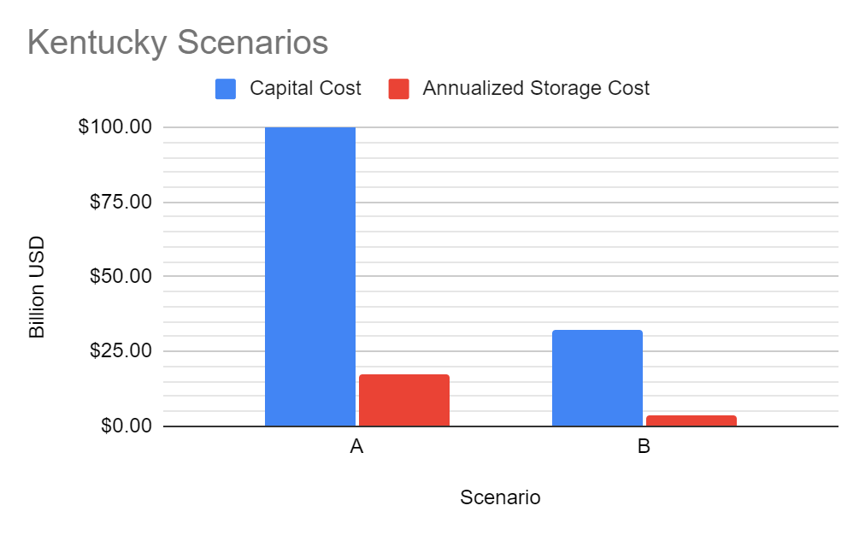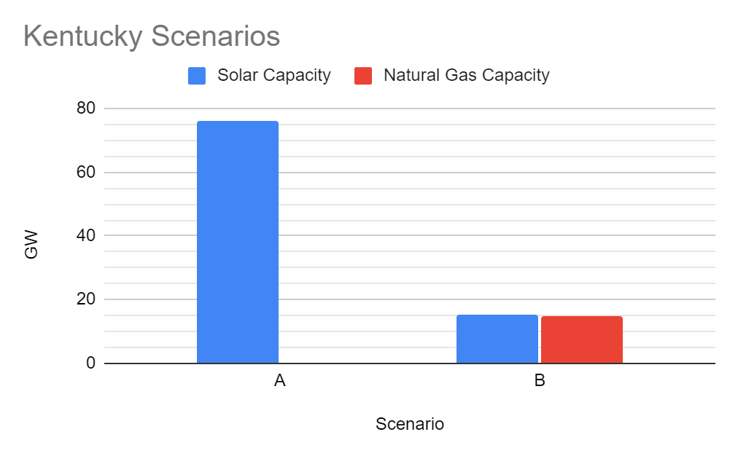

# Conclusion

## Overall feasibility of strategy

As seen in Table 4, implementing wind farms in the southeast states of Alabama, Tennessee, Missouri, and North Carolina would result in around $700 billion dollars of spending and 75,731 km2 of land area. North Carolina is the most feasible state to accomplish becoming coal-free by 2030, requiring 42.55 billion dollars in funding and only around 3.3% of the state's total landmass. This also makes North Carolina a candidate for exporting wind energy to other wind states. For example, Alabama (the worst cast wind state scenario) would require around 19.9% of the state’s total land to be filled with wind farms.

Assuming each state installed 10 wind farms per year, a full conversion of coal to wind energy in the southeast states in Alabama, Tennessee, Missouri, and North Carolina would take around 30 years on average. This is a long timescale, making the timeline of becoming coal-free by 2030 an unreasonable timeline for this area if we were to only use wind energy.

In total it will cost between $84 and $102 billion to install the solar capacity needed to replace coal in South Carolina, Georgia, Florida, and Mississippi, and the total annualized storage cost will be between $13 and $24 billion. Over the 20 year lifetime of the storage, this amounts to between $260 and $480 billion total cost of storage. Assuming a 2 MW farm is built in 3 months, 100 solar farms would need to be under construction at a time to reach the 70 GW capacity by 2030. Additionally, a flat and level landscape needs to be prepared prior to construction. Thus, while taking into account additional time needed to install storage capacity, it would be difficult for a system of this size to be fully operational by 2030.

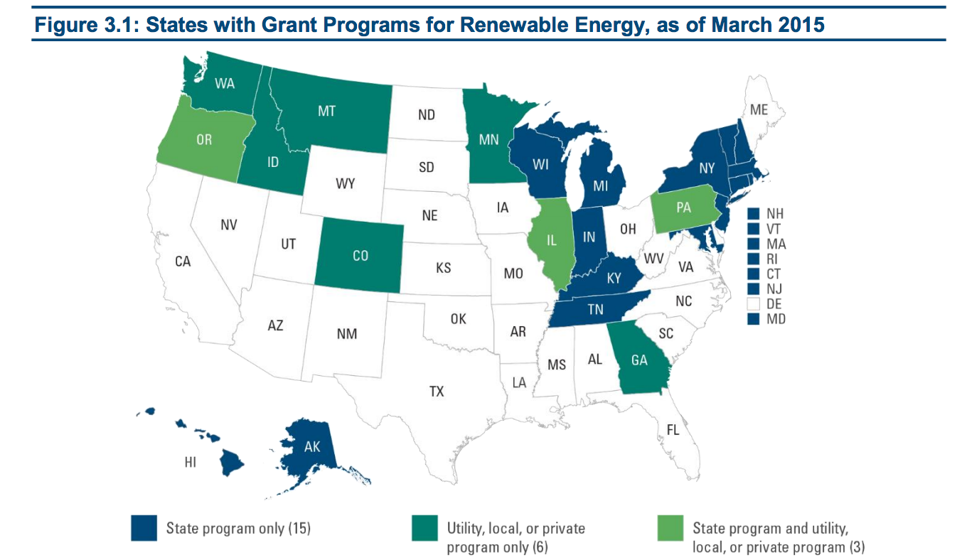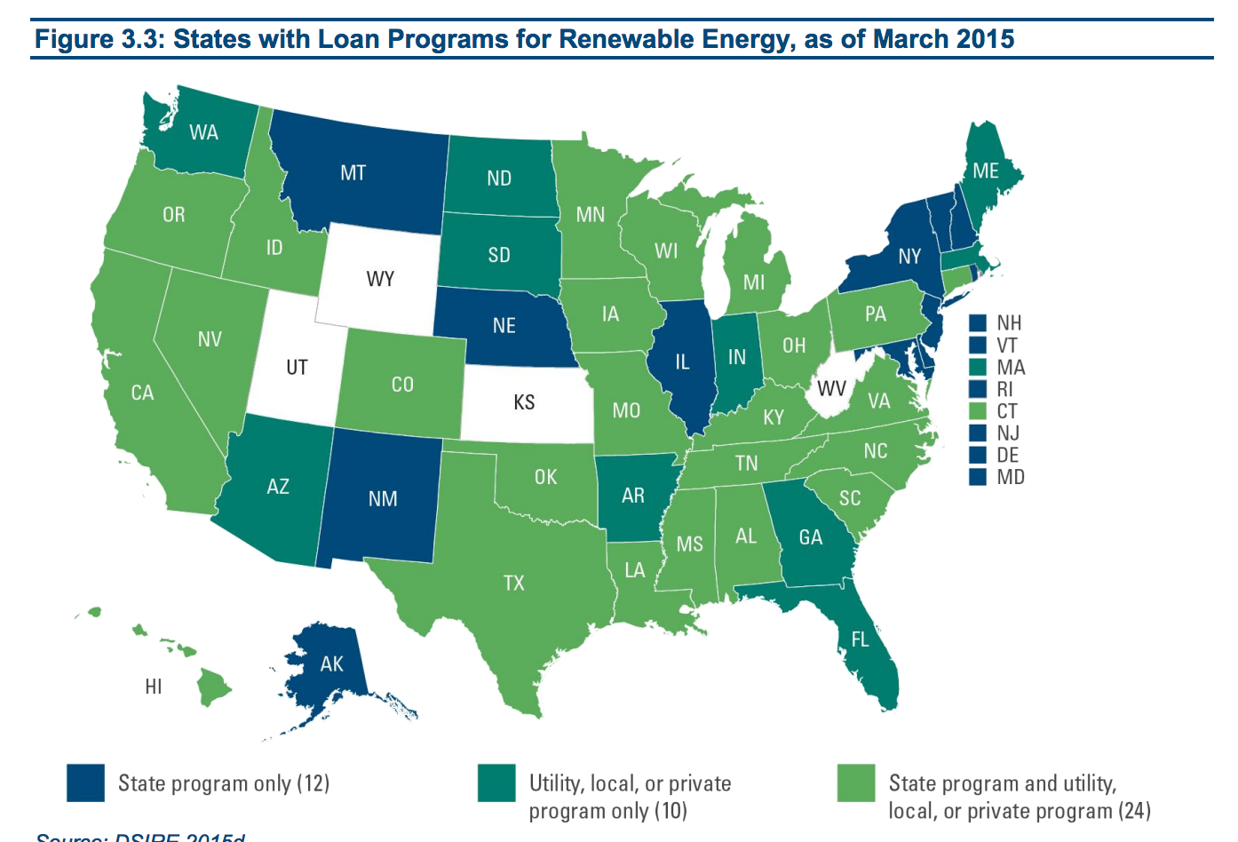

States with current grant and loan programs for renewable energy (Ballotpedia, 2017)

All southeast states currently have policies in place to offer loan programs for renewable energy. Additionally, Georgia, Tennessee, and Kentucky have grant programs for renewable energy (Ballotpedia, 2017). North Carolina increased its clean energy standards target to 100% of electricity sales from carbon-neutral generation by 2050 (EIA, 2022). Tax incentives and reimbursements are also in place to support the use of solar energy in many states. Although the southeastern states have policies and programs in place to support renewable energy, the funding needed to complete these projects far exceeds the bounds of current spending. State policy and allocation of funding toward this cause is likely to slow or halt this process, especially in states that currently rely heavily on coal, such as Missouri with 69.2% Utility-Scale Net Electricity Generation being Coal-Fired (EIA, 2022).

## Overall feasibility of 2030 coal free goal

This solution is not feasible for this region by 2030. It would cost around 700 billion dollars in spending and 75,731 km2  of land area needed to support new wind farms. Over the 20 year lifetime of solar storage, the total cost of storage is between $260 and $480 billion and 100 solar farms would need to be under construction at a time (assuming a 2 MW farm is built in 3 months) to reach the 70 GW capacity by 2030. With high costs and land usage, it is unlikely state policies would support these goals. If further incentives were given to land owners to build wind and solar farms, it could increase private spending on renewable energy. These private landowners could then benefit by storing and selling energy back to the state.

Although our proposed solution turned out to be an extremely challenging, if not impossible, solution that would require a lot of funding and labor, this doesn’t mean that going coal-free by 2030 is impossible for the southeast region. We chose to use only solar and only wind-powered energy in certain states. Perhaps a better solution would be to integrate the two so that we have more diverse sources of energy that can complement each other. We also didn’t look too much at the off-shore potential of certain states. Off-shore would reduce the amount of land we’d need which would help our chances of state policies and residents supporting this change. We could also look at a different strategy such as relying heavily on natural gas energy to replace coal. We could begin building solar and wind farms at a feasible rate while cutting down coal consumption. As more energy farms are built we gradually use less natural gas and eventually we wouldn’t need to use natural gas anymore. Our goal to be coal free by 2030 would be much more realistic since there’d be less coal to replace and such a strategy would likely be significantly cheaper, yield a higher energy output per land area, and take less time to install. This would be less environmentally friendly as we would still have carbon emissions from the natural gas than if we only used renewable energy but it’s much more realistic.

## What’s Next?

Natural gas is a huge source of energy for many states in the southeast. Georgia relies on natural gas for 44.2% of utility-scale net electricity generation (EIA, 2022) and Alabama at 41.1% (EIA, 2022). Although natural gas is a relatively clean form of energy compared to coal as it results in fewer emissions, our natural gas supply is finite. Assuming the same annual rate of U.S. dry natural gas production in 2020 of about 30 trillion cubic feet, the US has enough dry natural gas to last about 98 years (EIA, 2022).

Nuclear energy, also a widely used source of energy in this area, poses concerns, as it is both dangerous and expensive to build. Nuclear power plants can be targets for terrorist operations, as major explosions from an attack could put population centers at risk while ejecting radioactive material into the atmosphere and surrounding regions. South Carolina, for example, relies on nuclear energy for 55.3% of utility-scale net electricity generation (EIA, 2022). However, with the right precautions these risks can be mitigated and nuclear energy could be expanded in this region. Our report doesn’t factor in any nuclear energy options given our time constraint but if we had a longer time we would certainly have included some nuclear plants in states like Kentucky. Given the time requirements and the expenses required to build all of the wind farms we proposed, some states should focus on building a nuclear plant alongside these wind farms to become coal-free as soon as possible.

Renewable energy is a better alternative to both natural gas and nuclear energy, as they can function with wind and the sun and pose limited safety risks. Continuing to implement renewable energy beyond becoming coal-free is a sustainable and safe way to produce energy. States like South Carolina and Georgia should focus on off-shore wind farms as there is great potential for them. This wouldn’t take up any land and it would work alongside the solar farms we proposed. We would need less solar farms to reach our goal making it more feasible and any excess energy can go to states that consume much more coal than others to try and make it easier for those states to be coal free. Using more natural gas for now and focusing on building different sources of energy (wind farms, solar farms, nuclear plants) is the best thing to do. As long as a foundation of each source is built, it’s much easier to expand on them in the future until we finally reach our goal and we can start to phase out other forms of energy production that hurt the environment.

# Appendices

## Sources

“Weatherspark.com.” *Charlotte Climate, Weather By Month, Average Temperature (North Carolina, United States) - Weather Spark*, 2021, https://weatherspark.com/y/18893/Average-Weather-in-Charlotte-North-Carolina-United-States-Year-Round.

“Economics of Nuclear Power.” *Nuclear Power Economics | Nuclear Energy Costs - World Nuclear Association*, 2021, https://world-nuclear.org/information-library/economic-aspects/economics-of-nuclear-power.aspx#:~:text=Nuclear%20power%20plants%20are%20more,built%20in%20about%20two%20years.

“2022 South Carolina Electric & Gas (SCE&G) Net Metering | EnergySage.” Get Competing Solar Quotes Online | EnergySage, https://www.energysage.com/local-data/net-metering/sceg/#:~:text=The%20South%20Carolina%20Electric%20%26%20Gas,on%20your%20next%20month’s%20bill. Accessed 5 May 2022.

“Alabama Profile.” Homepage - U.S. Energy Information Administration (EIA), https://www.eia.gov/state/print.php?sid=AL. Accessed 5 May 2022.

“DSIRE.” DSIRE, https://programs.dsireusa.org/system/program/detail/243. Accessed 5 May 2022.

“Energy Policy in Tennessee, 2010-2017 - Ballotpedia.” Ballotpedia, https://ballotpedia.org/Energy_policy_in_Tennessee,_2010-2017. Accessed 5 May 2022.

“Frequently Asked Questions (FAQs) - U.S. Energy Information Administration (EIA).” Homepage - U.S. Energy Information Administration (EIA), https://www.eia.gov/tools/faqs/faq.php?id=58&t=8#:~:text=Assuming%20the%20same%20annual%20rate,to%20last%20about%2098%20years. Accessed 5 May 2022.

“Georgia Profile.” Homepage - U.S. Energy Information Administration (EIA), https://www.eia.gov/state/print.php?sid=GA. Accessed 5 May 2022.

“Georgia Solar Program | Georgia Environmental Finance Authority.” Georgia Environmental Finance Authority, https://gefa.georgia.gov/georgia-solar-program. Accessed 5 May 2022.

“How Long Does It Take To Construct A Solar Farm? | YSG Solar | YSG Solar.” YSG Solar, https://www.ysgsolar.com/blog/how-long-does-it-take-construct-solar-farm-ysg-solar#:~:text=As%20a%20general%20rule%20of,electrical%20contracting%20taking%20the%20longest. Accessed 5 May 2022.

“How Many MWh of Solar Energy Comes from a MW of Solar Panels?” Freeing Energy, https://www.freeingenergy.com/math/solar-pv-gwh-per-mw-power-energy-mwh-m147/. Accessed 5 May 2022.

“Kentucky Agricultural Development Board Approves More than $2.4 Million for Projects across the Commonwealth.” Https://Www.Kyagr.Com, https://www.kyagr.com/ky-agnews/press-releases/2022/KADB-approves-more-than-2.4-million-for-projects-across-the-commonwealth.html. Accessed 5 May 2022.

“Lazard.Com | Levelized Cost Of Energy, Levelized Cost Of Storage, and Levelized Cost Of Hydrogen.” Lazard.Com, https://www.lazard.com/perspective/levelized-cost-of-energy-levelized-cost-of-storage-and-levelized-cost-of-hydrogen/. Accessed 5 May 2022.

“Missouri Profile.” Homepage - U.S. Energy Information Administration (EIA), https://www.eia.gov/state/print.php?sid=MO. Accessed 5 May 2022.

“Other Wind Energy Funding Opportunities | Department of Energy.” Energy.Gov, https://www.energy.gov/eere/wind/other-wind-energy-funding-opportunities#:~:text=Businesses%20that%20begin%20construction%20on,energy%20produced%20over%20a%20ten%2D. Accessed 5 May 2022.

“PACE Financing in Kentucky | Energize Kentucky Clean Energy Loans.” Kentucky PACE, https://kypace.org/. Accessed 5 May 2022.

“Power Plant Construction: How Much Does It Cost? | ProEst.” ProEst, https://www.facebook.com/pages/ProEst/130603419815, 22 Feb. 2021, https://proest.com/construction/cost-estimates/power-plants/#:~:text=Labor%20and%20Material%20Costs,-Labor%20and%20materials&text=Power%20plant%20construction%20is%20generally,with%20some%20extending%20considerably%20further.

“Renewable Energy Explained - Incentives - U.S. Energy Information Administration (EIA).” Homepage - U.S. Energy Information Administration (EIA), https://www.eia.gov/energyexplained/renewable-sources/incentives.php. Accessed 5 May 2022.

“Residential Solar Power Options | EmpowerSC Solar | Santee Cooper.” South Carolina Utility Provider | Santee Cooper, https://www.santeecooper.com/Save-Energy-Money/For-My-Home/Solar/Index.aspx. Accessed 5 May 2022.

R.J. Barthelmie, “Wind farms, siting and design”, Lecture Series, Cornell University, 2021.

R.J. Barthelmie, “Climate Change”, Lecture Series, Cornell University, 2022.

“Solar Incentives & Financing in Florida - Solar United Neighbors.” Solar United Neighbors, 18 Sept. 2017, https://www.solarunitedneighbors.org/florida/learn-the-issues-in-florida/solar-incentives-in-florida/#:~:text=Florida%20provides%20a%20100%20percent,non%2Dresidential%20renewable%20energy%20property.

Solar Nation Team. “Solar Power in Kentucky: All You Need to Know.” Solar Nation, Solar Nation, 24 Apr. 2016, https://www.solar-nation.org/kentucky.

“South Carolina Legislature Online - Search.” South Carolina Legislature Online, https://www.scstatehouse.gov/query.php?search=DOC&searchtext=Solar&category=LEGISLATION&session=124&conid=37021851&result_pos=0&keyval=1240549&numrows=10. Accessed 5 May 2022.

“South Carolina Profile.” Homepage - U.S. Energy Information Administration (EIA), https://www.eia.gov/state/print.php?sid=SC. Accessed 5 May 2022.

Sunrun. “South Carolina Solar Incentives | Sunrun.” Sunrun, Sunrun, 26 June 2019, https://www.sunrun.com/solar-by-state/sc/south-carolina-solar-incentives#:~:text=Eligible%20residents%20can%20get%20a,for%20up%20to%2010%20years.

“Using Nuclear Waste Heat as Power Source.” Professor Robert B. Laughlin, Department of Physics, Stanford University, http://large.stanford.edu/courses/2012/ph241/tilghman1/. Accessed 5 May 2022.

## Programs

MATLAB code to generate the wind solution data:

%Wind Farm Calcs

%Import the Wind Speed Data Sets

filename = '5010WindSpeedData.xlsx';

sheet = 1;

xlRangeNC = 'C15:C63';

xlRangeMO = 'M15:M83';

xlRangeAL = 'O15:O26';

xlRangeTN = 'R15:R26';

NCwind = xlsread(filename,sheet,xlRangeNC);

MOwind = xlsread(filename,sheet,xlRangeMO);

ALwind = xlsread(filename,sheet,xlRangeAL);

TNwind = xlsread(filename,sheet,xlRangeTN);

NCw=NCwind.^3;

MOw=MOwind.^3;

ALw=ALwind.^3;

TNw=TNwind.^3;

NCwin=mean(NCw);

MOwin=mean(MOw);

ALwin=mean(ALw);

TNwin=mean(TNw);

%Calc the power needed for each state in GJ/year

PNC=0.5*0.59*1.21*(pi*(129/2)^2)*NCwin*31536000/10^9;

PMO=0.5*0.59*1.21*(pi*(129/2)^2)*MOwin*31536000/10^9;

PAL=0.5*0.59*1.21*(pi*(129/2)^2)*ALwin*31536000/10^9;

PTN=0.5*0.59*1.21*(pi*(129/2)^2)*TNwin*31536000/10^9;

nNC=3.357e8/PNC; %number of turbines

nMO=6.169e8/PMO; %number of turbines

nTN=1.699e8/PTN; %number of turbines

nAL=3.3466e8/PAL; %number of turbines

D=0.129; %km (rotor diameter)

n=[nNC,nMO,nTN,nAL];

disp(n)

%spacing (assume a uniform flow upwind)

%say horizontal spacing = 3 rotor diameters (wake interference not

%horizontal between turbines

%say vertical spacing is 7 rotor diameters (bit large but on the safer

%side)

%taking average wind farm sizes from NC and MO site size=56km^2

%Area=(3*D*num)*(7*D*num)=21*D^2*num^2

Area=56; %km^2 desired

turbFarm=sqrt(Area/(21*D^2)); %number of turbines in each row and column of our farm

num=floor(turbFarm);

numTurb=num^2; %number of turbines per wind farm of given Area

%disp(numTurb)

%Calc actual area needed

AreaActual=21*D^2*num^2;

%disp(AreaActual)

numFarmfull=floor(n./numTurb);

%disp(numFarmfull)

r=ceil(rem(n,numTurb));

%disp(r)

AreaRem=21*D^2.*r;

%disp(AreaRem)

cost=2.9.*1.11.*n; %cost to install n number of turbines in millions of dollars

%disp(cost)

d=mean(cost);

%calculate wake losses

X=7*D; %spacing downwind of turbines

k=0.075; %land wake constant

WR=1-((D/(D+(2*k*X)))^2); %wake ratio, assume loss in v proportional to loss in power

ratiowake=WR^3; %get percentage of power actually produced

pNC=PNC*ratiowake;

nwakeNC=ceil(3.357e8/pNC);

pMO=PMO*ratiowake;

nwakeMO=ceil(6.169e8/pMO);

pTN=PTN*ratiowake;

nwakeTN=ceil(1.699e8/pTN);

pAL=PAL*ratiowake;

nwakeAL=ceil(3.3466e8/pAL);

nwake=[nwakeNC,nwakeMO,nwakeTN,nwakeAL]; %this is the new number of turbines for wake

turbFarmwake=sqrt(Area/(21*D^2)); %number of turbines in each row and column of our farm

numwake=floor(turbFarmwake);

numTurbwake=numwake^2; %number of turbines per wind farm of given Area

disp(numTurbwake)

%Calc actual area needed

AreaActualwake=21*D^2*numwake^2;

disp(AreaActualwake)

numFarmfullwake=floor(nwake./numTurbwake);

disp(numFarmfullwake)

rwake=rem(nwake,numTurbwake);

disp(rwake)

AreaRemwake=21*D^2.*rwake;

disp(AreaRemwake)

costwake=2.9.*1.11.*nwake; %cost to install n number of turbines in millions of dollars

disp(costwake)