**How the Radiative Cooling Effect Can Improve Photovoltaic Mini-Grid Application in Underdeveloped Communities**

**Abstract**

Photovoltaic solar cells are well suited to bring electricity to **off-grid communities**; however, one challenge associated with PV cells is their **lack of electric power generation during nighttime**. To offset this, solar panel systems are often paired with energy storage systems that collect extra energy generated during the day to be used at night [1].

A possible solution to this challenge has been found using thermoelectric generators (TEGs) to **collect electricity from the radiative cooling of the cell during night**. The sun acts as a heat source to the cells acting as the heat engine. We can collect electricity from the radiative cooling process of the cell as it releases heat into the ambient environment, the heat sink. The transfer between the heat engine and the heat sink happens both during the day and the night. This is beneficial because in addition to allowing for continuous renewable energy generation during day and night, this process would also **reduce battery storage requirements** and less energy would need to be generated by the solar panels during the day [1].

A limitation of this concept is that **silicon cells do not meet the requirement** that the PV cell be made of **small-bandgap semiconductors** that can operate in thermal wavelengths. Additionally, the maximum power density is small compared to the cell’s daily output [1].

It is expected that this technology could produce an **average of 50 mW/m2** with a clear night sky [1].

**Challenge**

Currently a significant portion of the **global population does not have access to electric grid** energy [1]. This problem is prevalent in areas such India, which is falling behind in government electrification goals [3], and Sub-Saharan Africa, where electricity expansion remains an unaddressed development priority[4].

**Private funding of mini-grids** is considered to be a good option to help address these problems, and solar and storage systems are well suited to this situation. **Solar mini-grids are more economically viable** than some fossil fuel alternatives, and are additionally advantageous as a low carbon option for helping to **reduce GHG emissions growth**[4]. PV systems have been cost effective since 2018[6], but grid expansion remains to be a preferred option [4], which makes mini-grid development difficult[3].

Furthermore, PV cells have a disadvantage not shared by other energy sources: they **do not produce electricity at night** [1]. This is one of the most limiting factors of solar PV as a reliable source of electricity.

**How it works**

A possible solution to the daylight limitation of PV panels is to take advantage of a **naturally occurring effect known as radiative cooling**. Radiative cooling is well known alongside radiative heating as the two thermodynamic processes that determine the thermal equilibrium of the Earth[2]. Radiative cooling occurs due to the interval of atmospheric emittance of 8-13 micrometers. The temperature difference of ideal surfaces is around 50 oC, providing a cooling power of around 100 W/m2. However the temperature difference is limited by nonradiative exchange[5].

A thermoelectric generator could be used to **generate electricity from the temperature difference between the PV cell and the ambient surrounding**. This could achieve a power generation of **50 mW/m2 on a clear night**, and allows for **additional power generation during daylight hours** separate from the PV panels conventionally generated electricity [1].

This process also has many **additional applications in providing no electricity cooling** for buildings, vehicles, and solar panels[8].

**Limitations**

There are several limitations to this technology currently. First, the expected power generation of 50 mW/m2 is **significantly smaller than the average output of PV panels** during the day, so this method alone would not be sufficient to meet high nighttime loads unless the system is considerably oversized for its daytime load [1].

Another limitation is that **silicon panels are poorly suited** for this method. This method works best with a PV cell made of a **small bandgap semiconductor** [1].

**Best case**

Best case for this system currently is in its application for solar mini-grid applications. While small compared to the daytime power output of solar PV, the 10-100 mW/m2 that this system achieves under various conditions is **sufficient for providing lighting and backup power** for communities that would benefit from a mini-grid installation [1].

Furthermore, this nighttime generation, along with additional power generation during the day, **decreases the battery storage requirements** for the system [1], helping to keep its physical size and cost down.

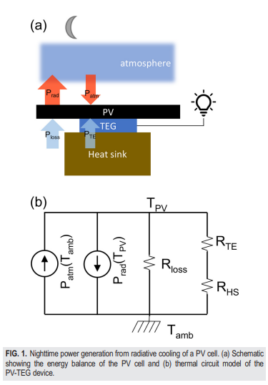

[1]

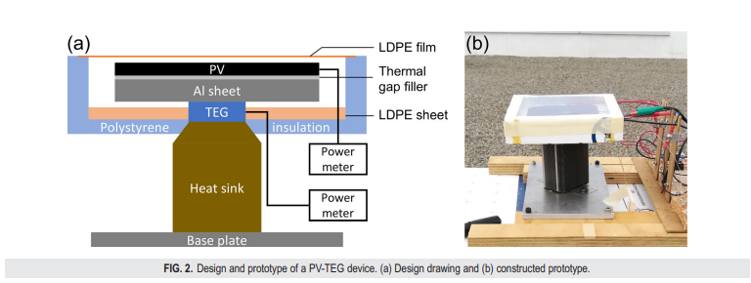

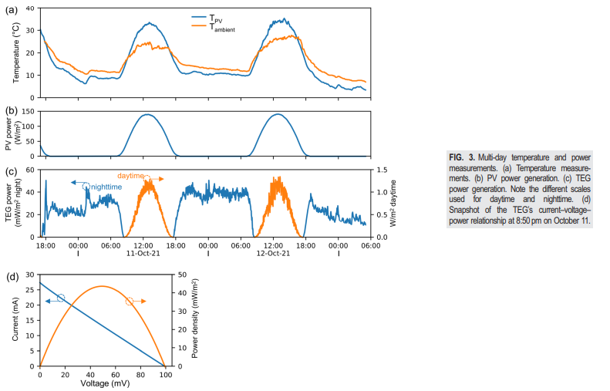

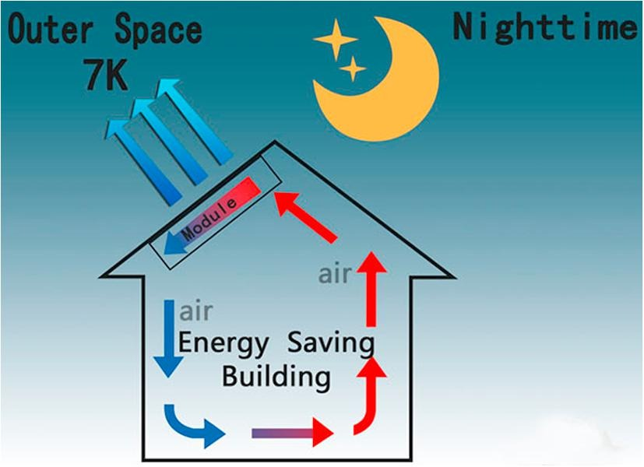

Low electricity building cooling using radiative cooling. [7]

**References**

1. S. Assawaworrarit, Z. Omair, and S. Fan. “Nighttime Electric Power Generation at a Density of 50 mW/m2 via Radiative Cooling of a Photovoltaic Cell” Applied Physics Letters 120, (2022): 143901.
2. B. Bartoli, S. Catalanotti, B. Coluzzi, V. Cuomo, V. Silvestrini, and G. Troise. “Nocturnal and diurnal performances of selective radiators” Appl. Energy 3, 267 (1977). https://doi-org.proxy.library.cornell.edu/10.1016/0306-2619(77)90015-0, Google ScholarCrossref
3. S. D. Comello, S. J. Reichelstein, A. Sahoo, and T. S. Schmidt. “Enabling Mini-Grid Development in Rural India” World Dev. 93, 94 (2017). https://doi-org.proxy.library.cornell.edu/10.1016/j.worlddev.2016.12.029, Google ScholarCrossref
4. U. Deichmann, C. Meisner, S. Murray, and D. Wheeler. “The economics of renewable energy expansion in rural Sub-Saharan Africa” Energy Policy 39, 215 (2011). https://doi-org.proxy.library.cornell.edu/10.1016/j.enpol.2010.09.034, Google ScholarCrossref
5. C. G. Granqvist and A. Hjortsberg. “Radiative cooling to low temperatures: General considerations and application to selectively emitting SiO films” J. Appl. Phys. 52, 4205 (1981). https://doi-org.proxy.library.cornell.edu/10.1063/1.329270, Google ScholarScitation, ISI
6. P. Sandwell, N. L. A. Chan, S. Foster, D. Nagpal, C. J. M. Emmott, C. Candelise, S. J. Buckle, N. Ekins-Daukes, A. Gambhir, and J. Nelson. “Off-grid solar photovoltaic systems for rural electrification and emissions mitigation in India” Sol. Energy Mater. Sol. Cells 156, 147 (2016). https://doi-org.proxy.library.cornell.edu/10.1016/j.solmat.2016.04.030, Google ScholarCrossref
7. B. Zhao, M. Hu, X. Ao, N. Chen, and G. Pei. “Radiative cooling: A review of fundamentals, materials, applications, and prospects” Appl. Energy 236, 489 (2019). https://doi-org.proxy.library.cornell.edu/10.1016/j.apenergy.2018.12.018, Google ScholarCrossref
8. D. Zhao, A. Aili, Y. Zhai, S. Xu, G. Tan, X. Yin, and R. Yang. “Radiative sky cooling: Fundamental principles, materials, and applications” Appl. Phys. Rev. 6, 021306 (2019). https://doi-org.proxy.library.cornell.edu/10.1063/1.5087281, Google ScholarScitation, ISI