**A Comprehensive Comparison between the Use of Solar and Nuclear Energies**

Grace Yun and Nicolaas Justice

Corresponding author email: [gay24@cornell.edu](mailto:gay24@cornell.edu) and [nj86@cornell.edu](mailto:nj86@cornell.edu)

**Contents**

**Abstract** **3**

**1. Introduction** **4**

1.1. Energy Capture from Solar Energy 4

1.1.1. PV Solar Power 4

1.1.2. Concentrating Solar-Thermal Power 5

1.2. Energy Capture from Nuclear Energy 6

**2. Capacity Factor Comparisons** **9**

2.1. Solar Capacity Factor 9

2.1.1. PV Solar Panel Capacity Factor 9

2.1.2. Concentrating Solar-Thermal Capacity Factor 10

2.2. Nuclear Capacity Factor 10

**3. Environmental Justice** **10**

3.1. Solar Energy 10

3.2. Nuclear Waste 11

**4. Comparisons to Conventional Fossil Fuels** **12**

4.1. Economic Analysis 12

4.2. Environmental Comparisons 13

4.2.1 Carbon Emissions 13

4.2.2 Global Supply 15

4.3. Safety Comparisons 16

**5. Discussion** **17**

**6. Conclusion** **17**

References **18**

**Term Paper Review Responses:** **22**

Term Paper Review Response 1: 22

Term Paper Review Response 2: 24

# Abstract

With continuously rising levels of greenhouse gasses from fossil fuels accelerating the rate of global warming, the need for low carbon energy on large scales is rising by the day. Solar and nuclear energy stand out as two possible solutions with their own unique sets of advantages and challenges associated with them. While solar offers a truly renewable energy supply, it suffers from various issues relating to efficiency and consistent output, having a capacity factor of less than 25%. The strengths of nuclear energy are able to counter the shortcomings of solar, with unrivaled energy density and efficiency, and a capacity factor of over 92%, a higher capacity factor than any other energy source. However, its fuel is nonrenewable, and nuclear power will not be able to continue to represent a large fraction of the global energy supply indefinitely. Both of these energy technologies hold an important role in moving towards a carbon neutral energy supply. Solar energy will eventually take precedence over nuclear energy, which is not expected to last through the century, but nuclear energy is still valuable as an extremely consistent low carbon energy source that is preferable to fossil fuels in terms of both carbon emissions and overall safety. Additionally, a continued reliance on nuclear energy is advantageous as it gives solar PV and relevant energy storage technologies more time to develop before being implemented at scales competitive with current fossil fuel usage.

# 1. Introduction

It has become obvious that the amount of greenhouse gasses (GHG) and carbon emissions needs to be reduced. The increase of carbon emissions and GHG is causing global warming and climate change, which causes more intense and severe weather occurrences, displacement of communities, extinction of wildlife, and many other problems and consequences.

To reduce the amount of GHG emissions into the atmosphere, we need to gradually replace traditional carbon based energy like fossil fuels to renewable energies, such as solar. The use of solar energy and nuclear energy would greatly reduce the amount of GHG that is polluted into the atmosphere, since neither of the sources are carbon based or release carbon emissions. Solar energy is considered to be a renewable energy source because the sun will always produce power and is always readily available. Also, using solar energy does not directly contribute to the increased emissions of GHG. Nuclear energy, however, is a non-renewable energy source, since uranium is not renewable. Yet, nuclear energy is still a viable alternative when compared to fossil fuels, since it does not emit any GHG.

Energy security is also very important when it comes to sustainability. With nonrenewable energy sources, there comes a point when all the resources are expended. Thus, the price increases and becomes less accessible to everyone. With the increased use of both solar and nuclear energy, we are able to get to a more sustainable future with reliable sources of energy. Even though nuclear energy is nonrenewable, its use will help give more time to better the solar technology to help increase its efficiency.

## 1.1. Energy Capture from Solar Energy

Solar energy is harnessed from the sun. Solar radiation, or electromagnetic radiation, is emitted by the sun and then either converted into electricity or heat. There are two types of solar technologies that are used conventionally: photovoltaic (PV) panels and concentrating solar-thermal power (CSP) plants (*How does solar work?*).

### 1.1.1. PV Solar Power

Solar radiation generates energy in photovoltaic cells by hitting electrons free from atoms to create an electrical current (Richardson, 2022). More specifically, in PV cells, there are two layers of silicon that are treated to create an electric field. The solar radiation loosens electrons and the electric field forces the electron to move, thus creating the current (Richardson, 2022). The current flows into a solar inverter[1] and now becomes usable electrical energy. This is shown further and in more detail in figure 1.

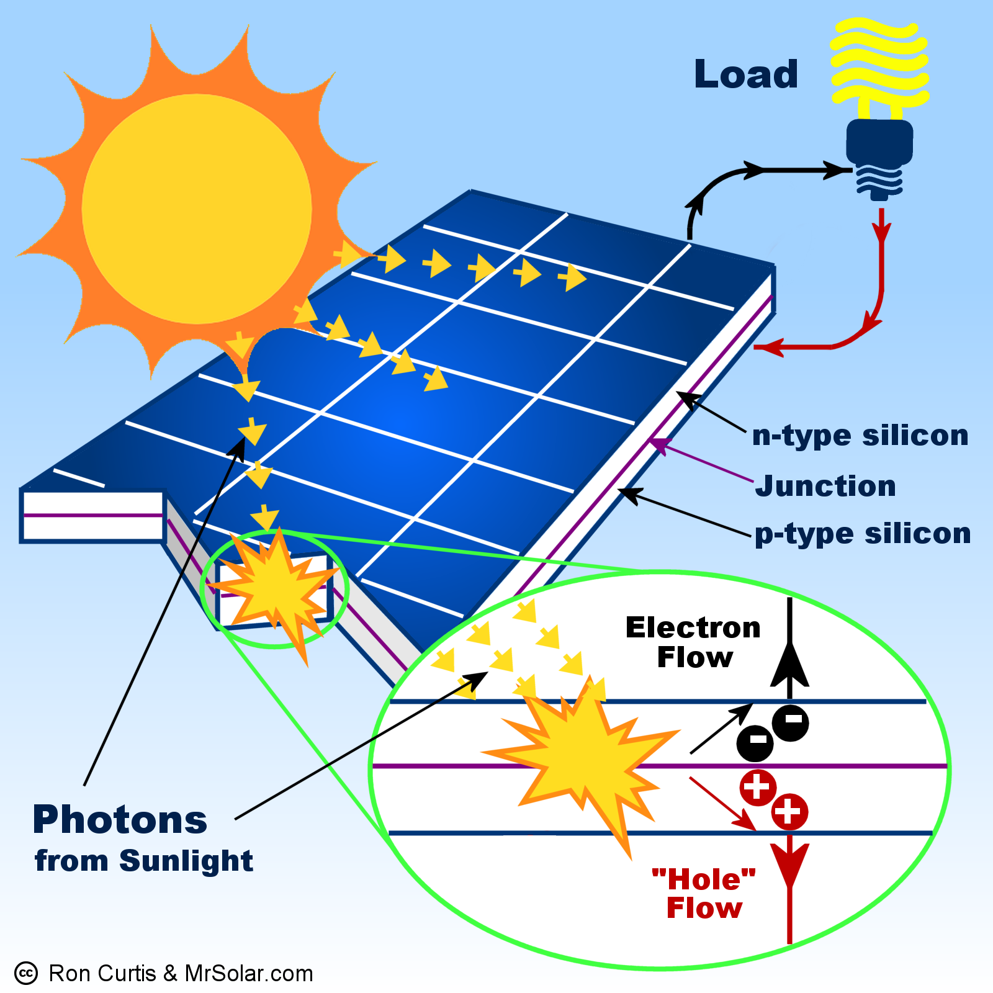

Figure 1. Diagram of solar radiation hitting photovoltaic panels to produce electricity

### 1.1.2. Concentrating Solar-Thermal Power

Concentrating solar-thermal power, on the other hand, utilizes focused sunlight (*Concentrating solar-thermal power*). CSP plants use a series of mirrors to help focus the sunlight into a singular area and point it toward a receiver (*Concentrating Solar Power (CSP) Technologies*). Once the receiver reaches a certain temperature[2], the heat is then used to boil water to turn it into steam. The steam spins a turbine and generates electricity.

There are three main types of systems that are used in CSP plants. The first is a trough system. This system utilizes U-shaped mirrors that are tilted toward the sun and reflect off of the mirror to help contrate the solar radiation and point it toward the receiver. The second is the power tower system. This system is a series of flat mirrors that tilt and focus the solar rays onto a separate receiver. The last system is called the dish engine system. This method utilizes mirrored dishes to help concentrate the sunlight onto the receiver.

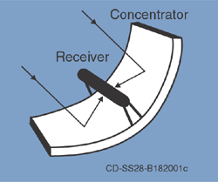

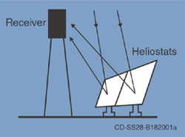

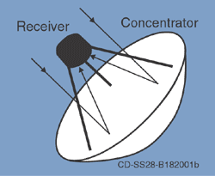

Figure 2. Trough system, Power tower system, Dish Engine system (top to bottom) (*Concentrating solar-thermal power*).

## 1.2. Energy Capture from Nuclear Energy

Nuclear energy is produced by splitting up an atom; this process is known as nuclear fission. During this nuclear fission, a large amount of heat is released when the atom is split. The heat is then used to boil water to create steam so that turbines can spin to generate electricity (*Nuclear Explained* 2021) (*Nuclear* 2022).

The atoms that are used in nuclear fission is an element called uranium. In nuclear fission, a specific isotope, U-235, is used for the process. Only U-235 is used in nuclear fission because these atoms split apart more easily. Uranium is considered nonrenewable, though it is commonly found in many rocks around the world. Even though uranium is more common to find than silver, isotope U-235 is considered very rare (*Nuclear Explained* 2021).

To obtain uranium, it must be mined by either underground[3] methods, open-pit[4] methods, or in-situ leaching[5] process. Once the uranium ore is mined, it is then crushed up and treated with acid to dissolve the uranium (*What is Uranium?* 2022). This uranium product is a mixture of various uranium oxides, which is then transformed into uranium hexafluoride (UF6) (*Yellowcake* 2021).

There are two main types of reactors: boiling water reactor (BWR) and pressurized water reactor (PWR). The BWR heats water directly from the heat produced by nuclear fission. The heated water turns into steam and powers turbines to spin. The spinning of the turbine produces electricity. In a PWR, the water is heated indirectly. The heat that is generated from fission heats up a pressurized water chamber that prevents the water from boiling. This water chamber flows into a different chamber filled with water and heats that water into steam. The steam powers the turbines the same way as the BWR (*Nuclear 101: How does a nuclear reactor work?* 2021).

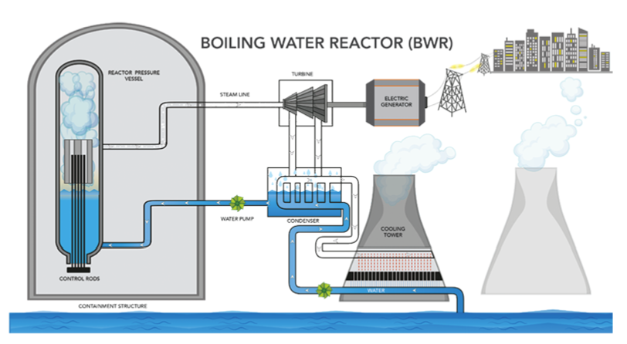 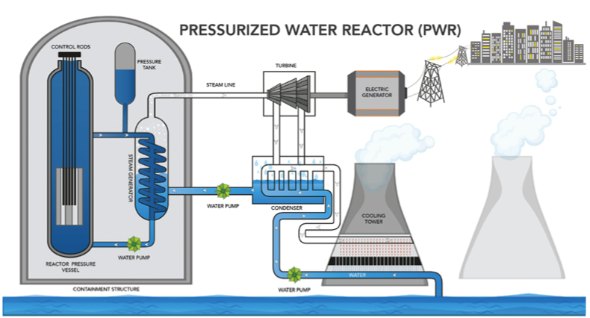

Figure 3. Boiling water reactor (BWR) (top), Pressurized water reactor (PWR) (bottom) (*Nuclear 101: How does a nuclear reactor work?* 2021)

# 2. Capacity Factor Comparisons

The amount of energy that is able to be harnessed differs for a variety of reasons. There is no such thing as 100% efficiency; energy is not fully conserved in everyday and real life situations. Even in fossil fuels, the amount of energy that is usable is only a fraction of the amount of energy that it originally held. The reason the amount of energy is due to energy lost in heat or mechanical work.

On average carbon based fuels have energy efficiencies of about “35% for coal, 45% for natural gas and 38% for oil-fired power generation” (Zeiss, 2010). To obtain these values, the amount of energy inputted and outputted from a system must be known. To calculate energy efficiency, one would divide the amount of energy output from a system over the amount of energy input into the same system (*Energy: Efficiency, Power and Measurement* 2018).

## 2.1. Solar Capacity Factor

### 2.1.1. PV Solar Panel Capacity Factor

PV efficiency is determined by a multitude of factors, such as materials used and temperature. For a large area silicon solar panel, the average efficiency is approximately 21.7% (Green et al., 2021). The capacity factor is fairly low when compared to fossil fuels or other renewable energy sources as well, at only 24.6% on average due to the distribution of sunlight and its intensity throughout the day (Alves, 2022). They typically can only operate at full capacity for 4-6 hours of the day corresponding to how many hours of peak sunlight a particular location gets.

There are many reasons why solar cell efficiency is so low when compared to other energy sources. Sunlight and solar rays are emitted from the sun at a certain range of frequency. Solar panels are not able to capture all wavelengths and frequencies from solar radiation. Because of this, some of the solar rays are reflected, passed through the solar cell, or converted to heat (Gonçalves, 2020).

A Solar panel's efficiency also decreases over time. One reason has to do with the cleaning and maintenance of the panels themselves. When solar panels are covered in dust or dirt, the amount of solar rays that penetrate and reach the electrons decreases which causes the overall efficiency to decrease as well. The increase in temperature also causes solar panels to work less efficiently (Melis et al., 2014). In order to combat both of these problems, one solution has been suggested and experimented on. The use of running water on top of solar panels would not only clean the tops but also cool down the exterior temperature to improve overall efficiency (Melis et al., 2014).

The low and decreasing efficiency of solar panels exacerbates the low capacity factor to make solar PV poorly suited to supply a consistently high energy output. A solar PV system needs to be sized for a larger capacity than many other types of energy systems in order to achieve the same total energy output. There is not currently a well established solution to generating electricity with solar PV during low daylight hours, so these systems need to compensate by generating an excess of energy during peak daylight hours to be stored for use when the PV panels cannot generate enough to meet demand during the majority of the day. This means that solar PV is extremely ineffective as a primary energy source without additional costs and complications associated with a substantial energy storage system to complement it.

### 2.1.2. Concentrating Solar-Thermal Capacity Factor

The capacity factors for a trough system is about 23-50%, power tower system is about 20-77%, and a dish engine system is about 25% (*Concentrating Solar Power*). The capacity factors are all so variable due to the amount of solar radiation that is present on any given day.

## 2.2. Nuclear Capacity Factor

Nuclear energy uses similar energy harness techniques as fossil fuels, yet achieves a much higher capacity factor of 92%. This is because they require less maintenance than fossil fuel plants and need to be refueled less frequently, allowing them to run 24/7 for up to 2 years at a time. The energy density of uranium plays a large role in the uptime of nuclear reactors. A single uranium pellet can supply the same amount of energy as 1 ton of coal, or 17,000 cubic feet of natural gas (*The Ultimate Fast Facts Guide to Nuclear Energy*). In other words, the energy density of nuclear energy makes it 8,000 times more efficient than traditional fossil fuel sources (*The Pros & Cons of Nuclear Energy: Is It Safe? - Spring Power & Gas*, 2018).

Although nuclear energy has a very high capacity factor, it still is not renewable. Some newer technology that can address this problem is nuclear fusion. Nuclear fusion is a process in which nuclei atoms combine to form a single atom (Barbarino, 2022). During this process, a massive amount of heat and energy is also released. Unlike nuclear fission, nuclear fusion is renewable since it does not require the use of U-235; more attainable material can be used (Feria, 2021). However, at this point, nuclear fusion requires a substantial amount of energy input for it to occur; more energy is put into the process than the amount of energy is produced (Ashish, 2022).

# 3. Environmental Justice

## 3.1. Solar Energy

Minorities have less access to renewable energy. Having less access to renewable energy is not only harmful to minorities but also to the environment. Not allowing all communities to be able to use and have access to renewable energy prevents the rest of the environment from having cleaner surroundings. Understanding that some communities have unequal access to renewable energies, we need to combat this problem by focusing on improving overall access to these resources. However, lots of times, equality is not the only factor that prevents access and use of resources; we need to be equitable with how we approach this situation. Since many poorer communities start off with an unequal opportunity to the playing field, we need to accommodate for that and adjust accordingly.

Solar PV is disproportionately installed in higher income communities in the United States. Less than half of U.S community solar projects benefit low-income households, and black and hispanic communities install less than average rooftop PV, even taking household income differences into account. Additionally, benefit programs such as Investment Tax Credits and renewable portfolio standards generally only apply to cases of upfront purchases of PV systems, which are rare in low income households due to the high capital cost of solar PV. Minimal research has been conducted up to this point on how policy can engage with these communities more effectively (Si and Stephans, 2021).

Metal mining is relevant to solar PV materials requirements, and has historically been associated with dangerous gas and particulate emissions. Sulfur dioxide has been a primary concern due to how it reacts with atmospheric water vapor to form acid rain. Fortunately, this has been addressed by modern smeltors that “drastically reduce particulate and sulfur dioxide emissions” (“How Can Metal Mining Impact the Environment? | American Geosciences Institute”).

Concentrating solar-thermal power requires a lot of space to be able to function properly. Each system is very large and needs direct sunlight to be able to work. This means that buildings, trees, or other infrastructure that can block the sunlight is not ideal. In this case, many lower income communities may be at risk to displacement when it comes to needing lots of land for renewable energy. Many lower income and ethnic communities are already at risk to displacement due to climate change (*Internal displacement in a changing climate* 2021).

## 3.2. Nuclear Waste

Communities surrounding nuclear power plants are more often poorer and non-white. Also, with the increased risk of nuclear waste leakage, it can cause harm to the local community. Dumping hazardous waste near any community will cause health conditions such as cancer to those around. It is especially discriminatory and racially charged when specific communities are targeted for these dumping grounds. We need to be more mindful of how we dispose of nuclear and toxic waste. Ideally, we would not need to worry about the possible health implications when disposed of properly. However, since this is not always the case, we, as a society and community, need to prioritize the health of individuals over the company’s well being.

Though, nuclear energy actually releases less radiation than other major energy sources, and studies show “even the worst possible accident at a nuclear plant is less destructive than other major industrial accidents” (Rhodes, 2018), indicating that nuclear is no more dangerous than many other common industrial facilities, and even safer than other energy sources in some aspects.

Uranium mining sites have shown to have negative health impacts both on the miners working with the resource and on those living in surrounding communities. While uranium itself is not particularly deadly, its decay products, particularly radon, has been linked to lung cancer in miners. Additionally, one particular mining site that has not been in operation since the 1960s still suffers from a contaminated water supply that is suspected to be linked to a high rate of kidney disease in nearby communities (Wagemans, 1991).

# 4. Comparisons to Conventional Fossil Fuels

One of the main advantages to solar and nuclear energy is as alternatives to conventional fossil fuel energy sources. Most notably, these energy sources offer significantly lower carbon emissions than fossil fuels, and additionally are more sustainable as long term energy sources. However, some fossil fuels maintain a strong hold on our energy infrastructure due to traditionally lower costs and high accessibility.

## 4.1. Economic Analysis

Solar PV is well known for its extremely high cost at the residential scale of up to $221/MWh levelized cost, but at the utility scale, which is potentially more relevant in terms of replacing fossil fuel on the power grid, solar PV has a levelized cost of between $28 and $41 per MWh, making it one of the cheapest options available. Meanwhile Nuclear energy has a levelized cost of between $131 and $204 per MWh. For comparison to common fossil fuel sources, coal has a levelized cost of $65-$152/MWh, and gas combined cycle has a cost of only $45-$74/MWh (*Lazard.Com | Levelized Cost Of Energy, Levelized Cost Of Storage, and Levelized Cost Of Hydrogen*, 2021). At first glance nuclear energy and residential solar PV are not cost competitive compared to gas combined cycle. While Solar PV at the utility scale is incredibly cheap even compared to the most cost effective fossil fuel options, its integration into the power grid would come with significant additional costs. Due to the incredibly low capacity factor associated with solar PV, a strong grid reliance would require ample energy storage to fill during peak daylight hours in order to continue to supply the grid when the solar panels are not producing any energy. Taking this additional cost into account, utility scale solar PV would see a levelized cost of $113-$199/MWh (*Lazard.Com, 2021*), slashing its competitiveness with gas combined cycle. Figure 4 displays all the levelized cost of energy of each of the sources above in more detail along with the the levelized cost of storage at the bottom.

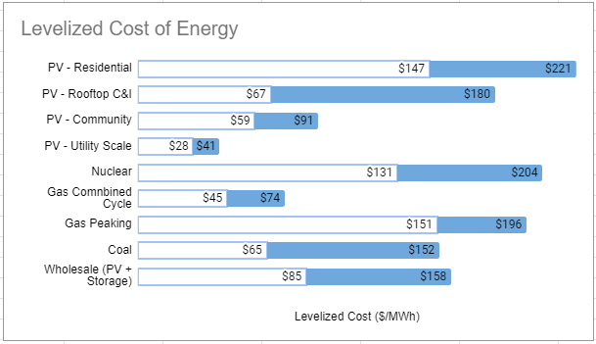Figure 4. Data provided by Lazard.com (*Lazard.Com | Levelized Cost Of Energy, Levelized Cost Of Storage, and Levelized Cost Of Hydrogen*, 2021).

## 4.2. Environmental Comparisons

Fossil fuels are well known for being extremely polluting compared to renewable energy sources, and for their clear contribution to global warming. Here we will explore to what extent nuclear and solar PV can help to reduce the environmental impacts of our energy usage.

### 4.2.1 Carbon Emissions

Electricity generation accounted for 25% of U.S. greenhouse gas emissions in 2020 (*Sources of Greenhouse Gas Emissions | US EPA*, 2015). As shown in figure 5, out of nearly 1.5 billion tons of carbon dioxide released from this sector, 54% came from coal, representing only 23% of total electricity generation, and 44% came from natural gas, comprising 33% of electricity generation (*Where Greenhouse Gases Come from - U.S. Energy Information Administration (EIA)*). Both solar PV and nuclear have no emissions associated with their day to day usage.

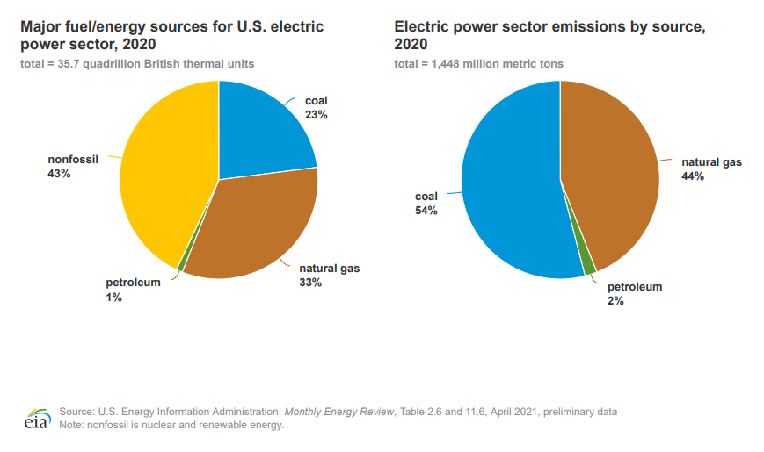  
Figure 5. Distribution of energy sources and emissions for U.S electric power sector (*Where Greenhouse Gases Come from - U.S. Energy Information Administration (EIA)*).

Taking a complete life cycle analysis into account, nuclear and solar PV have 117 grams per kilowatt-hour produced and 33 grams per kilowatt-hour produced respectively. Both of these values are considerably lower than natural gas and coal, which can be up to 30 times higher per kilowatt-hour (Welle). Figure 6 displays these emissions more precisely.

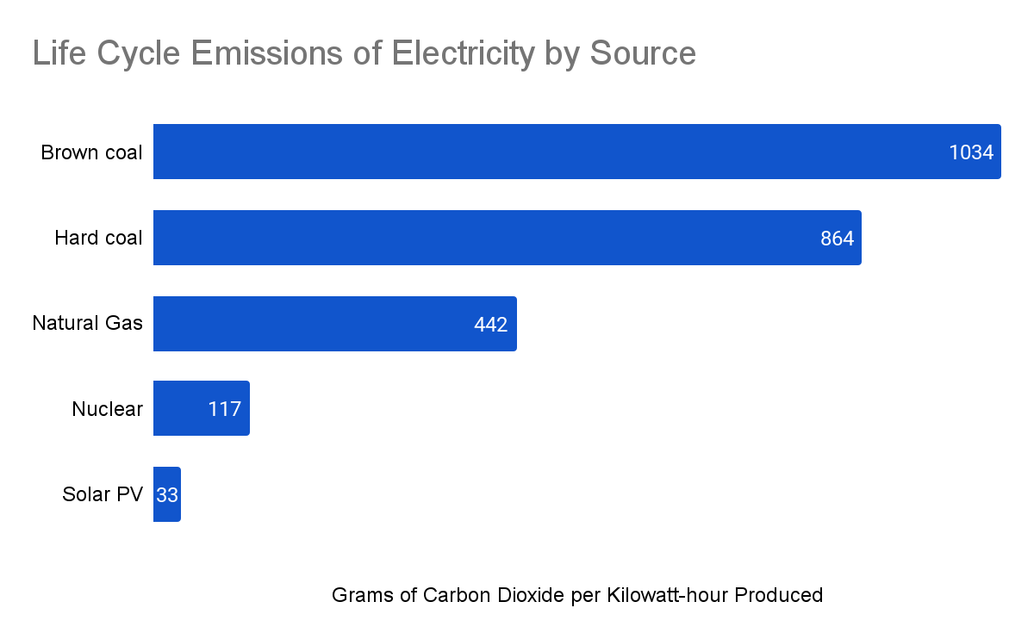

Figure 6. Life Cycle Electricity Emissions by Source (Welle).

The ratio between non fossil fuel emissions and fossil fuel emissions will increase even further as carbon neutral energy becomes better integrated into our manufacturing and transportation methods, reducing relevant emissions and leaving only emissions associated with mining. In addition to being more environmentally friendly with the current mining and manufacturing processes, solar PV also has greater potential for a further reduction in life cycle emissions than nuclear energy. Mining associated with solar PV is to gather metals necessary for the panels. This contribution to emissions can be reduced by recycling or refurbishing and reusing solar panels, reducing the need for additional metals to be mined. Recycling solar panels would reduce material costs and related emissions associated with other materials such as glass and plastic as well (“Solar Panel Recycling | US EPA”). Mining associated with nuclear energy cannot be reduced as easily due to its function as the source of nuclear energy’s nonrenewable fuel.

### 4.2.2 Global Supply

When looking for solutions to long term sustainable energy, it is important to consider the available supply of each energy source. Ignoring supplies needed for installation and maintenance of these technologies, solar energy offers a virtually unlimited supply of energy. As long as the earth remains habitable we will be able to extract energy from sunlight. Nuclear and fossil fuels on the other hand have a far more limited supply of fuel available. At the current rate of consumption, the viable global Uranium supply would last only 80 years (*Why Nuclear Power Will Never Supply the World’s Energy Needs*, 2011). This supply issue is similar to the state of fossil fuels, with a natural gas supply of 53 years and a coal supply of 114 (*When Will Fossil Fuels Run Out?*, 2021). Figure 7 displays these supply projections adjusted the data they were based on to reflect the supply remaining 2022. Increasing use of nuclear energy to replace fossil fuel use comes at the cost of depleting the global Uranium supply even sooner. While viable as an intermediary energy source to aid in the transition from fossil fuels to renewable energy, nuclear energy will need to be retired sometime in future.

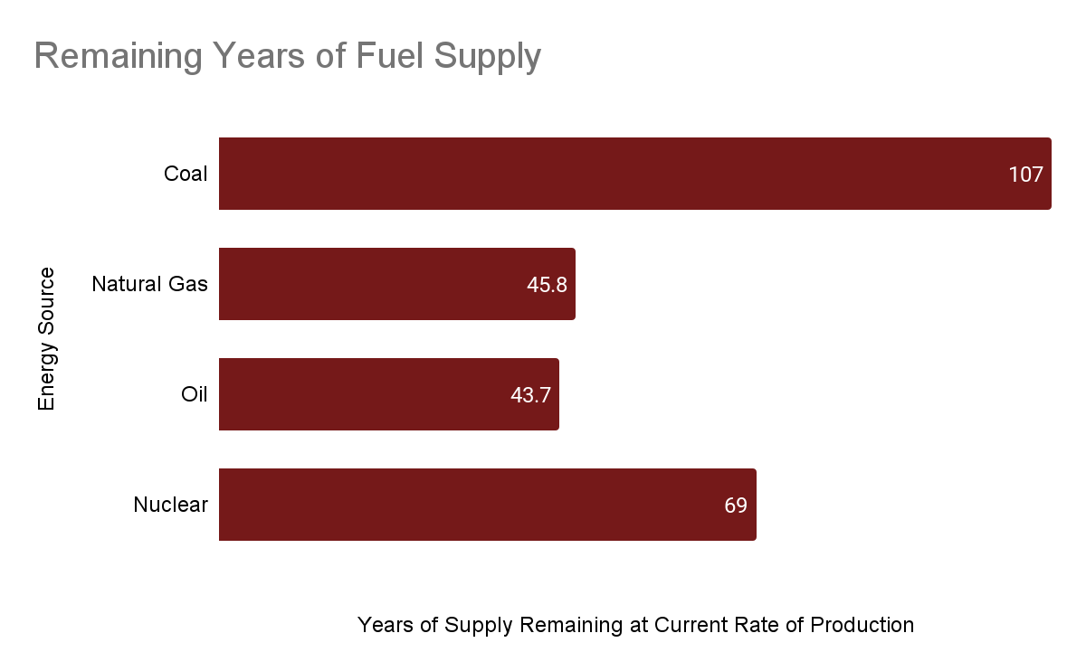

Figure 7. Years of Fuel Supply Remaining at Current Rate of Production (*Why Nuclear Power Will Never Supply the World’s Energy Needs*, 2011), (*When Will Fossil Fuels Run Out?*, 2021).

## 4.3. Safety Comparisons

Solar and nuclear energy have very low global death rates per TW generated of 0.02 and 0.07 respectively. Fossil fuels have significantly higher death rates by comparison. Natural gas has a global rate of 2.8 deaths per TW, and coal has a staggering 24.6 deaths per TW (Ritchie, 2020). This death rate is based on accidents and air pollution caused by energy production. Both solar and nuclear produce negligible air pollution in comparison with fossil fuels, and fatal accidents associated with the non-fossil sources are far less frequent.

# 5. Discussion

Nuclear power plants are far more efficient than solar PV panels in terms of their capacity factors. Nuclear reactors function at full capacity 92.7% of the time while solar panels are at full capacity only 24.6% of the time (Alves, 2021). Solar farms therefore need to be sized for a capacity nearly 4 times greater than nuclear plants in order to achieve the same energy output. This difference could explain why nuclear energy accounts for nearly 7 times more than solar PV in U.S. utility scale electricity generation (*Frequently Asked Questions (FAQs) - U.S. Energy Information Administration (EIA)*, 2022).

Overall, the environmental injustice between solar power and nuclear power is very comparable. They both have injustices that need to be addressed and worked on. However, there is no clear answer as to which one is better for all communities, especially the minority and poor communities.

Solar PV and nuclear energy have distinct strengths and weaknesses as replacements for fossil fuel energy sources. Solar PV is more appealing as a potentially more environmentally friendly alternative due to its lack of need for a subsurface fuel, and greater potential for recycling materials. Additionally its status as a renewable energy source suggests that it will ultimately win out over all other non-renewable energy sources. While nuclear fuel supplies are non-renewable and will likely not be able to last through the end of the century, its unrivaled reliability is crucial for reducing carbon emissions with as little impact to our current energy usage as possible. Renewable energy, especially solar PV, has a lot of room for improvement, and solar PV in particular is not reliable for supplying a consistently high energy supply 24 hours a day. Even though all nuclear energy will eventually need to be replaced with renewable alternatives, it is still worth using instead of fossil fuels for now due to its incredible efficiency and reliability as a low carbon energy source. Neither solar nor nuclear energy have a clear economic advantage over fossil fuels currently, but solar PV will likely become the cheapest option as both fossil and nuclear fuel become more scarce.

# 6. Conclusion

When comparing nuclear energy and solar PV as primary energy sources moving forward, neither option is clearly superior to the other. While nuclear energy has a clear advantage over solar in terms of efficiency, lifetime, and capacity factor, its fuel is not quite as unlimited as solar radiation, and will not be able to power the world indefinitely. Solar PV on the other hand has some significant challenges to tackle in order to be able to compete with nuclear in the short term. Extensive energy storage and continued improvements to solar panel design and material choice will be necessary to make solar a more viable option on large scales. Moving forward, it is best that both technologies continue to be implemented as replacements to fossil fuel sources while engineers and scientists continue to improve the technology and bring forward the day when fossil fuels will be permanently retired.

# References

Ahrens, Marty. “Natural Gas and Propane Fires, Explosions, and Leaks Estimates and Incident Descriptions.” NFPA Research, Oct. 2018.

Alves, Bruna. “• U.S. Energy Capacity Factors by Source 2021 | Statista.” Statista, https://www.statista.com/statistics/183680/us-average-capacity-factors-by-selected-energy-source-since-1998/. Accessed 6 May 2022.

Ashish. (2022, February 13). Why aren't we using nuclear fusion to generate power yet? Science ABC. Retrieved May 18, 2022, from <https://www.scienceabc.com/eyeopeners/why-arent-we-using-nuclear-fusion-to-generate-power-yet.html#:~:text=One%20of%20the%20biggest%20reasons,temperature%20of%20the%20Sun%27s%20core>

Barbarino, M. (2022, March 31). What is nuclear fusion? IAEA. Retrieved May 18, 2022, from https://www.iaea.org/newscenter/news/what-is-nuclear-fusion

Center for Sustainable Systems, University of Michigan. 2021. "Nuclear Energy Factsheet." Pub. No. CSS11-15.

“Coal Mining: Injuries, Illnesses, and Fatalities Fact Sheet.” U.S. Bureau of Labor Statistics, Apr. 2010, <https://www.bls.gov/iif/oshwc/osh/os/osar0012.htm#:~:text=Total%20private%20industry%3A%203.9%20cases,per%20100%20full%2Dtime%20workers>.

*Concentrating Solar Power (CSP) Technologies*. Solareis. (n.d.). Retrieved May 18, 2022, from <https://solareis.anl.gov/guide/solar/csp/>

Concentrating Solar Power. (n.d.). Retrieved May 18, 2022, from <https://library.cap-az.com/documents/meetings/10-17-2013/3_Combined_Solar_CSP.pdf>.

*Concentrating solar-thermal power*. Energy.gov. (n.d.). Retrieved May 18, 2022, from https://www.energy.gov/eere/solar/concentrating-solar-thermal-power#:~:text=Concentrating%20solar%2Dthermal%20power%20(CSP,enhanced%20oil%20recovery%2C%20food%20processing%2C

Ehren, Justin. “The Facts on the Fire Risks of Rooftop Solar Arrays.” Solar Power World, SPW, 19 Nov. 2020, https://www.solarpowerworldonline.com/2020/11/the-facts-on-the-fire-risks-of-rooftop-solar-arrays/#:~:text=Solar%20PV%20fire%20incidents%20are,1%20incident%20per%2010%2C000%20installations.

Energy: Efficiency, power and measurement. Planète Énergies. (2018, January 8). Retrieved May 6, 2022, from https://www.planete-energies.com/en/medias/close/energy-efficiency-power-and-measurement#:~:text=Energy%20efficiency%20is%20calculated%20by,Overall%20power

Environmental Protection Agency. (2021, August 9). Radioactive Waste From Uranium Mining and Milling. EPA. Retrieved May 6, 2022, from https://www.epa.gov/radtown/radioactive-waste-uranium-mining-and-milling#:~:text=Mining%3A%20When%20uranium%20is%20near,then%20removed%20through%20underground%20tunnels

Feria, M. (2021, November 22). *Nuclear fusion power: The future of renewable energy?* Commercial Waste. Retrieved May 18, 2022, from https://commercialwaste.trade/nuclear-fusion-power-future-renewable-energy/#:~:text=Unlike%20nuclear%20fission%20energy%2C%20which,and%20uses%20easily%20attainable%20materials

“Frequently Asked Questions (FAQs) - U.S. Energy Information Administration (EIA).” Homepage - U.S. Energy Information Administration (EIA), https://www.eia.gov/tools/faqs/faq.php?id=427&t=3. Accessed 6 May 2022.

Internal displacement in a changing climate. (2021). *Grid 2021*.

Gonçalves , A. (Ed.). (2020, September 24). What Are Solar Panels and Why They’re Growing Globally. YouMatter. Retrieved May 6, 2022, from https://youmatter.world/en/solar-panel-efficient-perovskites/#:~:text=The%20Average%20Solar%20Panel%20Silicon,of%20the%20light%20they%20get

Green, M. A., Dunlop, E. D., Hohl‐Ebinger, J., Yoshita, M., Kopidakis, N., &amp; Hao, X. (2021). Solar Cell Efficiency Tables (version 59). Progress in Photovoltaics: Research and Applications, 30(1), 3–12. https://doi.org/10.1002/pip.3506

“How Can Metal Mining Impact the Environment? | American Geosciences Institute.” American Geosciences Institute, 13 Nov. 2014, https://www.americangeosciences.org/critical-issues/faq/how-can-metal-mining-impact-environment#id5.

How does solar work? Energy.gov. (n.d.). Retrieved May 6, 2022, from https://www.energy.gov/eere/solar/how-does-solar-work#:~:text=When%20the%20sun%20shines%20onto,cell%2C%20causing%20electricity%20to%20flow

“Lazard.Com | Levelized Cost Of Energy, Levelized Cost Of Storage, and Levelized Cost Of Hydrogen.” Lazard.Com, 28 Oct. 2021, https://www.lazard.com/perspective/levelized-cost-of-energy-levelized-cost-of-storage-and-levelized-cost-of-hydrogen/.

Melis, W. J. C., Mallick, S. K., &amp; Relf, P. (2014). Increasing solar panel efficiency in a sustainable manner. 2014 IEEE International Energy Conference (ENERGYCON). https://doi.org/10.1109/energycon.2014.6850534

Nuclear Explained. U.S. Energy Information Administration - EIA - independent statistics and analysis. (2021, July 14). Retrieved May 6, 2022, from https://www.eia.gov/energyexplained/nuclear/#:~:text=All%20nuclear%20power%20plants%20use,when%20a%20uranium%20atom%20splits

Nuclear fuel facts: Uranium. Energy.gov. (n.d.). Retrieved May 6, 2022, from https://www.energy.gov/ne/nuclear-fuel-facts-uranium#:~:text=Natural%20Uranium%20%E2%80%93%20contains%20a%20238,0.711%20percent%20and%2020%20percent

Nuclear Power Plants. U.S. Energy Information Administration - EIA - independent statistics and analysis. (2021, April 6). Retrieved May 6, 2022, from https://www.eia.gov/energyexplained/nuclear/nuclear-power-plants.php#:~:text=The%20heat%20produced%20during%20nuclear,drive%20generators%20that%20make%20electricity

Nuclear. Student Energy Nuclear Source. (n.d.). Retrieved May 6, 2022, from https://studentenergy.org/source/nuclear/?gclid=Cj0KCQjwyMiTBhDKARIsAAJ-9Vsn9DH3AtjmT1xAurT2YYCGJDZDHd0Zk7SN-PVAdtOYas4_DO2z7CcaAoNmEALw_wcB

*Nuclear 101: How does a nuclear reactor work?* Energy.gov. (2021, March 29). Retrieved May 18, 2022, from https://www.energy.gov/ne/articles/nuclear-101-how-does-nuclear-reactor-work#:~:text=Boiling%20Water%20Reactors&text=BWRs%20heat%20water%20and%20produce,reused%20in%20the%20heating%20process

Rhodes, Richard. “Why Nuclear Power Must Be Part of the Energy Solution - Yale E360.” Yale E360, 19 July 2018, https://e360.yale.edu/features/why-nuclear-power-must-be-part-of-the-energy-solution-environmentalists-climate.

Richardson, L. (2022, February 3). Intro to Solar Energy; How Solar Panels Work: Energysage. EnergySage Blog. Retrieved May 6, 2022, from https://news.energysage.com/solar-panels-work/

Ritchie, Hannah. “What Are the Safest and Cleanest Sources of Energy? - Our World in Data.” Our World in Data, 10 Feb. 2020, <https://ourworldindata.org/safest-sources-of-energy#:~:text=Nuclear%2C%20wind%2C%20hydropower%20and%20solar,than%2010%25%20of%20primary%20energy>.

“Severe Nuclear Reactor Accidents Likely Every 10 to 20 Years, European Study Suggests.” ScienceDaily.Com, 22 May 2012.

Si, Yutong, and Jennie C. Stephans. “Frontiers | Energy Justice Through Solar: Constructing and Engaging Low-Income Households | Sustainable Cities.” Frontiers, 29 Apr. 2021, https://www.frontiersin.org/articles/10.3389/frsc.2021.632020/full.

“Solar Panel Recycling | US EPA.” *US EPA*, 23 Aug. 2021, https://www.epa.gov/hw/solar-panel-recycling.

“Sources of Greenhouse Gas Emissions | US EPA.” US EPA, 29 Dec. 2015, https://www.epa.gov/ghgemissions/sources-greenhouse-gas-emissions#electricity.

“The Pros & Cons of Nuclear Energy: Is It Safe? - Spring Power & Gas.” Spring Power & Gas, 5 Dec. 2018, <https://springpowerandgas.us/the-pros-cons-of-nuclear-energy-is-it-safe/#:~:text=It%20Has%20High%20Energy%20Density&text=Nuclear%20fission%20is%20nearly%208%2C000,creates%20less%20waste%20as%20well>.

The Ultimate Fast Facts Guide To Nuclear Energy. U.S. Department of Energy. Accessed 6 May 2022.

Welle, Deutsche. “Fact Check: Is Nuclear Energy Good for the Climate? | Environment | All Topics from Climate Change to Conservation | DW | 29.11.2021.” DW.COM, Deutsche Welle (www.dw.com), https://www.dw.com/en/fact-check-is-nuclear-energy-good-for-the-climate/a-59853315. Accessed 19 May 2022.

What is Uranium? How Does it Work? World Nuclear Association. (2022, February). Retrieved May 6, 2022, from https://world-nuclear.org/information-library/nuclear-fuel-cycle/introduction/what-is-uranium-how-does-it-work.aspx#:~:text=Uranium%20ore%20can%20be%20mined,which%20is%20recovered%20from%20solution

“When Will Fossil Fuels Run Out?” MET Group, 18 Jan. 2021, <https://group.met.com/en/mind-the-fyouture/mindthefyouture/when-will-fossil-fuels-run-out>.

“Where Greenhouse Gases Come from - U.S. Energy Information Administration (EIA).” Homepage - U.S. Energy Information Administration (EIA), https://www.eia.gov/energyexplained/energy-and-the-environment/where-greenhouse-gases-come-from.php. Accessed 6 May 2022.

Yellowcake. USNRC. (2021, March 9). Retrieved May 6, 2022, from https://www.nrc.gov/reading-rm/basic-ref/glossary/yellowcake.html

Zeiss, G. (2010, January 31). Energy Efficiency of Fossil Fuel Power Generation [web log]. Retrieved May 6, 2022, from https://geospatial.blogs.com/geospatial/2010/01/energy-efficiency-of-fossil-fuel-power-generation.html#:~:text=The%20average%20efficiencies%20of%20power,up%20the%20stack%22%20as%20heat.

Zyga, Lisa. “Why Nuclear Power Will Never Supply the World’s Energy Needs.” Phys.Org - News and Articles on Science and Technology, Phys.org, 11 May 2011, <https://phys.org/news/2011-05-nuclear-power-world-energy.html#:~:text=Uranium%20abundance%3A%20At%20the%20current,will%20last%20for%2080%20years>.

# Term Paper Review Responses:

## Term Paper Review Response 1:

**Topic**: A Comprehensive Comparison between the Use of Solar and Nuclear Energies

**Reviewers Comments**:

This term paper is comprehensive literature review of current situation of solar energy and nuclear energy. The Efficiency of the usage, life-cycle assessment, pollution treatment, energy justice and techno-economic assessment, safety are all included. This literature review can be further improved by adding sections concerning spatial resource distribution and history regarding technology development and future research directions.

Abstract:

The clarity of the sentence “The strengths of nuclear energy almost perfectly counter the shortcomings of solar” needs improvement. “Perfectly” is not an appropriate adverb in scientific writing.

* This has been fixed

Main Text:

1. The verb usage of first sentence of introduction part is not appropriate. “Mitigate” is not suitable as the predicate verb for “amount”. It could be better to replace “mitigate” with “reduce” or other verbs.

* This has been fixed

2. In the introduction, elaborating about photovoltaics and its principles and concentrating solar thermal power plant workings is what can be added.

* We have included more information about concentrated solar-thermal power plants

Recommended reference：

Accadia, T. et al. Virgo: a laser interferometer to detect gravitational waves. J. Instrum. 7, P03012– P03012 (2012).

3. In the energy capture from nuclear energy section, providing chemical reaction taking place within the fission reaction is necessary.

* Nuclear fission is not a chemical reaction, so this comment is irrelevant.

Recommended reference:

Wagemans, C., 1991. The nuclear fission process.

4. In the discussion section, further elaborating the comparison between solar and nuclear energy is recommended. (Other than efficiency and capacity, any other comparison factors, such as resource availability, policy, compatibility with current electric grid)

* We have added a different discussion section that addresses all these points

5. In the solar and nuclear efficiency section, additional case studies can be provided with emphasis on latest techniques which are being developed to increase the efficiency of each process.

* We have already mentioned this part in the PV section to increase overall efficiency.
* We have added a part in the nuclear capacity factor section that addresses nuclear fusion as a new technology as well as renewability

Recommended reference:

Abu-Khader, M.M., 2009. Recent advances in nuclear power: A review. *Progress in Nuclear Energy*, *51*(2), pp.225-235.

Yi-chong, X., 2011. Nuclear energy in Asia: An overview. Nuclear energy development in Asia, pp.1- 13.

Rising, A., 2019. Global overview of nuclear energy development.

6. The LCA analysis of both solar farms and nuclear power plants can be elaborated by taking a basic cradle-to-grave method and consider all the aspects from production to deployment. General case studies in terms of LCA can also be provided.

* We are no longer including an LCA, due to the scope and time constraints of this assignment.

7. In the environmental justice section for solar energy, recent case studies and latest policies to tackle such situation should be explained. The ill effects of mining metals required for solar cells on poor communities can also be explained.

* The effects of relevant policies have not been well researched at this point, this is now addressed in the paper
* Information on potential metal mining health impacts has been added

8. In the environmental justice section for solar energy, no specific reasons and cases have been listed about “Minorities have less access to renewable energy”. Besides,

* Additional context with citation has been provided to support this claim

9. In the nuclear waste section, the ill effects of mining uranium and the workers working in such mines and the effect of radiation of them can be explained. Also, during enrichment of uranium, how will the use of chemicals and emission of harmful gases effect the people living in surrounding areas and its effects on the natural habitat.

* Information on this topic has been gathered and added to this section

## Term Paper Review Response 2:

1. Because you already have a reference, there is no need to add parentheses to cite from after the sentence. Delete all the citation included in parentheses.

* We do not really understand what this means. If they are saying that we do not need in-text citations, then we disagree. We will keep our in-text citations in our report.

2. For introduction part, the word “used” existing in the sentence “renewable energies or non-carbon based energy sources need to be used” needs to be replaced by “ gradually replace traditional carbon based energy like fossil fuels”.

* This has been fixed

3. For 1.1 energy capture from solar energy. You already have told how solar panel worked, and it could be better if you add a diagram describing its process.

* A diagram has been included to help describe the process.

4. All the figures and tables need to be numbered in paper. For example, figure1 , figure2 … and so on.

* Yes, this has been added and addressed

5. For 2.1 solar efficiency, delete “again” in first paragraph.

* fixed

6. Change the title“2.3 comparison” with “ conclusion of comparison” should better make sense.

* fixed

7. The title of section 5.1 “Cost Comparison” should be replaced with “ Economic Analysis”

* fixed

8. Also, I think section 5.1 deserves to put more efforts to do some deeper research. In this section, just simply compare the cost. But exception those basic cost, the energy storage and infrastructure for both renewable energy should be considered. Also, solar energy is not stable, and the sunlight did not spread the same in one place per year. Usually, it could accumulate more energy via solar panel in summer, but how to store and integrate those energy in grid and then release to make up the peak demand remains a question?

* Again, we are not completely sure what this comment is stating. We are simply comparing the cost of energy per MWh. We are not taking into account peak efficiency, but rather an averaged amount over one year.

9. For abstract, you could also include some of your conclusions.

* fixed

1. A solar inverter converts the direct current (DC) output into alternating current (AC).
2. The temperature of the contents of the receiver depend on the type of CPS system that is being used.
3. Underground method for mining is used when the mineral or ore that one is looking for is found deep underground. Thus, miners must dig in underground mines to excavate the material and use underground tunnels to bring it up to the surface (*Radioactive Waste From Uranium Mining and Milling* 2021).
4. Open-pit mining is used when the mineral or ore that one is looking for is found near the surface. Thus, miners must dig the rocks out of open pits and strip away at the topsoil to get to the mineral or ore (*Radioactive Waste From Uranium Mining and Milling* 2021).
5. In-situ leaching process is used when uranium is located in an area that is surrounded by groundwater. In order to obtain the uranium, chemicals are pumped into the groundwater to dissolve the uranium from porous rocks. The uranium is recovered by processing it into uranium hexafluoride (*Radioactive Waste From Uranium Mining and Milling* 2021).