Personalized Search

1. Introduction

Different people look for different things with the same search queries. Classic examples include queries like jaguar, Columbia, ﬂash, mercury, ... This makes it harder for search engines to come up with results that are relevant to a user’s current information need. My research project will attempt to learn a user’s interests by looking at different sources of
personal data. The ﬁnal output is a personalized search system that will aim to bring the results of a search engine relevant to that user to the top of the search ranking, which should make searching faster and allow for more relevant discovery .

2. Aims of the project

Core goals:
• Development of methods and technologies that make it possible to capture data sets and evaluate results in personalized search projects.
• Development of 1 or more algorithms that are able to extract keywords (and more speciﬁcally interests) from data related to the user in HTML format. The project should also assess which algorithm is the most successful and effective in this task.
• Development of a method that can re-rank the output of an online search engine given information about a user’s interests.
• Development and dissemination of a personalized search browser add-on that makes it possible to use the developed technologies and algorithms on a daily basis.

Additional goals:
•Assessment of which personal data source (browser history, e-mail, ﬁles on HD, FaceBook proﬁle, ...) describe a user and his interests best.
•Produce a publication that talks about the ideas, approaches and outcomes of this project.

3. Data Gathering

A browser (Firefox) plugin has been written which captures the browsing behaviour of a user in order to collect the dataset to work on.

The add-on captures all of the URLs that people visit (except for https websites), together with the length of the source HTML, an MD5 sum of the source HTML and the duration of their visit. This is then written into the MySQL database using some PHP scripts and AJAX communication. An additional script will fetch the actual source HTML in an asynchronous fashion. If the length of the fetched HTML is too different to the length (50 characters) of the original source HTML, we assume that we have hit a login or protected page and we do not save that entry. This is to ensure we respect privacy and to make sure that the user's history isn't cluttered with several versions of the same login page.

A custom scripts that takes Mysql dumps from time to time and stores these backups on disk has been written.

A website is built for the dissemination of the plug-in, and can be found at http://alterego.caret.cam.ac.uk . The source code has been Open Sourced on the same website as well. People are found by doing personal recruitment, sending mails to the Sakai Dev list, posting on Twitter and FaceBook, sending an e-mail to the CARET work list, the Graduate Union mailing list, the LinkedIn text analytics group, …

An example of such an email would be:

Internet Surfers Needed ----------------------- I'm currently doing a Masters course in Computer Speech, Text and Internet Technology. The main aim of the MPhil course is to teach the fundamental theory of speech and natural language processing and its use in a variety of advanced applications, especially those related to the Internet. In the last term, I have to undertake a 3 month research project. My project is about Personalized Search. I'll look at how the computer can learn a user's interests by looking at different data sources like browsing history, search queries, ... and how we can use those interests to make the output of search engines more biased towards the user using it and make searching the web more effective. Because there are no publicly available corpora or data sets available for this, I need to gather my own data set. That's why I need your help. I've created a FireFox add-on that captures some of that data. It doesn't get in the way of anything and respects your privacy. If you want to help me out, please visit http://alterego.caret.cam.ac.uk/ and install the add-on. That's all you need to do. The page also contains more information about the project. This is very important for me as I need to collect as much data as possible. You can win a prize worth 50£ as well. Please let me know if you've got any additional question (nm417), Nicolaas Matthijs.

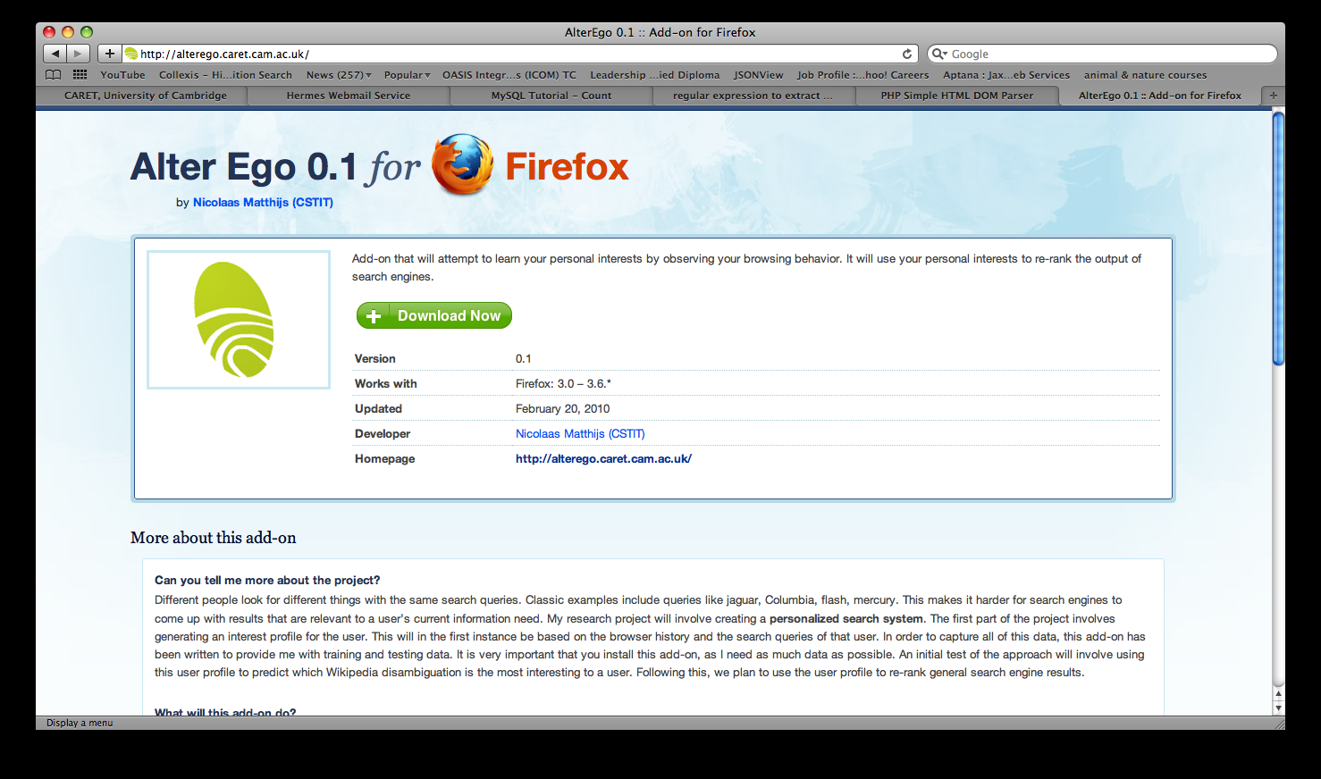

4. Transforming the data into a usable format

The results captured by the 21st of March are shown in Appendix A. This will be cut off at this point in order to prepare the test and training sets. A total of 40 users has been found to install the add-on. Users with less than 500 page visits will be filtered out and then a random selection will be made to determine the test and training set. The outcome of this process can be seen in appendix B:

Training set:

usr_2434413, usr_2543662, usr_2554801, usr_261821, usr_2917559, usr_406338, usr_4362753. usr_4965278, usr_5945189, usr_6145747, usr_6318797, usr_6422669, usr_6989158, usr_7318689, usr_7600860, usr_8002037, usr_9533453

Test set:

usr_2296654, usr_2555137, usr_263177, usr_3762438, usr_4130066, usr_4593969, usr_5117040, usr_5136203, usr_597873, usr_6150712, usr_6326553, usr_6460086, usr_6921645, usr_7865799, usr_8613294, usr_9918599

Development set:

usr_3484406

The source HTMLs for all of the visited is now extracted and ungzipped. A giant XML document is created per user in which a processed and unified version of all of the data is stored in the following format: The plain text is recorded, but also a more structured version per type of tag is extracted.
The detailed format can be seen in Appendix C. It's going to be hard to retrieve anything reliably by looking at the tag used for it, as there is a huge discrepancy in how different tags are used across the web (e.g. headings, ...)

For writing this code, we make use of PHP and simplehtmldom (http://simplehtmldom.sourceforge.net/), and the native PHP gzip and xml libraries.

Later, a script is written that fetches all of the visited pages per user and stores the appropriate html in a test, development and train folder.

This is the architecture for the process:

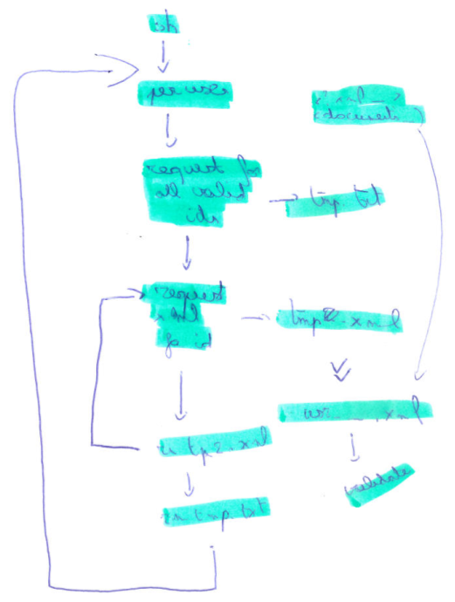
Because of problems with the file sizes and the PHP server, an architecture was created in which a shell script runs through a list of sets and a list of users for each of these sets. Next, a list of all the usable visit ids (excluding login pages, …) is extracted for each user. For each of these ids, a request is done in which the original entry is transformed into the XML schema of Appendix C. The generated XML is then merged into 1 xml file for each user, which is then beautified using a python XML beautifier.

This data set will be used to assess different user profile algorithms and generates the user profiles.

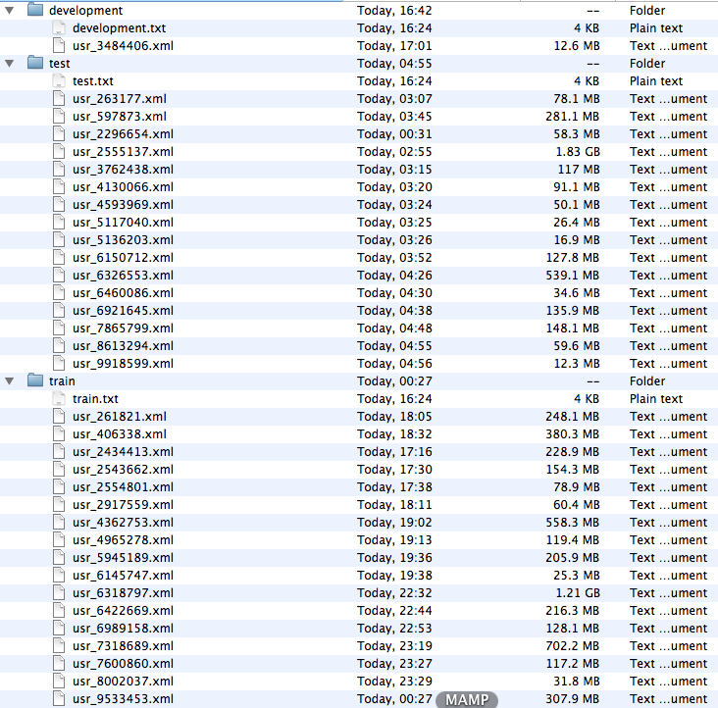
Extraction of Wikipedia disambiguation statistics. A program is written in Java that parses the User Data XML file using a Sax parser.

Then a class is written that extracts the Wikipedia usage statistics out of the data.

Appendix A: Captured data at development cut-off point

User No Page Visits Google Searches Bing Searches Wikipedia Pages
User 1 45 2 0 5
User 2 1562 111 0 3
User 3 2643 248 0 78
User 4 5821 227 1 15
User 5 3520 124 0 3
User 6 25393 562 0 8
User 7 7686 74 0 1
User 8 3232 230 0 19
User 9 17 9 0 0
User 10 3313 149 0 0
User 11 440 74 0 15
User 12 4324 406 0 3
User 13 6366 149 0 17
User 14 2949 302 0 24
User 15 6559 168 6 28
User 16 112 20 0 0
User 17 1336 38 0 0
User 18 112 6 0 0
User 19 2489 363 21 22
User 20 698 16 0 0
User 21 959 1 53 3
User 22 9209 71 0 7
User 23 4833 295 0 7
User 24 55 10 0 0
User 25 951 18 0 0
User 26 3610 57 0 3
User 27 7676 107 0 2
User 28 8763 1081 0 38
User 29 3026 450 0 28
User 30 743 158 0 7
User 31 3663 530 0 4
User 32 4342 199 0 3
User 33 119 29 0 2
User 34 6733 1707 0 34
User 35 4271 160 0 3
User 36 3077 509 0 18
User 37 1096 346 0 59
User 38 2836 48 0 0
User 39 14633 464 1 10
User 40 303 49 0 3
Appendix B: Division into training and test set

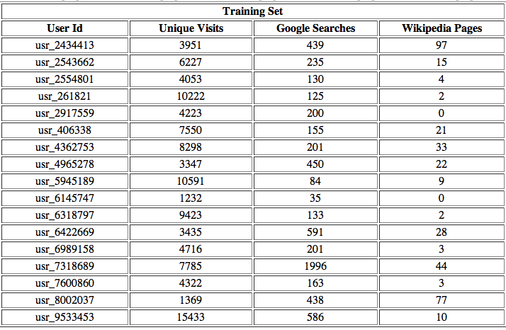
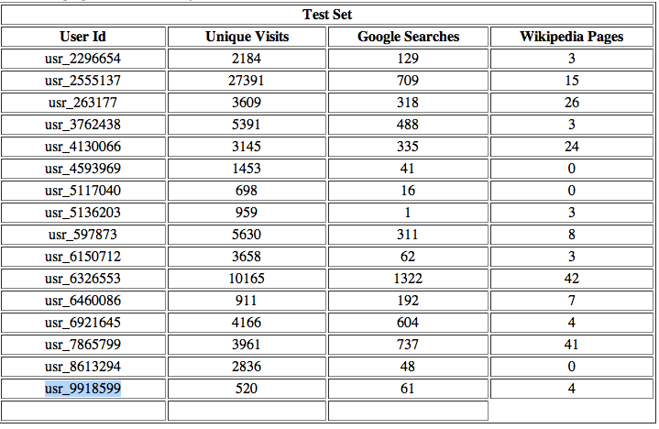
Appendix C: Data storage XML format

<?xml>
<user id=””>
<entries=””>
<documents>
<document>
<url/>
<duration/>
<plaintext/>
<structured>
<head>
<metadescription/>
<metakeywords/>
<title/>
</head>
<images>
<img alt=”” title=””/>
<img alt=”” title=””/>
</images>
<anchors>
<a title=”” href=””/>
<a title=”” href=””/>
</anchors>
<headings>
<heading type=””/>
<heading type=””/>
</headings>
<textual>
<text type=”p”/>
<text type=”span”/>
</textual>
<lists>
<list type=”ol”>
<item/>
<item/>
</list>
<list type=”ul”>
<item/>
<item/>
</list>
</lists>
<tables>
<table>
<cell type=””/>
<cell type=””/>
</table>
<table>
<cell type=””/>
<cell type=””/>
</table>
</tables>
</structured>
</document>
…
</documents>
Appendix D: Sample processed user entry

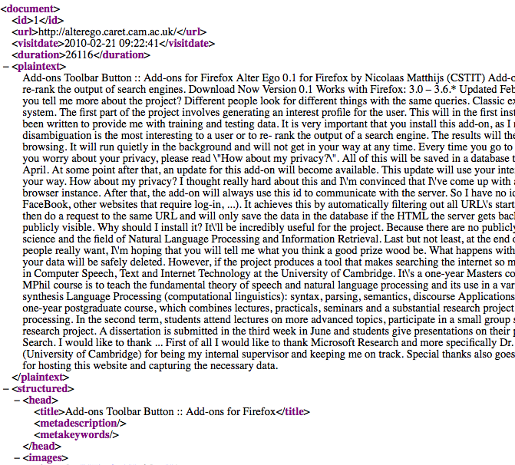
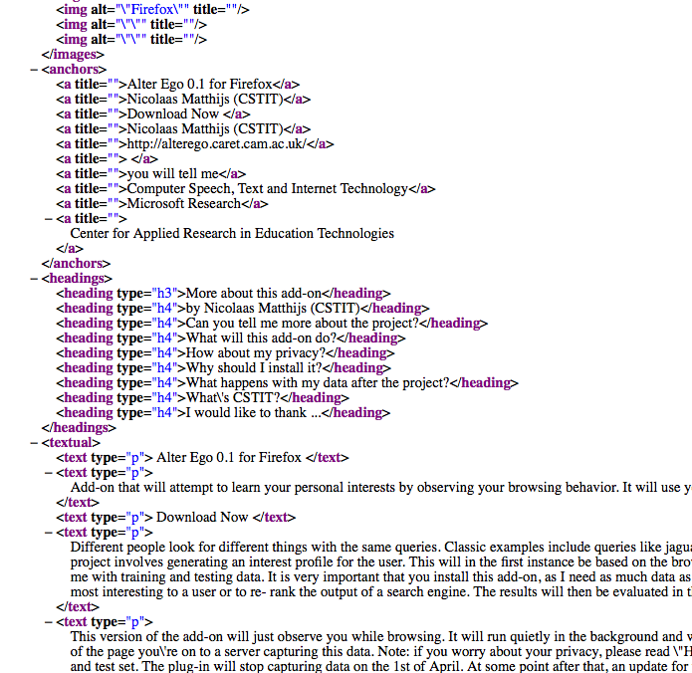
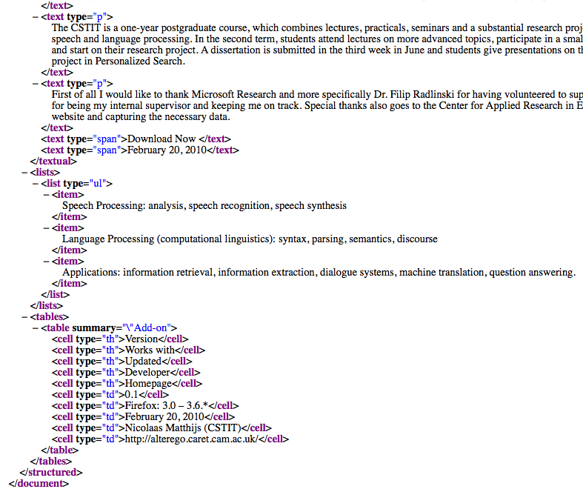

Wikipedia Statistics

Summary:

Training Set |  |  |  | Test Set
User | WP | WPD | DP | User | WP | WPA | AP
User 1 | 97 | 14 | 2 | User 1 | 11 | 1 | 0
User 2 | 15 | 3 | 0 | User 2 | 20 | 0 | 0
User 3 | 7 | 0 | 0 | User 3 | 21 | 1 | 0
User 4 | 13 | 2 | 0 | User 4 | 5 | 0 | 0
User 5 | 0 | 0 | 0 | User 5 | 24 | 2 | 0
User 6 | 16 | 0 | 0 | User 6 | 0 | 0 | 0
User 7 | 15 | 2 | 0 | User 7 | 0 | 0 | 0
User 8 | 21 | 1 | 1 | User 8 | 3 | 0 | 0
User 9 | 9 | 0 | 0 | User 9 | 11 | 0 | 0
User 10 | 0 | 0 | 0 | User 10 | 6 | 0 | 0
User 11 | 2 | 1 | 0 | User 11 | 50 | 4 | 0
User 12 | 27 | 2 | 0 | User 12 | 9 | 0 | 0
User 13 | 3 | 0 | 0 | User 13 | 4 | 2 | 0
User 14 | 26 | 6 | 0 | User 14 | 43 | 3 | 0
User 15 | 4 | 0 | 0 | User 15 | 6 | 0 | 0
User 16 | 12 | 0 | 0 | User 16 | 4 | 0 | 0
User 17 | 10 | 2 | 0

WP = Wikipedia pages
WPA = Wikipedia pages with link to disambiguation page
DP = Disambiguation pages

==================
== Training Set ==
==================

User document parsed in 14 seconds
Wikipedia page: http://en.wikipedia.org/wiki/Chimpanzee
Wikipedia page with disambiguation: http://en.wikipedia.org/wiki/Orchid
Wikipedia page: http://en.wikipedia.org/wiki/Orchid
Wikipedia page with disambiguation: http://en.wikipedia.org/wiki/Orchid
Wikipedia page: http://en.wikipedia.org/wiki/Orchid
Wikipedia page with disambiguation: http://en.wikipedia.org/wiki/Orchid
Wikipedia page: http://en.wikipedia.org/wiki/Orchid
Disambiguation page: http://en.wikipedia.org/wiki/Orchid_(disambiguation)
Wikipedia page with disambiguation: http://en.wikipedia.org/wiki/Orchid
Wikipedia page: http://en.wikipedia.org/wiki/Orchid
Wikipedia page: http://en.wikipedia.org/wiki/Orchis
Wikipedia page: http://en.wikipedia.org/wiki/Glossary_of_botanical_terms
Wikipedia page: http://en.wikipedia.org/wiki/Orchis
Wikipedia page: http://en.wikipedia.org/wiki/Glossary_of_botanical_terms
Wikipedia page: http://en.wikipedia.org/wiki/Orchis
Wikipedia page: http://en.wikipedia.org/wiki/Glossary_of_botanical_terms#T
Wikipedia page: http://en.wikipedia.org/wiki/Glossary_of_botanical_terms#T
Wikipedia page: http://en.wikipedia.org/wiki/Special:Search?search=demand5&sourceid=Mozilla-search
Wikipedia page with disambiguation: http://en.wikipedia.org/wiki/Monk
Wikipedia page: http://en.wikipedia.org/wiki/Monk
Disambiguation page: http://en.wikipedia.org/wiki/Monk_(disambiguation)#In_entertainment
Wikipedia page: http://en.wikipedia.org/wiki/Adrian_Monk#Personality
Wikipedia page: http://en.wikipedia.org/wiki/Cuban_revolution#Post-1959:_After_the_revolution
Wikipedia page: http://en.wikipedia.org/wiki/Pluto#Relationship_with_Neptune
Wikipedia page: http://en.wikipedia.org/wiki/Mary_Mallon
Wikipedia page: http://en.wikipedia.org/wiki/Compartmental_models_in_epidemiology#Elaborations_on_the_basic_SIR_model
Wikipedia page: http://en.wikipedia.org/wiki/Compartmental_models_in_epidemiology#Elaborations_on_the_basic_SIR_model
Wikipedia page: http://en.wikipedia.org/wiki/Lycopodium
Wikipedia page: http://en.wikipedia.org/wiki/Dogo_Argentino
Wikipedia page: http://en.wikipedia.org/wiki/Cordoba_Fighting_Dog
Wikipedia page: http://en.wikipedia.org/wiki/Dogo_Argentino
Wikipedia page: http://en.wikipedia.org/wiki/Dogue_de_Bordeaux
Wikipedia page: http://en.wikipedia.org/wiki/Tibetan_Mastiff
Wikipedia page: http://en.wikipedia.org/wiki/Dogue_de_Bordeaux
Wikipedia page: http://en.wikipedia.org/wiki/Neapolitan_Mastiff
Wikipedia page: http://en.wikipedia.org/wiki/Fila_Brasileiro
Wikipedia page: http://en.wikipedia.org/wiki/Molosser
Wikipedia page: http://en.wikipedia.org/wiki/Molossus
Wikipedia page: http://en.wikipedia.org/wiki/Molossus_(dog)
Wikipedia page: http://en.wikipedia.org/wiki/Bernese_Mountain_Dog
Wikipedia page: http://en.wikipedia.org/wiki/Molossus_(dog)
Wikipedia page: http://en.wikipedia.org/wiki/Greater_Swiss_Mountain_Dog
Wikipedia page: http://en.wikipedia.org/wiki/Molossus_(dog)
Wikipedia page with disambiguation: http://en.wikipedia.org/wiki/Rottweiler
Wikipedia page: http://en.wikipedia.org/wiki/Rottweiler
Wikipedia page: http://en.wikipedia.org/wiki/Molossus_(dog)
Wikipedia page: http://en.wikipedia.org/wiki/Great_Pyrenees
Wikipedia page: http://en.wikipedia.org/wiki/Maremma_Sheepdog
Wikipedia page: http://en.wikipedia.org/wiki/Great_Pyrenees
Wikipedia page: http://en.wikipedia.org/wiki/Kuvasz
Wikipedia page: http://en.wikipedia.org/wiki/Great_Pyrenees
Wikipedia page: http://en.wikipedia.org/wiki/Akbash_Dog
Wikipedia page: http://en.wikipedia.org/wiki/Great_Pyrenees
Wikipedia page: http://en.wikipedia.org/wiki/Polski_Owczarek_Podhala%C5%84ski
Wikipedia page: http://en.wikipedia.org/wiki/Great_Pyrenees
Wikipedia page: http://en.wikipedia.org/wiki/Molossus_(dog)
Wikipedia page: http://en.wikipedia.org/wiki/Molossus
Wikipedia page: http://en.wikipedia.org/wiki/Molosser
Wikipedia page: http://en.wikipedia.org/wiki/Pyrenean_Mastiff
Wikipedia page: http://en.wikipedia.org/wiki/Molosser
Wikipedia page: http://en.wikipedia.org/wiki/Bullmastiff
Wikipedia page: http://en.wikipedia.org/wiki/Molosser
Wikipedia page: http://en.wikipedia.org/wiki/Spanish_Mastiff
Wikipedia page: http://en.wikipedia.org/wiki/Molosser
Wikipedia page: http://en.wikipedia.org/wiki/Boxer_(dog)
Wikipedia page: http://en.wikipedia.org/wiki/Molosser
Wikipedia page: http://en.wikipedia.org/wiki/Old_English_Bulldog
Wikipedia page: http://en.wikipedia.org/wiki/Olde_English_Bulldogge
Wikipedia page: http://en.wikipedia.org/wiki/Old_English_Bulldog
Wikipedia page: http://en.wikipedia.org/wiki/Renascence_Bulldogge
Wikipedia page: http://en.wikipedia.org/wiki/Old_English_Bulldog
Wikipedia page with disambiguation: http://en.wikipedia.org/wiki/Bulldog
Wikipedia page: http://en.wikipedia.org/wiki/Bulldog
Wikipedia page: http://en.wikipedia.org/wiki/American_Bulldog
Wikipedia page with disambiguation: http://en.wikipedia.org/wiki/Bulldog
Wikipedia page: http://en.wikipedia.org/wiki/Bulldog
Wikipedia page: http://en.wikipedia.org/wiki/French_Bulldog
Wikipedia page with disambiguation: http://en.wikipedia.org/wiki/Bulldog
Wikipedia page: http://en.wikipedia.org/wiki/Bulldog
Wikipedia page: http://en.wikipedia.org/wiki/Old_English_Bulldog
Wikipedia page: http://en.wikipedia.org/wiki/Alaunt
Wikipedia page with disambiguation: http://en.wikipedia.org/wiki/Sarmatian
Wikipedia page: http://en.wikipedia.org/wiki/Sarmatian
Wikipedia page: http://en.wikipedia.org/wiki/Alaunt
Wikipedia page: http://en.wikipedia.org/wiki/Armenian_Gampr_dog
Wikipedia page: http://en.wikipedia.org/wiki/Parameter_space
Wikipedia page: http://en.wikipedia.org/wiki/Overcome_(Alexandra_Burke_album)
Wikipedia page: http://en.wikipedia.org/wiki/Crinoline
Wikipedia page: http://en.wikipedia.org/wiki/Gravity_as_an_entropic_force
Wikipedia page: http://en.wikipedia.org/wiki/R101
Wikipedia page: http://en.wikipedia.org/wiki/Hindenburg_disaster
Wikipedia page: http://en.wikipedia.org/wiki/Airships
Wikipedia page: http://en.wikipedia.org/wiki/Aerostat
Wikipedia page: http://en.wikipedia.org/wiki/Airships
Wikipedia page with disambiguation: http://en.wikipedia.org/wiki/Non-rigid_airship
Wikipedia page: http://en.wikipedia.org/wiki/Non-rigid_airship
Wikipedia page with disambiguation: http://en.wikipedia.org/wiki/Non-rigid_airship
Wikipedia page: http://en.wikipedia.org/wiki/Non-rigid_airship
Wikipedia page: http://en.wikipedia.org/wiki/Hindenburg_disaster
Wikipedia page: http://en.wikipedia.org/wiki/R101
Wikipedia page: http://en.wikipedia.org/wiki/Airships
Wikipedia page: http://en.wikipedia.org/wiki/Zeppelin
Wikipedia page: http://en.wikipedia.org/wiki/Tiananmen_Square_protests_of_1989
Wikipedia page: http://en.wikipedia.org/wiki/Th%C3%ADch_Qu%E1%BA%A3ng_%C4%90%E1%BB%A9c
Wikipedia page: http://en.wikipedia.org/wiki/Pachamama
Wikipedia page: http://en.wikipedia.org/wiki/Green_Eggs_and_Ham
Wikipedia page: http://en.wikipedia.org/wiki/Charles_M._Schulz
Wikipedia page: http://en.wikipedia.org/wiki/Sid_Meier
Wikipedia page: http://en.wikipedia.org/wiki/List_of_rivers_of_Africa
Wikipedia page with disambiguation: http://en.wikipedia.org/wiki/Fosse
Wikipedia page: http://en.wikipedia.org/wiki/Fosse
Wikipedia page with disambiguation: http://en.wikipedia.org/wiki/Cloaca
Wikipedia page: http://en.wikipedia.org/wiki/Cloaca
Wikipedia pages visited: 97
Wikipedia pages with disambiguation page visited: 14
Wikipedia disambiguation pages visited: 2
User visited 4355 documents
****************
User document parsed in 20 seconds
Wikipedia page with disambiguation: http://en.wikipedia.org/wiki/Girl_with_a_Pearl_Earring
Wikipedia page: http://en.wikipedia.org/wiki/Girl_with_a_Pearl_Earring
Wikipedia page: http://en.wikipedia.org/wiki/Girl_with_a_Pearl_Earring_(novel)
Wikipedia page with disambiguation: http://en.wikipedia.org/wiki/Girl_with_a_Pearl_Earring
Wikipedia page: http://en.wikipedia.org/wiki/Girl_with_a_Pearl_Earring
Wikipedia page: http://en.wikipedia.org/wiki/Usability_testing
Wikipedia page: http://en.wikipedia.org/wiki/Usability_testing
Wikipedia page: http://nl.wikipedia.org/wiki/Jimmy_Samijn
Wikipedia page with disambiguation: http://en.wikipedia.org/wiki/Greenwich
Wikipedia page: http://en.wikipedia.org/wiki/Greenwich
Wikipedia page: http://en.wikipedia.org/wiki/File:Greenwich_Park_Vista.jpg
Wikipedia page: http://en.wikipedia.org/wiki/File:Greenwich_Park_Vista.jpg
Wikipedia page: http://en.wikipedia.org/wiki/Tresco_Abbey_Gardens
Wikipedia page: http://en.wikipedia.org/wiki/SoShy
Wikipedia page: http://en.wikipedia.org/wiki/SoShy
Wikipedia page: http://en.wikipedia.org/wiki/SoShy
Wikipedia page: http://en.wikipedia.org/wiki/MySpace
Wikipedia page: http://en.wikipedia.org/wiki/SoShy
Wikipedia pages visited: 15
Wikipedia pages with disambiguation page visited: 3
Wikipedia disambiguation pages visited: 0
User visited 7475 documents
****************
User document parsed in 6 seconds
Wikipedia page: http://en.wikipedia.org/wiki/Corey_Haim
Wikipedia page: http://en.wikipedia.org/wiki/The_Lost_Boys
Wikipedia page: http://en.wikipedia.org/wiki/Saint_Patrick%27s_Day
Wikipedia page: http://en.wikipedia.org/wiki/Latin_America
Wikipedia page: http://en.wikipedia.org/wiki/Tom_Joad
Wikipedia page: http://en.wikipedia.org/wiki/Opossum
Wikipedia page: http://en.wikipedia.org/wiki/Virginia_Opossum
Wikipedia pages visited: 7
Wikipedia pages with disambiguation page visited: 0
Wikipedia disambiguation pages visited: 0
User visited 4409 documents
****************
User document parsed in 29 seconds
Wikipedia page: http://en.wikipedia.org/wiki/Fokker_70
Wikipedia page: http://en.wikipedia.org/wiki/Dortmund
Wikipedia page: http://en.wikipedia.org/wiki/Hiroyuki_Sakai
Wikipedia page: http://en.wikipedia.org/wiki/Iron_Chef
Wikipedia page: http://en.wikipedia.org/wiki/Hiroyuki_Sakai
Wikipedia page: http://en.wikipedia.org/wiki/Sakai
Wikipedia page: http://en.wikipedia.org/wiki/Sakai_(name)
Wikipedia page: http://en.wikipedia.org/wiki/Sakai
Wikipedia page: http://en.wikipedia.org/wiki/Sakai_Project
Wikipedia page with disambiguation: http://en.wikipedia.org/wiki/Chaos_theory
Wikipedia page: http://en.wikipedia.org/wiki/Chaos_theory
Wikipedia page: http://en.wikipedia.org/wiki/Quantum_chaos
Wikipedia page with disambiguation: http://en.wikipedia.org/wiki/Chaos
Wikipedia page: http://en.wikipedia.org/wiki/Chaos
Wikipedia page: http://en.wikipedia.org/wiki/Quantum_mechanics
Wikipedia pages visited: 13
Wikipedia pages with disambiguation page visited: 2
Wikipedia disambiguation pages visited: 0
User visited 12359 documents
****************
User document parsed in 5 seconds
Wikipedia pages visited: 0
Wikipedia pages with disambiguation page visited: 0
Wikipedia disambiguation pages visited: 0
User visited 4344 documents
****************
User document parsed in 47 seconds
Wikipedia page: http://en.wikipedia.org/wiki/Taibe,_Galilee
Wikipedia page: http://en.wikipedia.org/wiki/Taibe,_Galilee
Wikipedia page: http://en.wikipedia.org/wiki/Tamra,_Jezreel_Valley
Wikipedia page: http://en.wikipedia.org/wiki/Na%27ura
Wikipedia page: http://en.wikipedia.org/wiki/Sandala,_Israel
Wikipedia page: http://en.wikipedia.org/wiki/Muqeible
Wikipedia page: http://en.wikipedia.org/wiki/Sandala,_Israel
Wikipedia page: http://en.wikipedia.org/wiki/Na%27ura
Wikipedia page: http://en.wikipedia.org/wiki/Tamra,_Jezreel_Valley
Wikipedia page: http://en.wikipedia.org/wiki/Taibe,_Galilee
Wikipedia page: http://en.wikipedia.org/wiki/Sun
Wikipedia page: http://en.wikipedia.org/wiki/Absolute_magnitude
Wikipedia page: http://en.wikipedia.org/wiki/Main_Page
Wikipedia page: http://en.wikipedia.org/wiki/Maxine_Sullivan
Wikipedia page: http://en.wikipedia.org/wiki/Special:Search?search=usein+bolt&go=Go
Wikipedia page: http://en.wikipedia.org/wiki/Usain_bolt
Wikipedia pages visited: 16
Wikipedia pages with disambiguation page visited: 0
Wikipedia disambiguation pages visited: 0
User visited 8188 documents
****************
User document parsed in 86 seconds
Wikipedia page: http://en.wikipedia.org/wiki/FCK
Wikipedia page: http://en.wikipedia.org/wiki/Picon
Wikipedia page: http://en.wikipedia.org/wiki/Sakai
Wikipedia page: http://en.wikipedia.org/wiki/Sakai_Project
Wikipedia page: http://en.wikipedia.org/wiki/Sakai_Project#Background
Wikipedia page: http://en.wikipedia.org/wiki/Sakai_Project
Wikipedia page: http://en.wikipedia.org/wiki/Sakai_Project
Wikipedia page: http://en.wikipedia.org/wiki/Sakai_Project
Wikipedia page: http://en.wikipedia.org/wiki/Sakai_Project
Wikipedia page with disambiguation: http://en.wikipedia.org/wiki/Facehugger#Facehugger
Wikipedia page: http://en.wikipedia.org/wiki/Facehugger#Facehugger
Wikipedia page: http://en.wikipedia.org/wiki/List_of_castes_from_the_Alien_expanded_universe
Wikipedia page with disambiguation: http://en.wikipedia.org/wiki/Facehugger#Facehugger
Wikipedia page: http://en.wikipedia.org/wiki/Facehugger#Facehugger
Wikipedia page: http://en.wikipedia.org/wiki/Area_code_562
Wikipedia page: http://en.wikipedia.org/wiki/Area_code_510
Wikipedia page: http://en.wikipedia.org/wiki/Cocktail_strainer
Wikipedia pages visited: 15
Wikipedia pages with disambiguation page visited: 2
Wikipedia disambiguation pages visited: 0
User visited 10861 documents
****************
User document parsed in 12 seconds
Wikipedia page: http://en.wikipedia.org/wiki/First_Things_First_(book)
Wikipedia page: http://en.wikipedia.org/wiki/F5
Wikipedia page: http://en.wikipedia.org/wiki/Zotero
Wikipedia page: http://en.wikipedia.org/wiki/.NET_Framework
Wikipedia page with disambiguation: http://en.wikipedia.org/wiki/Rpm
Wikipedia page: http://en.wikipedia.org/wiki/Rpm
Disambiguation page: http://en.wikipedia.org/wiki/RPM_(disambiguation)
Wikipedia page: http://en.wikipedia.org/wiki/RPM_Package_Manager
Wikipedia page: http://en.wikipedia.org/wiki/.net
Wikipedia page: http://en.wikipedia.org/wiki/Sudbury_Basin
Wikipedia page: http://en.wikipedia.org/wiki/Wilkes_Land_crater
Wikipedia page: http://en.wikipedia.org/wiki/Active_Server_Pages
Wikipedia page: http://en.wikipedia.org/wiki/Active_Server_Pages
Wikipedia page: http://en.wikipedia.org/wiki/Zotero
Wikipedia page: http://en.wikipedia.org/wiki/TinyMCE
Wikipedia page: http://en.wikipedia.org/wiki/Andrew_Pollard
Wikipedia page: http://en.wikipedia.org/wiki/Institute_of_Education
Wikipedia page: http://en.wikipedia.org/wiki/Andrew_Pollard
Wikipedia page: http://en.wikipedia.org/wiki/Make_(software)
Wikipedia page: http://en.wikipedia.org/wiki/Make_(software)
Wikipedia page: http://en.wikipedia.org/wiki/Phobos-Grunt
Wikipedia page: http://en.wikipedia.org/wiki/KisMAC
Wikipedia page: http://en.wikipedia.org/wiki/Niche_construction
Wikipedia pages visited: 21
Wikipedia pages with disambiguation page visited: 1
Wikipedia disambiguation pages visited: 1
User visited 3468 documents
****************
User document parsed in 25 seconds
Wikipedia page: http://en.wikipedia.org/wiki/Special:Search?search=Portal+Companion+Cube&sourceid=Mozilla-search
Wikipedia page: http://en.wikipedia.org/wiki/Special:Search?search=Portal+Companion+Cube&sourceid=Mozilla-search
Wikipedia page: http://en.wikipedia.org/wiki/Portal_(video_game)
Wikipedia page: http://en.wikipedia.org/wiki/Companion_Cube
Wikipedia page: http://en.wikipedia.org/wiki/Windows_2000#Server_family_features
Wikipedia page: http://en.wikipedia.org/wiki/History_of_Microsoft_Windows
Wikipedia page: http://en.wikipedia.org/wiki/Virtual_Boy
Wikipedia page: http://en.wikipedia.org/wiki/Ruby_on_Rails
Wikipedia page: http://en.wikipedia.org/wiki/Mario_Kart_64
Wikipedia pages visited: 9
Wikipedia pages with disambiguation page visited: 0
Wikipedia disambiguation pages visited: 0
User visited 12243 documents
****************
User document parsed in 4 seconds
Wikipedia pages visited: 0
Wikipedia pages with disambiguation page visited: 0
Wikipedia disambiguation pages visited: 0
User visited 1442 documents
****************
User document parsed in 258 seconds
Wikipedia page: http://de.wikipedia.org/wiki/Milizsystem_(Schweiz)
Wikipedia page with disambiguation: http://en.wikipedia.org/wiki/English_articles
Wikipedia page: http://en.wikipedia.org/wiki/English_articles
Wikipedia pages visited: 2
Wikipedia pages with disambiguation page visited: 1
Wikipedia disambiguation pages visited: 0
User visited 11288 documents
****************
User document parsed in 26 seconds
Wikipedia page: http://en.wikipedia.org/wiki/Apache_Ant#References
Wikipedia page: http://en.wikipedia.org/wiki/Trie#Algorithms
Wikipedia page: http://en.wikipedia.org/wiki/Trie#Algorithms
Wikipedia page: http://en.wikipedia.org/wiki/Trie#Algorithms
Wikipedia page: http://en.wikipedia.org/wiki/Directed_acyclic_word_graph
Wikipedia page: http://en.wikipedia.org/wiki/Trie#Algorithms
Wikipedia page: http://en.wikipedia.org/wiki/Radix_tree
Wikipedia page: http://en.wikipedia.org/wiki/Suffix_tree#Functionality
Wikipedia page: http://en.wikipedia.org/wiki/Suffix_array
Wikipedia page: http://en.wikipedia.org/wiki/Trie#Dictionary_representation
Wikipedia page: http://en.wikipedia.org/wiki/Suffix_tree#Functionality
Wikipedia page: http://en.wikipedia.org/wiki/Trie#Dictionary_representation
Wikipedia page: http://en.wikipedia.org/wiki/Hash_array_mapped_trie
Wikipedia page: http://en.wikipedia.org/wiki/Trie#Dictionary_representation
Wikipedia page: http://en.wikipedia.org/wiki/Trie#Dictionary_representation
Wikipedia page: http://en.wikipedia.org/wiki/Trie#Dictionary_representation
Wikipedia page: http://en.wikipedia.org/wiki/Adium
Wikipedia page with disambiguation: http://en.wikipedia.org/wiki/IRC
Wikipedia page: http://en.wikipedia.org/wiki/IRC
Wikipedia page: http://en.wikipedia.org/wiki/Adium
Wikipedia page: http://en.wikipedia.org/wiki/George_W._Bush
Wikipedia page with disambiguation: http://en.wikipedia.org/wiki/Guy_fawkes
Wikipedia page: http://en.wikipedia.org/wiki/Guy_fawkes
Wikipedia page: http://en.wikipedia.org/wiki/Special:Search?search=shareholic+firefox+plugin&sourceid=Mozilla-search
Wikipedia page: http://en.wikipedia.org/wiki/Special:Search?search=integrate+connotea+with+delicious&sourceid=Mozilla-search
Wikipedia page: http://en.wikipedia.org/wiki/Special:Search?search=shareholic&sourceid=Mozilla-search
Wikipedia page: http://en.wikipedia.org/wiki/Special:Search?search=http+delet+method+support&sourceid=Mozilla-search
Wikipedia page: http://en.wikipedia.org/wiki/XMLHttpRequest#Support_in_Internet_Explorer_versions_5.2C_5.5_and_6
Wikipedia page: http://en.wikipedia.org/wiki/Iss
Wikipedia pages visited: 27
Wikipedia pages with disambiguation page visited: 2
Wikipedia disambiguation pages visited: 0
User visited 3681 documents
****************
User document parsed in 39 seconds
Wikipedia page: http://en.wikipedia.org/wiki/Dialogic
Wikipedia page: http://en.wikipedia.org/wiki/Moodle
Wikipedia page: http://en.wikipedia.org/wiki/Percentile
Wikipedia pages visited: 3
Wikipedia pages with disambiguation page visited: 0
Wikipedia disambiguation pages visited: 0
User visited 5457 documents
****************
User document parsed in 107 seconds
Wikipedia page: http://en.wikipedia.org/wiki/Grace_Under_Fire
Wikipedia page: http://en.wikipedia.org/wiki/Brett_Butler_(comedian)
Wikipedia page: http://en.wikipedia.org/wiki/Martha_Logan
Wikipedia page: http://en.wikipedia.org/wiki/Pristina
Wikipedia page: http://en.wikipedia.org/wiki/HTML5#Differences_from_HTML_4.01.2FXHTML_1.x
Wikipedia page: http://en.wikipedia.org/wiki/Lightbox_(JavaScript)
Wikipedia page: http://en.wikipedia.org/wiki/Meritocracy
Wikipedia page: http://en.wikipedia.org/wiki/Cleveland
Wikipedia page with disambiguation: http://en.wikipedia.org/wiki/Holy_Grail
Wikipedia page: http://en.wikipedia.org/wiki/Holy_Grail
Wikipedia page: http://en.wikipedia.org/wiki/List_of_birthday_songs
Wikipedia page with disambiguation: http://en.wikipedia.org/wiki/Permutation
Wikipedia page: http://en.wikipedia.org/wiki/Permutation
Wikipedia page: http://en.wikipedia.org/wiki/Sharable_Content_Object_Reference_Model#SCORM_2004
Wikipedia page: http://en.wikipedia.org/wiki/SCORM
Wikipedia page: http://en.wikipedia.org/wiki/SCORM
Wikipedia page: http://en.wikipedia.org/wiki/Rsync
Wikipedia page: http://en.wikipedia.org/wiki/Span_and_div
Wikipedia page: http://en.wikipedia.org/wiki/HTML_element#Inline_elements
Wikipedia page: http://en.wikipedia.org/wiki/Span_and_div
Wikipedia page: http://en.wikipedia.org/wiki/Block-level_element#Block_elements
Wikipedia page with disambiguation: http://en.wikipedia.org/wiki/Through_the_Looking-Glass
Wikipedia page: http://en.wikipedia.org/wiki/Through_the_Looking-Glass
Wikipedia page with disambiguation: http://en.wikipedia.org/wiki/Through_the_Looking-Glass
Wikipedia page: http://en.wikipedia.org/wiki/Through_the_Looking-Glass
Wikipedia page with disambiguation: http://en.wikipedia.org/wiki/Jabberwocky
Wikipedia page: http://en.wikipedia.org/wiki/Jabberwocky
Wikipedia page with disambiguation: http://en.wikipedia.org/wiki/Through_the_Looking-Glass
Wikipedia page: http://en.wikipedia.org/wiki/Through_the_Looking-Glass
Wikipedia page: http://en.wikipedia.org/wiki/Carpal_tunnel_syndrome
Wikipedia page: http://en.wikipedia.org/wiki/Socialism
Wikipedia page: http://en.wikipedia.org/wiki/Twilight_(soundtrack)
Wikipedia pages visited: 26
Wikipedia pages with disambiguation page visited: 6
Wikipedia disambiguation pages visited: 0
User visited 8449 documents
****************
User document parsed in 24 seconds
Wikipedia page: http://nl.wikipedia.org/wiki/Broodje_Bakpao
Wikipedia page: http://nl.wikipedia.org/wiki/Bapao
Wikipedia page: http://en.wikipedia.org/wiki/2010_FIFA_World_Cup
Wikipedia page: http://en.wikipedia.org/wiki/FIFA_10
Wikipedia pages visited: 4
Wikipedia pages with disambiguation page visited: 0
Wikipedia disambiguation pages visited: 0
User visited 5916 documents
****************
User document parsed in 3 seconds
Wikipedia page: http://nl.wikipedia.org/wiki/Atlanta
Wikipedia page: http://nl.wikipedia.org/wiki/Bestand:Map_of_USA_highlighting_Georgia.png
Wikipedia page: http://nl.wikipedia.org/wiki/Atlanta
Wikipedia page: http://nl.wikipedia.org/wiki/Martin_Luther_King
Wikipedia page: http://nl.wikipedia.org/wiki/Micrometer_(eenheid)
Wikipedia page: http://nl.wikipedia.org/wiki/Syst%C3%A8me_International
Wikipedia page: http://nl.wikipedia.org/wiki/YouTube
Wikipedia page: http://nl.wikipedia.org/wiki/Microsoft_SQL_Server
Wikipedia page: http://nl.wikipedia.org/wiki/Hoofdpagina
Wikipedia page: http://nl.wikipedia.org/wiki/Hoofdpagina
Wikipedia page: http://nl.wikipedia.org/wiki/Speciaal:Zoeken?search=perne+road&go=Zoeken
Wikipedia page: http://en.wikipedia.org/wiki/Peterhouse,_Cambridge
Wikipedia pages visited: 12
Wikipedia pages with disambiguation page visited: 0
Wikipedia disambiguation pages visited: 0
User visited 1544 documents
****************
User document parsed in 36 seconds
Wikipedia page: http://en.wikipedia.org/wiki/PXE
Wikipedia page with disambiguation: http://en.wikipedia.org/wiki/Theft
Wikipedia page: http://en.wikipedia.org/wiki/Theft
Wikipedia page: http://en.wikipedia.org/wiki/Pityriasis_rubra_pilaris
Wikipedia page: http://en.wikipedia.org/wiki/Hac%C4%B1bekta%C5%9F
Wikipedia page: http://en.wikipedia.org/wiki/Hemp_oil
Wikipedia page: http://en.wikipedia.org/wiki/Kais_Nashef
Wikipedia page: http://en.wikipedia.org/wiki/Primary_sclerosing_cholangitis
Wikipedia page: http://en.wikipedia.org/wiki/Chronic
Wikipedia page with disambiguation: http://en.wikipedia.org/wiki/Chronic_(medicine)
Wikipedia page: http://en.wikipedia.org/wiki/Chronic_(medicine)
Wikipedia page: http://en.wikipedia.org/wiki/User_(computing)
Wikipedia pages visited: 10
Wikipedia pages with disambiguation page visited: 2
Wikipedia disambiguation pages visited: 0
User visited 15433 documents
****************

==============
== Test Set ==
==============

User document parsed in 4 seconds
Wikipedia page: http://en.wikipedia.org/wiki/Decorator_pattern
Wikipedia page: http://en.wikipedia.org/wiki/Strategy_pattern
Wikipedia page: http://en.wikipedia.org/wiki/Visitor_pattern
Wikipedia page: http://en.wikipedia.org/wiki/Reservation_in_India
Wikipedia page: http://en.wikipedia.org/wiki/Forward_Castes
Wikipedia page: http://en.wikipedia.org/wiki/Vaishya
Wikipedia page: http://en.wikipedia.org/wiki/Other_Backward_Classes
Wikipedia page: http://en.wikipedia.org/wiki/Category:Agarwal
Wikipedia page: http://en.wikipedia.org/wiki/Reservation_in_India
Wikipedia page: http://en.wikipedia.org/wiki/Forward_Castes
Wikipedia page with disambiguation: http://en.wikipedia.org/wiki/Bali
Wikipedia page: http://en.wikipedia.org/wiki/Bali
Wikipedia pages visited: 11
Wikipedia pages with disambiguation page visited: 1
Wikipedia disambiguation pages visited: 0
User visited 3108 documents
****************
User document parsed in 170 seconds
Wikipedia page: http://en.wikipedia.org/wiki/Nut_butter
Wikipedia page: http://en.wikipedia.org/wiki/Macadamia
Wikipedia page: http://en.wikipedia.org/wiki/Nut_butter
Wikipedia page: http://en.wikipedia.org/wiki/Vickers_plc
Wikipedia page: http://en.wikipedia.org/wiki/Katy_Wix
Wikipedia page: http://en.wikipedia.org/wiki/Daylight_saving_time
Wikipedia page: http://en.wikipedia.org/wiki/Image_based_lighting
Wikipedia page: http://en.wikipedia.org/wiki/High_dynamic_range_imaging#Video
Wikipedia page: http://en.wikipedia.org/wiki/Audi_A4#B7_.28Typ_8E.2F8H.2C_2005b.E2.80.932008.29
Wikipedia page: http://en.wikipedia.org/wiki/SEAT_Exeo
Wikipedia page: http://en.wikipedia.org/wiki/Audi_A4#B7_.28Typ_8E.2F8H.2C_2005b.E2.80.932008.29
Wikipedia page: http://en.wikipedia.org/wiki/Gasoline_direct_injection
Wikipedia page: http://en.wikipedia.org/wiki/Audi_A4#B7_.28Typ_8E.2F8H.2C_2005b.E2.80.932008.29
Wikipedia page: http://en.wikipedia.org/wiki/Unit_Injector
Wikipedia page: http://en.wikipedia.org/wiki/Audi_A4
Wikipedia page: http://en.wikipedia.org/wiki/Elbow_engine
Wikipedia page: http://en.wikipedia.org/wiki/Diesel_engine#Major_advantages
Wikipedia page: http://en.wikipedia.org/wiki/Oscillating_cylinder
Wikipedia page: http://en.wikipedia.org/wiki/Matthias_Rath
Wikipedia page: http://en.wikipedia.org/wiki/David_Eady
Wikipedia pages visited: 20
Wikipedia pages with disambiguation page visited: 0
Wikipedia disambiguation pages visited: 0
User visited 29190 documents
****************
User document parsed in 7 seconds
Wikipedia page: http://en.wikipedia.org/wiki/Markov_random_field
Wikipedia page: http://en.wikipedia.org/wiki/Clique_(graph_theory)
Wikipedia page: http://en.wikipedia.org/wiki/Markov_random_field
Wikipedia page: http://en.wikipedia.org/wiki/Conditional_random_field
Wikipedia page: http://en.wikipedia.org/wiki/Kleene_operator
Wikipedia page: http://en.wikipedia.org/wiki/Love_Symbol_Album
Wikipedia page: http://en.wikipedia.org/wiki/Prince_(musician)
Wikipedia page: http://en.wikipedia.org/wiki/Love_Symbol_Album
Wikipedia page: http://en.wikipedia.org/wiki/Voice_of_the_customer
Wikipedia page: http://en.wikipedia.org/wiki/Picket
Wikipedia page: http://en.wikipedia.org/wiki/Linked_Data
Wikipedia page: http://en.wikipedia.org/wiki/The_IT_Crowd
Wikipedia page with disambiguation: http://en.wikipedia.org/wiki/Occult
Wikipedia page: http://en.wikipedia.org/wiki/Occult
Wikipedia page: http://en.wikipedia.org/wiki/Rack_(torture)
Wikipedia page: http://en.wikipedia.org/wiki/Daniel_John_Ayers
Wikipedia page: http://en.wikipedia.org/wiki/Memory_organisation
Wikipedia page: http://en.wikipedia.org/wiki/Main_Page
Wikipedia page: http://en.wikipedia.org/wiki/Roy_Castle
Wikipedia page: http://en.wikipedia.org/wiki/Ben_Castle
Wikipedia page: http://en.wikipedia.org/wiki/Phil_Coulter
Wikipedia page: http://en.wikipedia.org/wiki/Priceline.com
Wikipedia pages visited: 21
Wikipedia pages with disambiguation page visited: 1
Wikipedia disambiguation pages visited: 0
User visited 3907 documents
****************
User document parsed in 12 seconds
Wikipedia page: http://en.wikipedia.org/wiki/Dingle,_Liverpool
Wikipedia page: http://en.wikipedia.org/wiki/File:L8ElswickStreet.jpg
Wikipedia page: http://en.wikipedia.org/wiki/Dingle,_Liverpool
Wikipedia page: http://en.wikipedia.org/wiki/Andrew_Pollard
Wikipedia page: http://en.wikipedia.org/wiki/Andrew_Pollard
Wikipedia pages visited: 5
Wikipedia pages with disambiguation page visited: 0
Wikipedia disambiguation pages visited: 0
User visited 6346 documents
****************
User document parsed in 10 seconds
Wikipedia page: http://en.wikipedia.org/wiki/Normal_distribution
Wikipedia page: http://en.wikipedia.org/wiki/Maximum_likelihood
Wikipedia page: http://en.wikipedia.org/wiki/Bayesian_information_criterion
Wikipedia page: http://en.wikipedia.org/wiki/Trace_(linear_algebra)
Wikipedia page: http://en.wikipedia.org/wiki/Invertible_matrix
Wikipedia page: http://en.wikipedia.org/wiki/Multivariate_normal_distribution#cite_note-2
Wikipedia page: http://en.wikipedia.org/wiki/Kullback%E2%80%93Leibler_divergence#Symmetrised_divergence
Wikipedia page: http://en.wikipedia.org/wiki/Operators_in_C_and_C%2B%2B
Wikipedia page: http://en.wikipedia.org/wiki/Larry_Ellison
Wikipedia page: http://en.wikipedia.org/wiki/Larry_Ellison
Wikipedia page: http://en.wikipedia.org/wiki/Atlanta
Wikipedia page: http://en.wikipedia.org/wiki/Piedmont_Park
Wikipedia page: http://en.wikipedia.org/wiki/Atlanta
Wikipedia page: http://en.wikipedia.org/wiki/U.S._cities_with_teams_from_four_major_sports
Wikipedia page: http://en.wikipedia.org/wiki/Income_in_the_United_Kingdom
Wikipedia page: http://en.wikipedia.org/wiki/Gini_coefficient
Wikipedia page: http://en.wikipedia.org/wiki/File:Gini_Coefficient_World_CIA_Report_2009.png
Wikipedia page: http://en.wikipedia.org/wiki/File:Gini_Coefficient_World_CIA_Report_2009.png
Wikipedia page: http://en.wikipedia.org/wiki/Gini_coefficient
Wikipedia page with disambiguation: http://en.wikipedia.org/wiki/Sed
Wikipedia page: http://en.wikipedia.org/wiki/Sed
Wikipedia page with disambiguation: http://en.wikipedia.org/wiki/Jim_Davies
Wikipedia page: http://en.wikipedia.org/wiki/Jim_Davies
Wikipedia page: http://en.wikipedia.org/wiki/Most_common_words_in_English
Wikipedia page: http://en.wikipedia.org/wiki/Pic_Saint-Loup
Wikipedia page: http://en.wikipedia.org/wiki/Languedoc-Roussillon
Wikipedia pages visited: 24
Wikipedia pages with disambiguation page visited: 2
Wikipedia disambiguation pages visited: 0
User visited 3145 documents
****************
User document parsed in 6 seconds
Wikipedia pages visited: 0
Wikipedia pages with disambiguation page visited: 0
Wikipedia disambiguation pages visited: 0
User visited 1453 documents
****************
User document parsed in 2 seconds
Wikipedia pages visited: 0
Wikipedia pages with disambiguation page visited: 0
Wikipedia disambiguation pages visited: 0
User visited 698 documents
****************
User document parsed in 1 seconds
Wikipedia page: http://en.wikipedia.org/wiki/BBC_Radio_Cambridge
Wikipedia page: http://en.wikipedia.org/wiki/Radio_4
Wikipedia page: http://en.wikipedia.org/wiki/BBC_Radio_4
Wikipedia pages visited: 3
Wikipedia pages with disambiguation page visited: 0
Wikipedia disambiguation pages visited: 0
User visited 959 documents
****************
User document parsed in 45 seconds
Wikipedia page: http://en.wikipedia.org/wiki/SOC
Wikipedia page: http://nl.wikipedia.org/wiki/Symbian
Wikipedia page: http://nl.wikipedia.org/wiki/Overleg_gebruiker:Maxime.Debosschere
Wikipedia page: http://en.wikipedia.org/wiki/Special:Search?search=apache+top+level+project&go=Go
Wikipedia page: http://en.wikipedia.org/wiki/Apache_Incubator
Wikipedia page: http://en.wikipedia.org/wiki/Community_(TV_series)
Wikipedia page: http://nl.wikipedia.org/wiki/Men_at_Work
Wikipedia page: http://en.wikipedia.org/wiki/Masaaki_Hatsumi
Wikipedia page: http://en.wikipedia.org/wiki/Sheeeeeit
Wikipedia page: http://en.wikipedia.org/wiki/The_other_guy_from_Wham!
Wikipedia page: http://en.wikipedia.org/wiki/It%27s_a_trap
Wikipedia pages visited: 11
Wikipedia pages with disambiguation page visited: 0
Wikipedia disambiguation pages visited: 0
User visited 6529 documents
****************
User document parsed in 73 seconds
Wikipedia page: http://en.wikipedia.org/wiki/Uri_Kabiri
Wikipedia page: http://en.wikipedia.org/wiki/Edgard_Var%C3%A8se
Wikipedia page: http://en.wikipedia.org/wiki/S%C3%A1ndor_Veress
Wikipedia page: http://en.wikipedia.org/wiki/Michael_Makkai
Wikipedia page: http://en.wikipedia.org/wiki/Enteric_nervous_system
Wikipedia page: http://en.wikipedia.org/wiki/Road_coloring_problem
Wikipedia pages visited: 6
Wikipedia pages with disambiguation page visited: 0
Wikipedia disambiguation pages visited: 0
User visited 3922 documents
****************
User document parsed in 140 seconds
Wikipedia page: http://en.wikipedia.org/wiki/Dengue_fever
Wikipedia page: http://en.wikipedia.org/wiki/By_Any_Means
Wikipedia page: http://en.wikipedia.org/wiki/Saint_David%27s_Day
Wikipedia page: http://en.wikipedia.org/wiki/General_Motors
Wikipedia page: http://en.wikipedia.org/wiki/XPath
Wikipedia page: http://en.wikipedia.org/wiki/XPath_2.0
Wikipedia page with disambiguation: http://en.wikipedia.org/wiki/Premenstrual_syndrome
Wikipedia page: http://en.wikipedia.org/wiki/Premenstrual_syndrome
Wikipedia page: http://en.wikipedia.org/wiki/Stratford-upon-Avon
Wikipedia page: http://en.wikipedia.org/wiki/Stratford-upon-Avon
Wikipedia page: http://en.wikipedia.org/wiki/ICalendar
Wikipedia page: http://en.wikipedia.org/wiki/File:ICalendarSpecification.png
Wikipedia page: http://en.wikipedia.org/wiki/European_Economic_Area
Wikipedia page: http://simple.wikipedia.org/wiki/Bath,_Somerset
Wikipedia page: http://simple.wikipedia.org/wiki/Main_Page
Wikipedia page: http://simple.wikipedia.org/wiki/Simple_English_Wikipedia
Wikipedia page: http://simple.wikipedia.org/wiki/Simple_English
Wikipedia page: http://simple.wikipedia.org/wiki/Simple_English_Wikipedia
Wikipedia page: http://simple.wikipedia.org/wiki/Main_Page
Wikipedia page: http://simple.wikipedia.org/wiki/Bath,_Somerset
Wikipedia page: http://simple.wikipedia.org/wiki/File:Roman_Baths,_Bath.jpg
Wikipedia page: http://simple.wikipedia.org/wiki/File:Roman_Baths,_Bath.jpg
Wikipedia page: http://en.wikipedia.org/wiki/Bath,_Somerset
Wikipedia page: http://en.wikipedia.org/wiki/File:Royal.crescent.aerial.bath.arp.jpg
Wikipedia page: http://en.wikipedia.org/wiki/File:Royal.crescent.aerial.bath.arp.jpg
Wikipedia page: http://en.wikipedia.org/wiki/Bath,_Somerset
Wikipedia page: http://en.wikipedia.org/wiki/Content_repository_API_for_Java
Wikipedia page: http://en.wikipedia.org/wiki/List_of_Internet_Relay_Chat_commands
Wikipedia page: http://en.wikipedia.org/wiki/Sparkline
Wikipedia page: http://en.wikipedia.org/wiki/TV_Links
Wikipedia page: http://en.wikipedia.org/wiki/Video_on_demand
Wikipedia page: http://en.wikipedia.org/wiki/Blip.tv
Wikipedia page: http://en.wikipedia.org/wiki/Million_Dollar_Homepage
Wikipedia page: http://en.wikipedia.org/wiki/Function_key
Wikipedia page: http://en.wikipedia.org/wiki/File:Qwerty.svg
Wikipedia page: http://en.wikipedia.org/wiki/Progressive_enhancement
Wikipedia page with disambiguation: http://en.wikipedia.org/wiki/Comma
Wikipedia page: http://en.wikipedia.org/wiki/Comma
Wikipedia page: http://en.wikipedia.org/wiki/Access_key
Wikipedia page: http://nl.wikipedia.org/wiki/De_vogeltjesdans
Wikipedia page: http://en.wikipedia.org/wiki/Copyright
Wikipedia page with disambiguation: http://en.wikipedia.org/wiki/Coordinated_Universal_Time
Wikipedia page: http://en.wikipedia.org/wiki/Coordinated_Universal_Time
Wikipedia page: http://en.wikipedia.org/wiki/L10n
Wikipedia page: http://en.wikipedia.org/wiki/Language_localisation
Wikipedia page: http://en.wikipedia.org/wiki/Hov
Wikipedia page: http://en.wikipedia.org/wiki/High-occupancy_vehicle
Wikipedia page: http://en.wikipedia.org/wiki/OSGi
Wikipedia page: http://en.wikipedia.org/wiki/Appraisal
Wikipedia page with disambiguation: http://fr.wikipedia.org/wiki/TTC
Wikipedia page: http://fr.wikipedia.org/wiki/TTC
Wikipedia page: http://en.wikipedia.org/wiki/York
Wikipedia page: http://en.wikipedia.org/wiki/William_I_of_England
Wikipedia page: http://en.wikipedia.org/wiki/Parens_patriae
Wikipedia pages visited: 50
Wikipedia pages with disambiguation page visited: 4
Wikipedia disambiguation pages visited: 0
User visited 11623 documents
****************
User document parsed in 4 seconds
Wikipedia page: http://en.wikipedia.org/wiki/The_Tyranny_of_Structurelessness
Wikipedia page: http://en.wikipedia.org/wiki/The_Tyranny_of_Structurelessness
Wikipedia page: http://en.wikipedia.org/wiki/Consensus_decision-making
Wikipedia page: http://en.wikipedia.org/wiki/Rough_consensus
Wikipedia page: http://en.wikipedia.org/wiki/Rough_consensus
Wikipedia page: http://en.wikipedia.org/wiki/Consensus_decision-making
Wikipedia page: http://en.wikipedia.org/wiki/Consensus_decision-making#Quaker_model
Wikipedia page: http://en.wikipedia.org/wiki/Diana_Eng
Wikipedia page: http://en.wikipedia.org/wiki/Oracle_SOA_Suite
Wikipedia pages visited: 9
Wikipedia pages with disambiguation page visited: 0
Wikipedia disambiguation pages visited: 0
User visited 1217 documents
****************
User document parsed in 14 seconds
Wikipedia page: http://en.wikipedia.org/wiki/Meta_refresh
Wikipedia page: http://en.wikipedia.org/wiki/In_Memoriam_A.H.H.
Wikipedia page with disambiguation: http://en.wikipedia.org/wiki/Ides_of_March
Wikipedia page: http://en.wikipedia.org/wiki/Ides_of_March
Wikipedia page with disambiguation: http://en.wikipedia.org/wiki/Ides_of_March
Wikipedia page: http://en.wikipedia.org/wiki/Ides_of_March
Wikipedia pages visited: 4
Wikipedia pages with disambiguation page visited: 2
Wikipedia disambiguation pages visited: 0
User visited 4621 documents
****************
User document parsed in 17 seconds
Wikipedia page: http://en.wikipedia.org/wiki/F1_score#cite_note-0
Wikipedia page: http://en.wikipedia.org/wiki/Glossary
Wikipedia page: http://nl.wikipedia.org/wiki/Opmaak
Wikipedia page: http://en.wikipedia.org/wiki/Page_layout
Wikipedia page: http://nl.wikipedia.org/wiki/Framework
Wikipedia page: http://nl.wikipedia.org/wiki/Aristoteles
Wikipedia page: http://en.wikipedia.org/wiki/Aristotle
Wikipedia page: http://en.wikipedia.org/wiki/HTML
Wikipedia page: http://en.wikipedia.org/wiki/Aristotle
Wikipedia page: http://en.wikipedia.org/wiki/Talk:Aristotle
Wikipedia page: http://en.wikipedia.org/wiki/Graph_drawing
Wikipedia page: http://en.wikipedia.org/wiki/Graphviz
Wikipedia page: http://nl.wikipedia.org/wiki/Taalfamilie
Wikipedia page with disambiguation: http://en.wikipedia.org/wiki/Indo-European_languages
Wikipedia page: http://en.wikipedia.org/wiki/Indo-European_languages
Wikipedia page: http://en.wikipedia.org/wiki/Wikipedia:Google_statistics
Wikipedia page: http://nl.wikipedia.org/wiki/Syntaxis_(taalkunde)
Wikipedia page: http://nl.wikipedia.org/wiki/Zinsontleding
Wikipedia page: http://nl.wikipedia.org/wiki/Woordsoort
Wikipedia page: http://nl.wikipedia.org/wiki/Part-of-speech_tagging
Wikipedia page: http://en.wikipedia.org/wiki/Grammatical_category
Wikipedia page with disambiguation: http://en.wikipedia.org/wiki/Definiteness
Wikipedia page: http://en.wikipedia.org/wiki/Definiteness
Wikipedia page: http://en.wikipedia.org/wiki/Article_(grammar)#Indefinite_article
Wikipedia page: http://nl.wikipedia.org/wiki/Meetschalen
Wikipedia page: http://nl.wikipedia.org/wiki/Hyves
Wikipedia page: http://nl.wikipedia.org/wiki/Definitie
Wikipedia page with disambiguation: http://en.wikipedia.org/wiki/Punctuation
Wikipedia page: http://en.wikipedia.org/wiki/Punctuation
Wikipedia page: http://nl.wikipedia.org/wiki/Leesteken
Wikipedia page: http://en.wikipedia.org/wiki/Noun_phrase
Wikipedia page: http://nl.wikipedia.org/wiki/Naamwoordgroep
Wikipedia page: http://en.wikipedia.org/wiki/Determiner
Wikipedia page: http://en.wikipedia.org/wiki/Determiner_(linguistics)
Wikipedia page: http://nl.wikipedia.org/wiki/Determinator_(klasse)
Wikipedia page: http://nl.wikipedia.org/wiki/Lidwoord
Wikipedia page: http://nl.wikipedia.org/wiki/Determinator_(klasse)
Wikipedia page: http://nl.wikipedia.org/wiki/Adjectief
Wikipedia page: http://nl.wikipedia.org/wiki/Trappen_van_vergelijking
Wikipedia page: http://en.wikipedia.org/wiki/Relative_clause
Wikipedia page: http://nl.wikipedia.org/wiki/Bijvoeglijke_bijzin
Wikipedia page: http://en.wikipedia.org/wiki/Likert_scale
Wikipedia page: http://nl.wikipedia.org/wiki/Aanwijzend_voornaamwoord
Wikipedia page: http://en.wikipedia.org/wiki/Demonstrative
Wikipedia page: http://nl.wikipedia.org/wiki/Aanwijzend_voornaamwoord
Wikipedia page: http://nl.wikipedia.org/wiki/Voornaamwoord
Wikipedia pages visited: 43
Wikipedia pages with disambiguation page visited: 3
Wikipedia disambiguation pages visited: 0
User visited 4524 documents
****************
User document parsed in 6 seconds
Wikipedia pages visited: 0
Wikipedia pages with disambiguation page visited: 0
Wikipedia disambiguation pages visited: 0
User visited 2836 documents
****************
User document parsed in 1 seconds
Wikipedia page: http://en.wikipedia.org/wiki/Motion_picture_rating_system#United_Kingdom
Wikipedia page: http://en.wikipedia.org/wiki/History_of_virtual_learning_environments
Wikipedia page: http://en.wikipedia.org/wiki/History_of_virtual_learning_environments
Wikipedia page: http://en.wikipedia.org/wiki/History_of_virtual_learning_environments
Wikipedia pages visited: 4
Wikipedia pages with disambiguation page visited: 0
Wikipedia disambiguation pages visited: 0
User visited 572 documents
****************
TODO List:

V Write alternative version of FireFox plug-in and Open source it
V Write a post on Linked-In about this
V Divide data in test and training data
- Look for a quick way of evaluating the results
V Extract data out of the HTML
V Decide on an XML format
V Come up with a list of User Profile extraction algorithms
V Back up a dump of the current database
V Write about the firefox add-on
V Mention references
V Mention tools used for development
V Insert technical schema for extraction of datasets
V Include example XML file
V Insert screenshot for end result of data sets
V Extraction of Wikipedia disambiguation statistics
V User profile creation using unigram statistics
- Write about unigram system
- Generate some results for unigram system
- Find correlation between lists in unigram system
- (User profile creation using Term extraction (Vu et al))
- User profile creation using C&C parser (including noun phrases, excluding certain POS tags, ...)
- Duplication of Teevan personalization algorithm as a system to compare with

Summary of week of 15/03/2010:

- Written script to extract a database summary
- Meeting with Filip

Summary of week of 22/03/2010:

- Written script to backup database
- Quick write-up of FireFox add-on development
- Printing the selected papers
- Prepared the add-on for Open Source distribution
- Communicated that the code has been Open Sourced
- Decided on an XML format to store all the data
- Decided on a training set and test set
- Written scripts to extract the data out of the HTML for all of the users
- Documentation of the data extraction scripts
- Read a number of papers (teevan, dumais, ...)
- Meeting with Filip
- Sent meeting summary to Stephen Clark
- Wrote data parser in Java
- Wrote Wikipedia stats extraction script

Summary of week of 29/03/2010:

- Ran Wikipedia stats extraction script
- Unigram extraction script
References

Dumais, S., 2006. “SIGIR 2006 PIM Workshop Position Paper: Interfaces for Combining Persona and General Information”. In Personal Information Management – A SIGIR 2006 Workshop

→ Desktop search index = rich & unstructured representation of user's long and short term interests => assume relevant to user => relevance feedback framework
→ Re-rank web results based on similarity between results & index
→ Displayed inline as additional results

Teevan, J., Dumais, S.T., Horvitz, E., 2005. “Personalizing search via automated analysis of interests and activities”. In Proceedings of the 28th annual international ACM SIGIR conference on Research and development in information retrieval.

→ Uses an implicit user profile (emails, web pages, documents, …) using desktop index
→ Probabilistic weighting scheme BM25: sum over query terms the log odds of the query terms occurring in relevant and non-relevant documents
→ Important bits are corpus representation, user representation and document/query representation

