Advanced topics in Machine Learning

Assignment 1

Mariuta Nicolae (rqt629) September 13, 2015

# Question 1

# 1.

For this exercise, I will define the samples $Z_{i}$ to have values $\{0,1\}$ where 0 means that it is a red ball and 1 if we have a green ball. When extracting one ball from all the 2n from a bin, we have the probabilities:

$P\left\{Z_{i}=1\right\}=1- ε$, $P\left\{Z_{i}=0\right\}=ε$ and we know that $0<ϵ≤\frac{1}{2}$.

Given these, I will have to calculate the probability that if we extract the balls without replacement:

$$P\{\frac{1}{n}\sum_{i=1}^{n}{Z_{i}}=1\}$$

According to Heoffding without replacement, in our case, we have that:

$$P\left\{\frac{1}{n}\sum_{i=1}^{n}{Z_{i}}- μ>ϵ\right\}≤e^{-2nϵ^{2}}$$

Where:

$$μ= \frac{1}{2n}\sum_{i=1}^{2n}{Z_{i }=\frac{1}{2n}2n\left(1-ε\right)=1- ε }$$

I am not sure how correct this poof might be, but if I would sample repeatedly with replacement, we will have the probability to get n green balls at n extractions:

$$\hat{μ}= {(1- ε)}^{n}$$

So if we make the sampling without replacing, we will have

$$\hat{μ}≤ {\left(1- ε\right)}^{n}=e^{-nε}$$

But I think this proof is not complete and correct.

# 2.

For this exercise, I will mostly follow the steps shown in the lecture last week. So we have a sample with

$\hat{L}\left(h,S\right)=0$ so without empirical loss and we are interested in the expected loss, $L(h)$. And I suppose that we have infinite hypotheses.

**Step1**: we introduce the ghost sample with empirical loss $\hat{L}\left(h,S'\right)$ as in the picture:

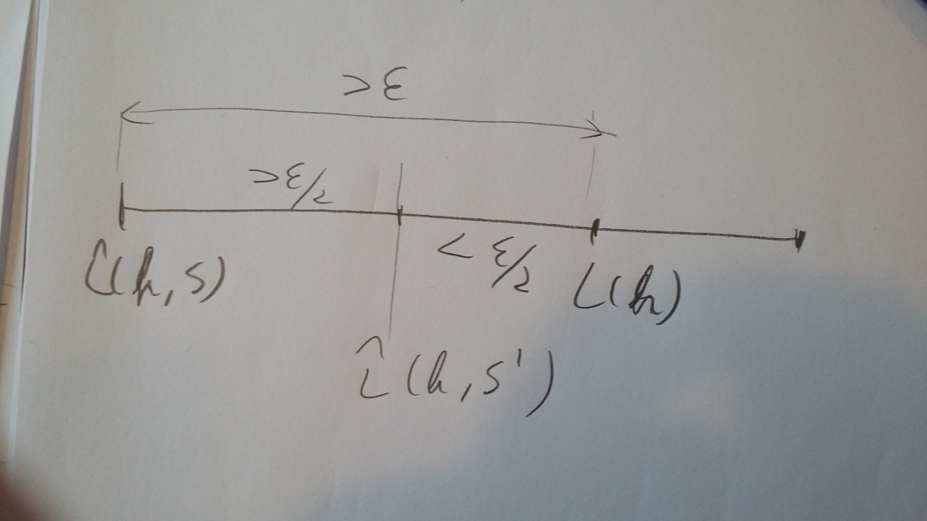

**Step2**: Now we show that:

$$P\left\{\sup_{h∈H}\left(L\left(h\right)-\hat{L}\left(h,S\right)\right)>ε\right\}≤2P\{\sup_{h∈H}\left(\hat{L}\left(h,S^{'}\right)-\hat{L}\left(h,S\right)\right)>\frac{ε}{2}\}$$

Since we have that $\hat{L}\left(h,S\right)=0$ the equation above becomes:

$$P\left\{\sup_{h∈H}L(h)>ε\right\}≤2P\{\sup_{h∈H}\hat{L}\left(h,S^{'}\right)>\frac{ε}{2}\}$$

$$P\left\{\sup_{h∈H}\hat{L}\left(h,S^{'}\right)>\frac{ε}{2}\right\}≥P\{\sup_{h∈H}\hat{L}\left(h,S^{'}\right)>\frac{ε}{2} AND \sup_{h∈H}L(h)>ε\}$$

And I am interested in the event that: $L(h)>ε$

I have to show that the distance $L\left(h\right)-0$ is large and that also the distance $\hat{L}\left(h,S^{'}\right)-0$ is large.

$P\left\{\sup_{h∈H}\hat{L}\left(h,S^{'}\right)>\frac{ε}{2} AND \sup_{h∈H}L\left(h\right)>ε\right\}= P\left\{\sup_{h∈H}L(h)>ε\right\}*P\left\{\sup_{h∈H}\hat{L}\left(h,S^{'}\right)> \frac{ε}{2} \right|\sup_{h∈H}L(h)>ε\}$

Now, I fix $h^{*}$ for which $L\left(h^{*}\right)-\hat{L}\left(h^{*},S\right)> ε$ calculate:

$$P\left\{\sup_{h∈H}\hat{L}\left(h,S^{'}\right)> \frac{ε}{2} \right|\sup_{h∈H}L(h)>ε\}≥P\{\hat{L}\left(h^{*},S^{'}\right)-\hat{L}\left(h^{*},S\right)> \frac{ε}{2} \left| L\left(h^{*}\right)-\hat{L}\left(h^{*},S\right)> ε\right\}≥$$

$$P\left\{L\left(h^{*}\right)-\hat{L}\left(h^{*},S'\right)≤ \frac{ε}{2} | L\left(h^{*}\right)-\hat{L}\left(h^{*},S\right)> ε \right\}$$

Because $S'$ and $S$ are independent, we have that $L\left(h^{*}\right)-\hat{L}\left(h^{*},S'\right)≤ \frac{ε}{2}$ confirmed so we can get rid of condition $L\left(h^{*}\right)-\hat{L}\left(h^{*},S\right)> ε$

$$P\left\{L\left(h^{*}\right)-\hat{L}\left(h^{*},S^{'}\right)≤ \frac{ε}{2} | L\left(h^{*}\right)-\hat{L}\left(h^{*},S\right)> ε \right\} =P\left\{L\left(h^{*}\right)-\hat{L}\left(h^{*},S^{'}\right)≤ \frac{ε}{2}\right\}=$$

$$= 1-P\left\{L\left(h^{*}\right)-\hat{L}\left(h^{*},S^{'}\right)> \frac{ε}{2}\right\}≥1-e^{-2n{\left(\frac{ε}{2}\right)}^{2}}≥\frac{1}{2}$$

**Step3**: now, I get to the step where I have to use Hoeffding’s inequality:

We have to bound: $P\left\{\sup_{h∈H}\left(\hat{L}\left(h,S^{'}\right)-\hat{L}\left(h,S\right)\right)>\frac{ε}{2}\right\}$ which is : $P\left\{\sup_{h∈H}\left(\hat{L}\left(h,S^{'}\right)\right)>\frac{ε}{2}\right\}$ in our case, because $\hat{L}\left(h,S\right)=0$.

I decide to use the method that we sample $S^{2n}$ and we split into: S and S’.

$$P\left\{\sup_{h∈H}\left(\hat{L}\left(h,S^{'}\right)\right)>\frac{ε}{2}\right\}= \sum_{ S^{2n}}{P\left\{S^{2n}\right\}*P\left\{\sup_{h∈H}\left(\hat{L}\left(h,S^{'}\right)\right)>\frac{ε}{2}\right|S^{2n}\}≤}$$

$$≤\sup_{S^{2n}}P_{split}\left\{\sup_{h∈H}\left(\hat{L}\left(h,S^{'}\right)\right)>\frac{ε}{2}\right|S^{2n}\}$$

There is a finite number of ways to label 2n points, at most $2^{2^{n}}$. Let $m_{H}(2n)$ be the maximal number of ways to label 2n points with hypotheses in H.

Let $M(S^{2n})$ be the number of ways to label $S^{2n}$ and let $h_{1}, h_{2}, …,h_{M(S^{2n})}$ be the corresponding hypothesis.

$$m_{H}\left(2n\right)= \max_{S} M(S^{2n})$$

$$P_{split}\left\{\sup_{h∈H}\left(\hat{L}\left(h,S^{'}\right)\right)>\frac{ε}{2}\right|S^{2n}\}= P_{split}\left\{\max_{h∈\left\{h_{1}, h_{2}, …,h_{M\left(S^{2n}\right)} \right\}}\left(\hat{L}\left(h,S^{'}\right)\right)>\frac{ε}{2}\right|S^{2n}\}$$

$$≤ \sum_{i=1}^{M\left(S^{2n}\right)}{P\left\{\left(\hat{L}\left(h,S^{'}\right)\right)>\frac{ε}{2} | S^{2n}\right\}}≤M(S^{2n}) \max_{h_{i} }P\left\{\left(\hat{L}\left(h,S^{'}\right)\right)>\frac{ε}{2} | S^{2n}\right\}$$

So we I can conclude that:

$$P\left\{\sup_{h∈H}\left(\hat{L}\left(h,S^{'}\right)\right)>\frac{ε}{2}\right\}≤ M\left(S^{2n}\right)\sup_{2n}\sup_{h∈H}P_{split}\left\{\left(\hat{L}\left(h,S^{'}\right)\right)>\frac{ε}{2} | S^{2n}\right\}$$

Since we have that $\hat{L}\left(h,S\right)=0$ as in the previous exercise, we have shown that:

$$P\left\{\left(\hat{L}\left(h,S^{'}\right)\right)>\frac{ε}{2} | S^{2n}\right\}≤e^{-nε}$$

**Now, I put everything together**:

$$P\left\{\sup_{h∈H}\left(\hat{L}\left(h,S^{'}\right)\right)>ε \right\}≤2P\left\{\sup_{h∈H}\left(\hat{L}\left(h,S^{'}\right)\right)>\frac{ε}{2}\right\}≤2m_{H}\left(2n\right)≤e^{-nε}$$

And with probability greater than $1- δ$, for all $hϵH$:

$$L\left(h\right)≤\frac{\sqrt{\ln\left(\frac{2m_{H}\left(2n\right)}{δ}\right)}}{n}$$

So I have proven that for all $hϵH$ that satisfy $\hat{L}\left(h,S\right)=0$ we have with probability greater than $1- δ$:

$L\left(h\right)≤O\left(\frac{\ln\left(\frac{2m_{H}\left(2n\right)}{δ}\right)}{n}\right)$ and I have also calculated the complete result.

# Question 2

I struggled much to install LIBSVM to make this exercise, but I did not manage to use any functions from the library in Matlab, so I could not make this exercise.

# Question 3

I will start with choosing just 2 more random values for distributions p and q. I will take that $p=0.2$ and $q=0.4$. In this case, we will have that kl-divergence between p and q:

$$kl(p|\left|q\right)=0.2\ln\left(\frac{0.2}{0.4}\right)+\left(1-0.2\right)\ln\left(\frac{1-0.2}{1-0.4}\right)=0.2ln0.5+0.8\ln\left(\frac{0.8}{0.6}\right)= -0.138+0.23=0.092$$

and the divergence between q and p:

$kl(q|\left|p\right)=0.4\ln\left(\frac{0.4}{0.2}\right)+\left(1-0.4\right)\ln\left(\frac{1-0.4}{1-0.2}\right)=0.4ln2+0.6\ln{0.25}=0.277-0.172=0.105$

Since I provided an example for p and q that have $kl(p|\left|q\right) ≠kl(q|\left|p\right)$, I proved that kl is asymmetric in its arguments.

# Question 4

I have plotted together the upper and lower bounds for both inequalities, by varying the value of $\hat{p}$ and calculating the values of inequalities for different values of n, by using:

$p≤ \hat{p}+\frac{\sqrt{\ln\left(\frac{1}{δ}\right)}}{2n}$ for Hoeffding’s inequality and $|p-\hat{p|}≤ \frac{\sqrt{\ln\left(\frac{n+1}{δ}\right)}}{2n}$ for KL inequality with values between 0 and 1 for $\hat{p}$ and I only get 2 linear plots for each, which is not really what I was expecting:

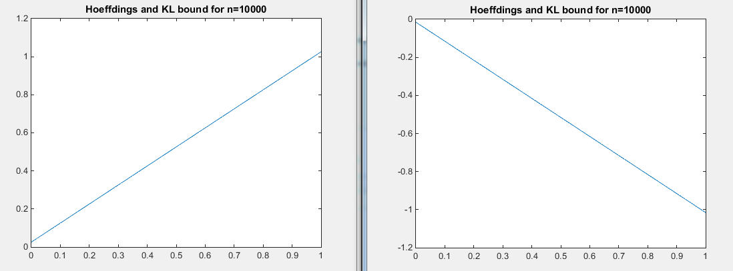

I do not understand why there is not any difference between the two lines, but I think I miss something.