Advanced topics in Machine Learning

Assignment 4

Mariuta Nicolae (rqt629) October 4, 2015

# Question 1

## 1.

As described in the lecture, the Hedge algorithm is:

**Input:** Learning rates $η_{1}≥η_{2}≥…>0$

$$∀a:{\hat{L}}_{0}\left(a\right)=0$$

**for** t=1,2,… **do**

$$∀a:p_{t}\left(a\right)=\frac{e^{-η_{t}{\hat{L}}_{t-1}(a)}}{\sum_{a'}{e^{-η_{t}{\hat{L}}_{t-1}(a')}}}$$

Sample $A_{t}$ according to $p_{t}$ and play it

Observe $l_{t}^{1},..,l_{t}^{k}$

$∀a:{\hat{L}}_{t}\left(a\right)= {\hat{L}}_{t-1}\left(a\right)+l_{t}^{a}$

**end**

Now, for the analysis, let:

$$W_{t}= \sum_{a}{e^{-η{\hat{L}}_{t}(a)}}=\sum_{a}{e^{-ηl_{t}^{a}}e^{-η{\hat{L}}_{t-1}\left(a\right)}}$$

Now, we make the calculation:

$$\frac{W_{t}}{W_{t-1 }}= \frac{\sum_{a}{e^{-η{\hat{L}}_{t}(a)}}}{\sum_{a}{e^{-η{\hat{L}}_{t-1}(a)}}}= \frac{\sum_{a}{e^{-ηl_{t}^{a}}e^{-η{\hat{L}}_{t-1}(a)}}}{\sum_{a}{e^{-η{\hat{L}}_{t-1}(a)}}}= \sum_{a}{e^{-ηl_{t}^{a}}\frac{e^{-η{\hat{L}}_{t-1}(a)}}{\sum_{a'}{e^{-η_{t}{\hat{L}}_{t-1}(a')}}}= \sum_{a}{e^{-ηl_{t}^{a}}P_{t}\left(a\right) } }$$

At this point, in the lecture we bounded the expectation of the exponent of $e^{-ηl_{t}^{a}}$ but since, we have the Hoeffding’s inequality from Lemma 5:

$$lnE\left[e^{λX}\right]≤ λE\left[X\right]+\frac{λ^{2}{\left(b-a\right)}^{2}}{8}$$

And I think that here it is where I have to make change in the analysis. In this case, the variable $X= l_{t}^{a}$ and we know it has values in the interval $[0,1]$ so I think I can write:

$$ln⁡\sum_{a}{e^{-ηl_{t}^{a}}P_{t}\left(a\right) }≤ \sum_{a}{\left(-ηl_{t}^{a} +\frac{η^{2}{\left(1-0\right)}^{2}}{8}\right)P_{t}\left(a\right)= } \sum_{a}{\left(-ηl_{t}^{a} +\frac{η^{2}}{8}\right)P_{t}\left(a\right) }$$

So, I can conclude that:

$$ln\frac{W_{t}}{W_{0}}≤ -η\sum_{t=1}^{T}{\sum_{a}{l_{t}^{a}}}P_{t}\left(a\right) +\frac{η^{2}}{8}\sum_{t=1}^{T}{\sum_{a}{P_{t}\left(a\right)}}$$

$$-η\min_{a}\left({\hat{L}}_{T}\left(a\right)\right)-lnK≤-η\sum_{t=1}^{T}{\sum_{a}{l_{t}^{a}}}P_{t}\left(a\right) +\frac{η^{2}}{8}\sum_{t=1}^{T}{\sum_{a}{P_{t}\left(a\right)}}$$

By using the Hoeffding’s inequality I obtained a tighter bound because in the lecture we had $\frac{η^{2}}{2}\sum_{t=1}^{T}{\sum_{a}{{\left(l_{t}^{a}\right)}^{2}P_{t}\left(a\right)}}$ instead of mine $\frac{η^{2}}{8}\sum_{t=1}^{T}{\sum_{a}{P_{t}\left(a\right)}}$ which is lower.

## 2.

Now we have the calculation summary after dividing the equation above by $η$:

$$\sum_{t=1}^{T}{\sum_{a}{l_{t}^{a}}}P_{t}\left(a\right)-\min_{a}\left({\hat{L}}_{T}\left(a\right)\right)≤\ln{\frac{K}{η}} +\frac{η}{8} \sum_{t=1}^{T}{\sum_{a}{P_{t}\left(a\right)}}$$

and as shown in the lecture, we know that $\sum_{t=1}^{T}{\sum_{a}{l_{t}^{a}}}P_{t}\left(a\right)$ is the expected loss of Hedge, $\min_{a}\left({\hat{L}}_{T}\left(a\right)\right)$ is the loss of the last row in hindsight; $\sum_{t=1}^{T}{\sum_{a}{P_{t}\left(a\right)}}≤T$ so we obtain that:

$$E\left[R_{t}\right]≤\frac{\ln{K}}{η}+\frac{1}{8}ηT$$

So we minimize with respect to : $η= \sqrt{\frac{8lnK}{T}}$ so we obtain the expectation of the loss of Hedge:

$$E\left[R_{t}\right]=\sqrt{8TlnK}$$

So I obtained an improvement in comparison with the result from the lecture.

# Question 2

## 1.

Considering the fact that the sequence is binary and it has a fixed bias, I will have to somehow find the bias and generate only value 0 if bias is smaller than 0.5 and 1 otherwise.

For this, I will consider the advice from the two experts and at each step I will predict the value according to the expert that has the lowest loss.

So the algorithm is something like this:

**for** t=1,2,… **do**

**if $\sum{l_{t}^{0}} < \sum{l_{t}^{1}}$**

$p\left(x\right)=0$

**else**

$p\left(x\right)=1$

**end**

The algorithm is very simple, we only take the sum of losses for each expert and if the bias is somewhat far from 0.5 then we will have a low regret since we choose the expert with the highest probability to be correct. With only a few samples, it may not work correctly but I think it will perform well for a large number of variables $X_{i}$

## 2.

For this exercise, I implemented the algorithm as described previously and the 4 variants of Hedge that are proposed and I have plotted the results as described. I will also attach the code that has comments and I just implemented the algorithms straightforward as they were shown.

I used the values of bias that were suggested and used time horizon T =10000 to make sure I obtain proper results.

For the bias $μ=\frac{1}{2}-\frac{1}{4}$ I obtained:

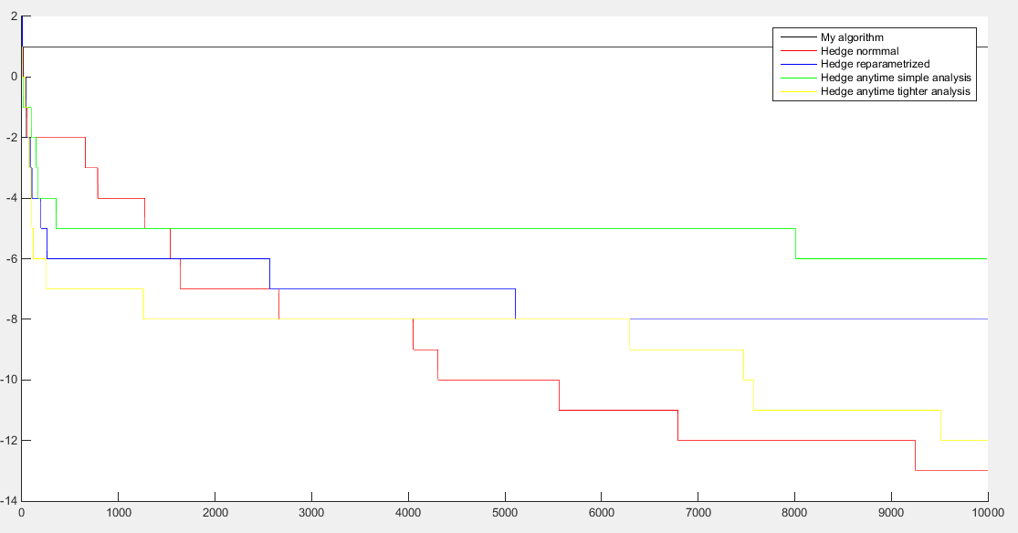

For the bias $μ=\frac{1}{2}-\frac{1}{8}$:

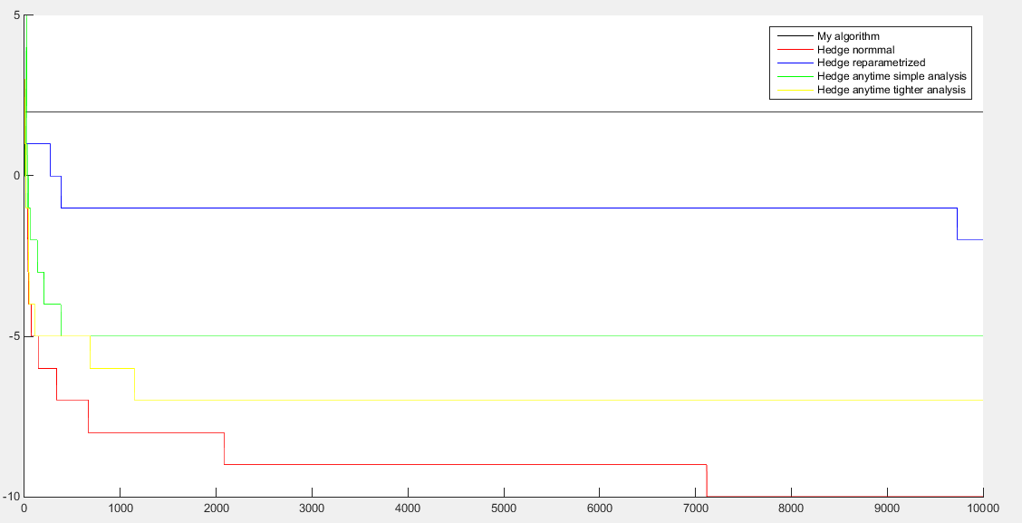

For the bias $μ=\frac{1}{2}-\frac{1}{16}$:

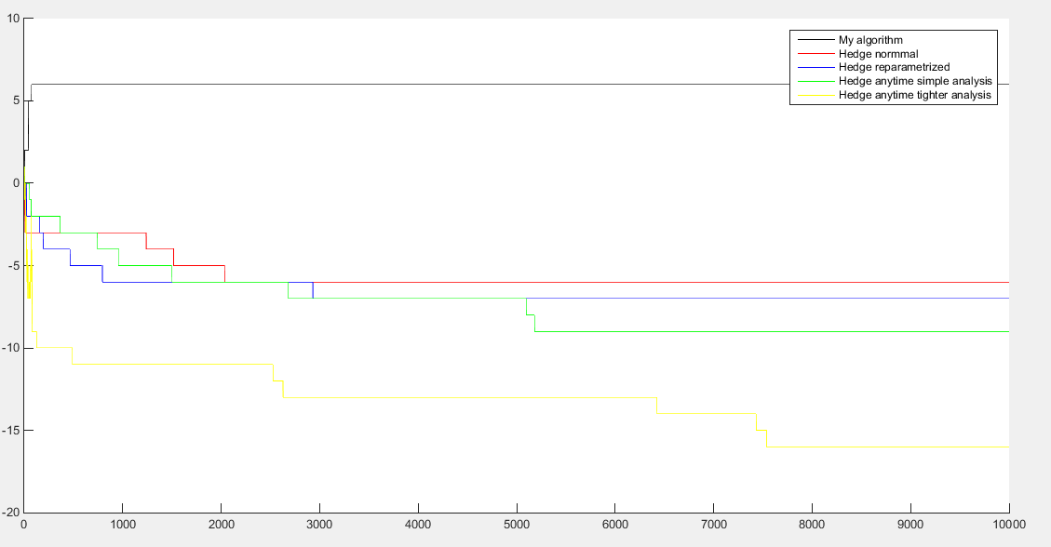

For my algorithm it seems to be the lowest performance when the value of bias is close to 0.5 because, as expected, both experts will have loss average close to 0.5 and each decision will have 50% chance to be wrong.

I also observe that the results are slightly different at each run but it looks like Hedge anytime with tighter analysis has lower regret in general and my algorithm seems to have a constant regret over all the time horizons.

# Question 3

## 1.

So we know from the exercise text that within a time period, the regret of Hedge is bounded by:

$$\sqrt{\frac{1}{2}2^{m}lnN}$$

So I basically have to prove that:

$$\sum_{m=1}^{t}{\sqrt{\frac{1}{2}2^{m}lnN}=\frac{1}{\sqrt{2}-1}\sqrt{\frac{1}{2}TlnN}}$$

I can rewrite the regret within a time period as:

$$\sqrt{\frac{1}{2}2^{m}lnN} =2^{\frac{m}{2}}\sqrt{\frac{1}{2}lnN}$$

And I think we have an infinite geometric series of the type:

$S_{n}=a+ar+ar^{2}+…+ar^{n-1}=\frac{a}{1-r}$ but in our case $a=\sqrt{\frac{1}{2}lnN}$ and $r=\sqrt{2}$ so the result should be:

$$\sum_{m=1}^{t}{\sqrt{\frac{1}{2}2^{m}lnN}=\frac{\sqrt{\frac{1}{2}lnN}}{1- \sqrt{2}} =\frac{1}{1- \sqrt{2}}}\sqrt{\frac{1}{2}lnN}$$

I think that we can write that:

$$\frac{1}{1- \sqrt{2}}\sqrt{\frac{1}{2}lnN}≤\frac{1}{\sqrt{2}-1 }\sqrt{\frac{1}{2}TlnN}$$

So I obtained that:

$$R_{T}= \frac{1}{\sqrt{2}-1}\sqrt{\frac{1}{2}TlnN}$$

I think I did not prove very correctly the result but I think this is almost the correct procedure to obtain that result.

## 2.

I obtained previously that for $T=2^{m}-1$ we have that

$$R_{T}= \frac{1}{\sqrt{2}-1}\sqrt{\frac{1}{2}TlnN}$$

I think I should make calculations for when we have that $<2^{m}-1$. In the equation above, if we make the replacement, there it will be:

$$R_{T}= \frac{1}{\sqrt{2}-1}\sqrt{\frac{1}{2}TlnN}=\frac{1}{\sqrt{2}-1}\sqrt{\frac{1}{2}(2^{m}-1)lnN} =\frac{1}{\sqrt{2}-1}\sqrt{\frac{2^{m}}{2}lnN-\frac{lnN}{2}}$$

I do not know how to continue, this but I think it should continue with calculation around the facts I thought about.