Computer Project 1

Nicolas Perez

Prof. Sergey Lototsky

3/12/2020

**Problem 1**

**Part 1**

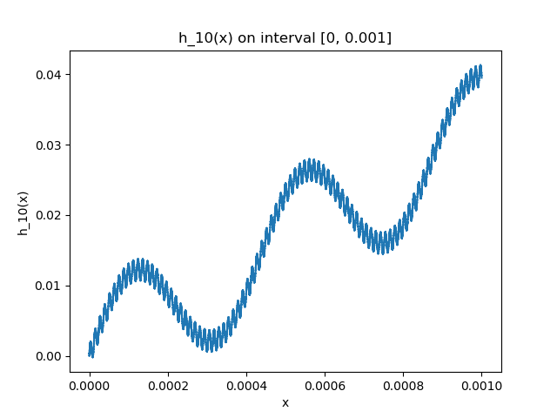Graphs:

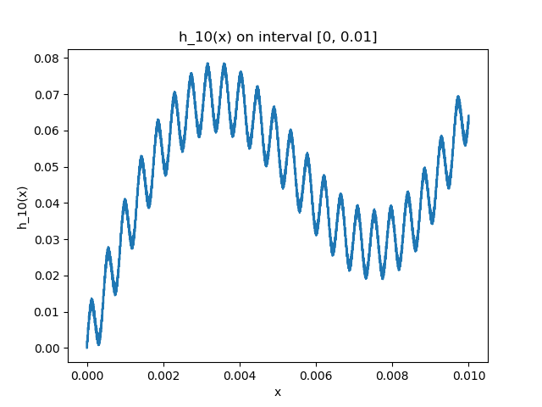

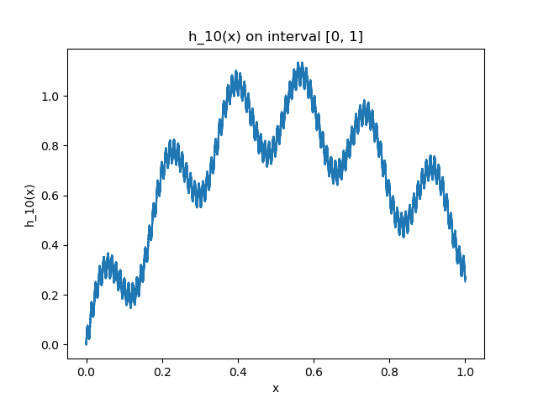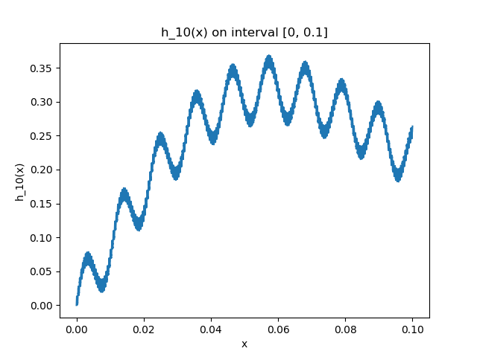

Printout of program:

import matplotlib.pyplot as plt

import numpy as np

from math import factorial, sin

import pandas as pd

def h10(x: int):

count = 0

for i in range(1, 11):

count += sin((factorial(i) ** 2) * x) / factorial(i)

return count

def plot_h10(interval: tuple, steps: int):

"""

interval: (tuple) containing boundaries for x

steps: (int) number of datapoints to generate

"""

result = {}

samples = np.linspace(interval[0], interval[1], num=steps)

for x in samples:

result[x] = h10(x)

result = pd.Series(result)

fig = plt.figure()

ax = plt.subplot(111)

ax.plot(result)

ax.set_xlabel('x')

ax.set_ylabel('h_10(x)')

ax.set_title('h_10(x) on interval [{}, {}]'.format(interval[0], interval[1]))

fig.savefig('h10_[{}_{}].png'.format(interval[0], interval[1]))

def main():

# testing functions

plot_h10((0, 1), 10000)

plot_h10((0, 0.1), 10000)

plot_h10((0, 0.01), 10000)

plot_h10((0, 0.001), 10000)

plot_h10

if __name__ == '__main__':

main()

**Part 2**

1. The series converges absolutely for all values of x (by comparison test with 1/k!), hence it is defined in the interval.
2. The series converges uniformly and thus it’s continuous
3. The series is not differentiable in the interval because its derivative doesn’t converge (not continuous).

**Problem 2**

1. Graphs:

­­

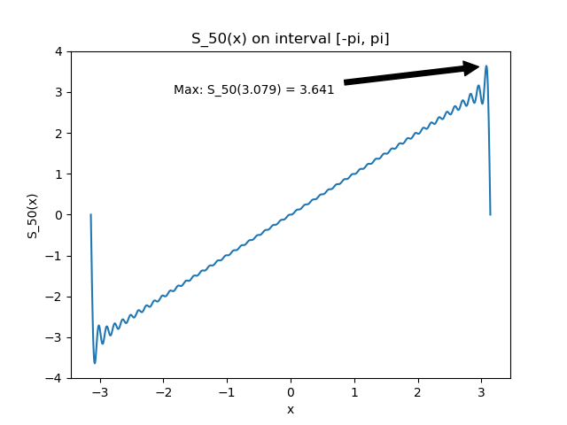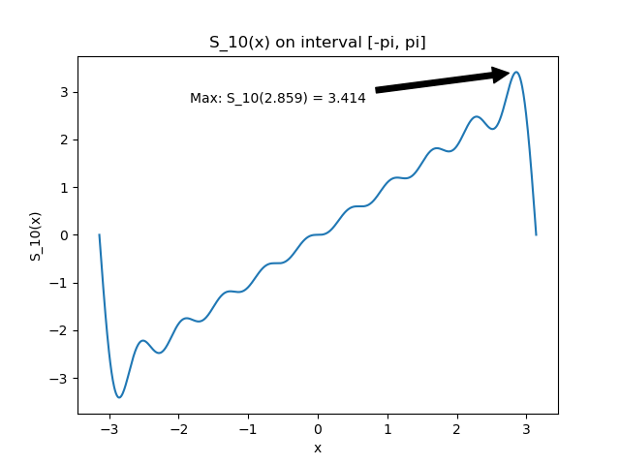

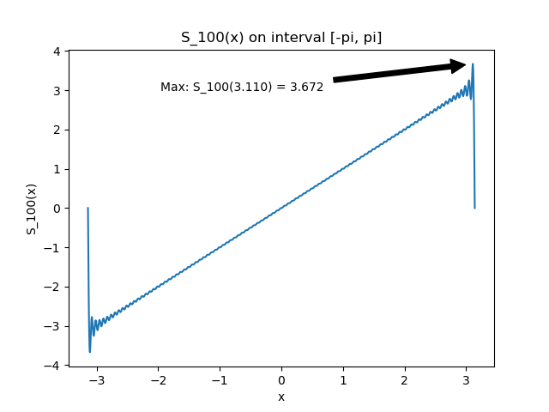

1. Program printout

In the program below, the coefficients b­­k have been computed in the function “compute_bk”. In this function I used the python library “scipy” and it’s “integrate.quad” function.

import numpy as np

import matplotlib.pyplot as plt

from scipy import integrate

def main():

# 1 Plot graphs of S_n(x) for n = 10, 50, 100

vals = [10, 50, 100]

for n in vals:

plot_S(n, "S_{}.png".format(str(n)))

"""

x (float): value to compute fourier Series

n (int): number for approximation

"""

def S_n(x, n):

result = 0

for k in range(1, n+1):

result += compute_bk(k)*np.sin(k*x)

return result

"""

steps (int): number of steps to approximate integral

k (int): index of coefficient

"""

def compute_bk(k):

i = integrate.quad(lambda x: x*np.sin(k*x), -np.pi, np.pi)[0]

return (1/np.pi) * i

"""

n (int): n approximation of fourier series

filename (str): name of file to save plot

"""

def plot_S(n, filename):

# divide interval:

x = np.linspace(-np.pi, np.pi, 1000)

s = np.vectorize(lambda x: S_n(x, n))

y = s(x)

p = (x[np.argmax(y)], y.max())

fig = plt.figure()

ax = plt.subplot(111)

ax.plot(x,y)

ax.annotate('Max: S_{}({:.3f}) = {:.3f}'.format(n, p[0], p[1]), xy = p,

xycoords='data', xytext=(0.6, 0.9), textcoords='axes fraction',

arrowprops=dict(facecolor='black', shrink=0.05),

horizontalalignment='right', verticalalignment='top'

)

ax.set_xlabel('x')

ax.set_ylabel('S_{}(x)'.format(str(n)))

ax.set_title('S_{}(x) on interval [-pi, pi]'.format(str(n)))

fig.savefig(filename)

if __name__ == '__main__':

main()

1. Gibbs phenomenon

We can see from the graphs above that the limit will go to 0.