Modular Dungeon
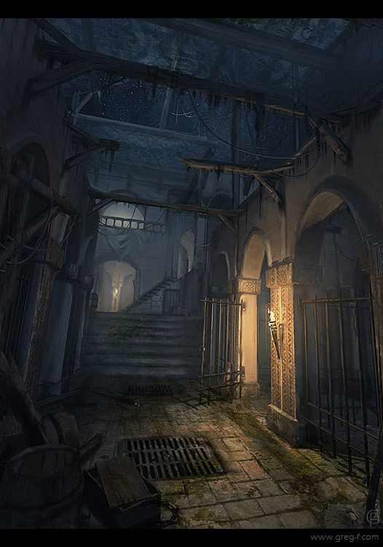

Main building
Wall
Grey brickwall like the Grimrock game
Prison cell doors
Arching doors with iron bars below
Floor tiles
Bricks like the walls
Doors
Iron Gitter Doors (like the image below)
Beam
Wood beam at the loft

Items
Iron Drain
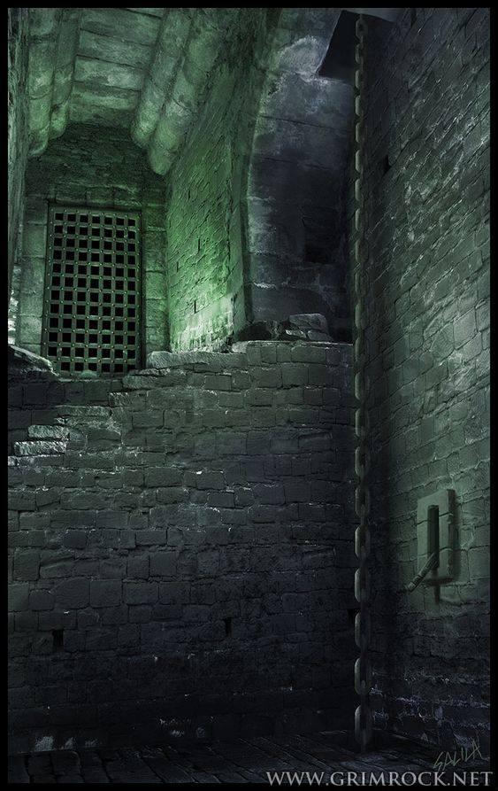
Chain
Torches
Barrels
Torture
Benches
Stools
Sarcophages
Lanterns
Skulls

