CPDOF Exam submission Template March 2020

-----------------------------------------------------------------------------------------------------------------------------------------------

Candidate Name:

Organization Name:

Date of the exam:

Trainer Name:

Contents

Please give screenshot of the Jenkins jobs used in the exam 2

Job 1 details 2

Job 2 details 2

Job 3 details 2

Please give screenshot running CPDOF exam web site on respective instance 3

Deployment screenshot on local tomcat 3

Deployment screenshot on Docker 1 instance (<mention port number> 3

Deployment screenshot on Docker 2 instance (<mention port number> - do this if the exam has asked you to do. Otherwise ignote 3

Please give screenshot of the running artifactory with the latest version of the war file deployed 3

Please copy any scripts used in the Jenkins job, or deploy.yml used if any 4

Script 1 – used. Mention which job it is used 4

Script 2 – used. Mention which job it is used 4

Docker related screenshot 4

screenshot of the docker ps -a command below 4

Text of the docker ps -a command below 4

Please showcase the directory listing of webapps of the first container 5

Please showcase the directory listing of webapps of the Second container 5

# Please give screenshot of the Jenkins jobs used in the exam

Please mention how many jobs were used for the exam purposes and their screen shots showing the Job main page, the last successful build console output in the following subsections. Please submit the entire code repository including the target folder for the build jobs. All file should be zipped together. E.g zip file name

CandidateName_CPDOF_DDMMYYYY.zip (it can be rar or any other standard compression format

## Job 1 details

<images for only main Jenkins job showing the history of build status, reports like pmd or cobertura displays >

For the last successful or unsuccessful build, Instead of giving screenshots of the build, please copy the text output in a separate text file. < **Give the filename here e.g. CANDIDATENAME_buildjob.txt** >

You can look at the console output in the text format and then use save as text / or use copy paste the console output in a text file

Instructions to save as text file – the following should be deleted to reduce the file size

>>>>>

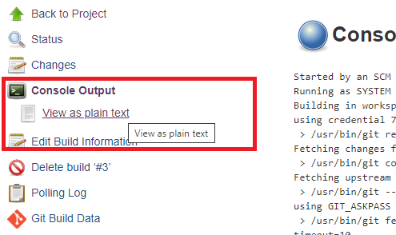

>>>>>>>>>

## Job 2 details

<images for only main Jenkins job showing the history of build status, reports like pmd or cobertura displays >

For the last successful or unsuccessful build, Instead of giving screenshots of the build, please copy the text output in a separate text file. <**Give the filename here e.g. CANDIDATENAME_buildjob.txt**>

## Job 3 details

<images for only main Jenkins job showing the history of build status, reports like pmd or cobertura displays >

For the last successful or unsuccessful build, Instead of giving screenshots of the build, please copy the text output in a separate text file. < **Give the filename here e.g. CANDIDATENAME_buildjob.txt** >

**ADD more sections if you have more jobs used in the exam**

# Please give screenshot running CPDOF exam web site on respective instance

Please ensure that the ipaddress and the port number is visible in the screen shot. Browser running the cpdof exam applications on local tomcat, and container ports.

## Deployment screenshot on local tomcat

<images>

## Deployment screenshot on Docker 1 instance (<mention port number>

<images>

## Deployment screenshot on Docker 2 instance (<mention port number> - do this if the exam has asked you to do. Otherwise ignote

<images>

Add more sections if there are further deployment related questions

# Please give screenshot of the running artifactory with the latest version of the war file deployed

Please ensure that the version number of the war file and the artifactry ip address on the URL is visible

# Please copy any scripts used in the Jenkins job, or deploy.yml used if any

Please ensure that the actual scripts used in the Jenkins job and deploy.yml are showcased here

## Script 1 – used. Mention which job it is used

<script>

## Script 2 – used. Mention which job it is used

<script>

# Docker related screenshot

Screen shot of the docker ps -a command should be pasted below – along with the text of the command

It should atleast have the docker container id’s being showcased which are being used to deploy the cpdof exam website.

## screenshot of the docker ps -a command below

<screenshot>

## Text of the docker ps -a command below

<text>

## Please showcase the directory listing of webapps of the first container

Screenshot of the webapps folder of container 1

## Please showcase the directory listing of webapps of the Second container

Screenshot of the webapps folder of container 2