PLAN4ARI

Deliverable D1.1
Project Management Report
DRAFT OUTLINE
Planning for Artificial Robotic Intelligence and Beyond

Project acronym | Plan4ARI
Project duration | 48 months
Work package/activity | Activity 1 - Scientific, Technical, and Project Management
Task basis | General Management, informed by Tasks 1.1-1.5
Activity period | M1-M48
Suggested delivery point | Initial issue in the project start-up phase; maintained as a living document (confirm)
Document status | Version 0.1
Lead beneficiary | CNR
Dissemination level | Restricted

Document control
Version | Date | Author/reviewer | Change description
0.1 | 4 April 2026 | Nicola Pedrocchi | Initial draft outline
0.2 | 18 April 2026 | Nicola Longo | COMAU Internal Revision
0.3 | 12 May 2026 | Nicola Pedrocchi | Tech Update
0.4 | 30 May 2026 | Nicola Pedrocchi | Tech Update
0.5 | 12 June 2026 | Nicola Pedrocchi | Tech Update
0.6 | 28 June 2026 | Nicola Pedrocchi | Tech Update
0.7 | 22 July2026 | Nicola Pedrocchi | Tech Update
1.0 | 31 Jan 2027 | TBC | Approved deliverable

Executive summary
D1.1 is a living document that tracks management actions and is based on the common rules agreed by the Consortium in the "Project Management Handbook" enclosed as Annex A to this Deliverable.

This document briefly describes the work carried out for each project work package (activity). Furthermore, a Section is dedicated to explaining and listing the project deviations and the actions taken by the consortium to preserve the results.

In addition, a set of revised Project documents is enclosed to track actual deviations/modifications to the scientific and deployment plans.

It is structured in a main document and several annexes

- Annex A Project Management Handbook (no modifications foreseen during the project)
- Annex B monthly status report (updated each month)
- Annex C Note on the Management of Risks (updated at each reporting period)
- Annex D Note on Financial Reporting (updated at each reporting period)
- Annex E Data Management (updated at each reporting period)
- Annex F Advisory Board (updated at each reporting period)
- Annex G Revision of the Plan4ARI project (updated at each reporting period)

Roles
Principal Investigator
Nicola Pedrocchi (CNR)

Project Manager
Damiano Morra (COMAU)

Control Lead
Nicola Longo (COMAU)

Technical Committee
Nicola Pedrocchi (CNR)
Nicola Longo (COMAU)
Caimmi Marco (CNR)
Chizzoli Guido (CNR)
Dinon Tito (CNR)
Fontana Gian Mauro (CNR)
Mottura Stefano (CNR)
Silva Fabrizio (CNR)
Villagrossi Enrico (CNR)
Samuele Sandrini (CNR)
Roberto Fausti (CNR)

XX
XX
XX
XX
XX
XX

Activity Leader
A1 Nicola Pedrocchi (CNR)
A2 Samuele Sandrini (CNR)
A3 ----- Metterei un COMAU ---
A4 ----- Metterei un COMAU ---
A5 ----- Metterei un COMAU ---
A6 Stefano Mottura (CNR)

Responsible, Accountable, Consulted, and Informed (RACI) matrix
The matrix below is a proposed baseline. "R" = Responsible; "A" = Accountable; "C" = Consulted; "I" = Informed. Formal role names and delegations require approval. Each row should retain one primary A.

Process | PI | Project Manager | Technical Committee | Activity Leader | Control lead
Project baseline and handbook | A | R | C | C | C
Activity planning and delivery | I | C | C | A/R | C
Cross-activity architecture | A | C | R | R | C
Monthly technical reporting | A | R | C | R | C
Deliverable authoring | I | C | C | A/R | C
Deliverable quality approval | A | R | C | R | R
Risk and opportunity management | A | R | C | R | R
Issue and dependency management | I | C | C | A/R | C
Change control | A | R | C/R | C | C
Financial reporting | A | C | I | R | R (Financial)
Data/ethics/privacy | A | C | C | R | R (Data/Ethics)
Safety/security release | A | C | C | R | R (Safety/Security)

Process | Coordinator / PI | Communication / Exploitation | Advisory Board | Partners/contributors | Financing institution
Public communication | A | R | C | C | I
Scientific dissemination | A | R | C | R | I
IPR / exploitable results | A | R | C | R | I
Advisory Board operation | A | C | R | I | I
Contractual submission | A/R | C | I | C | I/Approves as applicable
Major contractual change | A | C | C | C | Approves as applicable
Project closure | A | R | C | R | I/Accepts as applicable

Explanation of the work carried out and overview of the progress within the reporting period

Summary of the Objectives
Artificial General Intelligence (AGI) refers to AI that can understand, learn, and apply knowledge like a human across a range of tasks. Unlike narrow AI, AGI aims to replicate human reasoning, problem-solving, and adaptability. Key features of AGI include versatility, learning and adaptation, reasoning, common sense understanding, and self-improvement. While tools like ChatGPT-4 and Claude 3.5 Sonnet show progress, significant challenges remain in understanding human cognition and developing the necessary algorithms and computational power.

AGI is viewed as a crucial technology for achieving cognitive robotics, a long-standing goal in industrial robotics, and essential for the success of Industry 5.0. The rise of LLMs raises questions about when robots will incorporate such tools and become cognitive agents in manufacturing.

Plan4ARI aims to advance the development of intelligent robots through a systematic approach and identifies four levels of intelligence: the ability to tackle tasks based on user descriptions, autonomously determine task strategies considering other agents, plan movements with context and safety in mind, and react appropriately during task execution. By integrating advanced cognitive solutions, Plan4ARI envisions a new generation of intelligent robots, or Artificial Robotic Intelligence (ARI), where cognitive modules cooperate to support human workers effectively.

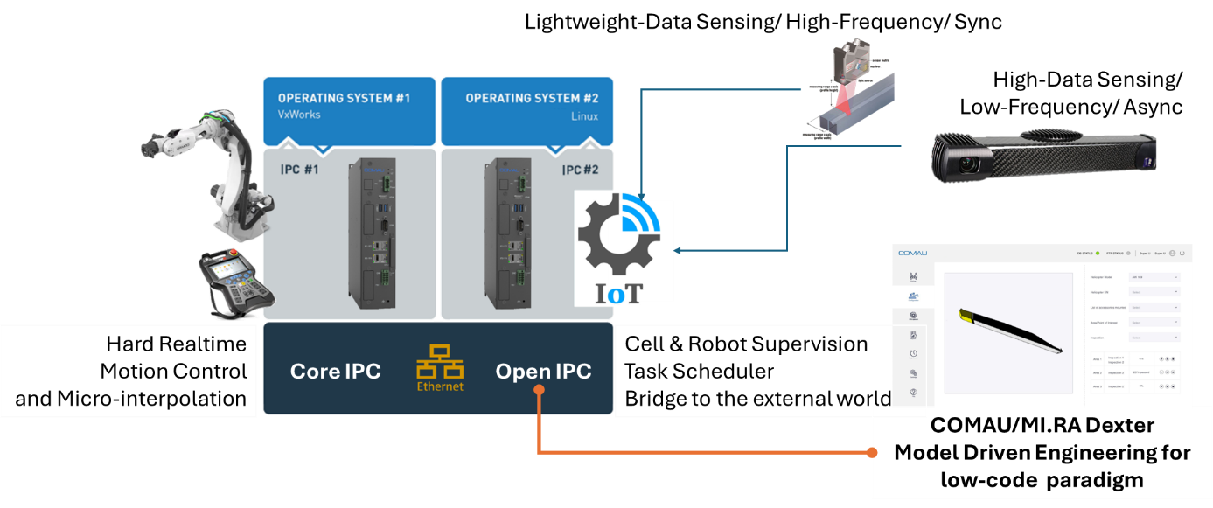
Figure 1 The Architecture for the new generation of robot controllers needs 2 IPC – The OPEN IPC provides all the programming tools, the motion planner, and the bridge to the world (cell & sensing). The Core IPC oversees the control loops and the micro-interpolation (high-rate real-time motion planner) and implements all the safety rules.

Given such powerful architecture, Plan4ARI will, specifically:
- Integrate Human-Robot Natural Communication in the MI.RA/Dexter platform. It will consist of a module translating the natural language into a verified and optimal flowchart. A powerful tool to reduce the coding to the minimum (e.g., zero for almost all situations)
- Plan4ARI will expand MI.RA/Dexter with further modules for scene/object registration/segmentation. The operative scene will be continuously updated, and innovative fusion techniques to integrate new sensors (like radar) will be implemented
- Plan4ARI will expand MI.RA/Dexter with an innovative motion planner that will run offline and in runtime. The points will be continuously streamed from the Core IPC to the Open IPC, which will translate the flow of motion references into real-time setpoints for the hard real-time motion controller
- Plan4ARI will develop an innovative Model Predictive Controller for micro-interpolating incoming external references. This will revolutionize the lookahead approach in industrial robotics, allowing us to achieve impressive tracking performance at Cartesian and Joint levels. This innovation will connect the high-rate sensor directly to the motion controller to continuously grant the tracking performance in every working condition.
- Plan4ARI will develop an innovative neural controller for motion control with a prescribed performance constraint design. This will open a new generation of controllers that learn and tune the model, allowing customization of the robotic controller within the system and impressively reducing deployment time.
- Plan4ARI will be natively developed in compliance with the EU AI Act, ensuring that all proposed AI solutions adhere to the highest standards of safety, transparency, and data protection required. The architecture will include specific measures to ensure critical AI systems are safe and reliable and respect fundamental rights.

Plan4ARI foresees five objectives; each focused on solving a functional aspect of the cognitive architecture.
- Low-code programming and Human-Robot Natural Communication. This module will investigate all aspects of programming the robot in natural language, ensuring that the autonomously generated program is as good as possible.
- Intelligent Sensing for Mobile Manipulators and Multi-Agents Interaction. This module will innovate in sensing the environment in which the robot is operating.
- Safe Motion Planning for Mobile Manipulators and Multi-Agents Interaction. The planner will tackle all techniques related to path generation, including offline path generation, online replanning, and high-rate, safe, hard-real-time planning.
- Advanced Robot Motion Controlling through Machine Learning Methods. This module will investigate a new generation of neural controllers to speed up tuning and improve tracking performance across all possible working conditions.
- Trustworthiness and Human-Centric Optimisation. This module introduces tools for evaluating users' acceptance of AI-powered robots. AI could be scary if not correctly managed. The module will also investigate how to increase acceptance.

Explanation of the work carried out by technical work packages

Activity 1

Objectives
Project Managing

Work performed by CNR

Work performed by COMAU

Deliverables Overview

Activity 2

Objectives

Work performed by CNR
Within the first 6 months of the project, CNR has conducted an in-depth review of the state of the art and identified a more plausible approach to achieve the overall objective of the PLAN4ARI project.

Work performed by COMAU

Deliverables Overview
The D1.1 draft has been delivered by M6.
A complete update of the Scientific Plan has been performed

Milestones Achievement

Technical Deviations

Activity 3

Objectives

Work performed by each beneficiary

Deliverables Overview

Milestones Achievement

Technical Deviations

Activity 4

Objectives

Work performed by each beneficiary

Deliverables Overview

Milestones Achievement

Technical Deviations

Activity 5

Objectives

Work performed by each beneficiary

Deliverables Overview

Milestones Achievement

Technical Deviations

Activity 6

Objectives

Work performed by each beneficiary

Deliverables Overview

Milestones Achievement

Technical Deviations

Activity 7

Objectives

Work performed by each beneficiary

Deliverables Overview

Milestones Achievement

Technical Deviations

Impact Evaluation

Update of the plan for exploitation and dissemination (Activity 8)

Follow-up Recommendation

Summary of Project Deviations

List of Annexes
- Annex A Project Management Handbook
- Annex B monthly status report
- Annex C Note on the Management of Risks
- Annex D Note on Financial Reporting
- Annex E Data Management
- Annex F Advisory Board
- Annex G Revision of the Plan4ARI project

