<https://www.utcluj.ro/>

<!DOCTYPE html>

<head>

<\head>

<body>

<\body>

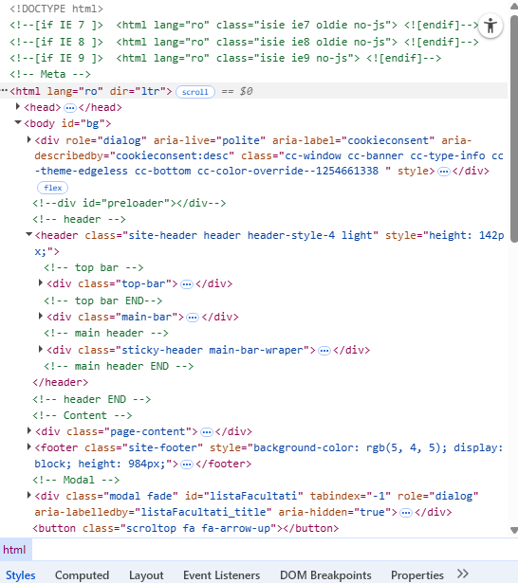

B

<head> <\head>



<header> <\header>

****

<script> <\script>

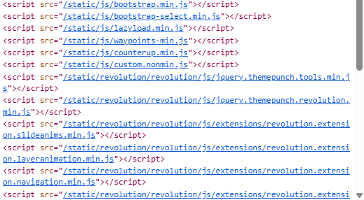

C

